**NAME: SHALMON N. ANANDAS**

**CLASS: M.Sc. PART – I**

**COURSE: BIOINFORMATICS**

**ACADEMIC YEAR: 2021-2022**

**ROLL NO: 91**

**PAPER CODE: GNKPSBI201 (PAPER 1)**

**COURSE TITLE: ADVANCE BIOLOGY**

**GURU NANAK KHALSA COLLGE**

**MATUNGA, MUMBAI – 400019**

**DEPARTMENT OF BIOINFORMATICS**

**CERTIFICATE**

This is to certify that Mr. **Shalmon N Anandas** of M.Sc. Part I Bioinformatics has satisfactorily completed the practical semester I course prescribed by the university of Mumbai during the academic year 2021-2022

**TEACHER IN CHARGE HEAD OF DEPARTMENT**

**INDEX**

|  |  |  |  |  |
| --- | --- | --- | --- | --- |
| **SR. NO** | **WEBLEM** | **PAGE NO** | **DATE** | **SIGNATURE** |
| 1 | Introduction to NCBI | 5 | 20/09/21 |  |
| 1a | To gather information for the query Diabetes using various NCBI resources | 7 | 25/09/21 |  |
| 2 | To explore literature databases and collect information on Scoliosis | 23 | 25/09/21 |  |
| 3 | Nucleotide databases that were introduced to us in this weblem were GenBank, EMBL-EBI and DDBJ. | 40 | 29/09/21 |  |
| 3a | To study the genes involved in the causation of Klinefelter’s syndrome using GenBank Database. | 41 | 29/09/21 |  |
| 3b | To study the genes involved in the causation of Klinefelter’s syndrome using EMBL-EBI Database. | 49 | 29/09/21 |  |
| 3c | To study the genes involved in the causation of Klinefelter’s syndrome using DDBJ Database. | 59 | 29/09/21 |  |
| 4 | Introduction to Protein sequence Databases | 64 | 2/10/21 |  |
| 4a | To study ‘Rhodopsin’ Protein information using UniProt Database. | 66 | 2/10/21 |  |
| 4b | To study ‘Rhodopsin’ Protein information using SwissProt Database: Reviewed and Manually annotated Database. | 75 | 2/10/21 |  |
| 4c | To study ‘Rhodopsin’ Protein information using TrEMBL Database: Unreviewed and manually annotated Database. | 84 | 2/10/21 |  |
| 4d | To study ‘Rhodopsin’ Protein information using PIR Database: An Integrated Protein Informatics Database. | 92 | 2/10/21 |  |
| 5 | Introduction to Domain Databases | 100 | 16/10/21 |  |
| 5a | To study Prothrombin domain information using Prosite database. | 102 | 16/10/21 |  |
| 5b | To study Cadherin domain information using Pfam database. | 113 | 16/10/21 |  |
| 5c | To study Cadherin domain information using InterPro database. | 123 | 16/10/21 |  |
| 6 | Introduction to Specializsed databases | 132 | 13/10/21 |  |
| 6a | To study the AKT Pathway using KEGG Database | 133 | 13/10/21 |  |
| 6b | To study the disease Sickle Cell anemia using OMIM database. | 140 | 13/10/21 |  |
| 7 | Introdcution to Structural Database | 149 | 17/10/21 |  |
| 7a | To study “Insulin” Query in Structure Database PDB. | 152 | 17/10/21 |  |
| 8 | To explore the ExPasy Tools. | 160 | 8/11/21 |  |
| 9 | Introduction to Genome Browser | 167 | 8/11/21 |  |
| 9a | To study the Staphylococcus epidermidis in NCBI genome browser | 168 | 8/11/21 |  |
| 9b | GOLD | 174 | 8/11/21 |  |
| 10 | Introduction to Pairwise Alignment | 177 | 31/10/21 |  |
| 10a | To Study the query “Actin Sequence” in Needleman-Wunsch algorithm | 179 | 31/10/21 |  |
| 10b | To study the query “Actin” in Smith-Waterman alignment algorithm | 184 | 31/10/21 |  |
| 11 | Introduction to Sequence Alignment | 188 | 7/11/21 |  |
| 11a | To study the Query ‘Keratin’ in BLASTn. | 190 | 7/11/21 |  |
| 11b | To study the Query ‘Keratin’ in BLASTp | 197 | 7/11/21 |  |
| 11c | To study the Query ‘Keratin’ in FASTAn | 203 | 7/11/21 |  |
| 11d | To study the Query ‘Keratin’ in FASTAp | 209 | 7/11/21 |  |
| 11e | To study the Query ‘Keratin’ in PHI-BLAST | 215 | 7/11/21 |  |
| 11f | To study the Query ‘Keratin’ in PHI-BLAST | 223 | 7/11/21 |  |
| 12 | Comparison between BLAST and FASTA | 235 | 9/11/21 |  |
| 13 | Introduction to Multiple Sequence Alignment | 236 | 12/11/21 |  |
| 13a | To study rhodopsin sequnces similarity using Clustal Omega | 239 | 10/11/21 |  |
| 13b | To view query Rhodopsin phylogenetic tree data produced in Clustal Omega in tree view | 247 | 10/11/21 |  |

**Date : 20-09-21**

**WEBLEM: 1**

**National Centre for Biotechnology Information (NCBI)**

**(URL:** [**https://www.ncbi.nlm.nih.gov/**](https://www.ncbi.nlm.nih.gov/)**)**

**Introduction:**

The National Center for Biotechnology Information (NCBI) was created in 1988 as a division of the National Library of Medicine (NLM) at the National Institutes of Health, to develop information systems in the field of molecular biology and bioinformatics.The data accessible from NCBI’s home page (https://www.ncbi.nlm.nih.gov/) provides a range of information from short sequences representing parts of genes, such as sequence tags (ESTs), to complete genomic sequences, such as the 21 complete microbial genomes in GenBank today. In addition to maintaining the GenBank, NCBI also provides data analysis and retrieval and resources that operate on GenBank data and also on a variety of other biological data made available through NCBI.

**Databases and tools associated with NCBI:**

1. **Entrez:**
   * It is an Integrated database retrieval system for access to publicly available GenBank and other sequence data mapping and complete genome data, 3D structures and the biomedical literature throught PubMed.
   * Entrez provides text searching of sequence or bibiliographic records by simple Boolean queries. Plus extensive links to related information.
2. **The Taxonomy Browser:**
   * It is a search tool for the NCBI taxonomy database, which indexes over 55,000 organisms represented in the sequence databases by at least one nucleotide or protein sequence.
   * From the data displayed for a particular organism, one can retrieve and download the sequence data for that organism or protein 3D structure data if available.
3. **UniGene:**
   * The UniGene system automatically partitions GenBank sequences, including EST’s into a non-redundant set of gene-oriented clusters.
   * This currently includes the totl genome sequencing for human, mouse and rat in its database.
4. **ORF Finder**
   * This is a tool used for performing a six-frame translation of a nucleotide query and returns a graphic that indicates the location of each ORF found.
   * The restrictions on the size of the ORFs returned can be set by the user and the predicted protein sequences can be submitted directly for BLAST similarity searching.
5. **Human Genome Resources:**
   * It provides a centralized access to a full range of human genome resources available from NCBI and elsewhere.
   * It also includes the Genese and Disease site, which has general synopses of over 60 diseases of genetic origin.
6. **GeneMap ‘99:**
   * An international effort was made in 1994 to construct a human gene mp by determining the locations of ESTs relative to a framework of well-characterized genetic markers.
   * The latest version of this map is called GeneMap ‘99 and features 30,261 uniqure gene loci representing approximately half of the 60k-80k genes that are thought to tbe a part of the human genome.
7. **Entrez Genomes:**
   * Entres Genomes Database provides access to genomic data contributed by the scientific community for over 600 species whose sequencing and maaping is either complete or in progress.
   * In this each and every genome is represented as a clickable graphic for quick navigation to more detailed representations of smaller regions.
8. **Retroviral Genotyping Tools:**
   * Genotyping of retrovirus sequences has a number of impications for attempts at characterization of viral genetic diversity, tracking of the epidemic and in case of HIV-1 the impact that it has on vaccine development.
   * The tools helps detect reombinant genomes by performing local blastn comparisons over a sliding window of size and step values set by the user.
9. **Cancer Genome Anatomy Project (CGAP):**
   * The CGAP service provides access to genetic data on normal precancerous and malignant cells generated by the CGAP initiative.
   * The cDNA library information from CGAP can be retrieved by text words, or by using an interactive library by select a summary table that organizes data by gene, clone, tissue, type, method of sample preparation, stage of tumor development, etc
10. **Molecular Modeling Database (MMDB):**
    * The MMDB is a structural database derived from the protein Data Bank and accessible via the Entrez system.

**Conclusion:**

In conclusion, NCBI is a great database with an amazing set of tools required by scientists and students alike to either organize or to collect data/information on a particular topic. The suite of tools that NCBI offers under one umbrella is expansive and ever mutating, recieving new features to handle new complicatons and edge cases in data management.

**References:**

1. Nucleic Acids Research, 2000, Vol. 28, No 1, Benson,D.A., Karsch-Mizrachi,I., Lipman,D.J., Ostell,J., Rapp,B.A. and Wheeler,D.L.
2. Science, 1998, Vol 282, Deloukas,P., Schuler,G.D., Gyapay,G., Beasley,E.M., Soderlund,C., Rodriguez-Tome,P., Hui,L., Matise,T.C., McKusick,K.B., Beckmann,S.
3. Nature Genet, 1998, Vol 20, Ermolaeva,O., Rastogi,M., Pruitt,K.D., Schuler,G.D., Bittner,M.L., Chen,Y., Simon,R., Meltzer,P., Trent,J.M. and Boguski,M.S.
4. Human genes and Genetic Disorders, 12th Edition, John Hopkins University Press, Baltimore.
5. Molecular biology, 1990, Vol 125, Ermolaeva,O., Rastogi,M., Pruitt,K.D., Schuler,G.D., Bittner,M.L., Chen,Y., Simon,R., Meltzer,P., Trent,J.M. and Boguski,M.S.

**Date: 25-09-21**

**WEBLEM: 1a**

**National Center for Biotechnology Information (NCBI)**

**(URL:** [**https://www.ncbi.nlm.nih.gov/**](https://www.ncbi.nlm.nih.gov/) **)**

**Aim:**

To gather information for the query “Diabetes” using various NCBI Resources

**Introduction:**

The National Center for Biotechnology Information (NCBI) was created in 1988 as a division of the National Library of Medicine (NLM) at the National Institutes of Health, to develop information systems in the field of molecular biology and bioinformatics. In addition to maintaining the GenBank, NCBI also provides data analysis and retrieval and resources that operate on GenBank data and also on a variety of other biological data made available through NCBI.

The query used today is Diabetes. Diabetes is a disorder affecting 422 million people worldwide. Most commonly observed in obese individuals above the age of 40, diabetes is directly attributed with causing about 1.6 millions deaths each year. Learning more of how this disorder works on a molecular and genomix level will help us cushion the further blow of this disease.

**Methodology:**

1. Open Homepage of NCBI Database (url: [**https://www.ncbi.nlm.nih.gov/**](https://www.ncbi.nlm.nih.gov/) **)**
2. Enter search Query of Diabetes in various resources of NCBI.
3. Interpret the results.

**Observations:**

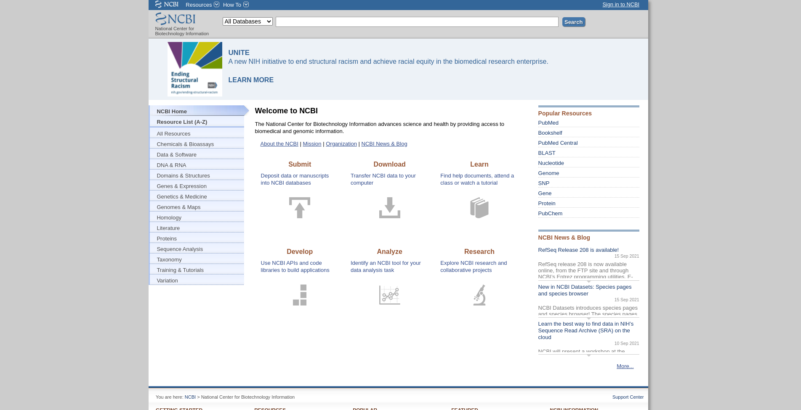**Fig1. NCBI Database Homepage**

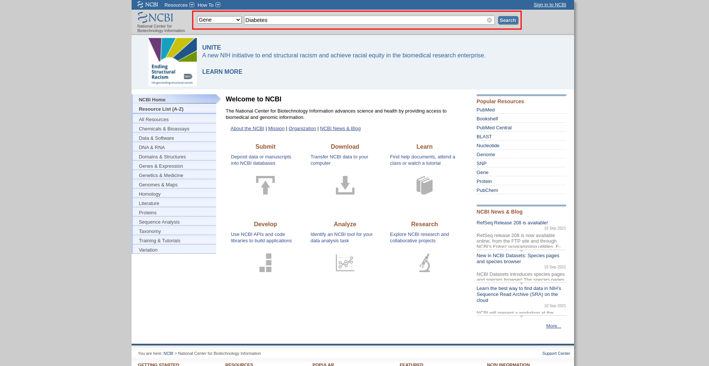**Fig2. Search page with resource Gene selected for query “Diabetes”**

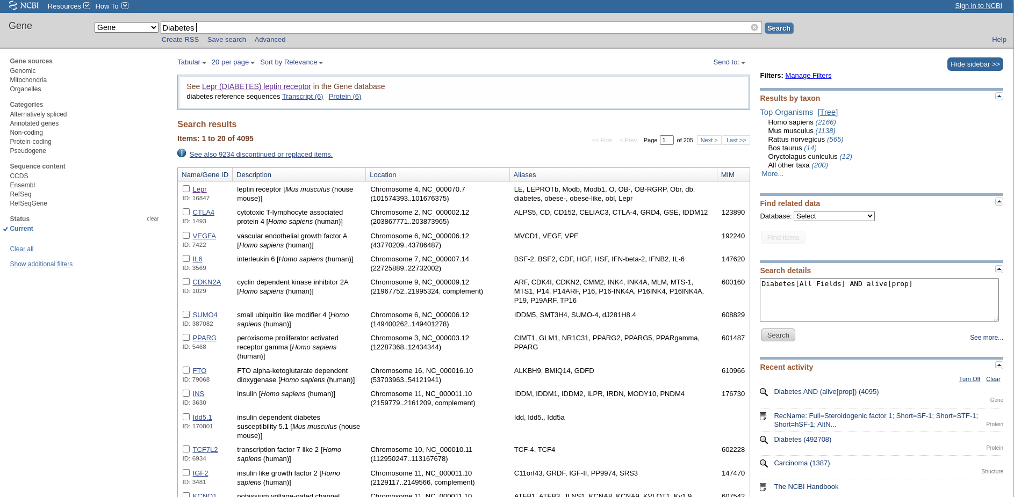**Fig3. Hit page for search query “Diabetes” in the Gene resource**

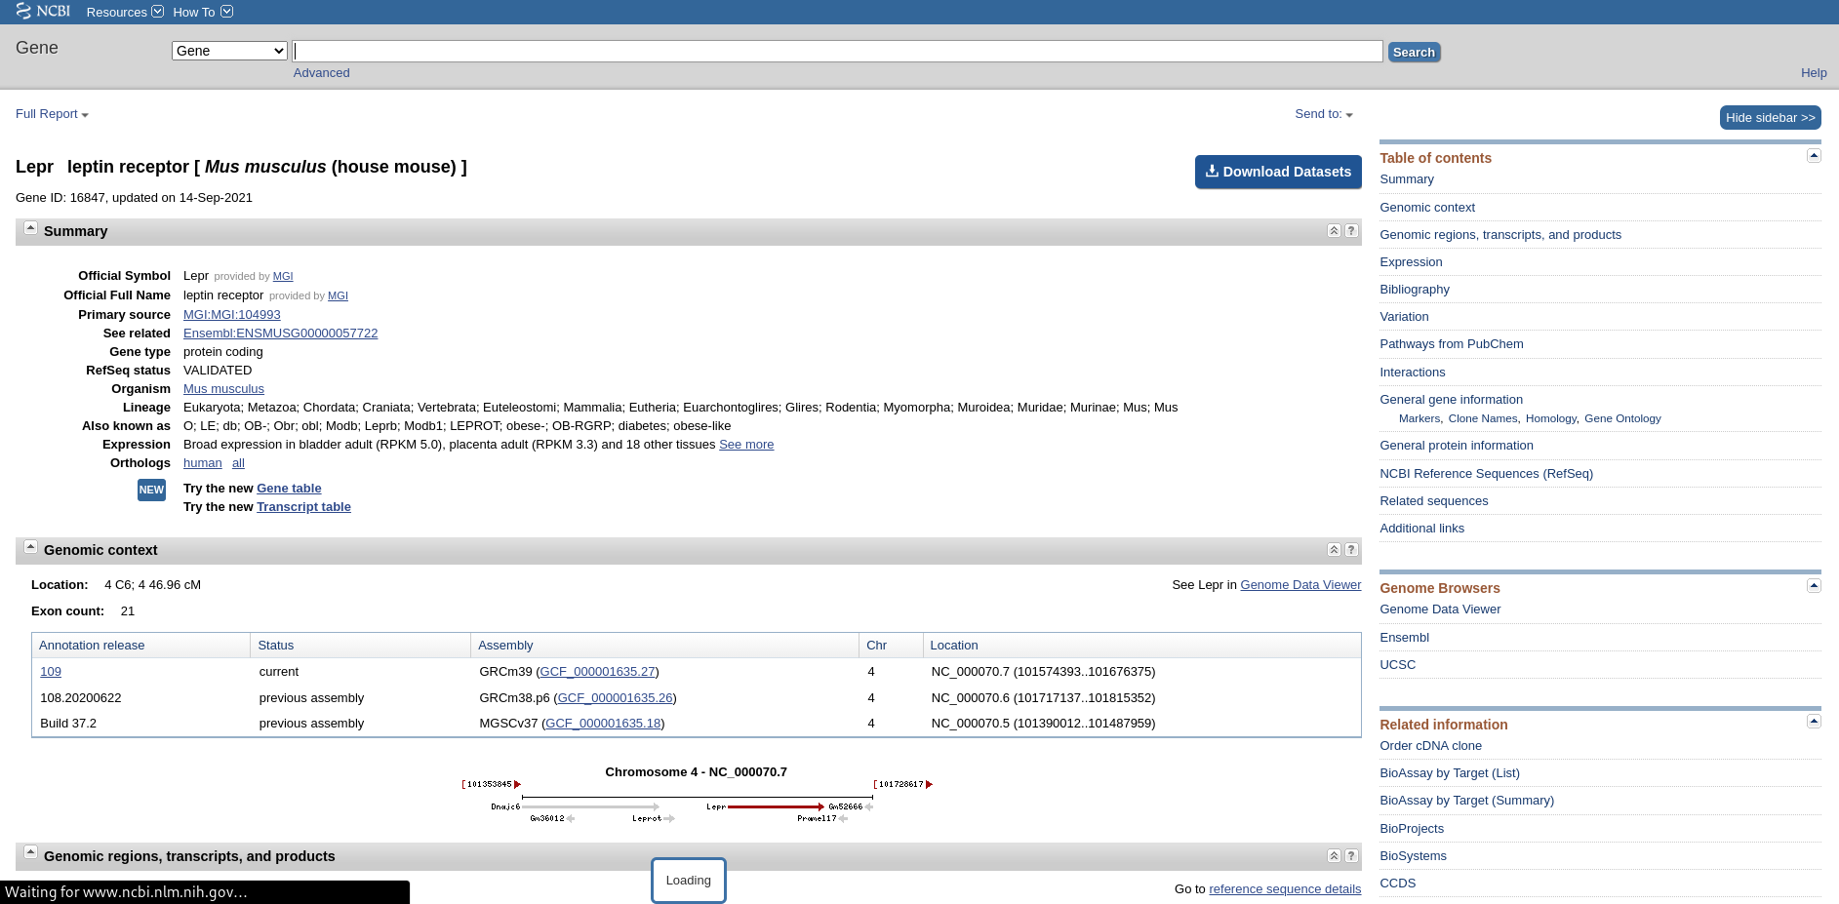**Fig4. Result page for** **gene resource on “Diabetes” [Lepr : leptin receptor in Mus musculus(house mouse)]**

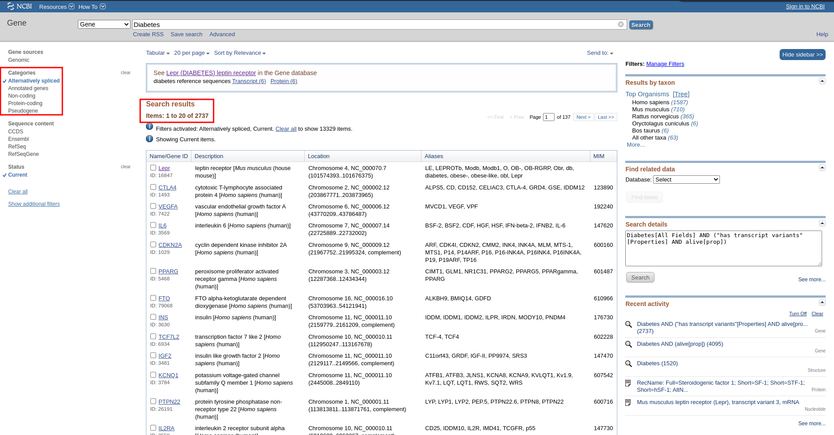**Fig5. Hit page for query “Diabetes” in gene resource with limit option and refined results.**

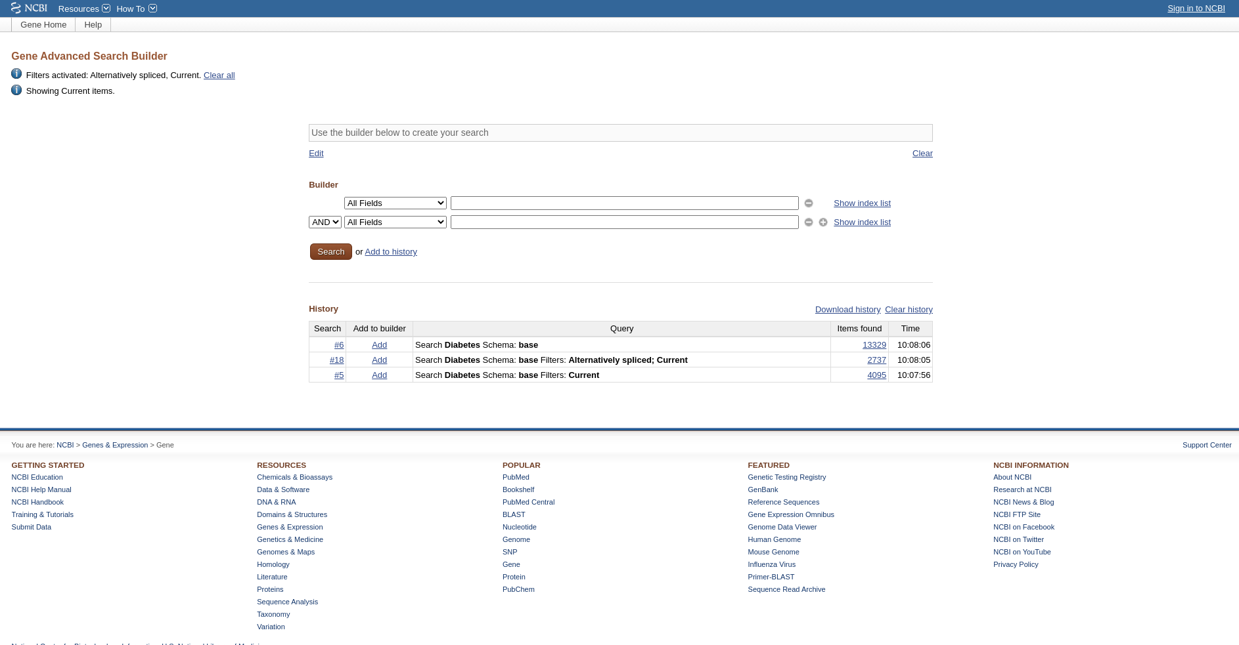**Fig6. Advanced search of query “Diabetes” in Gene Resource**

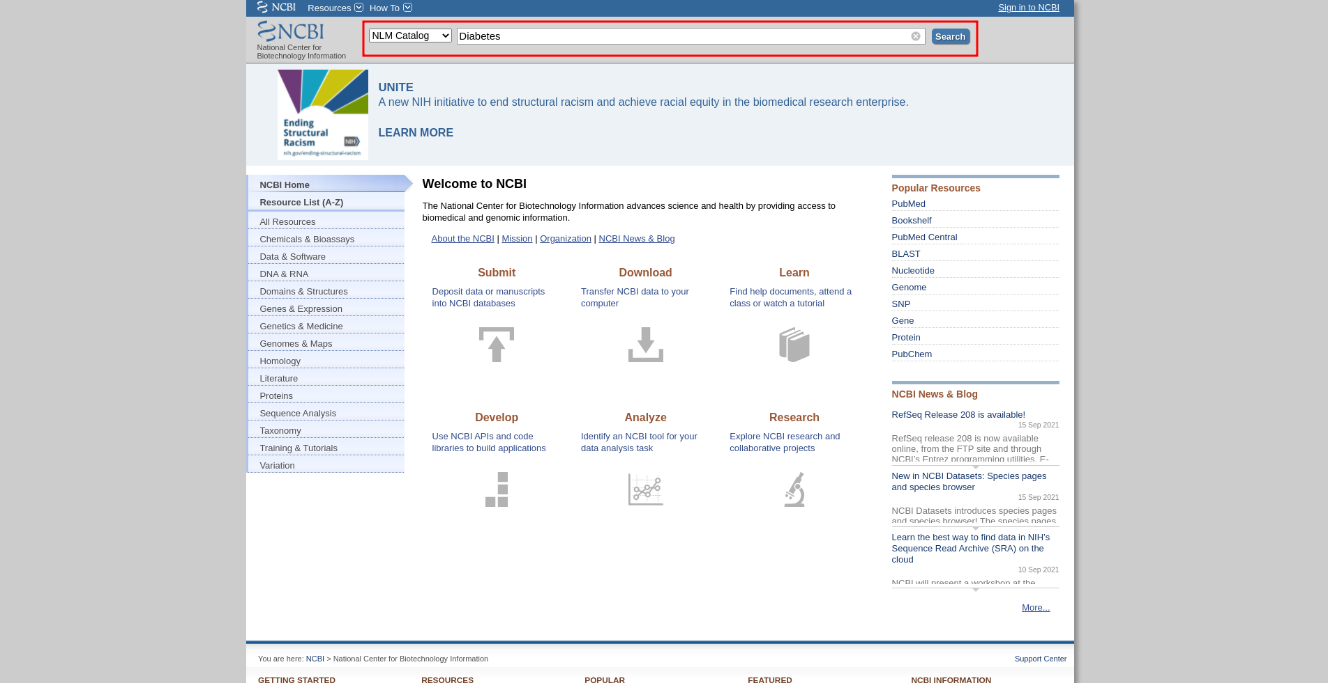**Fig7. Search page with resource NLM Catalog selected with query “Diabetes”**

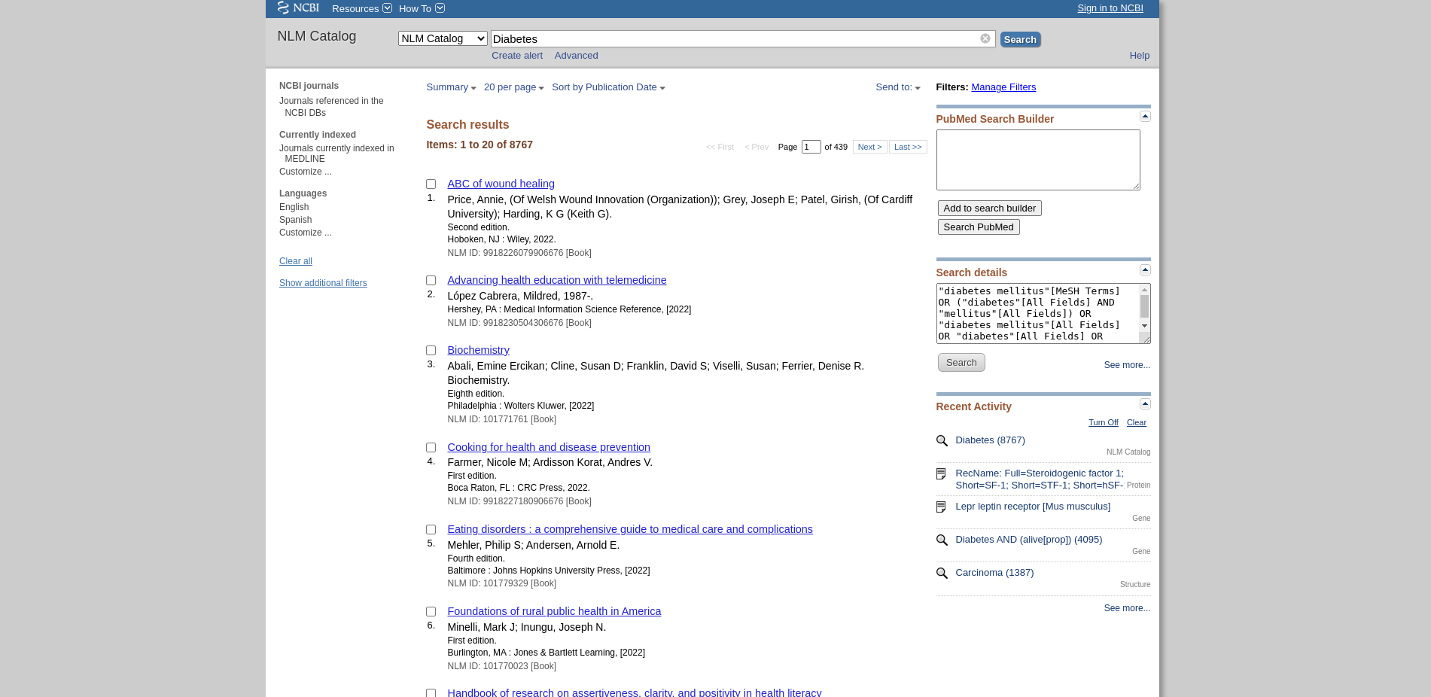**Fig8. Hit page for search query “Diabetes” in NLM catalog resource**

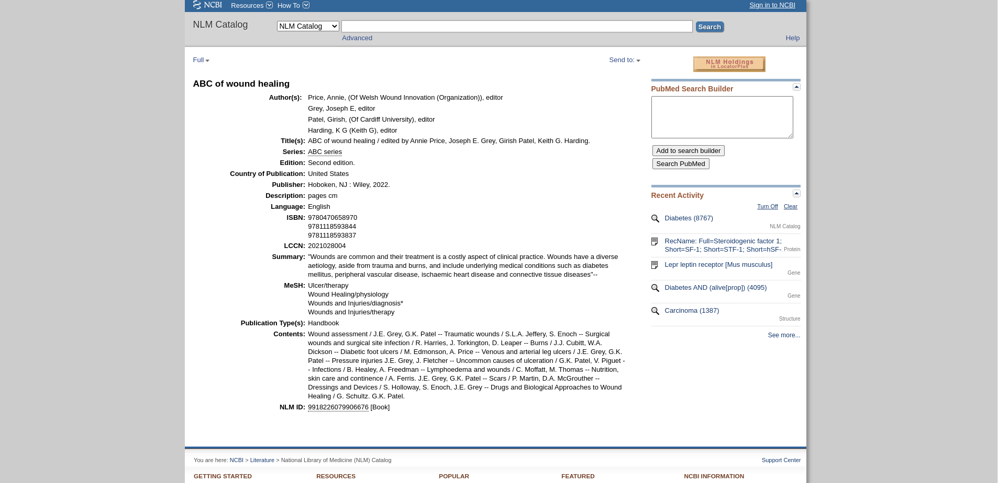**Fig9. Result Page for NLM catalog resource on “Diabetes” [ABC of wound healing]**

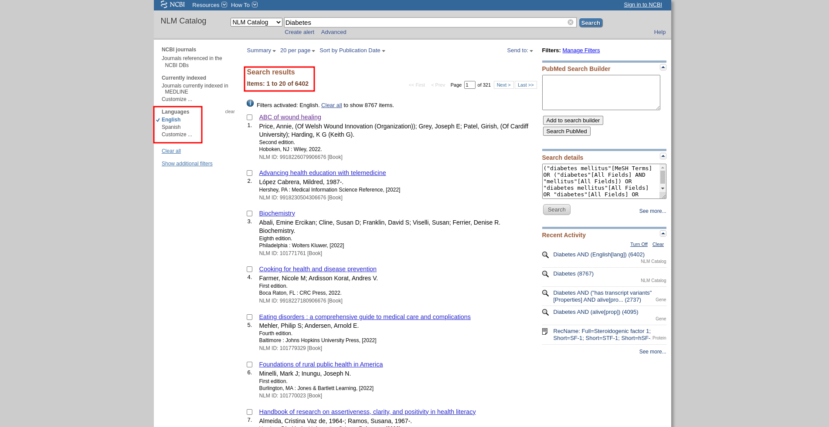**Fig10. Hit page for search query “Diabetes” in resource NLM catalog with Limit option and refined results**

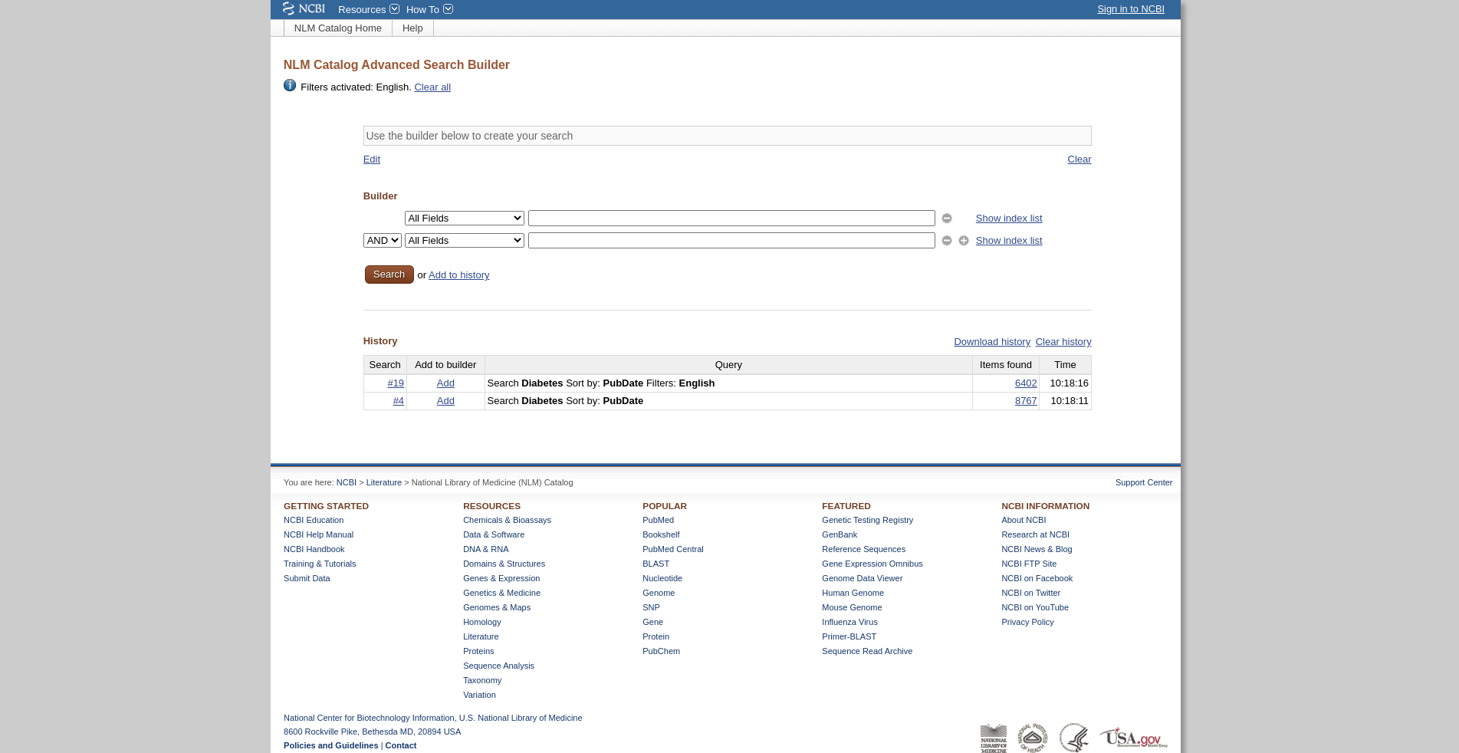**Fig11. Advanced search of Query “Diabetes” in NLM Catalog resource.**

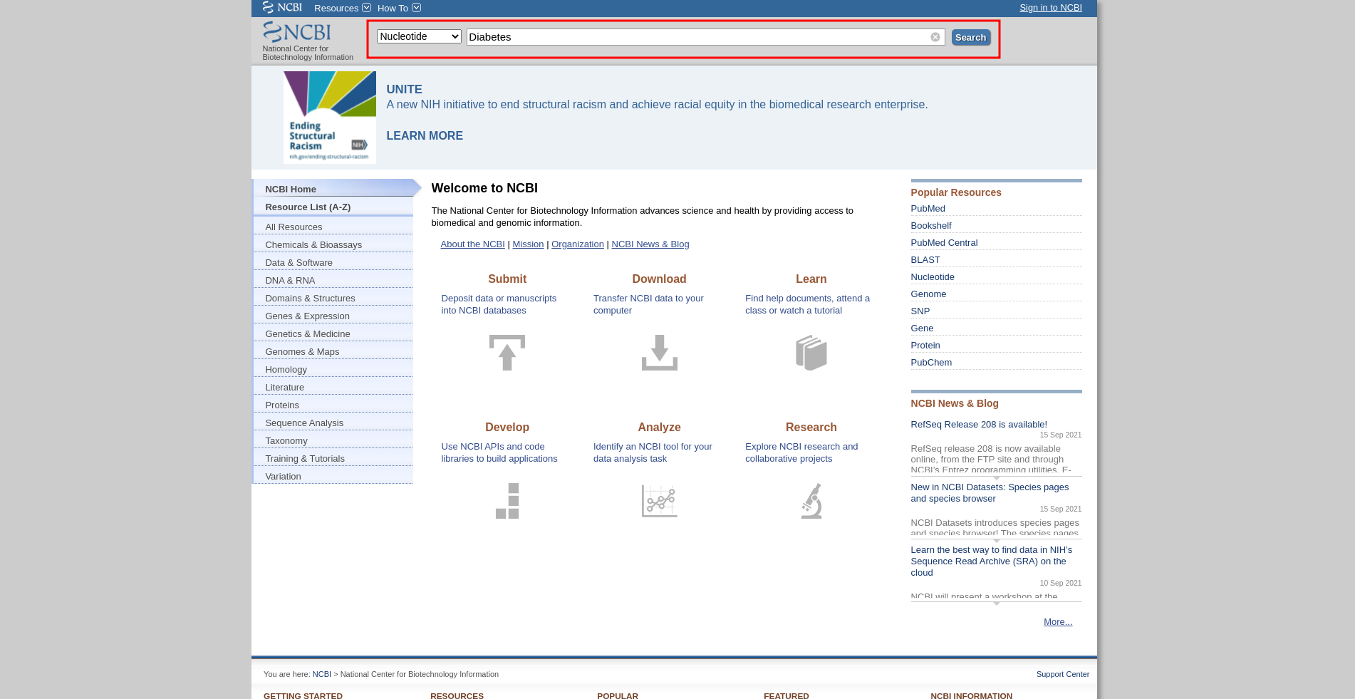**Fig12. Search page with resource Nucleotide selected with query “Diabetes”**

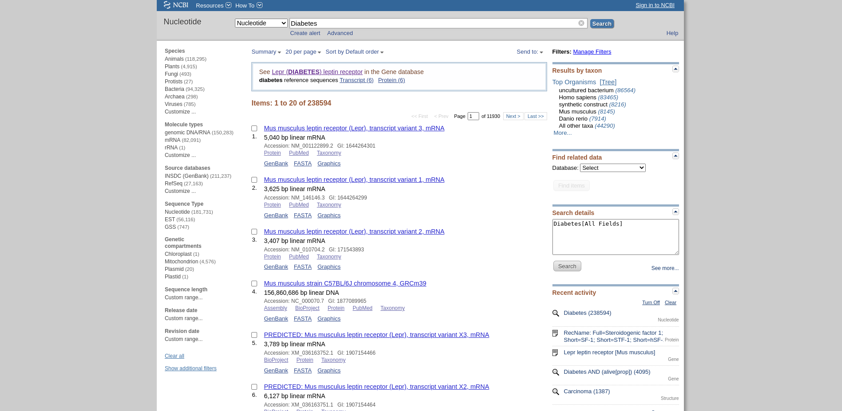**Fig13. Hit page for search query “Diabetes” in Nucleotide resource**

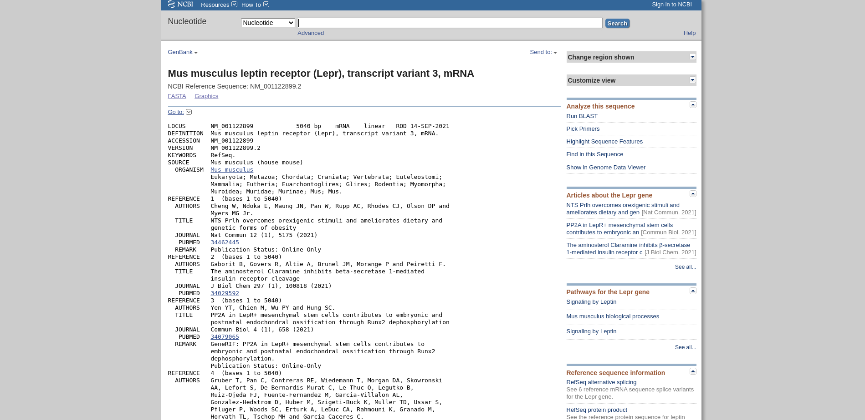**Fig14. Result Page for Nucleotide resource on “Diabetes” [Mus musculus leptin receptor (Lepr), transcript variant 3, mRNA]**

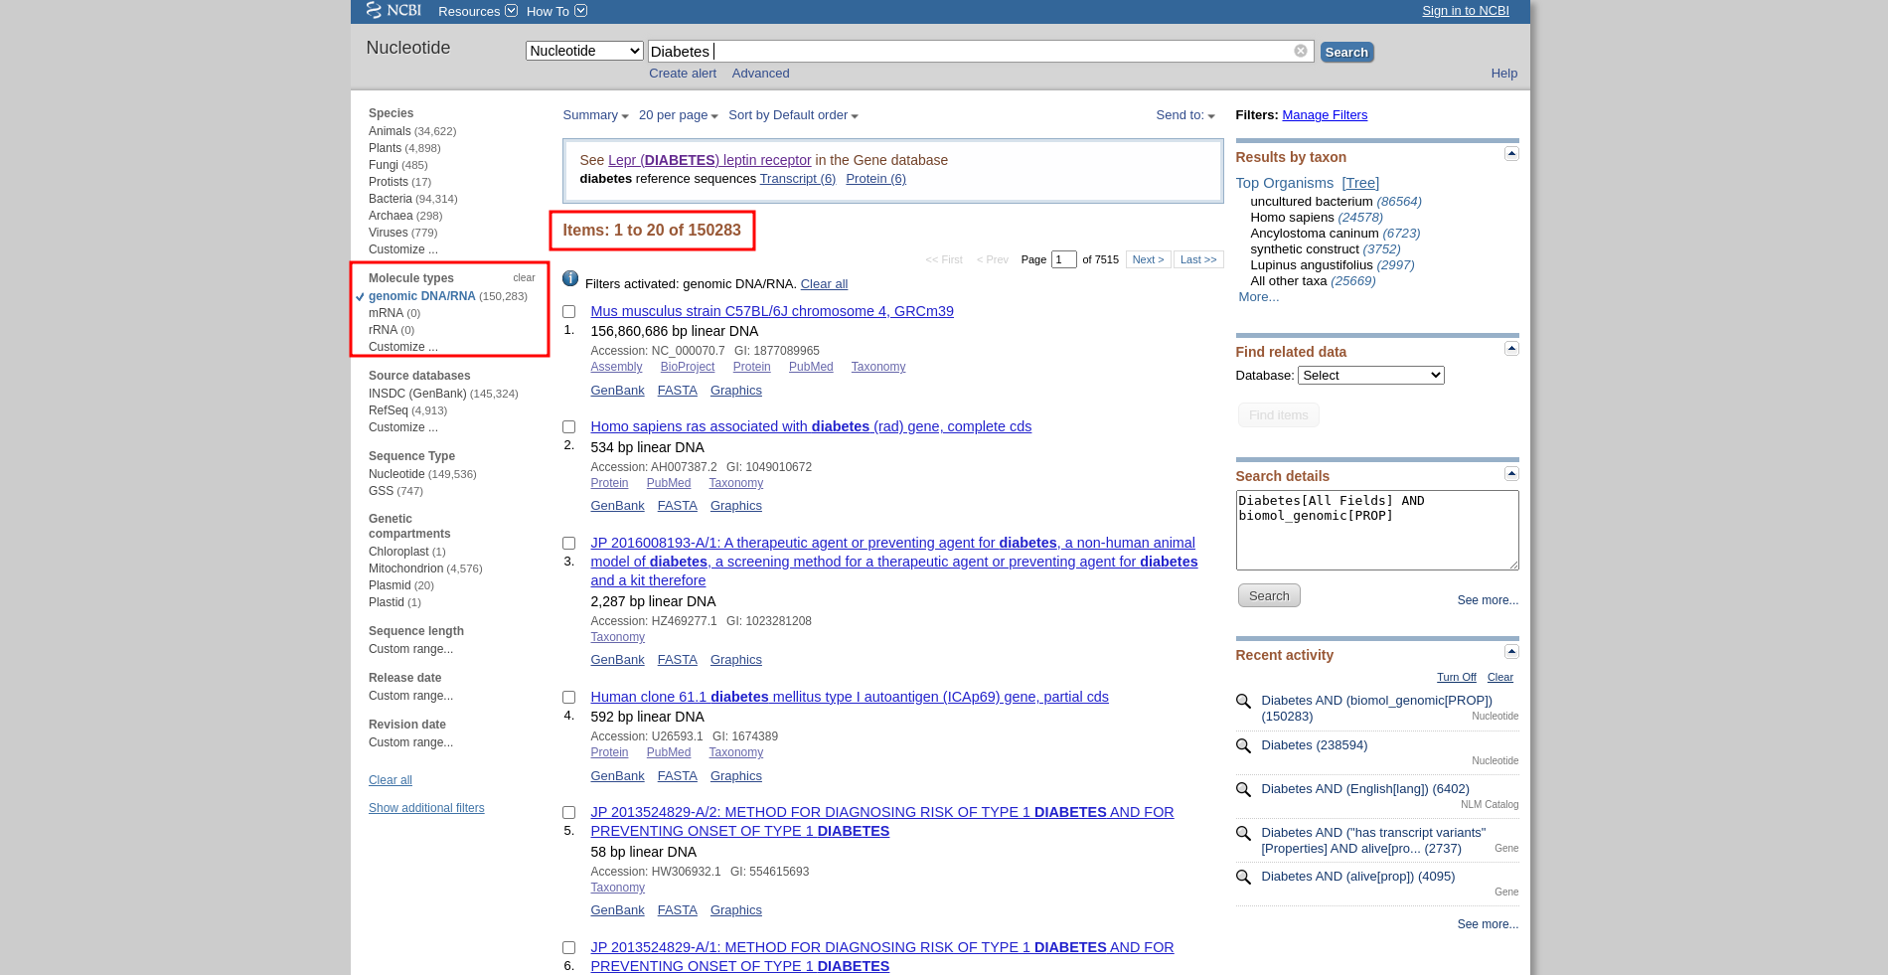**Fig15. Hit page for search query “Diabetes” in resource Nucleotide with Limit option and refined results**

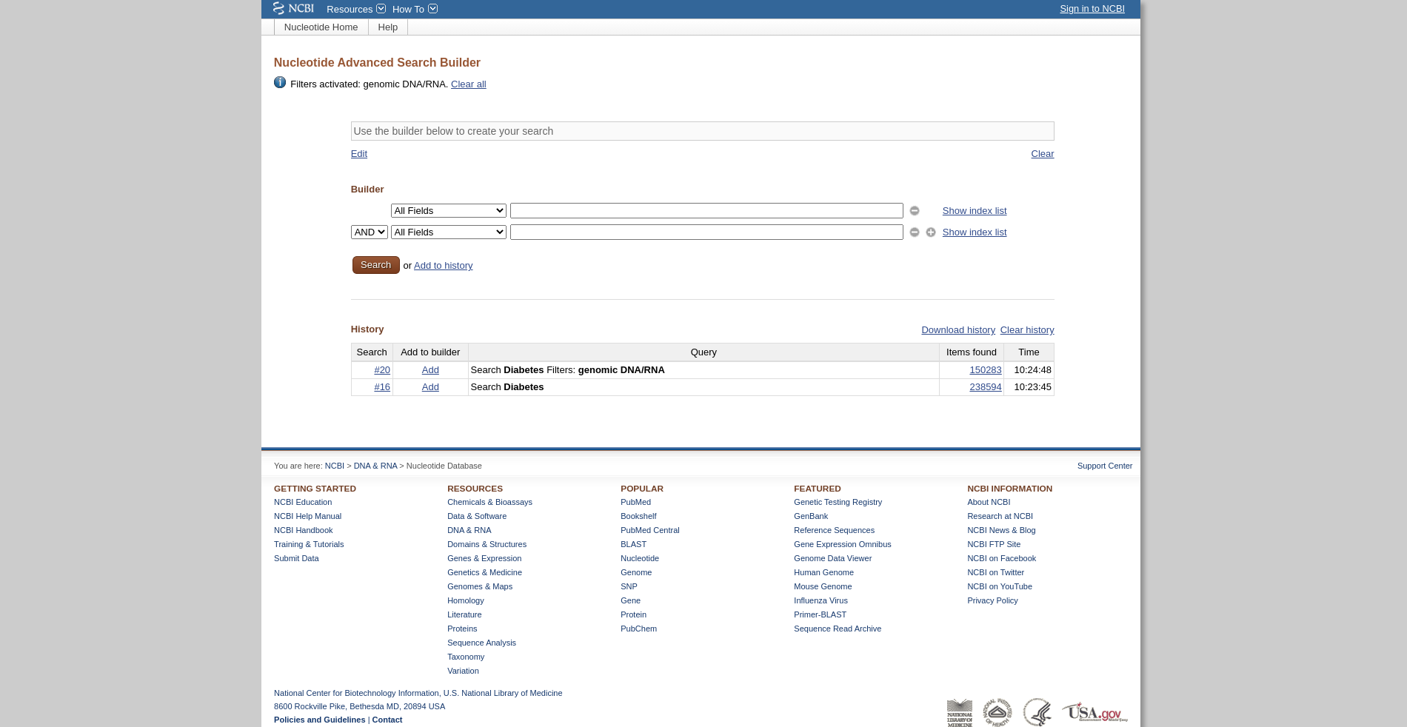**Fig16. Advanced search of Query “Diabetes” in Nucleotide resource.**

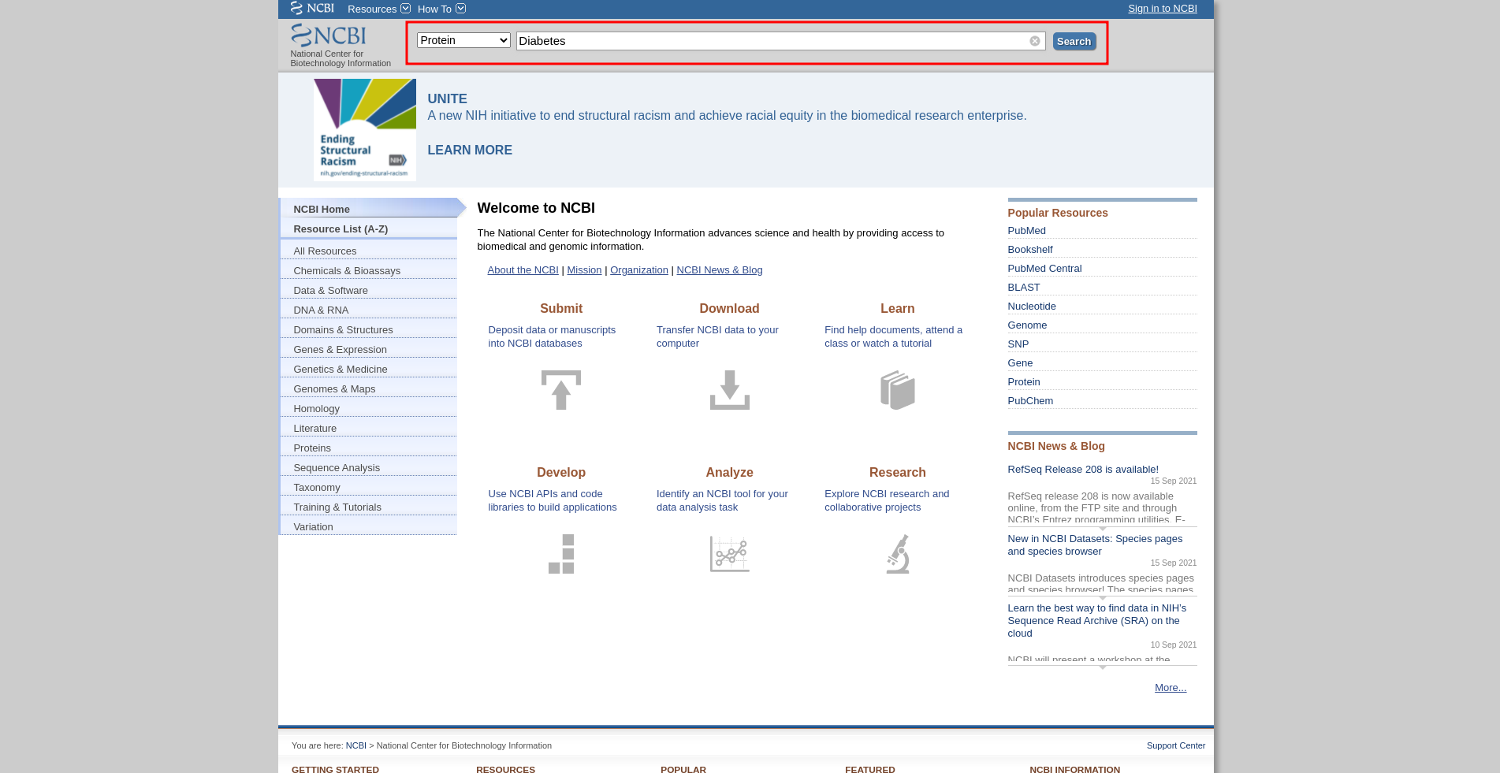**Fig17. Search page with resource Protein selected with query “Diabetes”**

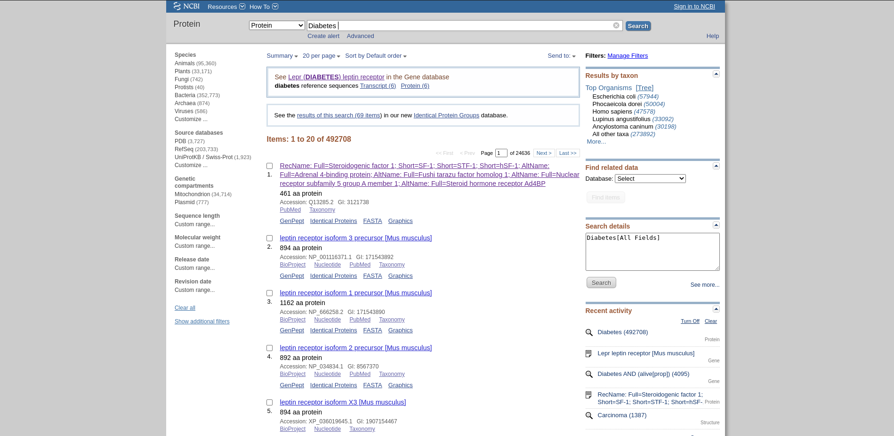**Fig18. Hit page for search query “Diabetes” in Protein resource**

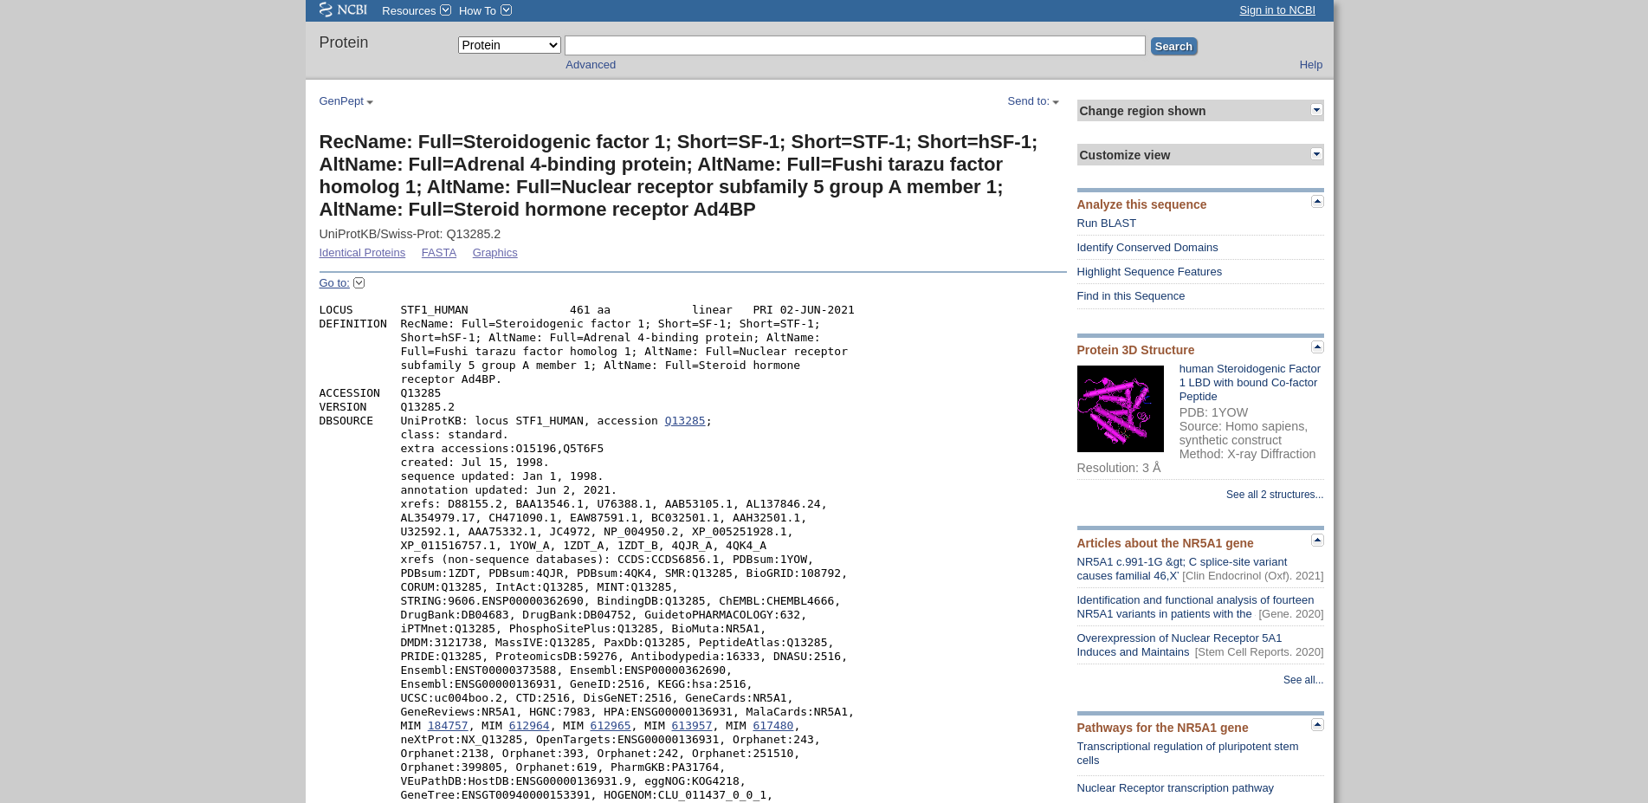**Fig19. Result Page for Protein resource on “Diabetes” [RecName: Full=Steroidogenic factor 1; Short=SF-1; Short=STF-1; Short=hSF-1; AltName: Full=Adrenal 4-binding protein; AltName: Full=Fushi tarazu factor homolog 1; AltName: Full=Nuclear receptor subfamily 5 group A member 1; AltName: Full=Steroid hormone receptor Ad4BP]**

**Fig20. Hit page for search query “Diabetes” in resource Protein with Limit option and refined results**

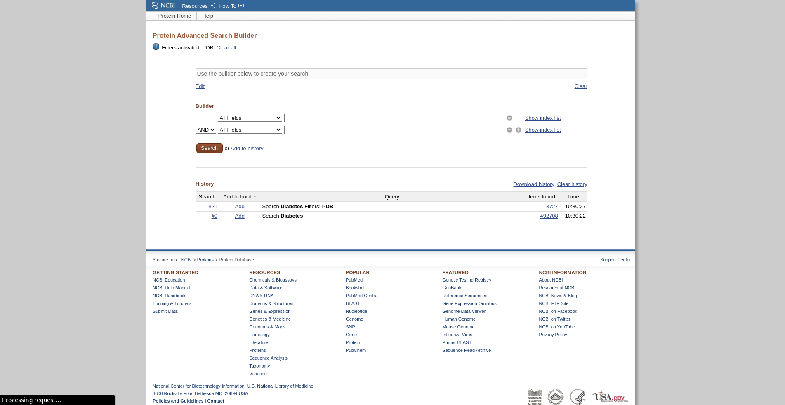**Fig21. Advanced search of Query “Diabetes” in Protein resource.**

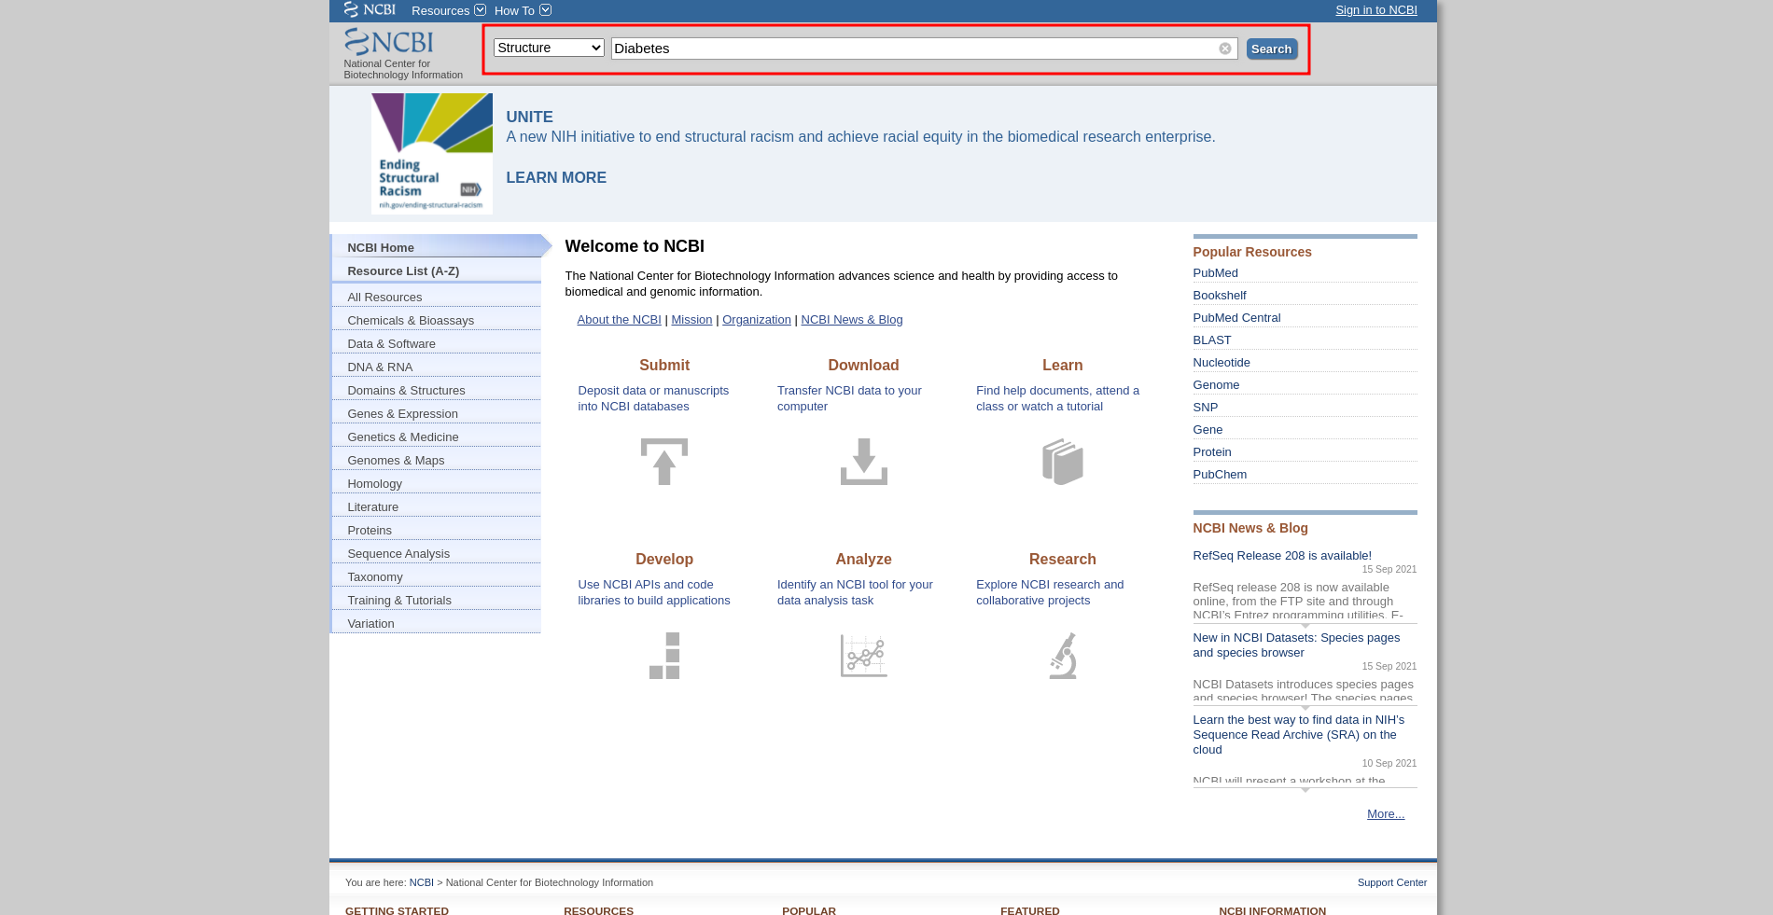**Fig22. Search page with resource Structure selected with query “Diabetes”**

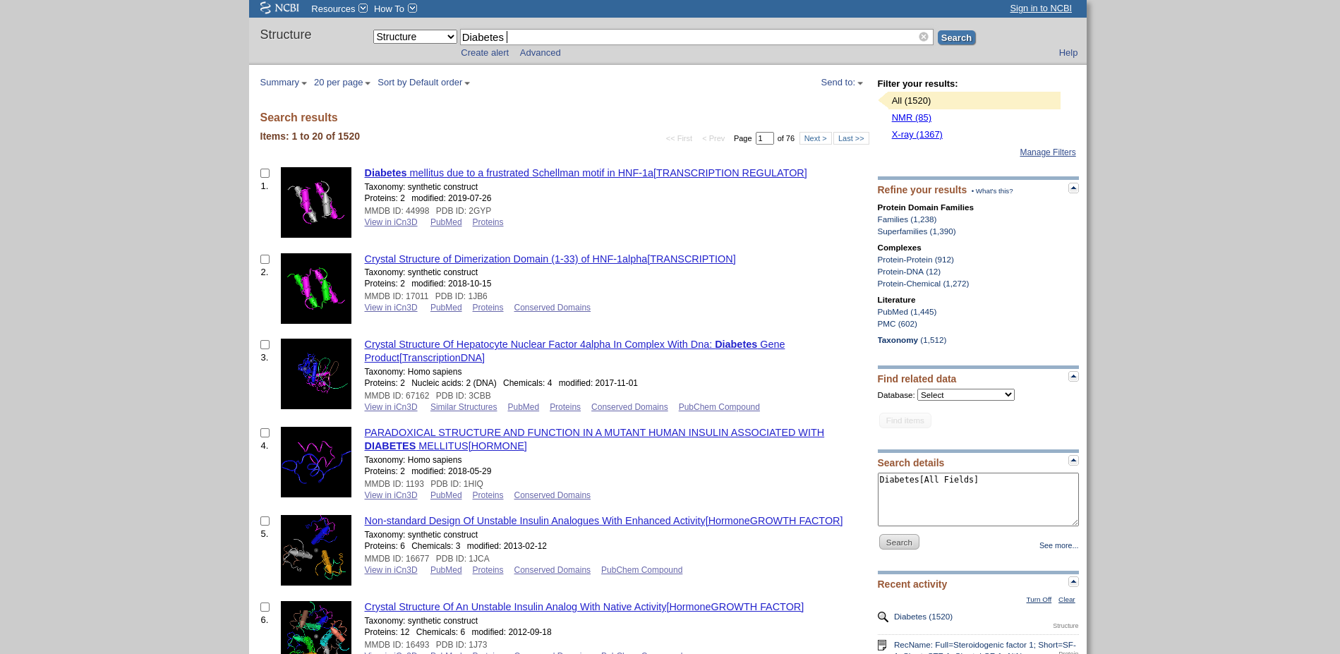**Fig23. Hit page for search query “Diabetes” in Structure resource**

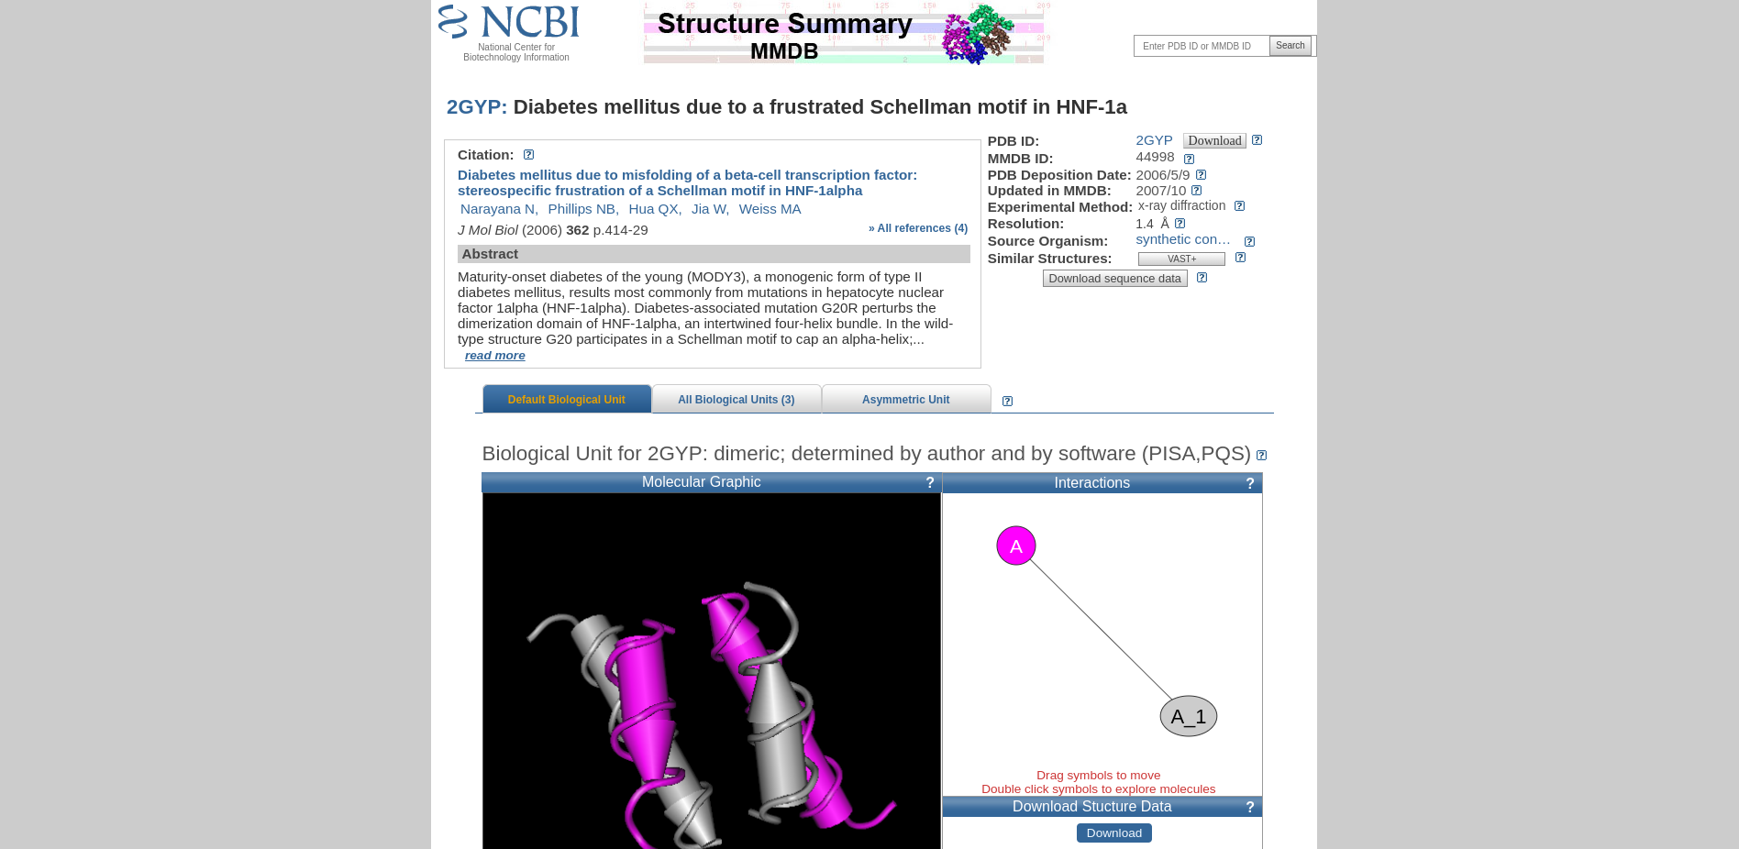

**Fig24. Result Page for Structure resource on Diabetes [****Diabetes mellitus due to a frustrated Schellman motif in HNF-1a]**

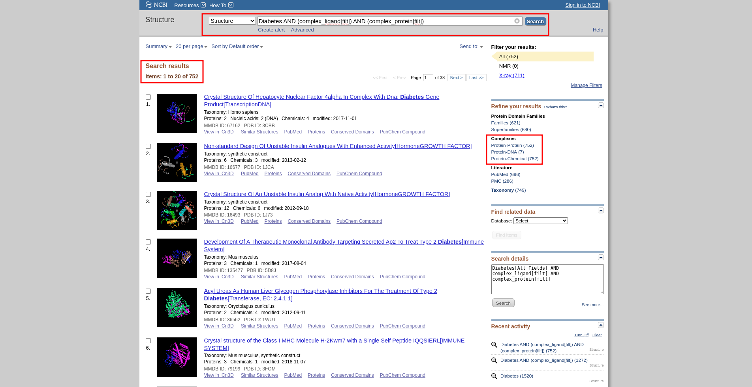**Fig25. Hit page for search query “Diabetes” in resource Structure with Limit option and refined results**

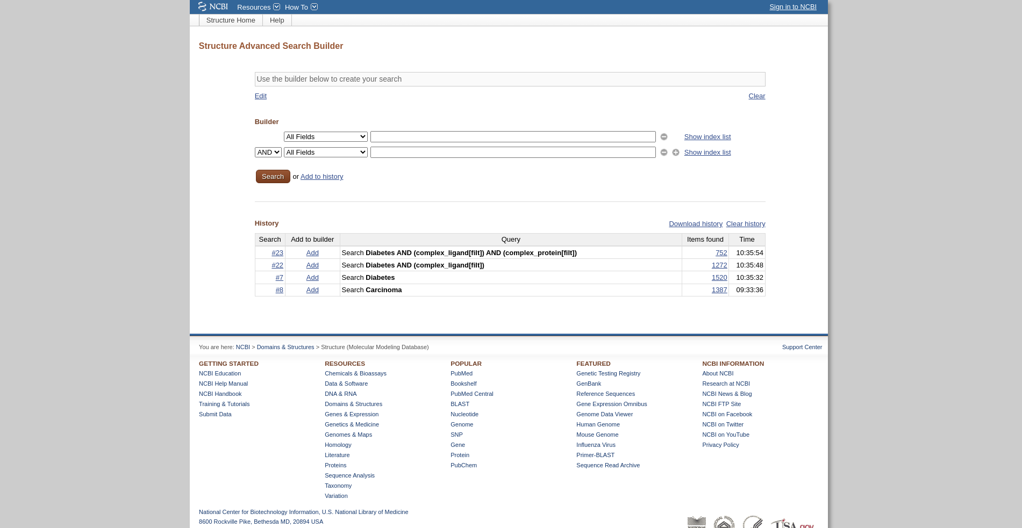  
**Fig26. Advanced search of Query “Diabetes” in Structure resource.**

**Results:**

Below are the NCBI resources used to retrieve the results for “Diabetes” query.

|  |  |  |
| --- | --- | --- |
| **Sr No** | **Resource** | **Results** |
| 1 | Gene | 4095 |
| 2 | NLM Catalog | 8767 |
| 3 | Nucleotide | 238594 |
| 4 | Protein | 492708 |
| 5 | Structure | 1520 |

**Conclusion:**

NCBI is a great website with plenty of resources to find and study data. The filters such as advanced and limit refines the results for better understanding and to gather relevant information. The resources of NCBI Database are useful and they are crucial for the effective searching of information and to gain knowledge which makes it easy to access huge amounts of data swiftly and without bloat.

**References:**

1. **Gene**
   1. <https://www.ncbi.nlm.nih.gov/gene/?term=Diabetes>
   2. <https://www.ncbi.nlm.nih.gov/gene/advanced>
   3. <https://www.ncbi.nlm.nih.gov/gene/16847>
2. **NLM Catalog**
   1. <https://www.ncbi.nlm.nih.gov/nlmcatalog/?term=Diabetes>
   2. <https://www.ncbi.nlm.nih.gov/nlmcatalog/advanced>
   3. <https://www.ncbi.nlm.nih.gov/nlmcatalog/466125>
3. **Nucleotide**
   1. <https://www.ncbi.nlm.nih.gov/nuccore/?term=Diabetes>
   2. <https://www.ncbi.nlm.nih.gov/nuccore/advanced>
   3. <https://www.ncbi.nlm.nih.gov/nuccore/NM_001122899.2>
4. **Protein**
   1. <https://www.ncbi.nlm.nih.gov/protein/?term=Diabetes>
   2. <https://www.ncbi.nlm.nih.gov/protein/advanced>
   3. <https://www.ncbi.nlm.nih.gov/protein/Q13285.2>
5. **Structure**
   1. <https://www.ncbi.nlm.nih.gov/structure/?term=Diabetes>
   2. <https://www.ncbi.nlm.nih.gov/structure/advanced>
   3. <https://www.ncbi.nlm.nih.gov/Structure/pdb/2GYP>

**Date : 25-09-21**

**WEBLEM: 2**

**National Center for Biotechnology Information (NCBI)**

**(URL:** [**https://www.ncbi.nlm.nih.gov/**](https://www.ncbi.nlm.nih.gov/) **)**

**AIM:**

To explore literature databases and collect information on “Scoliosis”

**Introduction:**

The National Center for Biotechnology Information (NCBI) was created in 1988 as a division of the National Library of Medicine (NLM) at the National Institutes of Health, to develop information systems in the field of molecular biology and bioinformatics. The literature tools developed as a part of NCBI are extensive and thoroough as we will see in this weblem.

The query chosen for this Weblem is Scoliosis. Scoliosis is a sideways curvature of the spine that most often is diagnosed in adolescents. This affects about 3 percent of the population, majorly in ages from 10 to 15 and in both genders equally.

**Methodology:**

1. Open Homepage os NCBI database (<https://www.ncbi.nlm.nih.gov/>)
2. Enter search query of Alzheimer’s disease by Entrez search.
3. Interpret the results by and find the data needed.

**Observations:**

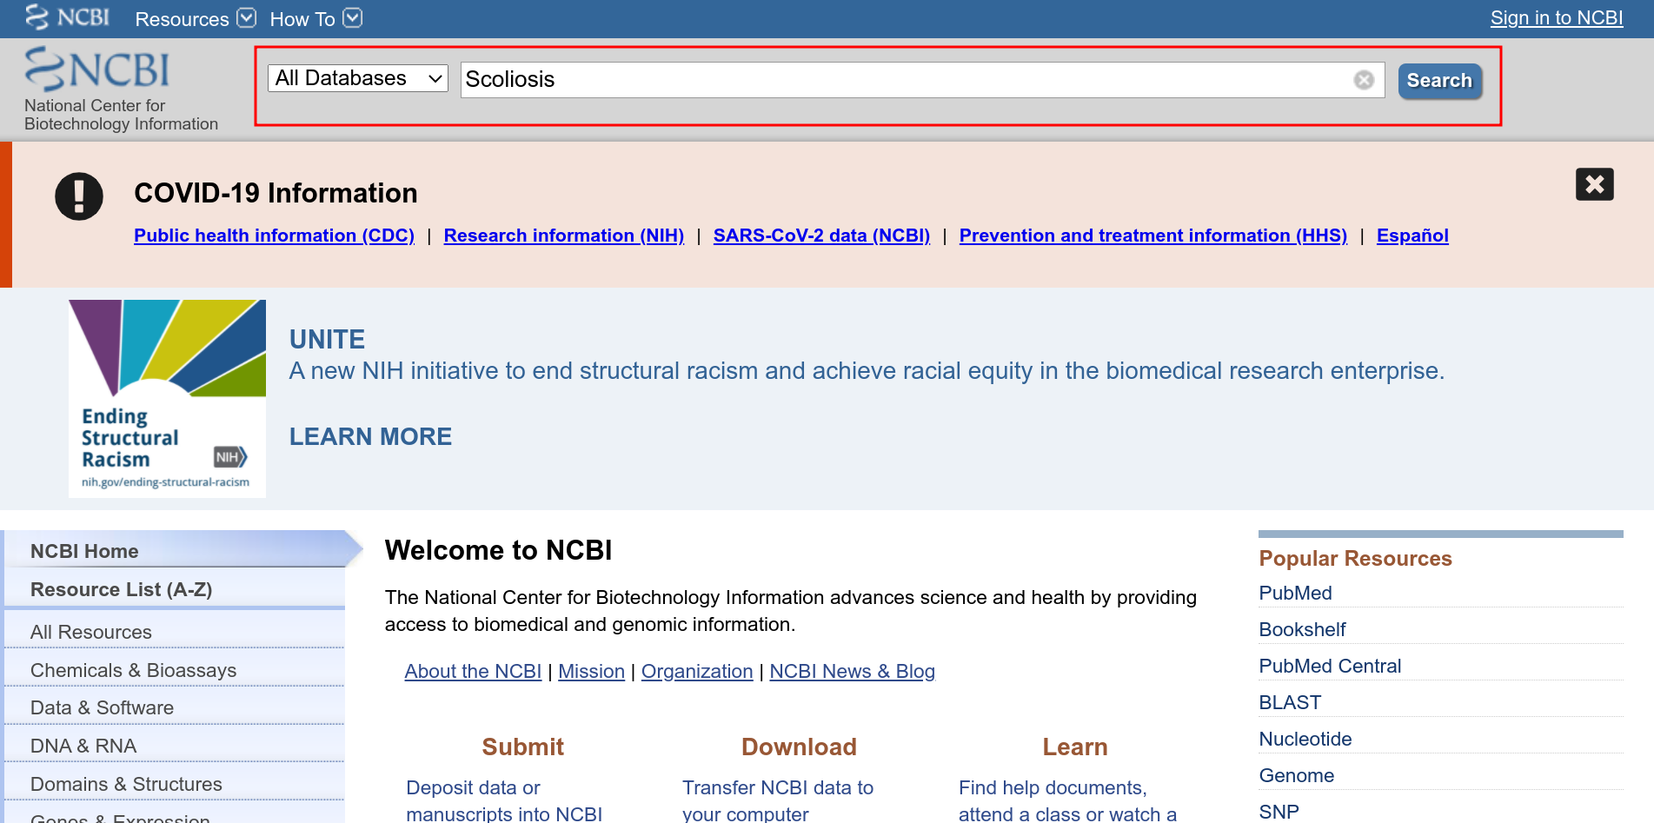**Fig1: NCBI homepage with query “Scoliosis” in search bar**

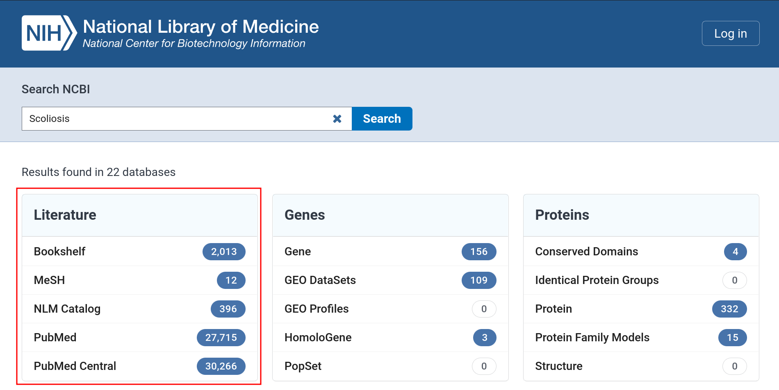**Fig2: Hit page of Entrez search**

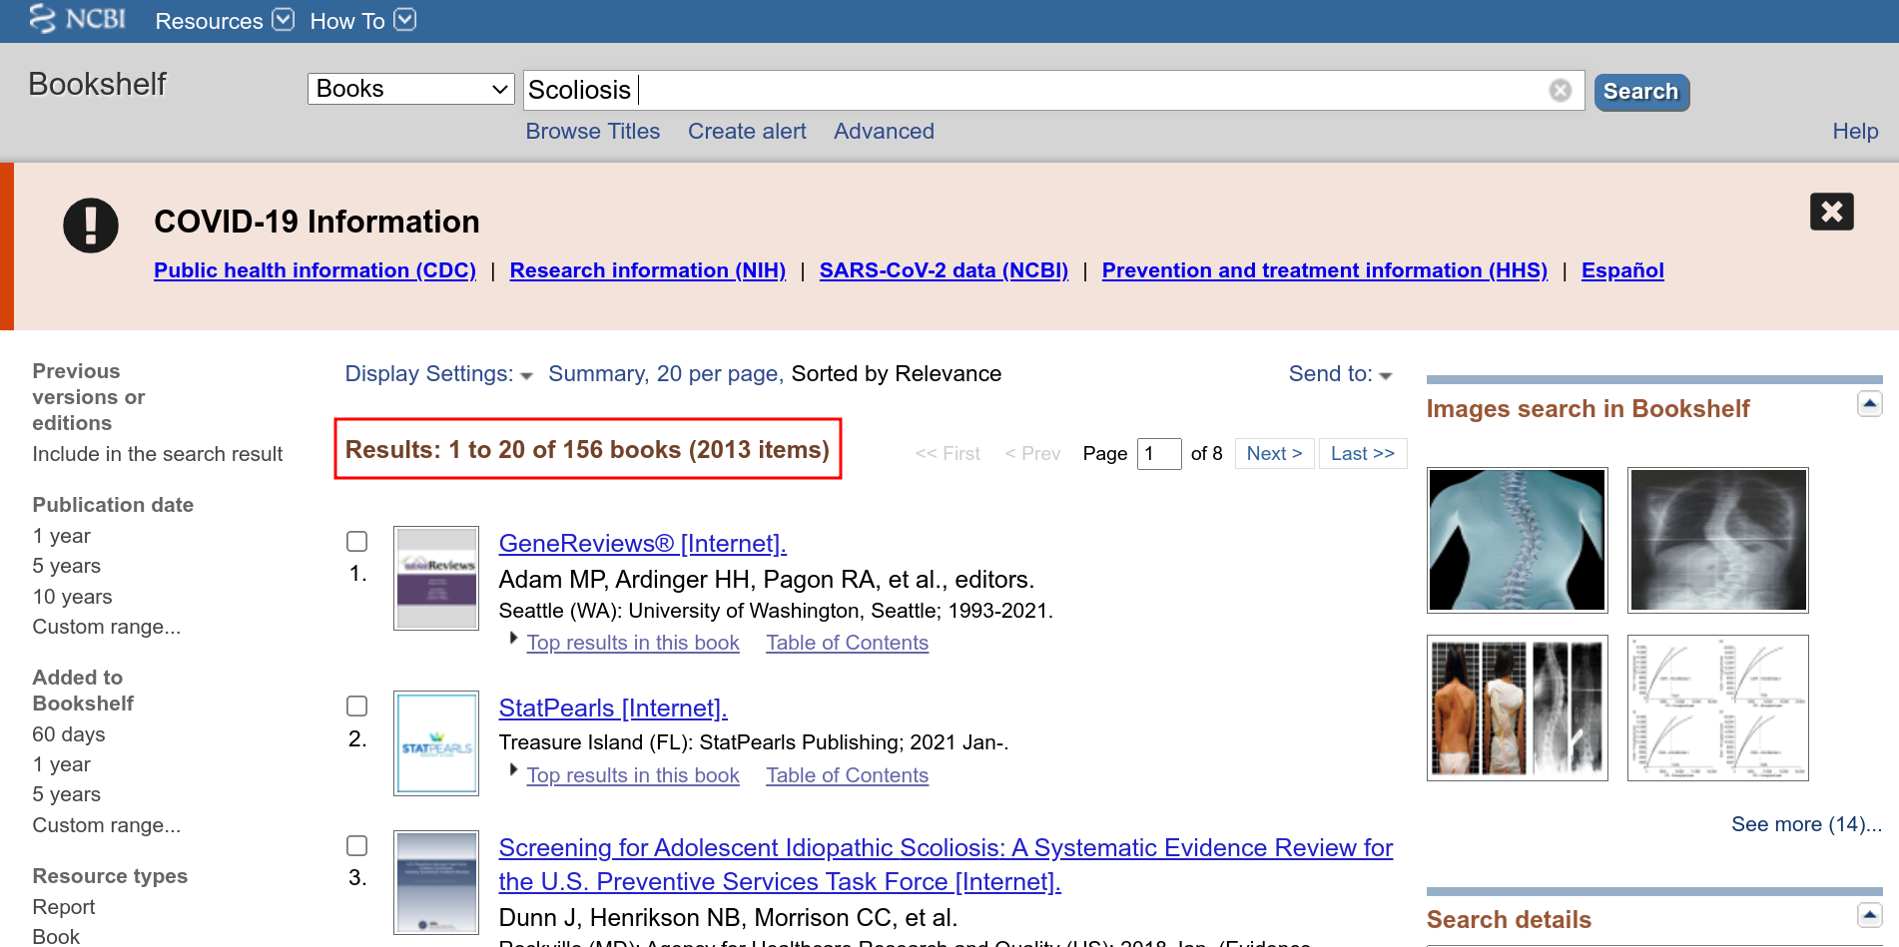**Fig3: Hit page for query “Scoliosis” in Bookshelf resource.**

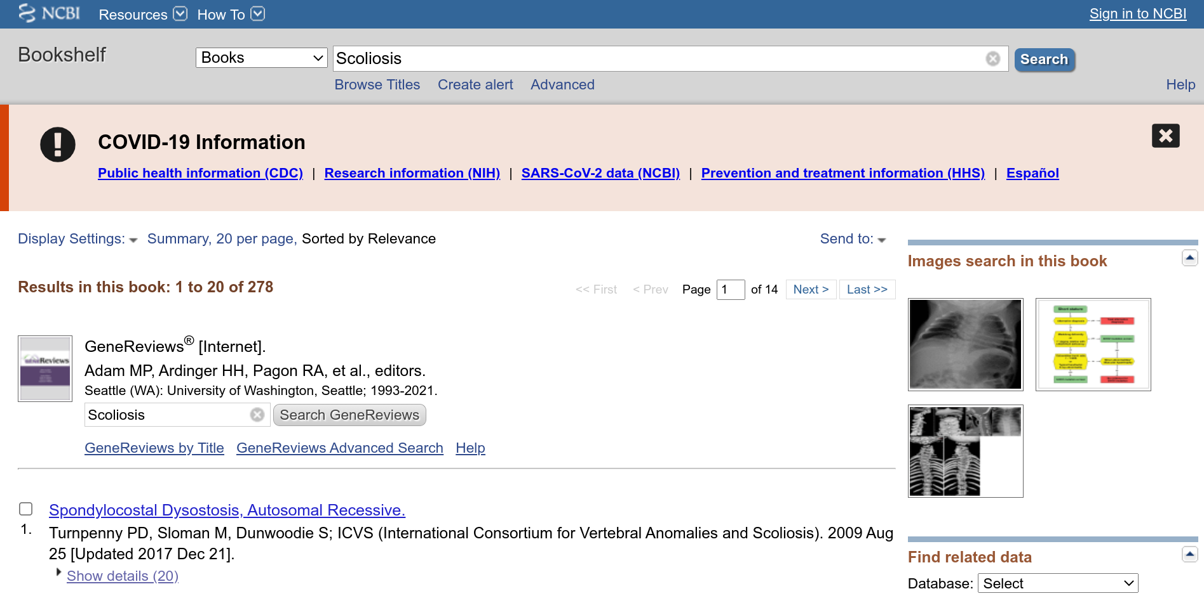**Fig4: Result page for query “Scoliosis” in Bookshelf Resource [Gene Reviews : Adam MP, Ardinger HH, Pagon RA, et al]**

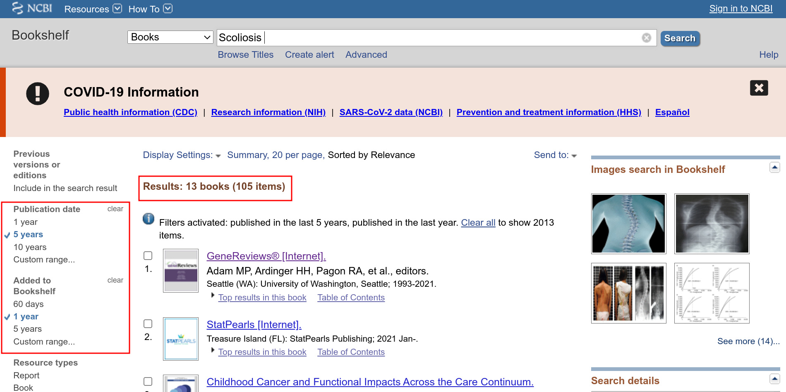**Fig5: Hit page of query “Scoliosis” in Bookshelf Resource with limit options enabled**

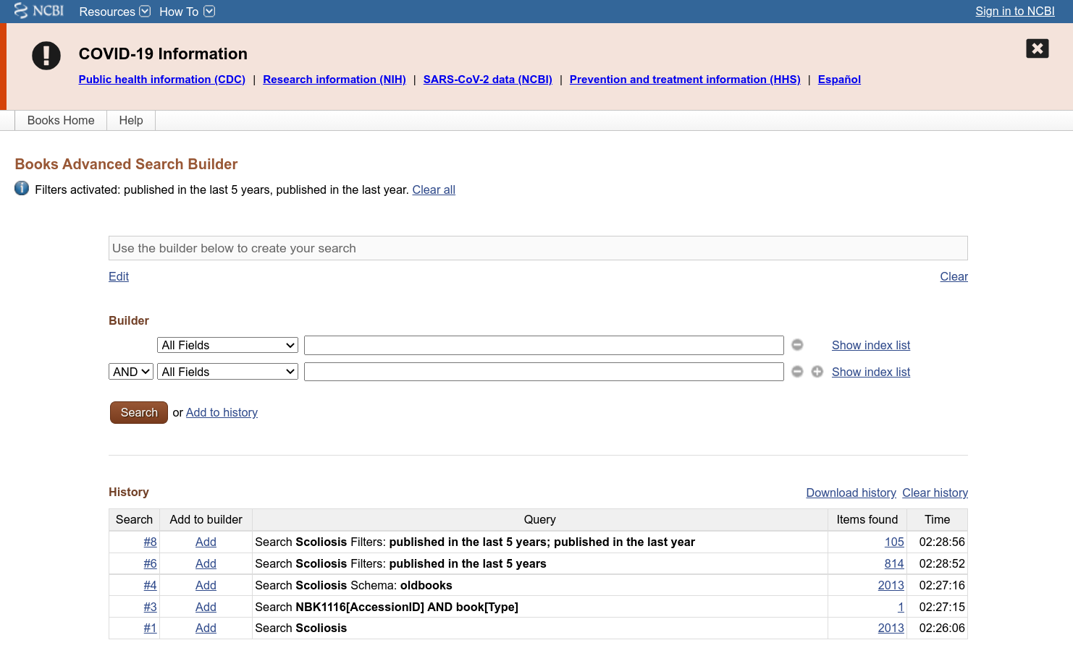**Fig6: Advanced Search building for Bookshelf resource**

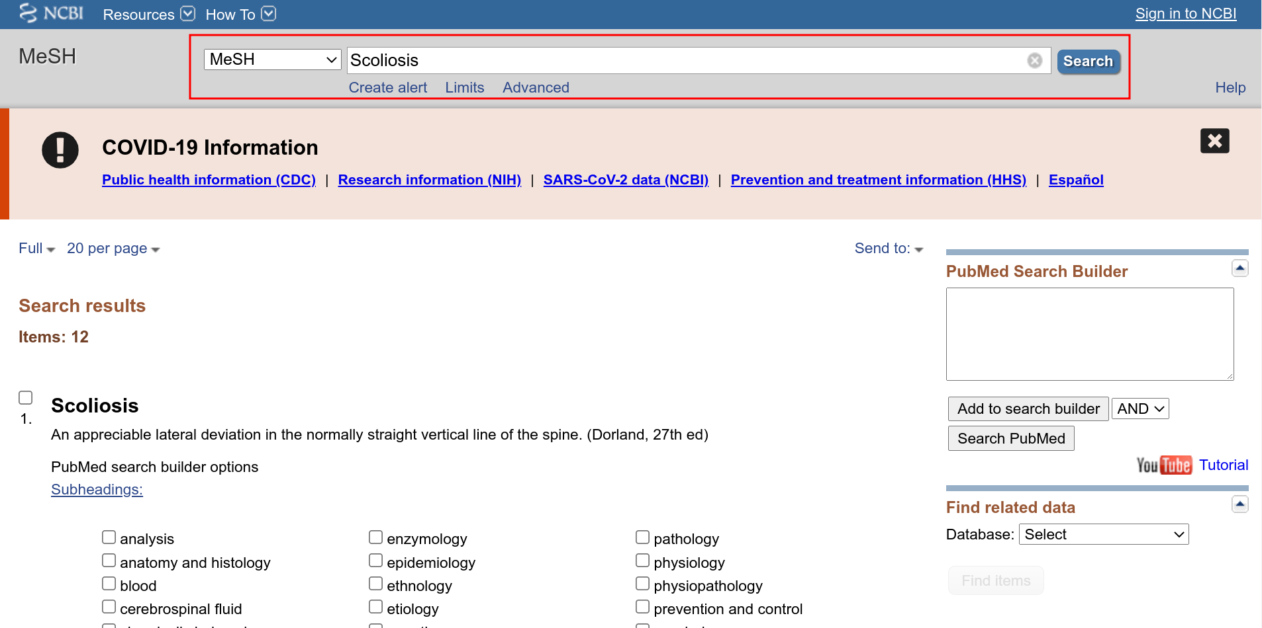**Fig7: Hit page in MeSH resource for query “Scoliosis”**

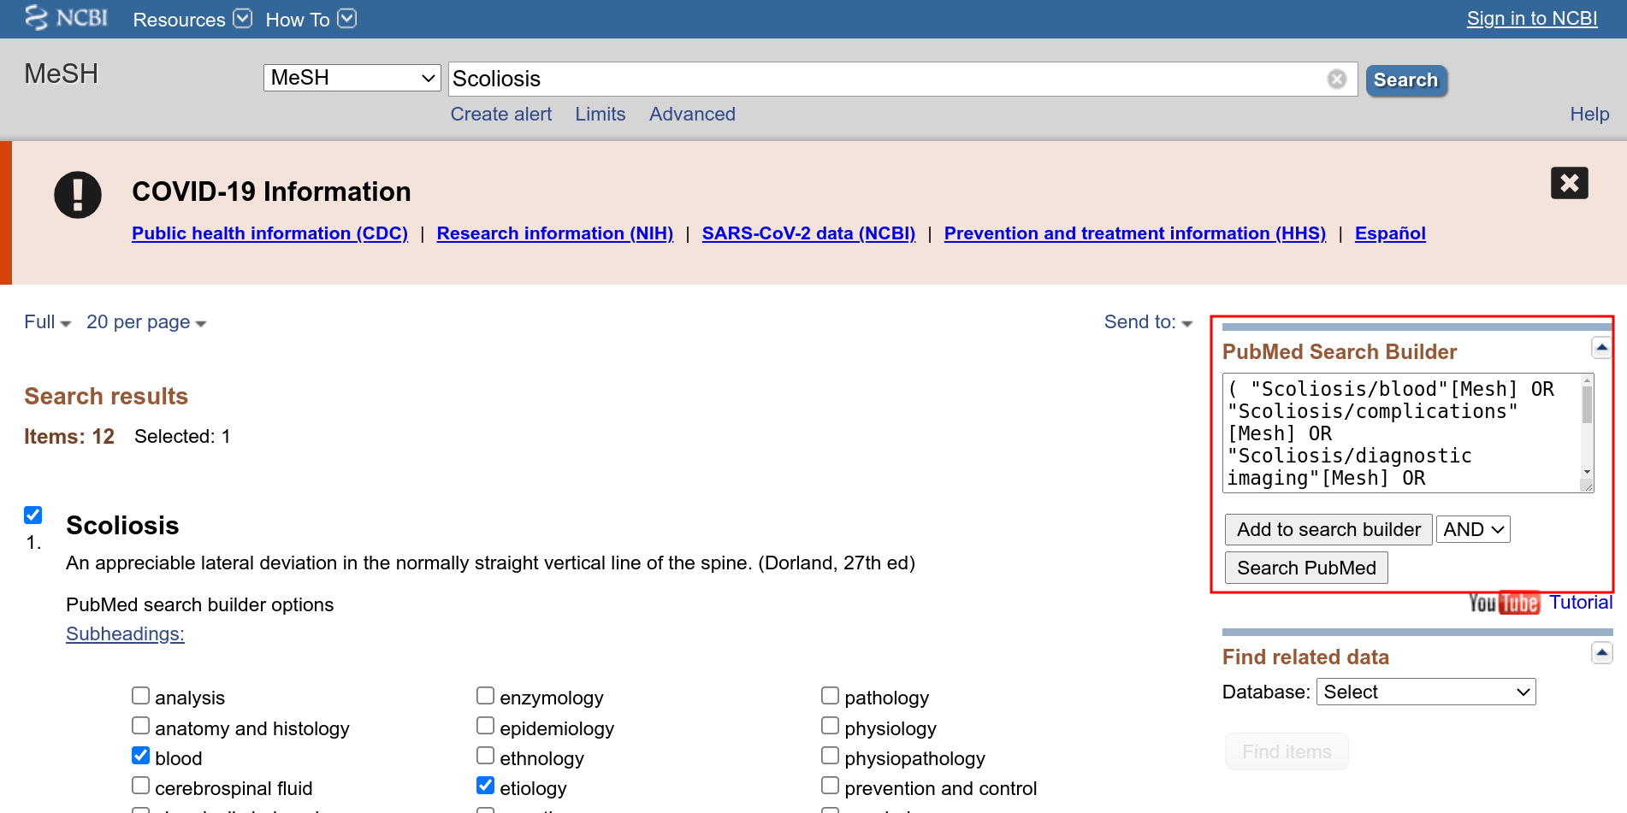**Fig8: MeSH resource page with search builder option added for query “Scoliosis”**

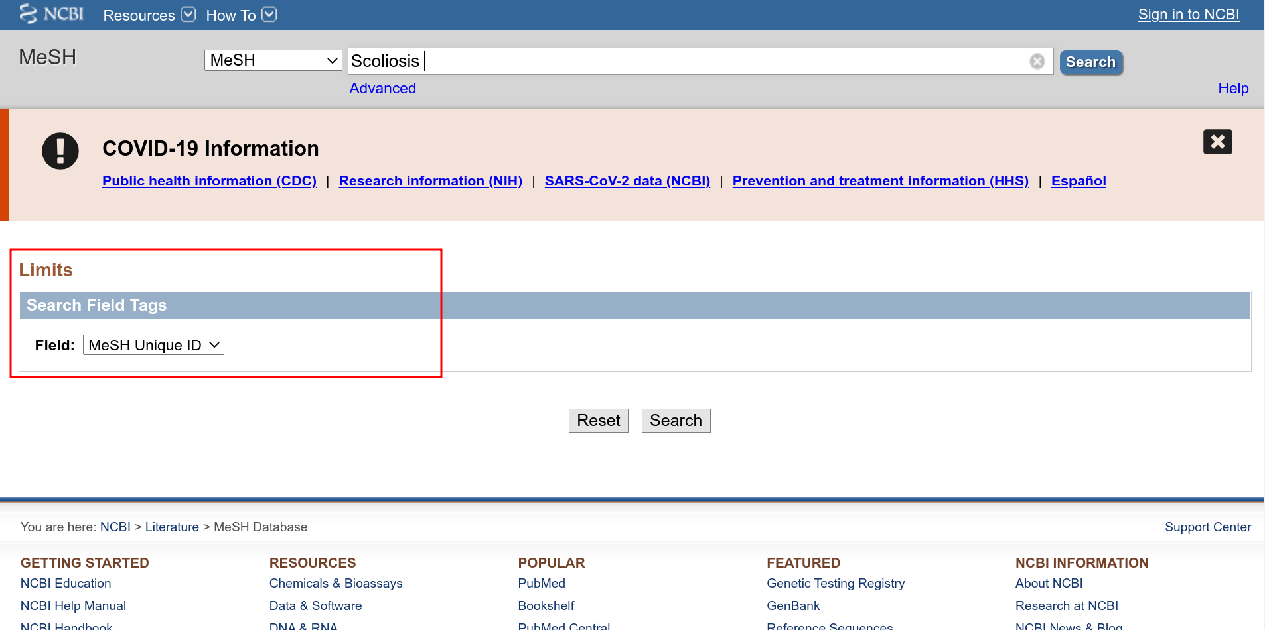**Fig9: Limit Options page for MeSH resource with option applied**

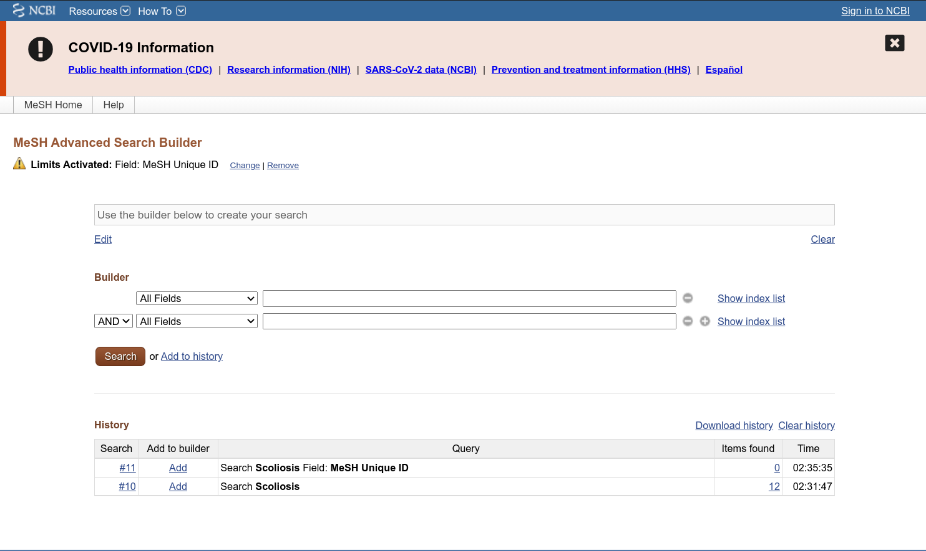**Fig10: Advanced search page for MeSH resource for query “Scoliosis”**

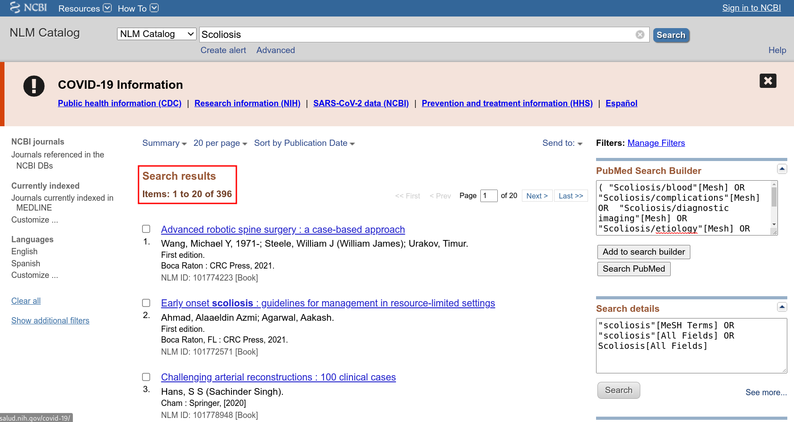**Fig11: Hit page in resource NLM Catalog for query “Scoliosis”**

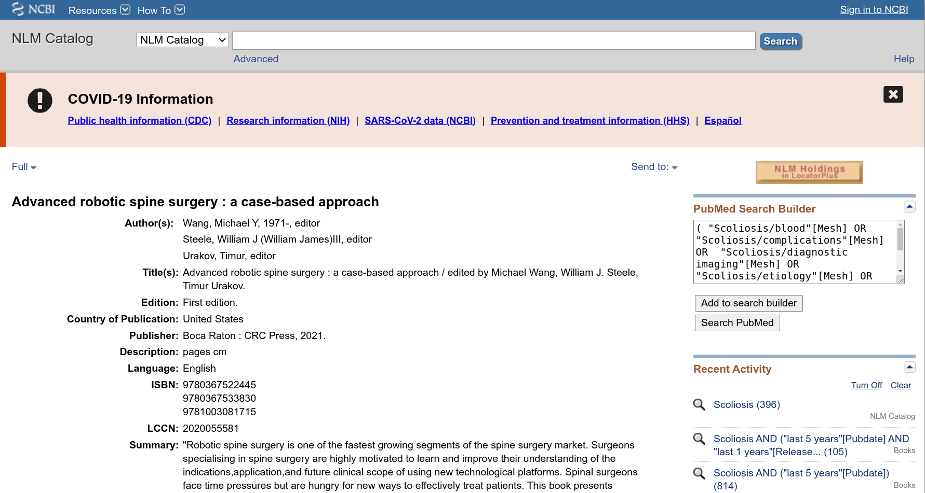**Fig12: Result Page for NLM catalog for query scoliosis [Advanced robotic spine surgery : a case-based approach]**

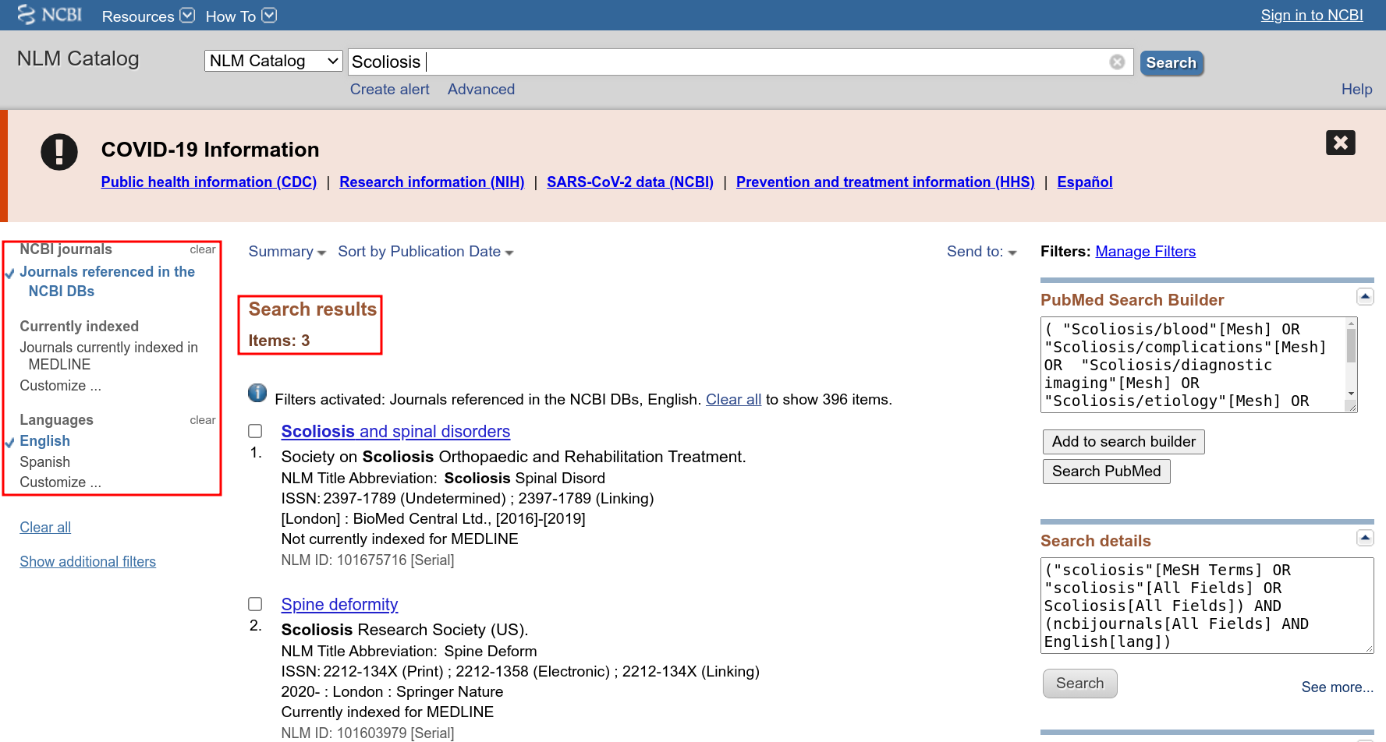**Fig13: Hit page for NLM catalog with limit options enabled for query “Scoliosis”**

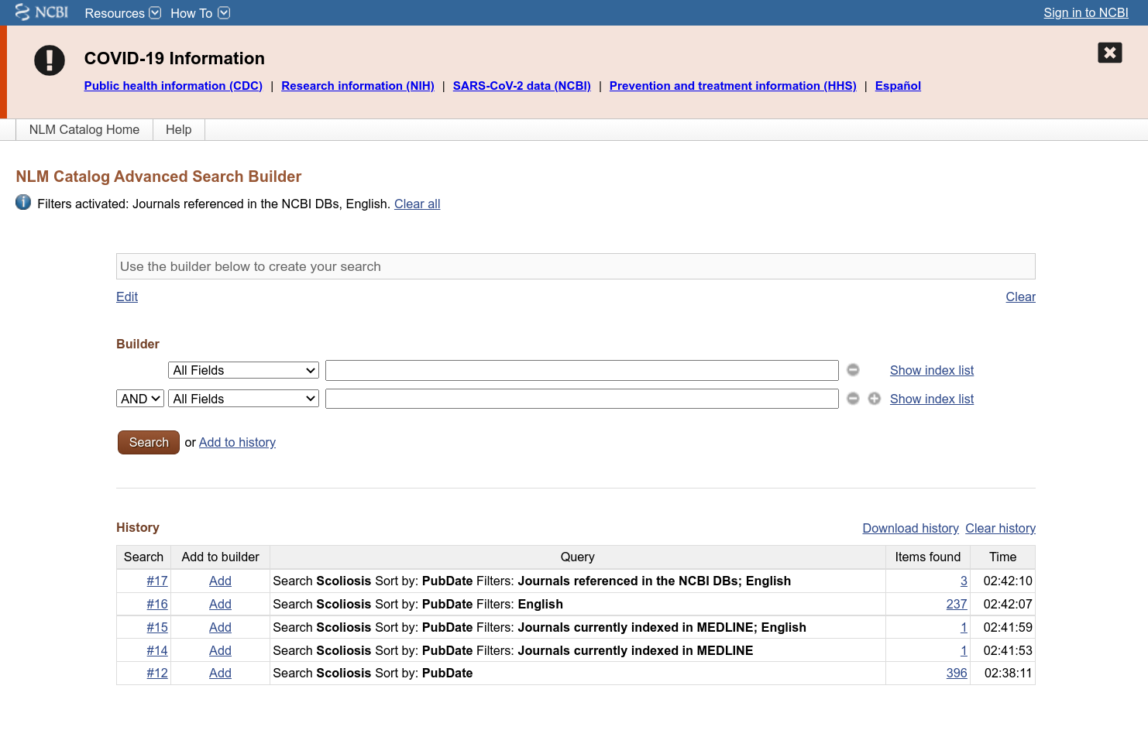**Fig14: Advanced search building for NLM Catalog for query “Scoliosis”**

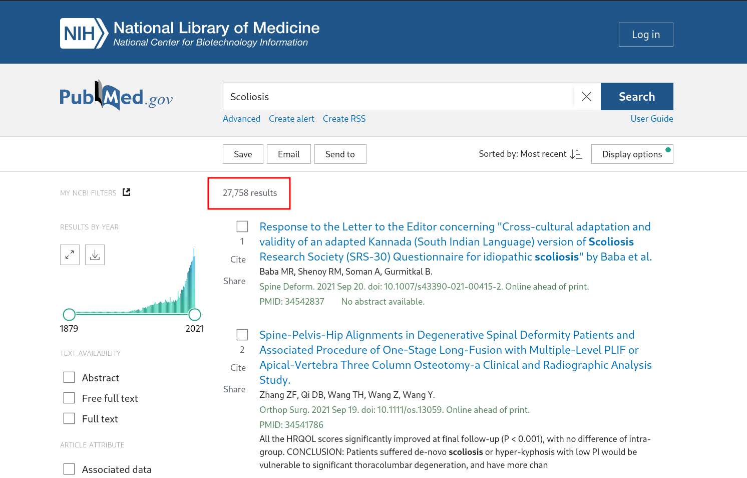**Fig15: Hit page for resource PubMed for query “Scoliosis”**

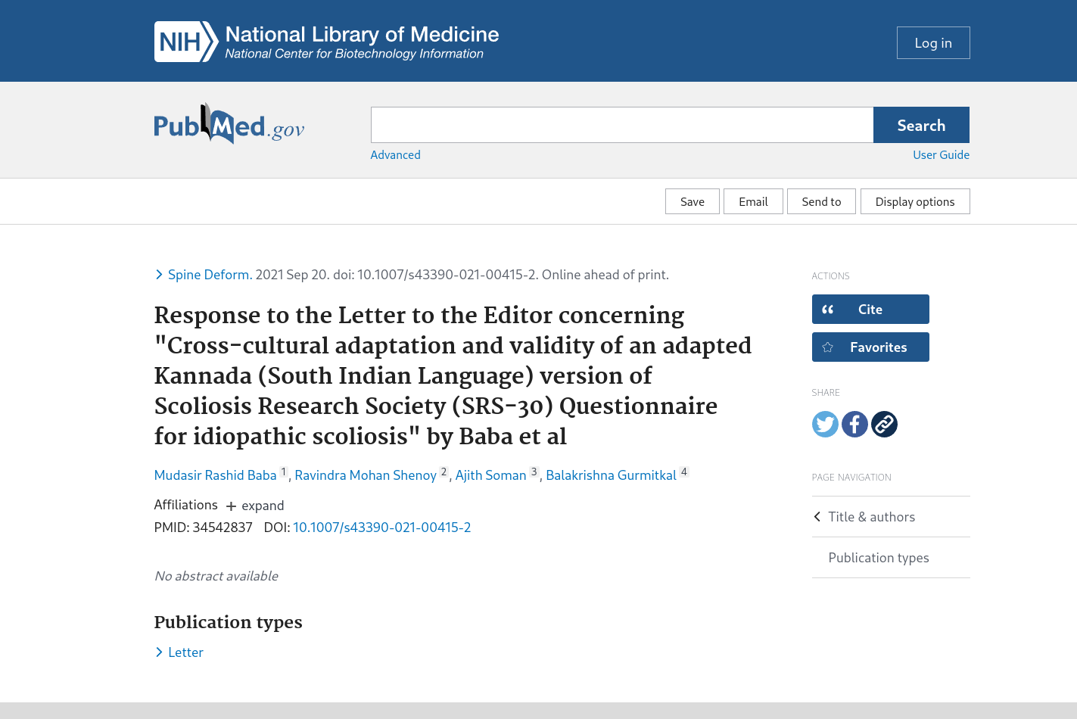**Fig16: Result page for resource PubMed for query “Scoliosis” [Response to the Letter to the Editor concerning "Cross-cultural adaptation and validity of an adapted Kannada (South Indian Language) version of Scoliosis Research Society (SRS-30) Questionnaire for idiopathic scoliosis" by Baba et al]**

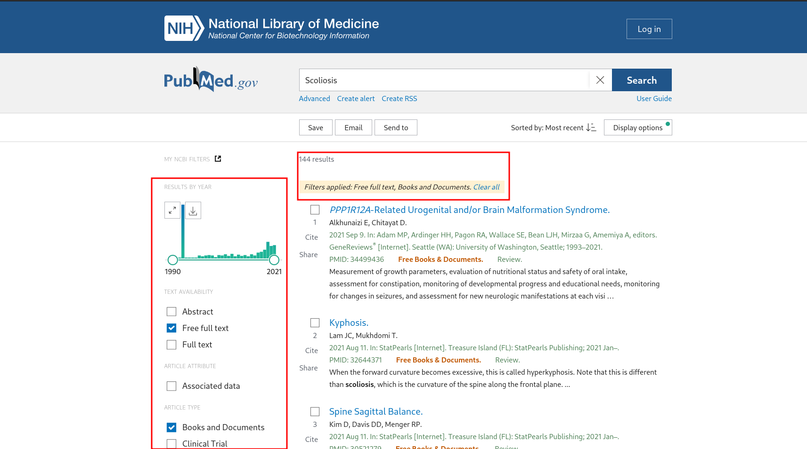**Fig17: Hit page for resource PubMed for query “Scoliosis” With limit options applied.**

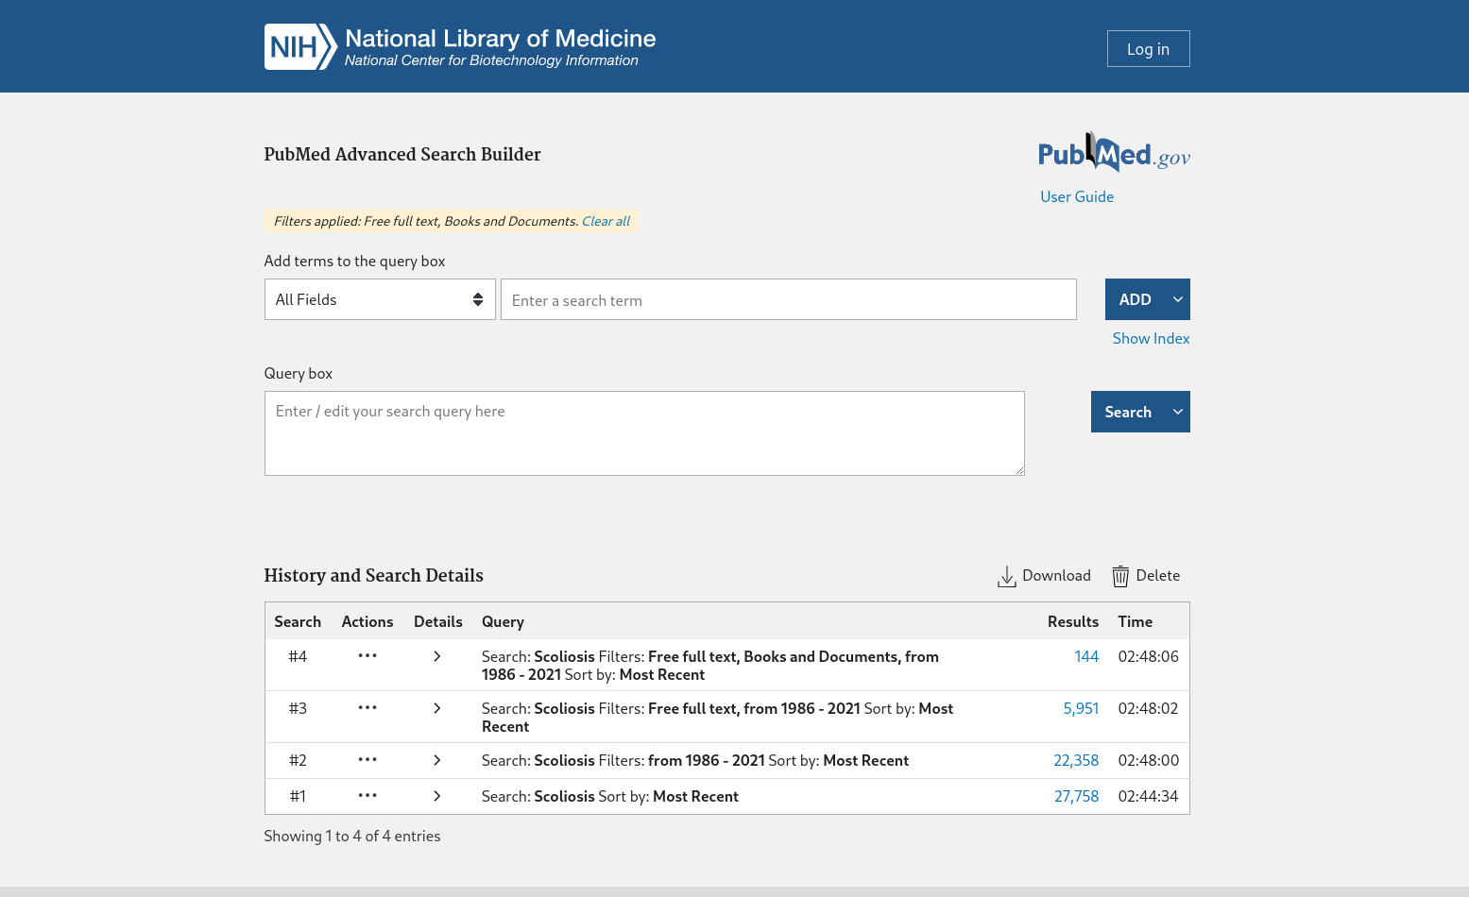**Fig18: Advanced Search builder for Resource PubMed for query “Scoliosis”**

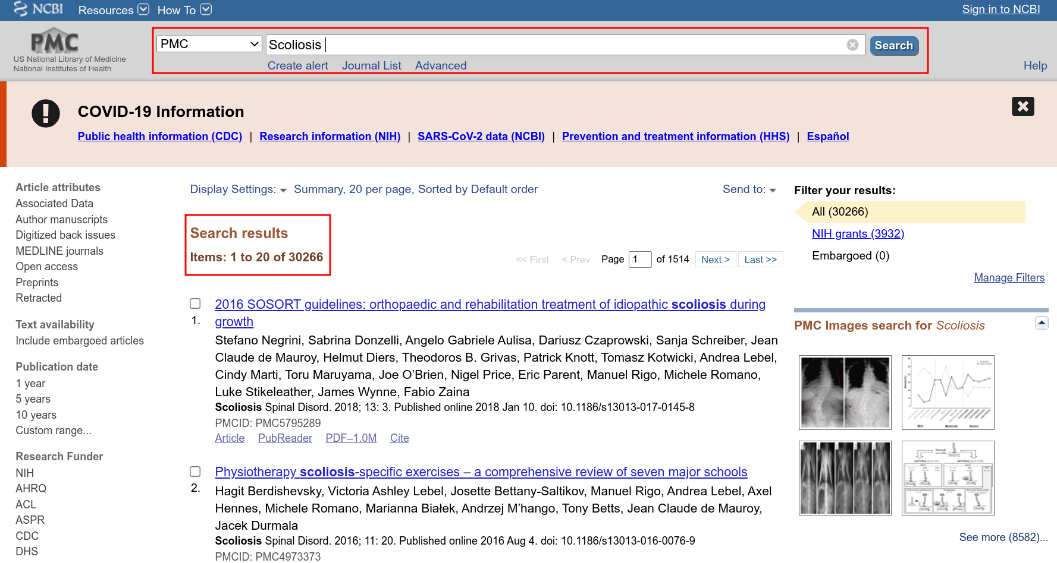**Fig19: Hit page for query “Scoliosis” under resource PMC**

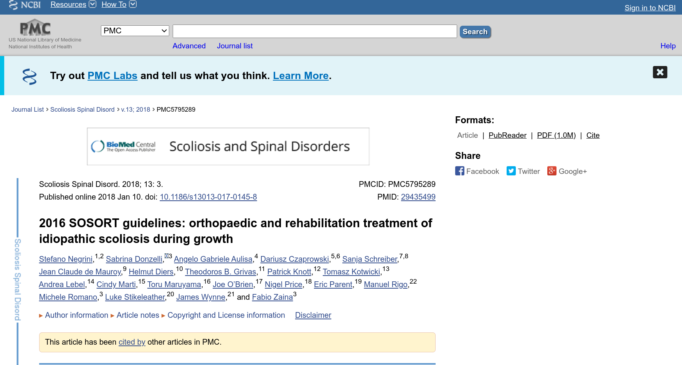**Fig20: Result page for query “Scoliosis” in resource PMC [2016 SOSORT guidelines: orthopaedic and rehabilitation treatment of idiopathic scoliosis during growth]**

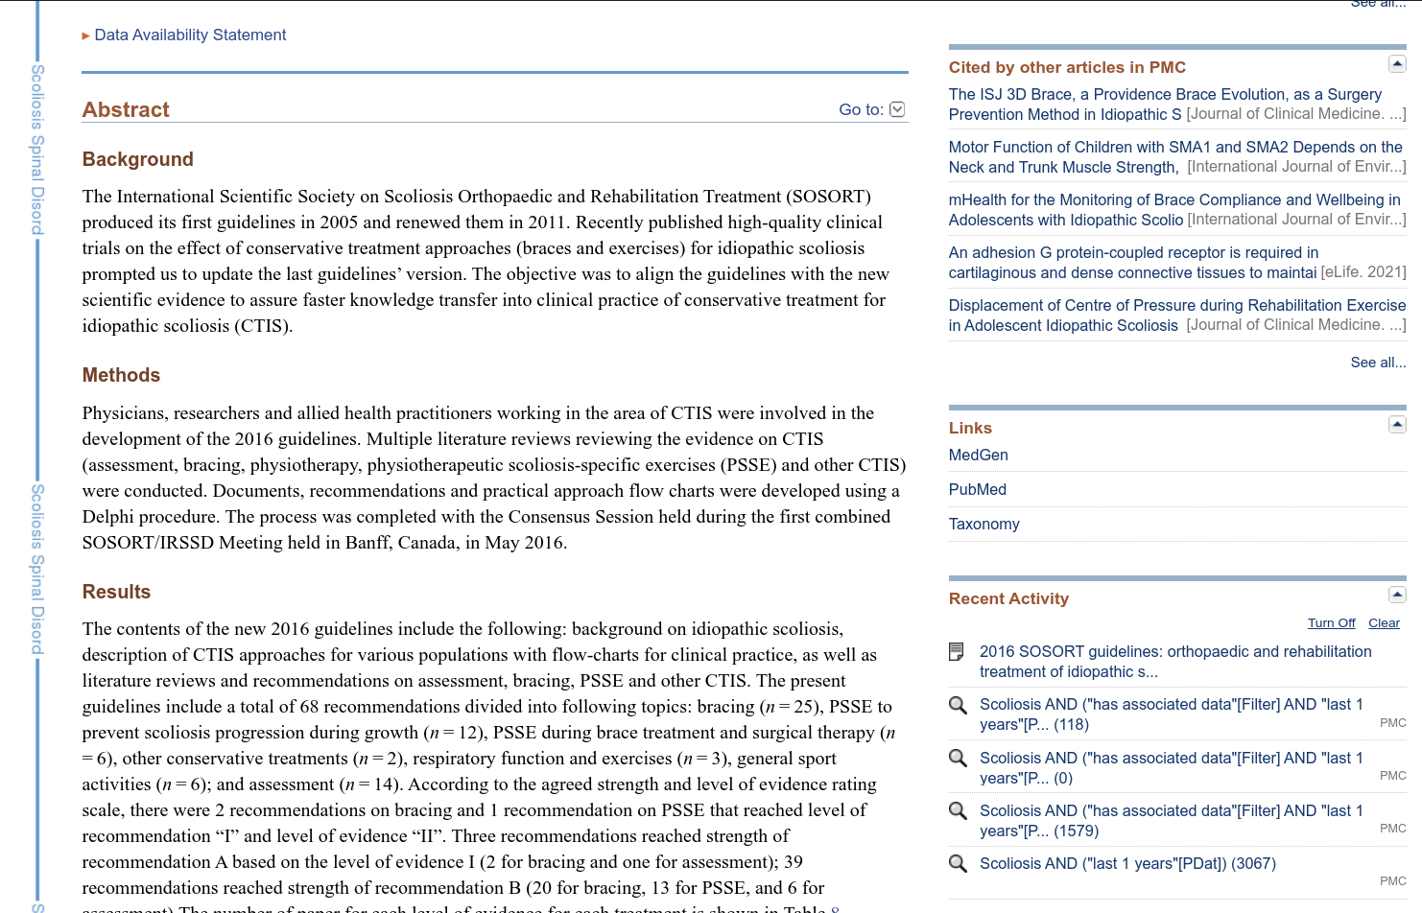**Fig21:Result page for query “Scoliosis” in resource PMC [2016 SOSORT guidelines: orthopaedic and rehabilitation treatment of idiopathic scoliosis during growth]**

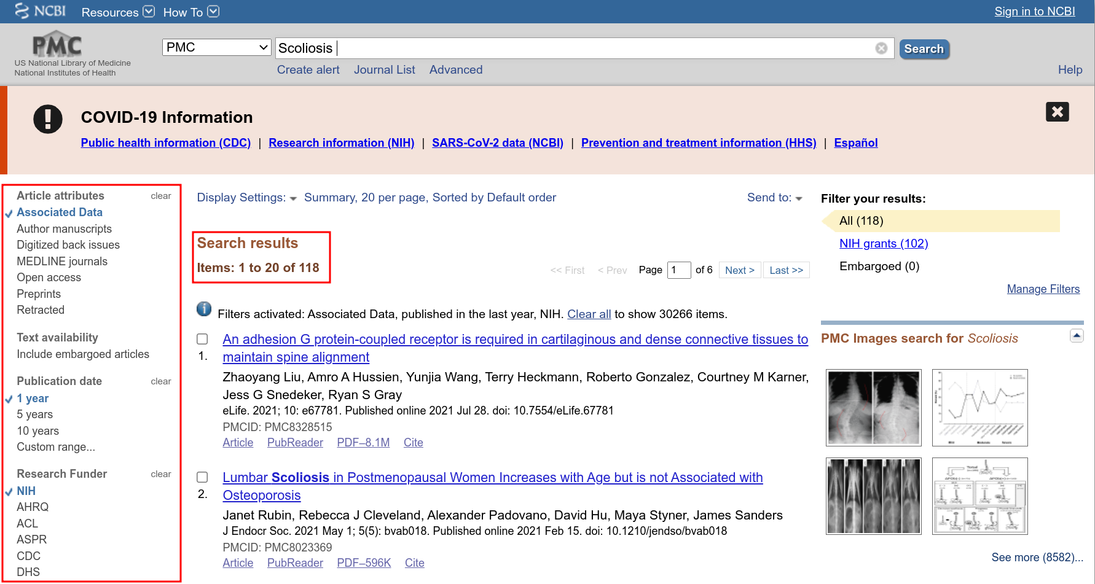**Fig21: Result page of query “Scoliosis” for resource PMC with limit options enabled**

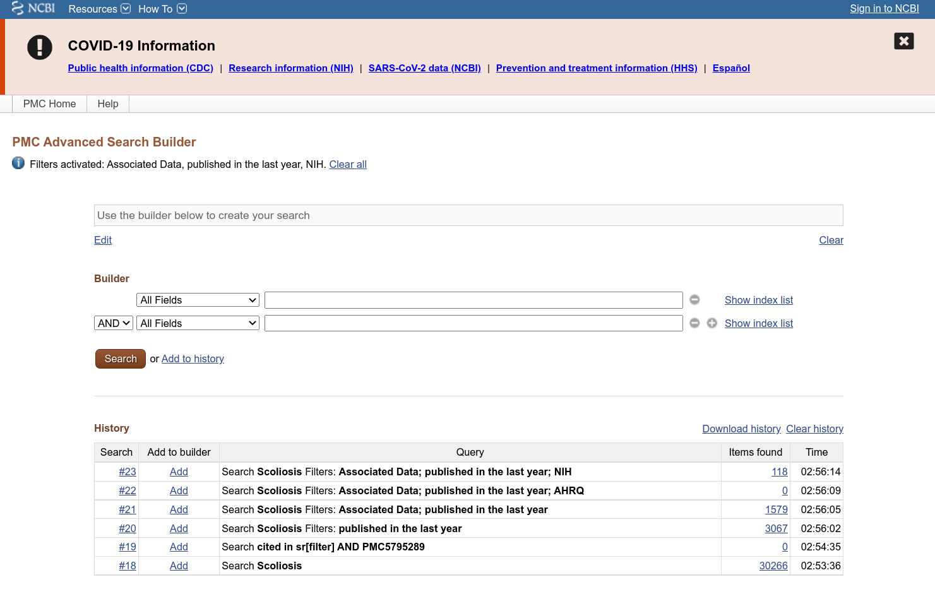**Fig22: Advanced Search builder for resource PMC for query “Scoliosis”**

**Results:**

|  |  |  |
| --- | --- | --- |
| **Sr. No.** | **Literature Databases** | **No. of Items** |
| **1** | Bookshelf | 2,013 |
| **2** | MeSH | 12 |
| **3** | NLM Catalog | 396 |
| **4** | PubMed | 27,715 |
| **5** | PubMed Central | 30,226 |

**Conslusion:**

The literature tools included in NCBI database are very vast and thorough. They can be efficinetly used by students and researchers to gather information about a topic. The Limit filters and advaned search builder, along with MeSH allow us to get hyper specific with the content we want. This is a great set of tools to collect information on any topic relating to Bioinformatics.

**References:**

1. **Bookshelf**
   1. U.S. National Library of Medicine. (n.d.). *Search: Scoliosishttps://www.ncbi.nlm.nih.gov/books/?term - NLM*. National Center for Biotechnology Information. Retrieved November 24, 2021, from https://www.ncbi.nlm.nih.gov/search/all/?term=Scoliosishttps%3A%2F%2Fwww.ncbi.nlm.nih.gov%2Fbooks%2F%3Fterm.
   2. U.S. National Library of Medicine. (n.d.). *Advanced search - books - NCBI*. National Center for Biotechnology Information. Retrieved November 24, 2021, from https://www.ncbi.nlm.nih.gov/books/advanced.
   3. U.S. National Library of Medicine. (n.d.). *GeneReviews® [internet].* National Center for Biotechnology Information. Retrieved November 24, 2021, from <https://www.ncbi.nlm.nih.gov/books/NBK1116/?term=Scoliosis>.
2. **MeSH**
   1. U.S. National Library of Medicine. (n.d.). *Advanced search - mesh - NCBI*. National Center for Biotechnology Information. Retrieved November 24, 2021, from https://www.ncbi.nlm.nih.gov/mesh/advanced.
   2. U.S. National Library of Medicine. (n.d.). *Home - Mesh - NCBI*. National Center for Biotechnology Information. Retrieved November 24, 2021, from https://www.ncbi.nlm.nih.gov/mesh.
   3. U.S. National Library of Medicine. (n.d.). *Limits - mesh - NCBI*. National Center for Biotechnology Information. Retrieved November 24, 2021, from https://www.ncbi.nlm.nih.gov/mesh/limits?term=Scoliosis.
   4. U.S. National Library of Medicine. (n.d.). *Scoliosis*. National Center for Biotechnology Information. Retrieved November 24, 2021, from https://www.ncbi.nlm.nih.gov/mesh/?term=Scoliosis.
3. **NLM Catalog**
   1. U.S. National Library of Medicine. (n.d.). *Advanced robotic spine surgery : A case-based approach - NLM catalog - NCBI*. National Center for Biotechnology Information. Retrieved November 24, 2021, from https://www.ncbi.nlm.nih.gov/nlmcatalog/101774223.
   2. U.S. National Library of Medicine. (n.d.). *Advanced robotic spine surgery : A case-based approach*. National Center for Biotechnology Information. Retrieved November 24, 2021, from https://www.ncbi.nlm.nih.gov/nlmcatalog/?term=Scoliosis.
   3. U.S. National Library of Medicine. (n.d.). *Advanced search - NLM catalog - NCBI*. National Center for Biotechnology Information. Retrieved November 24, 2021, from https://www.ncbi.nlm.nih.gov/nlmcatalog/advanced.
   4. U.S. National Library of Medicine. (n.d.). *Home - NLM catalog - NCBI*. National Center for Biotechnology Information. Retrieved November 24, 2021, from https://www.ncbi.nlm.nih.gov/nlmcatalog.
4. **PubMed**
   1. B;, B. M. R. S. R. M. S. A. G. (n.d.). *Response to the letter to the editor concerning "cross-cultural adaptation and validity of an adapted Kannada (South Indian language) version of Scoliosis Research Society (SRS-30) questionnaire for idiopathic scoliosis" by Baba et al*. Spine deformity. Retrieved November 24, 2021, from https://pubmed.ncbi.nlm.nih.gov/34542837/.
   2. U.S. National Library of Medicine. (n.d.). *Advanced search results - pubmed*. National Center for Biotechnology Information. Retrieved November 24, 2021, from https://pubmed.ncbi.nlm.nih.gov/advanced/.
   3. U.S. National Library of Medicine. (n.d.). *Scoliosis - search results - pubmed*. National Center for Biotechnology Information. Retrieved November 24, 2021, from https://pubmed.ncbi.nlm.nih.gov/?term=Scoliosis&filter=years.1986-2021&sort=date.
   4. U.S. National Library of Medicine. (n.d.). *Scoliosis - search results - pubmed*. National Center for Biotechnology Information. Retrieved November 24, 2021, from https://pubmed.ncbi.nlm.nih.gov/?term=Scoliosis&sort=date&ac=yes.
5. **PMC**
   1. Negrini, S., Donzelli, S., Aulisa, A. G., Czaprowski, D., Schreiber, S., de Mauroy, J. C., Diers, H., Grivas, T. B., Knott, P., Kotwicki, T., Lebel, A., Marti, C., Maruyama, T., O'Brien, J., Price, N., Parent, E., Rigo, M., Romano, M., Stikeleather, L., … Zaina, F. (2018, January 10). *2016 SOSORT guidelines: Orthopaedic and rehabilitation treatment of idiopathic scoliosis during growth*. Scoliosis and spinal disorders. Retrieved November 24, 2021, from https://www.ncbi.nlm.nih.gov/pmc/articles/PMC5795289/.
   2. U.S. National Library of Medicine. (n.d.). *Advanced search - PMC - NCBI*. National Center for Biotechnology Information. Retrieved November 24, 2021, from https://www.ncbi.nlm.nih.gov/pmc/advanced.
   3. U.S. National Library of Medicine. (n.d.). *Scoliosis - PMC - NCBI*. National Center for Biotechnology Information. Retrieved November 24, 2021, from https://www.ncbi.nlm.nih.gov/pmc/?term=Scoliosis.

**Date: 29-09-21**

**WEBLEM 3**

**Introduction to Nucleic Acid Databases**

**Introduction:**

Nucleotide databases that were introduced to us in this weblem were GenBank, EMBL-EBI and DDBJ.

1. **GenBank:**
   1. **GenBank sequence database is an annotated collection of all publicly available nucleotide sequences and their protein translations.**
   2. **This database is produced at the National Center for Biotechnology Information (NCBI) as part of an international collaboration with the European Molecular Biology Laboratory (EMBL) Data Library from the European Bioinformatics Institute (EBI) and the DNA Data Bank of Japan (DDBJ).**
   3. **GenBank and its collaborators receive sequences produced in laboratories throughout the world from hundreds of thousands of distinct organisms.**
   4. **GenBank continues to grow at an exponential rate, doubling every 18 months.**
   5. **GenBank is built by direct submissions from individual laboratories and from large-scale sequencing centers.**
2. **EMBL-EBI:**
   1. It makes the world’s public biological data freely available to the scientific community via a range of services and tools, perform basic research and provide professional training in bioinformatics.
   2. It is part of the European Molecular Biology Laboratory (EMBL), an international, innovative and interdisciplinary research organisation funded by over 20 member states, prospect and associate member states.
   3. It is situated on the Welcome Genome Campus in Hinxton, Cambridge, UK, one of the world’s large.
3. **DDBJ:**
   1. DDBJ Center collects nucleotide sequence data as a member of INSDC(International Nucleotide Sequence Database Collaboration) and provides freely available nucleotide sequence data and supercomputer system, to support research activities in life science concentrations of scientific and technical expertise in genomics.
   2. The principal purpose of DDBJ operations is to improve the quality of INSD, as public domains. When researchers make their data open to the public through INSD and [commonly shared in world wide](https://www.ddbj.nig.ac.jp/policies-e.html#copyright), we at DDBJ Center make efforts to describe information on the data as rich as possible, according to the unified rules of INSD, preferably without any stress by using DDBJ.

**References:**

1. <https://www.ncbi.nlm.nih.gov/books/NBK153518/>
2. <https://www.ebi.ac.uk/about>
3. <https://www.ddbj.nig.ac.jp/about/index-e.html>
4. https://www.mayoclinic.org/diseases-conditions/klinefelter-syndrome/symptoms-causes/syc-20353949

**WEBLEM 3a**

**Introduction to Nucleic Acid Databases**

**Aim:**

To study the genes involved in the causation of Klinefelter’s syndrome using GenBank Database.

**Introduction:**

The query taken for Genbank is “Klinefelter’s syndrome”. Klinefelter syndrome is a genetic condition that results when a boy is born with an extra copy of the X chromosome.

Klinefelter syndrome is a genetic condition affecting males, and it often isn't diagnosed until adulthood. Klinefelter syndrome may adversely affect testicular growth, resulting in smaller than normal testicles, which can lead to lower production of testosterone. The syndrome may also cause reduced muscle mass, reduced body and facial hair, and enlarged breast tissue.

The effects of Klinefelter syndrome vary, and not everyone has the same signs and symptoms. About 3% of the infertile male population have Klinefelter syndrome.

**Methodology:**

1. Open Homepage of GenBank (URL-https://www.ncbi.nlm.nih.gov/genbank/)
2. Enter Search query (Klinefelter’s syndrome)
3. Interpret the result and find the needed data.

**Observations:**

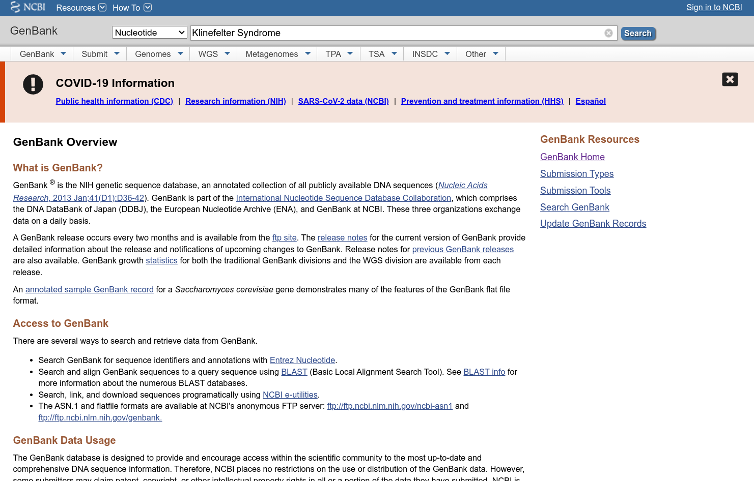

**Fig1. Homepage of GenBank**

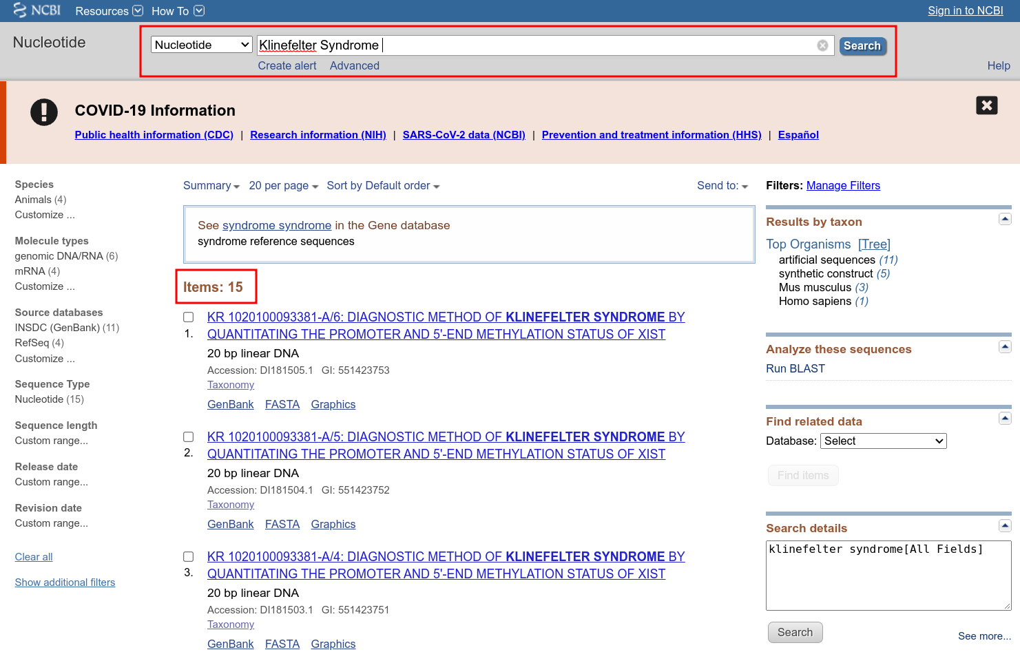**Fig2. Hit page with results for query Klinefelter syndrome**

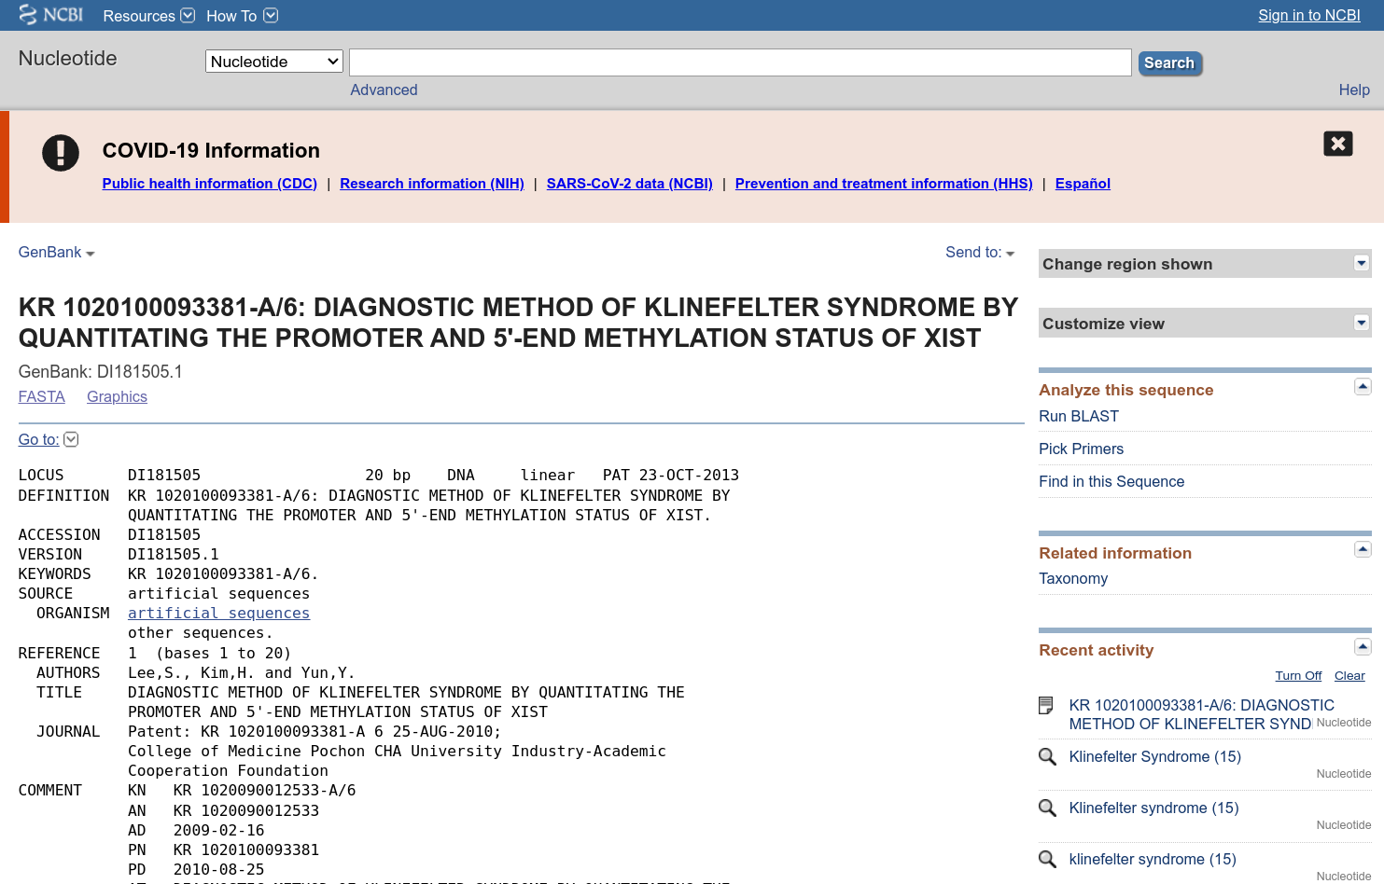**Fig3. Result page for query Klinefelter syndrome in GenBank [KR 1020100093381-A/6]**

**Fig4. Header of result for query Klinefelter syndrome [KR 1020100093381-A/6]**

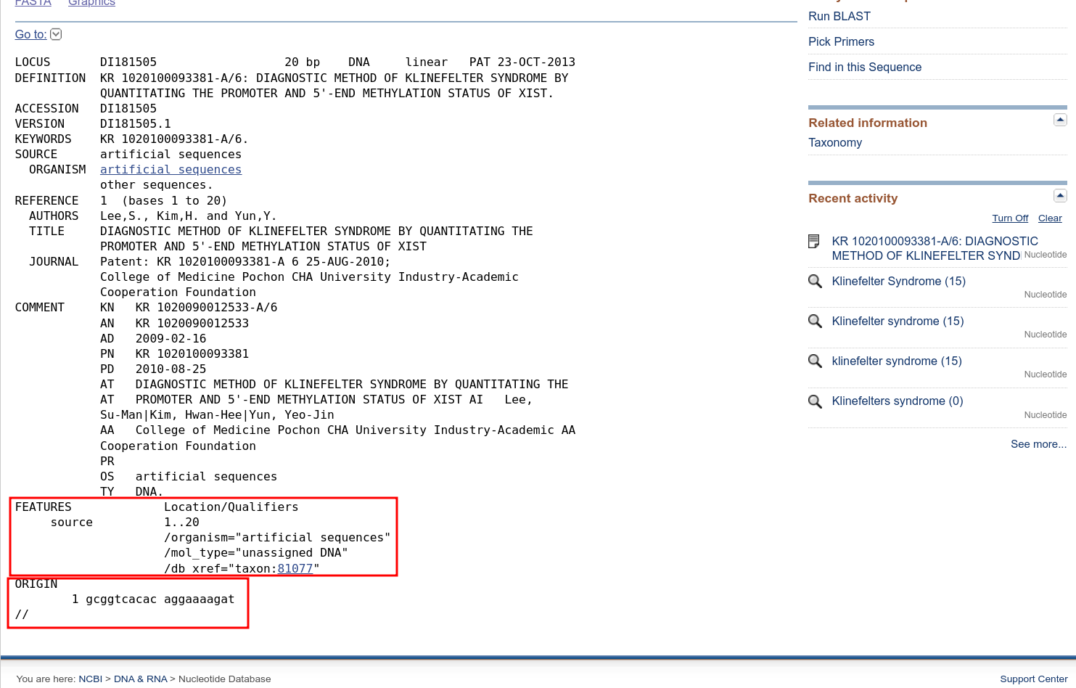**Fig5. Result page of query Klinefelter syndrome in GenBank with Features and Origin shown**

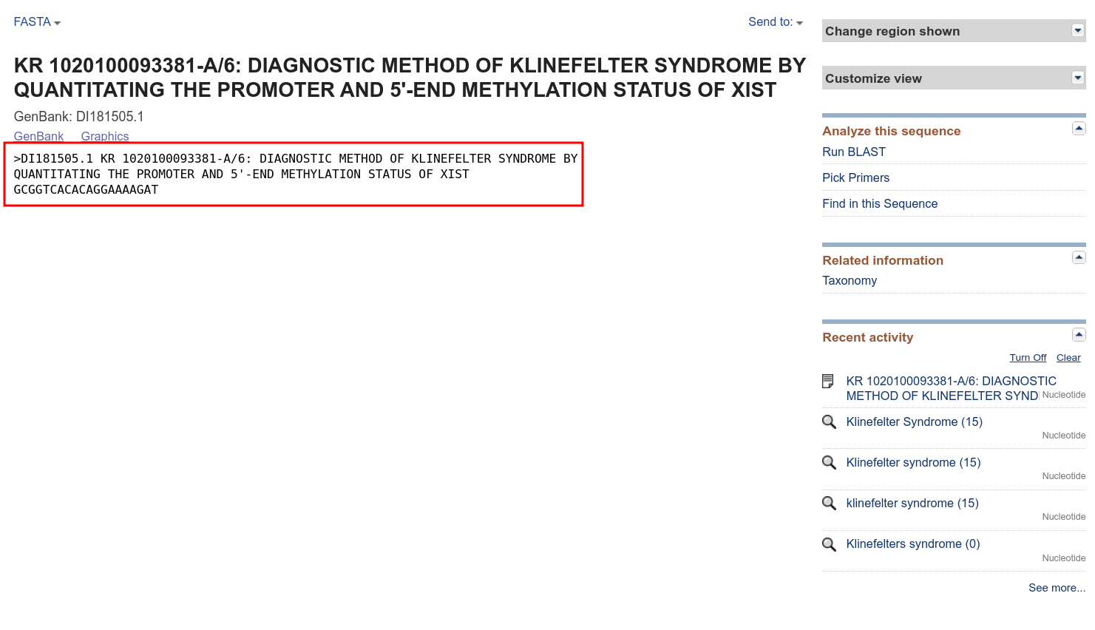**Fig6. FASTA sequence of Result of query Klinefelter syndrome in GenBank [KR 1020100093381-A/6]**

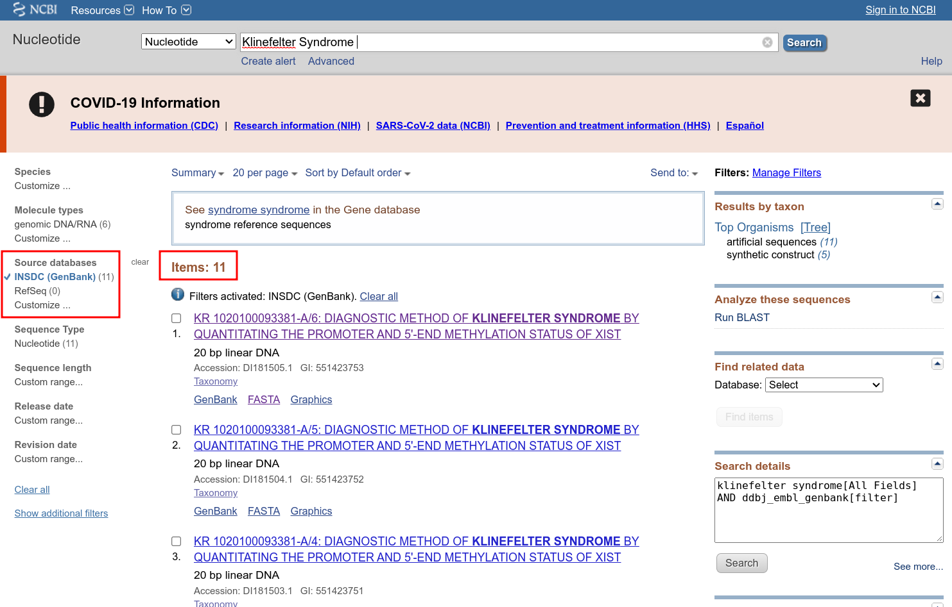**Fig7. Hit page for Klinefelter syndrome in GenBank with limit options and refined results**

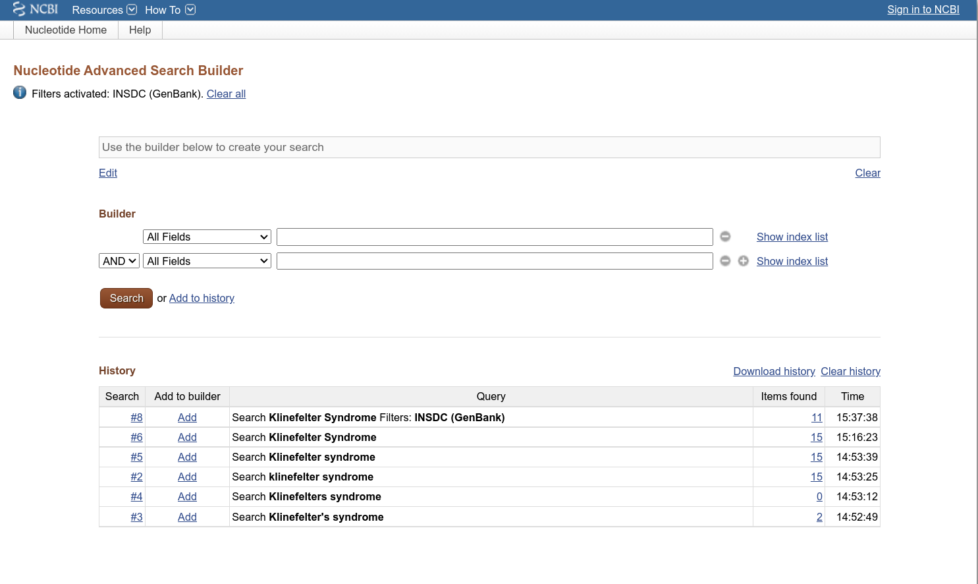**Fig8. Advanced search builder for Query Klinefelter Syndrome in GenBank**

**Conclusion:**

GenBank is an amazing tool integrated within NCBI to make the querying of nucleotide sequences easy and accesible. The dataset is vast and depending on the query thousands of results can be poured over in a very short amount of time.

According, to the current time GenBank also provide detailed information about the release and notifications of upcoming changes in GenBank.

**Result:**

|  |  |  |
| --- | --- | --- |
| **Sr. No.** | **Resource** | **Result** |
| 1 | GenBank | 15 |

**References:**

1. U.S. National Library of Medicine. (n.d.). *GenBank Overview*. National Center for Biotechnology Information. Retrieved November 24, 2021, from https://www.ncbi.nlm.nih.gov/genbank/.
2. U.S. National Library of Medicine. (n.d.). *KR 1020100093381-A/6: Diagnostic Method of Klinefelter syndrome by Qua - nucleotide - NCBI*. National Center for Biotechnology Information. Retrieved November 24, 2021, from https://www.ncbi.nlm.nih.gov/nuccore/DI181505.1.
3. U.S. National Library of Medicine. (n.d.). *KR 1020100093381-A/6: Diagnostic Method of Klinefelter syndrome by Qua - nucleotide - NCBI*. National Center for Biotechnology Information. Retrieved November 24, 2021, from https://www.ncbi.nlm.nih.gov/nuccore/DI181505.1?report=fasta.
4. U.S. National Library of Medicine. (n.d.). *KR 1020100093381-A/6: Diagnostic Method of Klinefelter syndrome by quantitating the promoter and 5'-end methylation status of Xist*. National Center for Biotechnology Information. Retrieved November 24, 2021, from <https://www.ncbi.nlm.nih.gov/nuccore/?term=Klinefelter%2BSyndrome>.

**WEBLEM 3b**

**Introduction to Nucleic Acid Sequence Database**

**Aim:**

To study the genes involved in the causation of Klinefelter’s syndrome using EMBL-EBI Database.

**Introduction:**

The query taken for EMBL-EBI is “Klinefelter’s syndrome”. Klinefelter syndrome is a genetic condition that results when a boy is born with an extra copy of the X chromosome.

Klinefelter syndrome is a genetic condition affecting males, and it often isn't diagnosed until adulthood. Klinefelter syndrome may adversely affect testicular growth, resulting in smaller than normal testicles, which can lead to lower production of testosterone. The syndrome may also cause reduced muscle mass, reduced body and facial hair, and enlarged breast tissue.

The effects of Klinefelter syndrome vary, and not everyone has the same signs and symptoms. About 3% of the infertile male population have Klinefelter syndrome.

**Methodology:**

1. Open Homepage of EMBL-EBI (URL-https://www.ebi.ac.uk/)
2. Enter Search query (Klinefelter’s syndrome)
3. Interpret the result and find the needed data.

**Observation:**

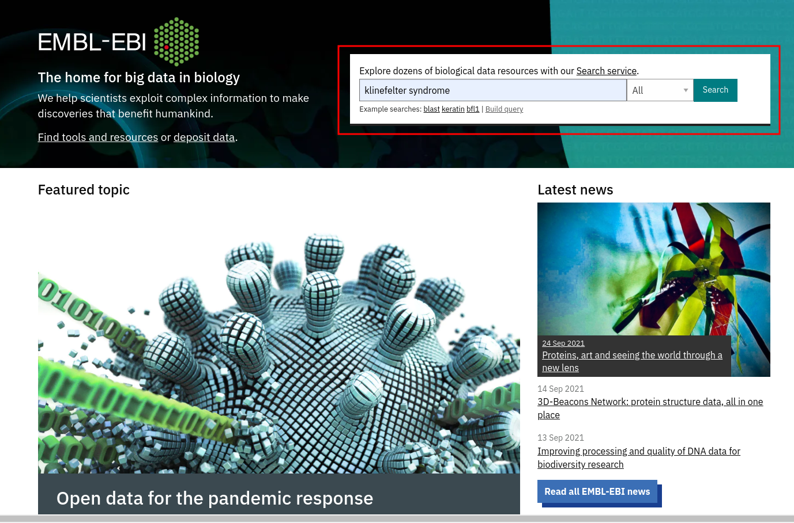**Fig1. Homepage of EMBL with query Klinefelter entered in the search bar**

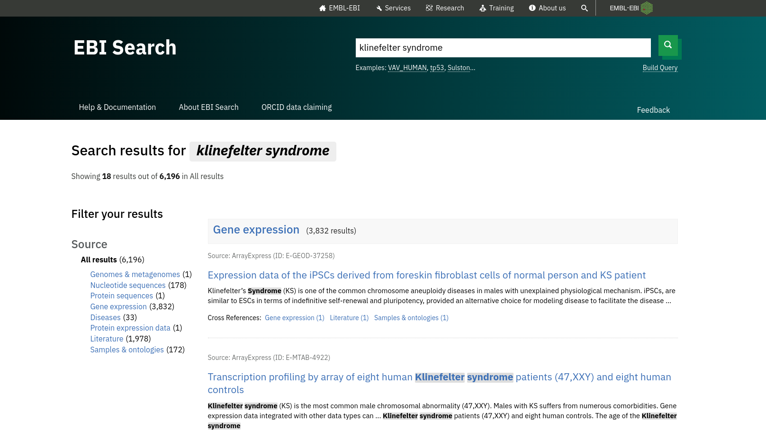**Fig2. Hit page of EMBL for query Klinefelter Syndrome**

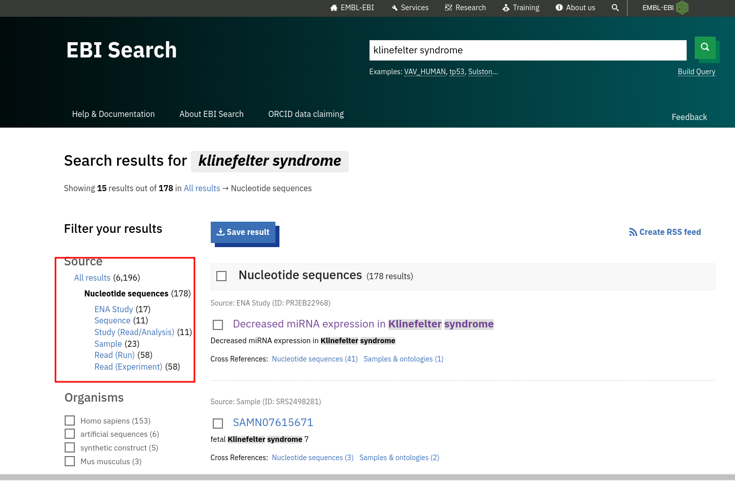**Fig3. Hit page of nucleotide sequences for Klinefelter syndrome**

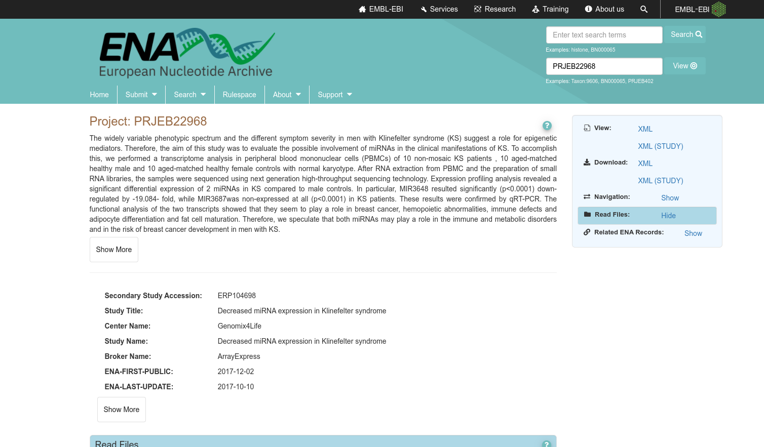**Fig4. Result page of nucleotide sequences for Klinefelter’s syndrome [Project: PRJEB22968]**

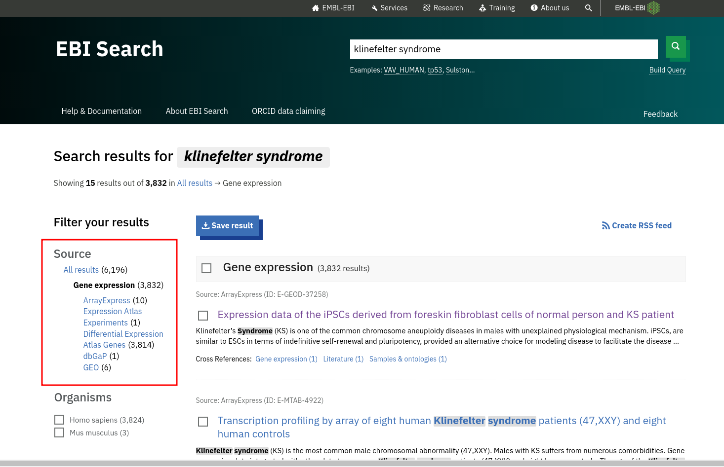**Fig5. Hit page of Gene expression for Klinefelter Syndrome**

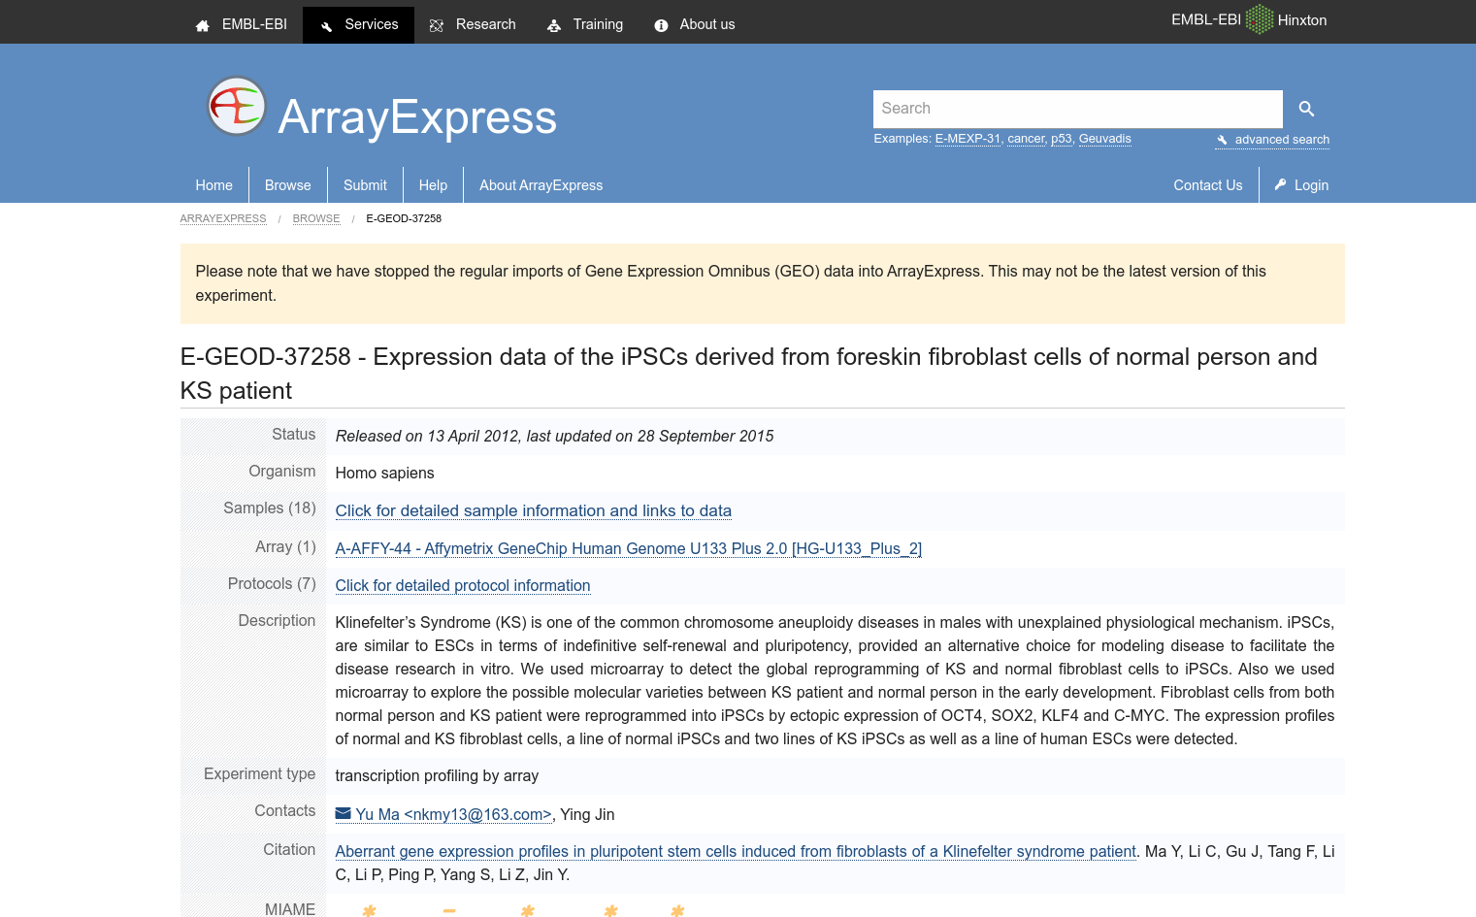**Fig6. Result page of Gene Expression for Klinefelter Syndrome [E-GEOD-37258]**

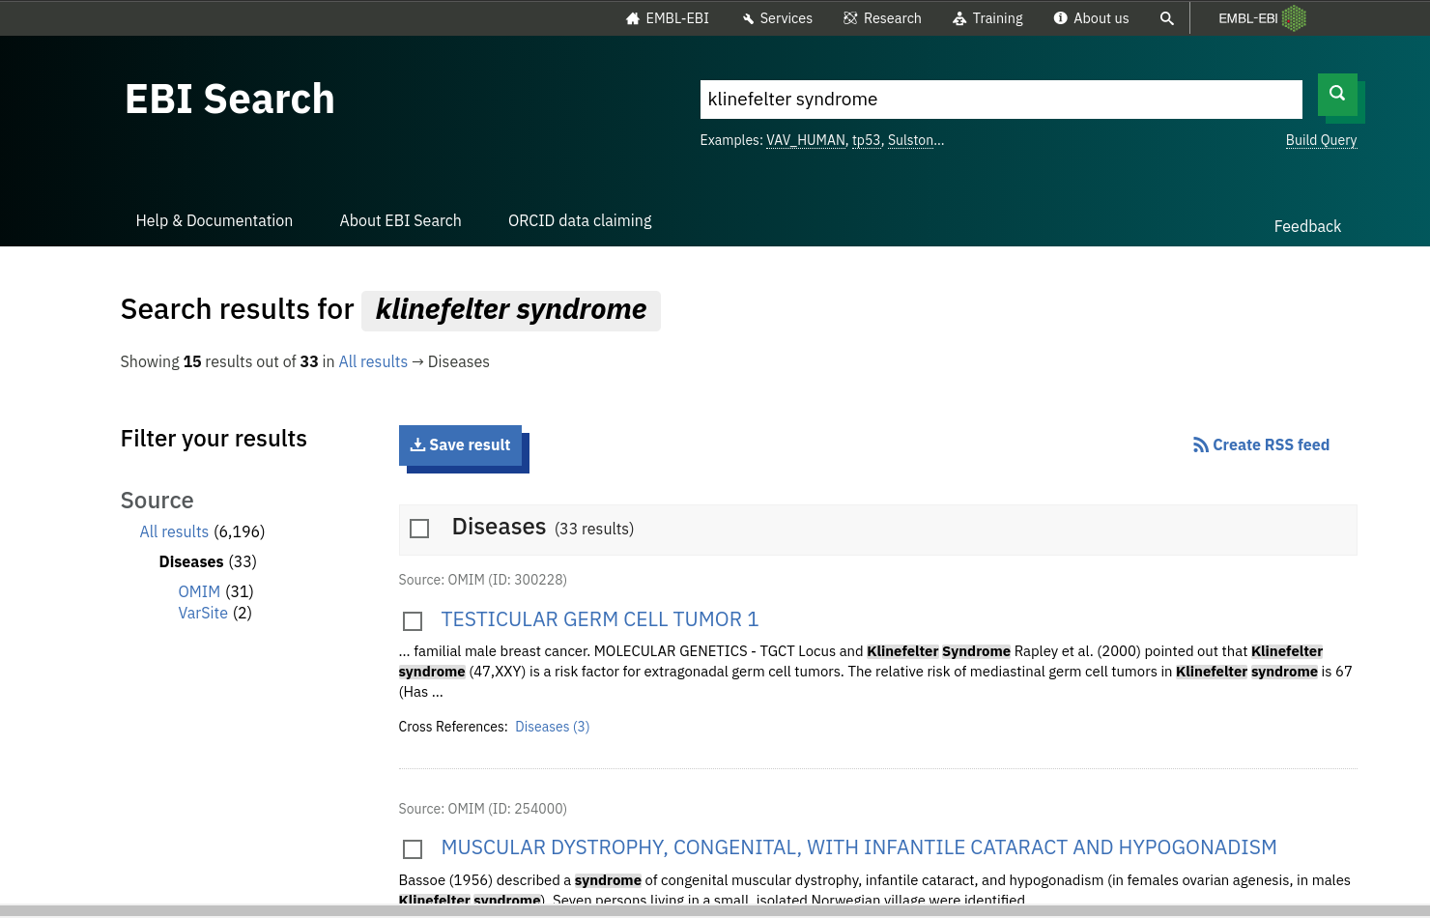**Fig7. Hit page of Diseases for Klinefelter’s syndrome**

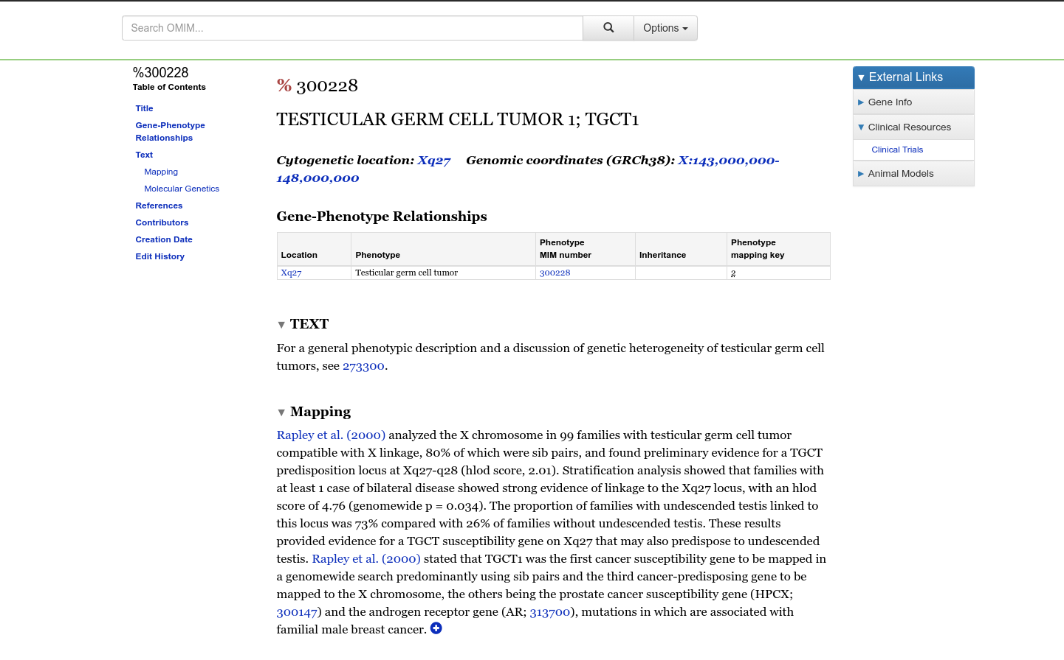**Fig8. Result page of Diseases for Klinefelter Syndrome [TESTICULAR GERM CELL TUMOR 1; TGCT1]**

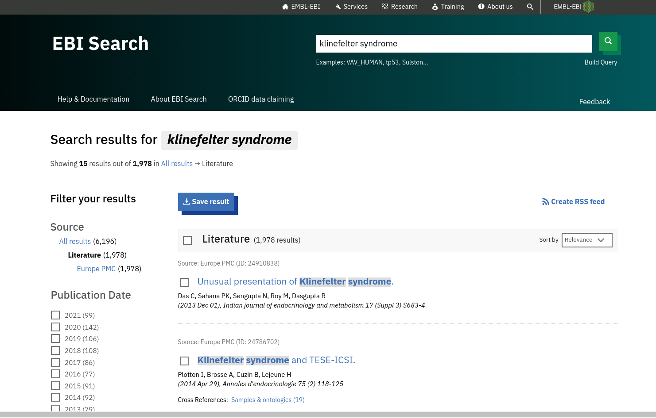**Fig9. Hit page of literature for Klinefelter’s Syndrome**

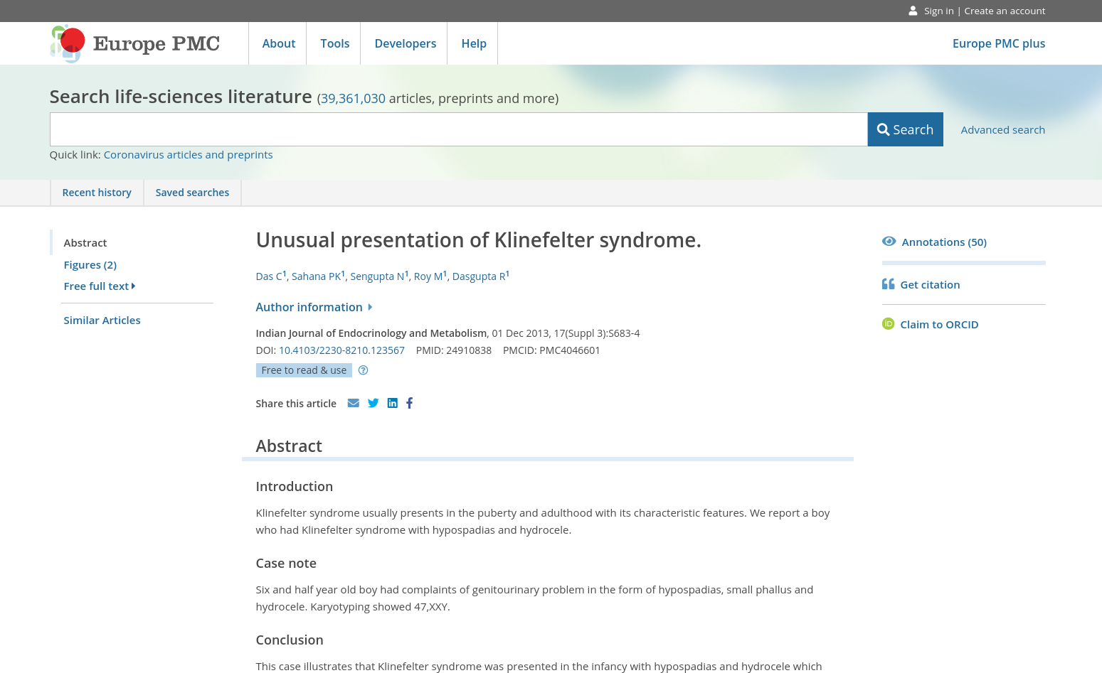**Fig10. Result page of Literature for Klinefelter’s syndrome [****Unusual presentation of Klinefelter syndrome]**

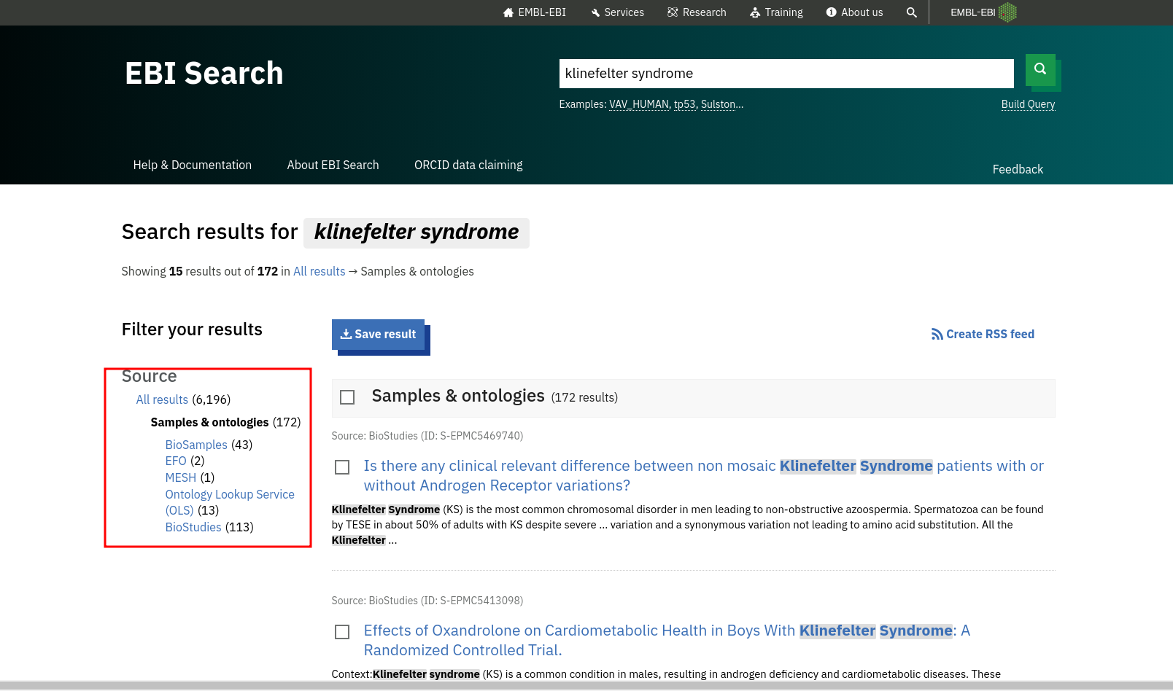**Fig11. Hit page of Samples and entologies for klinefelter’s syndrome**

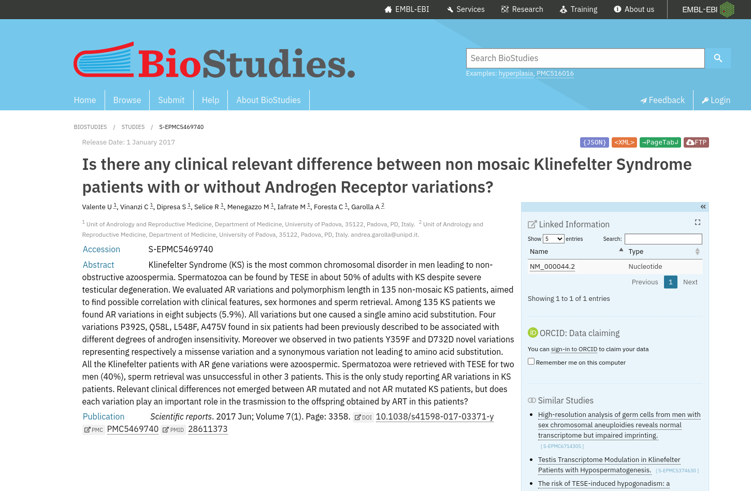**Fig12. Result page of Samples and entologies for Klinefelter’s Syndrome [S-EPMC5469740]**

**Conclusion:**

EMBL provides a big combination of databases to choose from just like NCBI does. We can use it to found almos all kinds of relevant information related to research topic

**Results:**

|  |  |  |
| --- | --- | --- |
| **Sr. No** | **Resource** | **Results** |
| 1 | Nucleotide Sequences | 178 |
| 2 | Gene Expression | 3832 |
| 3 | Diseases | 33 |
| 4 | Literature | 1978 |
| 5 | Samples and entologies | 172 |

**References:**

1. Ebi search. (n.d.). Retrieved November 24, 2021, from https://www.ebi.ac.uk/ebisearch/search.ebi?query=klinefelter+syndrome&db=allebi&requestFrom=ebi_index.
2. **Nucleotide Sequence**
   1. Ebi search. (n.d.). Retrieved November 24, 2021, from https://www.ebi.ac.uk/ebisearch/search.ebi?db=nucleotideSequences&query=klinefelter+syndrome.
   2. Embl-Ebi. (n.d.). Ena Browser. Retrieved November 24, 2021, from https://www.ebi.ac.uk/ena/browser/view/PRJEB22968?show=reads.
3. **Gene Expression**
   1. Embl-Ebi. (n.d.). *Arrayexpress*. E. Retrieved November 24, 2021, from https://www.ebi.ac.uk/arrayexpress/experiments/E-GEOD-37258.
4. **Diseases**
   1. Ebi search. (n.d.). Retrieved November 24, 2021, from https://www.ebi.ac.uk/ebisearch/search.ebi?db=diseases&query=klinefelter+syndrome.
   2. *OMIM entry - % 300228 - testicular germ cell tumor 1; TGCT1*. (n.d.). Retrieved November 24, 2021, from https://www.omim.org/entry/300228.
5. **Literature**
   1. Ebi search. (n.d.). Retrieved November 24, 2021, from https://www.ebi.ac.uk/ebisearch/search.ebi?db=literature&query=klinefelter+syndrome.
   2. PMC, E. (n.d.). Europe PMC. Retrieved November 24, 2021, from https://europepmc.org/article/MED/24910838.
6. **Samples and entologies**
   1. BioStudies. (n.d.). *Biostudies < the European Bioinformatics Institute < EMBL*. EBI. Retrieved November 24, 2021, from https://www.ebi.ac.uk/biostudies/studies/S-EPMC5469740.
   2. Ebi search. (n.d.). Retrieved November 24, 2021, from https://www.ebi.ac.uk/ebisearch/search.ebi?db=ontologies&query=klinefelter+syndrome.

**WEBLEM 3c**

**Introduction to Nuclei Acid Sequence Database**

**Aim:**

To study the genes involved in the causation of Klinefelter’s syndrome using DDBJ Database.

**Introduction:**

The query taken for DDBJ is “Klinefelter’s syndrome”. Klinefelter syndrome is a genetic condition that results when a boy is born with an extra copy of the X chromosome.

Klinefelter syndrome is a genetic condition affecting males, and it often isn't diagnosed until adulthood. Klinefelter syndrome may adversely affect testicular growth, resulting in smaller than normal testicles, which can lead to lower production of testosterone. The syndrome may also cause reduced muscle mass, reduced body and facial hair, and enlarged breast tissue.

The effects of Klinefelter syndrome vary, and not everyone has the same signs and symptoms. About 3% of the infertile male population have Klinefelter syndrome.

**Methodology:**

1. Open Homepage of DDBJ (URL-https://www.ddbj.nig.ac.jp/index-e.html)
2. Navigate to Services > Getentry
3. Enter Search query (Accesion ID of a paper based on Klinefelter Syndrome)
4. Interpret the result and find the needed data.

**Observations:**

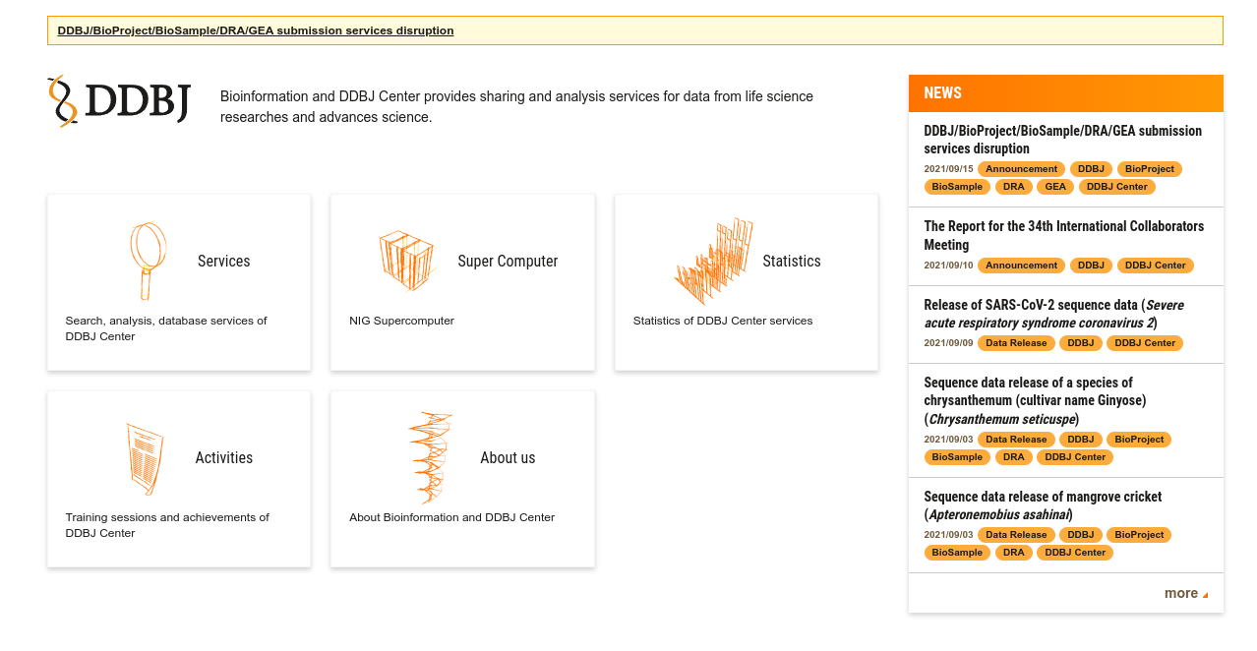**Fig1. Homepage of DDBJ**

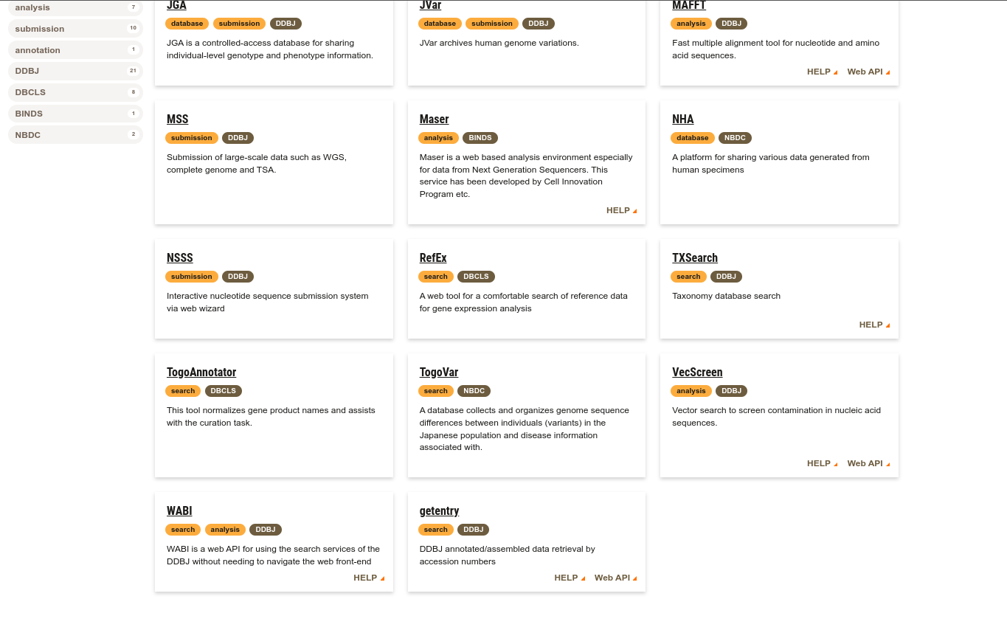**Fig2. Services page of DDBJ with gententry highlighted**

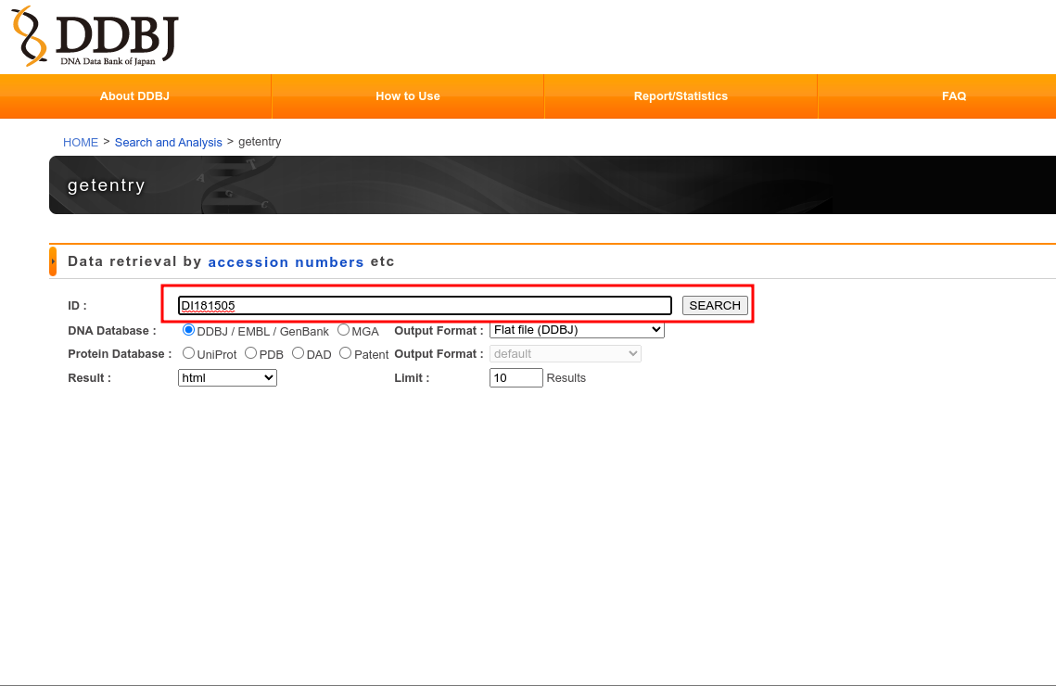**Fig3. Getentry page of DDBJ with accession ID of result from GenBank [Weblem 3a] entered**

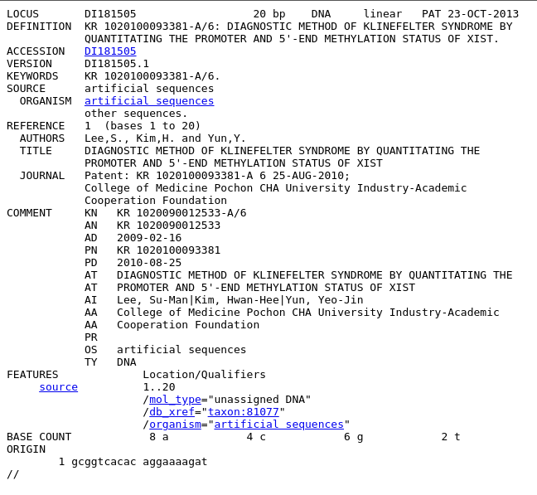**Fig4. Result page with Header, Features and Origin Highlighted for Klinefelter Syndrome**

HEADER

FEATURES

ORIGIN

**Conclusion:**

DDBJ provides complete data on a nucleotide sequence based on the accesion ID of the sequence. It is an easy and quick way to cross check and identify the necessary data

**Result:**

On firing the accession ID for the Klinefelter Syndrome sequence was retrived

**References:**

1. DDBJ. (2021, November 24). Retrieved November 24, 2021, from https://www.ddbj.nig.ac.jp/index-e.html.
2. DI181505. (n.d.). Retrieved November 24, 2021, from http://getentry.ddbj.nig.ac.jp/getentry/na/DI181505/?format=flatfile&filetype=html&trace=true&show_suppressed=false&limit=10.
3. *Getentry help*. DDBJ sequence search by accession number. (n.d.). Retrieved November 24, 2021, from http://getentry.ddbj.nig.ac.jp/top-e.html.
4. *Services*. DDBJ. (n.d.). Retrieved November 24, 2021, from https://www.ddbj.nig.ac.jp/services/index-e.html.

**Date: 2-10-21**

**WEBLEM 4**

**Introduction to Protein Sequence Database**

**Introduction:**

* **Uniprot:**

The Universal Protein Resource (UniProt) is a comprehensive resource for protein sequence and annotation data. The UniProt databases are the UniProt Knowledgebase (UniProtKB), the UniProt Reference Clusters (UniRef), and the UniProt Archive (UniParc). The UniProt consortium and host institutions EMBL-EBI, SIB and PIR are committed to the long-term preservation of the UniProt databases.

* **UniprotKb:**

The UniProt Knowledgebase (UniProtKB) is the central hub for the collection of functional information on proteins, with accurate, consistent and rich annotation. In addition to capturing the core data mandatory for each UniProtKB entry (mainly, the amino acid sequence, protein name or description, taxonomic data and citation information), as much annotation information as possible is added.

**Reviewed(Swiss-Prot)-**Manually annotated: Records with information extracted from literature and curator-evaluated computational analysis.

**Unreviewed(TeEMBL)-**Computationally analyzed: Record that await full manual annotation.

* **Uniref:**

The UniProt Reference Clusters (UniRef) provide clustered sets of sequences from the UniProt Knowledgebase (including isoforms) and selected UniParc records. This hides redundant sequences and obtains complete coverage of the sequence space at three resolution

* **UniParc:**

UniParc is a comprehensive and non-redundant database that contains most of the publicly available protein sequences in the world. Proteins may exist in different sources databases and in multiple copies in the same database. UniParc avoids such redundancy by storing each unique only once and giving it a stable and unique identifier (UPI)

* **Proteomes:**

A proteome is the set of proteins thought to be expressed by an organism. UniProt provides proteomes for species with completely sequenced genomes.

* **PIR:**

The Protein Information Resource (PIR) is an integrated public bioinformatics resource to support genomic, proteomic and systems biology research and scientific studies.

PIR was established in 1984 by the National Biomedical Research Foundation (NBRF) as a resource to assist researchers in the identification and interpretation of protein sequence information. Prior to that, the NBRF compiled the first comprehensive collection of macromolecular sequences in the Atlas of Protein Sequence and Structure, published from 1965-1978 under the editorship of Margaret). Dayhoff. Dr. Dayhoff and her research group pioneered in the development of computer methods for the comparison of protein sequences, for the detection of distantly related sequences and duplications within sequences, and for the inference of evolutionary histories from alignments of protein sequences.

* **PRO:**

PRO provides an ontological representation of protein-related entities by explicitly defining them and showing the relationships between them. Each PRO term represents a distinct class of entities (including specific modified forms, orthologous isoforms, and protein complexes) Ranging from the taxon-neutral to the taxon-specific.

* **IPTMnet:**

iPTMnet is a bioinformatics resource for integrated understanding of protein post-translational modification (PTMs) in systems biology context.

It connects multiple disparate bioinformatics tools and systems text mining, data mining, analysis and visualization tools, and databases and ontologies into an integrated cross-cutting research resource to address the knowledge gaps in exploring and discovering PTM networks.

* **IproLINK:**

iProLINK (integrated Protein Literature, Information and knowledge) is resource with access to text mining tools and annotated corpora developed in house. The collection of data sources can be utilized by computational and biological researches to explore literature information on proteins and their feature or properties.

1. **ItextMine**: Integrated text mining tools and relation extraction results from large-scale text processing.
2. **pGenN**: a gene normalization tool tailored for plants.
3. **MiRTex**: a relation extraction tool that identifies miRNA-target relations as well as miRNA-gene and gene-miRNA regulation relations.
4. **EFIP**: A relation extraction tool that identifies information relevant to phosphorylated proteins and phosphorylation-dependent protein-protein interactions.
5. **EmiRIT**: an integrative text mining system collecting miRNA information from the literature.
6. **RLIMS**-**P**: a generalizable relation extraction system (for developers)
7. **iSimp**: a sentence simplification system (for developers)

**Date: 2-10-21**

**WEBLEM 4a**

**(URL: https://www.uniprot.org/)**

**Aim:**

To study ‘Rhodopsin’ Protein information using UniProt Database.

**Introduction:**

The UniProt Knowledgebase (UniProtKD) is the central hub from the collection of functional information on proteins, with accurate, consistent and rich annotation. In addition to capturing the core data mandatory for each UniProtKB entry (mainly the amino acid sequence, protein name or description, taxomic data and citation information), as much annotation information as possible in added.

Rhodopsin is a biological pigment found in the rods of the retina and is a G-protein-coupled receptor (GPCR). It belongs to a group of photoswitchable opsins. Rhodopsin is extremely sensitive to light, and thus enables vision in low-light conditions. When rhodopsin is exposed to light, it immediately photobleaches.

**Methodolgy:**

1. Homepage of Uniprot.
2. Enter the UniprotKB and search the query ‘Rhodopsin’
3. Interpret the results.

**Observations:**

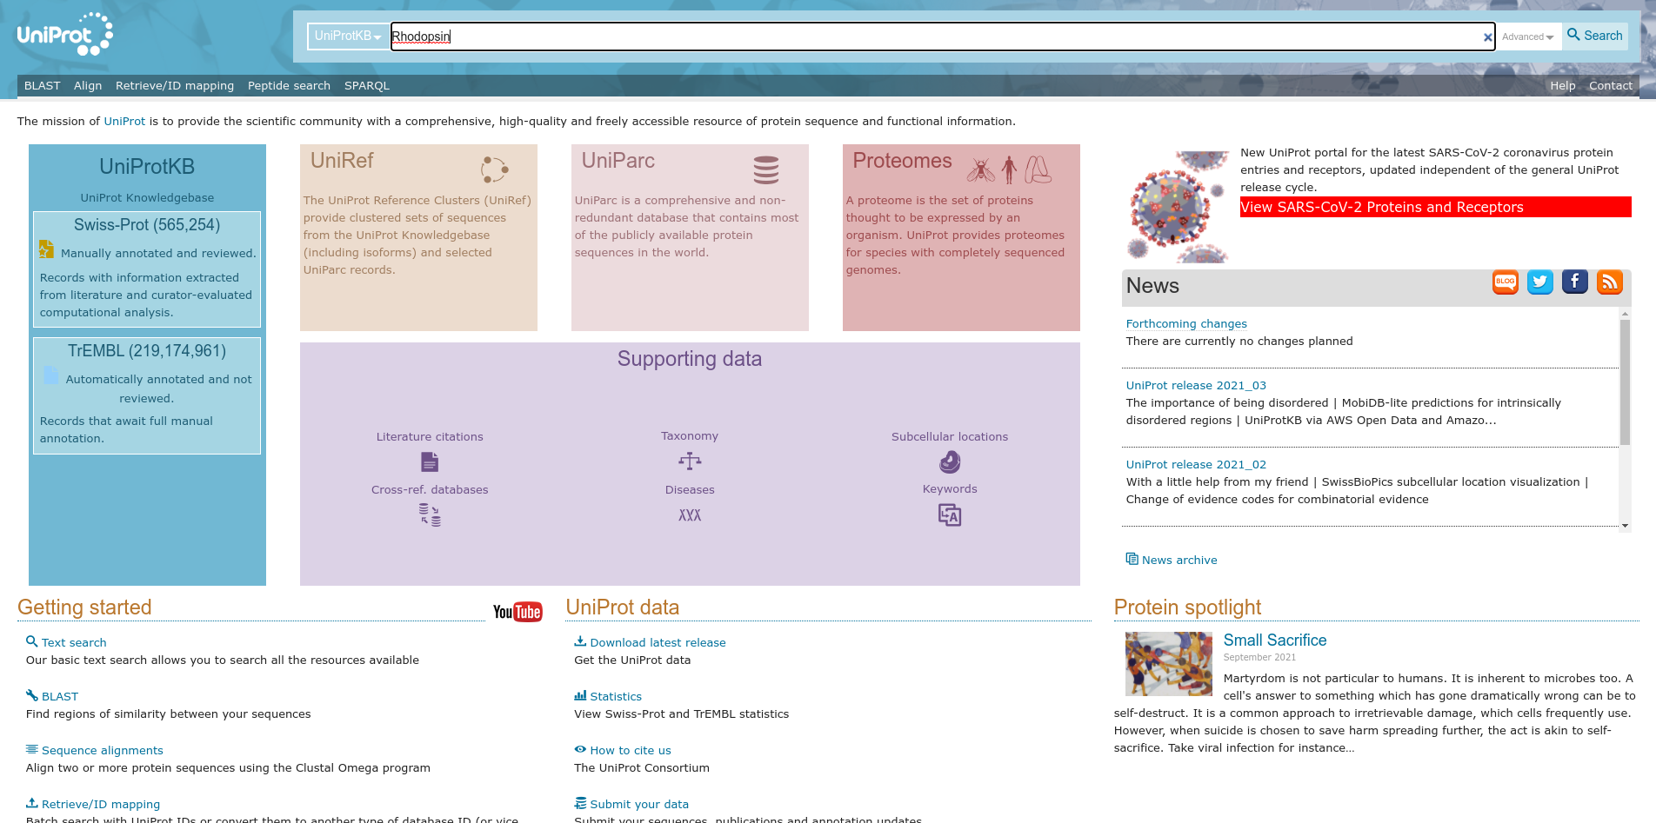**Fig1. Homepage of Uniprot with query ‘Rhodopsin’**

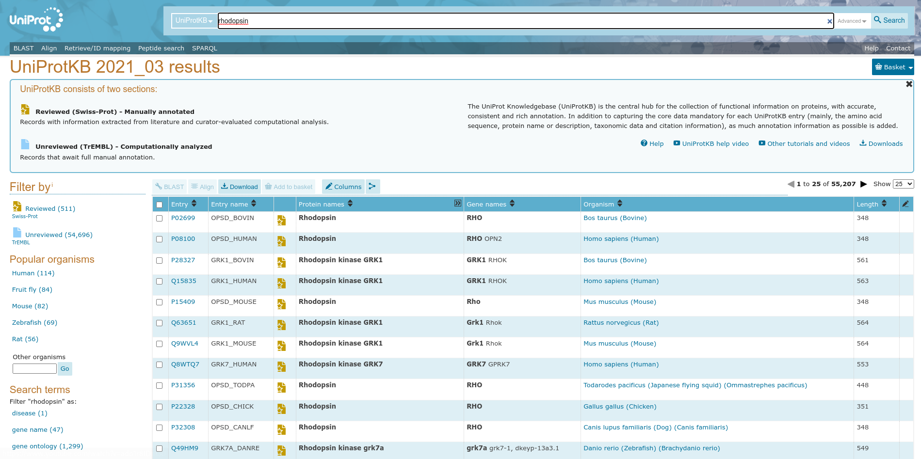**Fig2. Hit page of UniprotKB with query ‘Rhodopsin’**

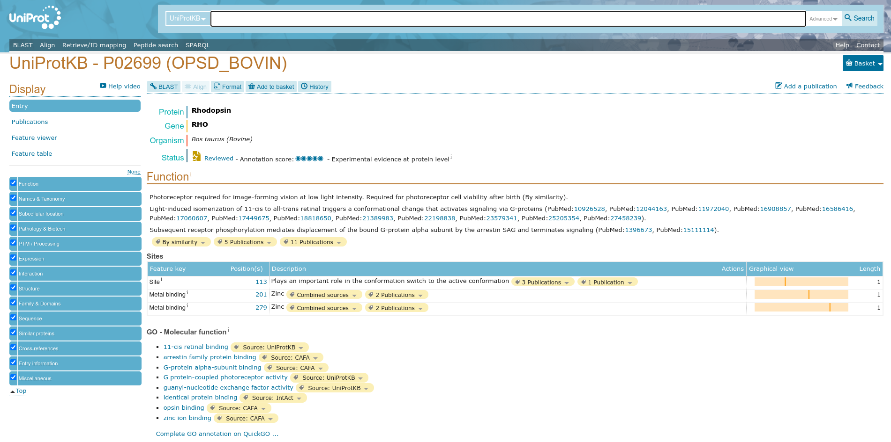**Fig3. Header page with of result with query ‘Rhodopsin’**

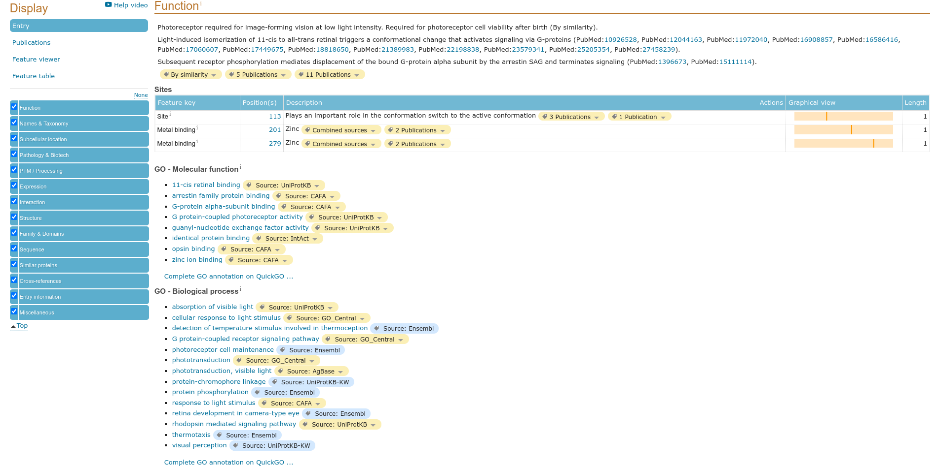**Fig4. Function page of result for query ‘Rhodopsin’**

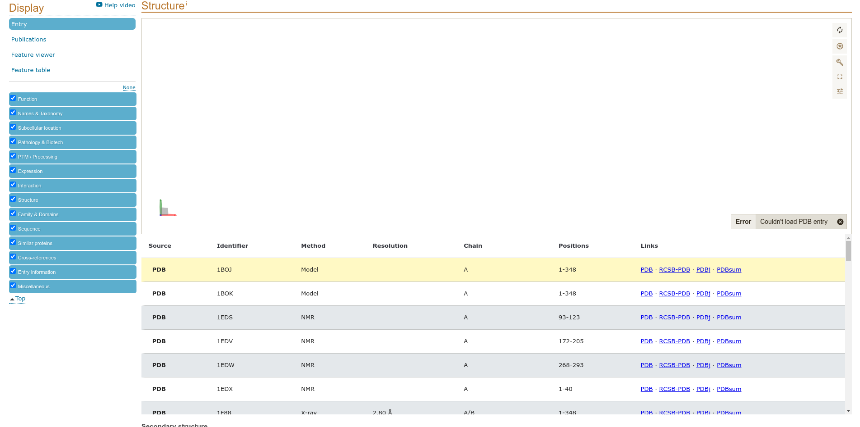**Fig5. Structure of result of query ‘Rhodopsin’**

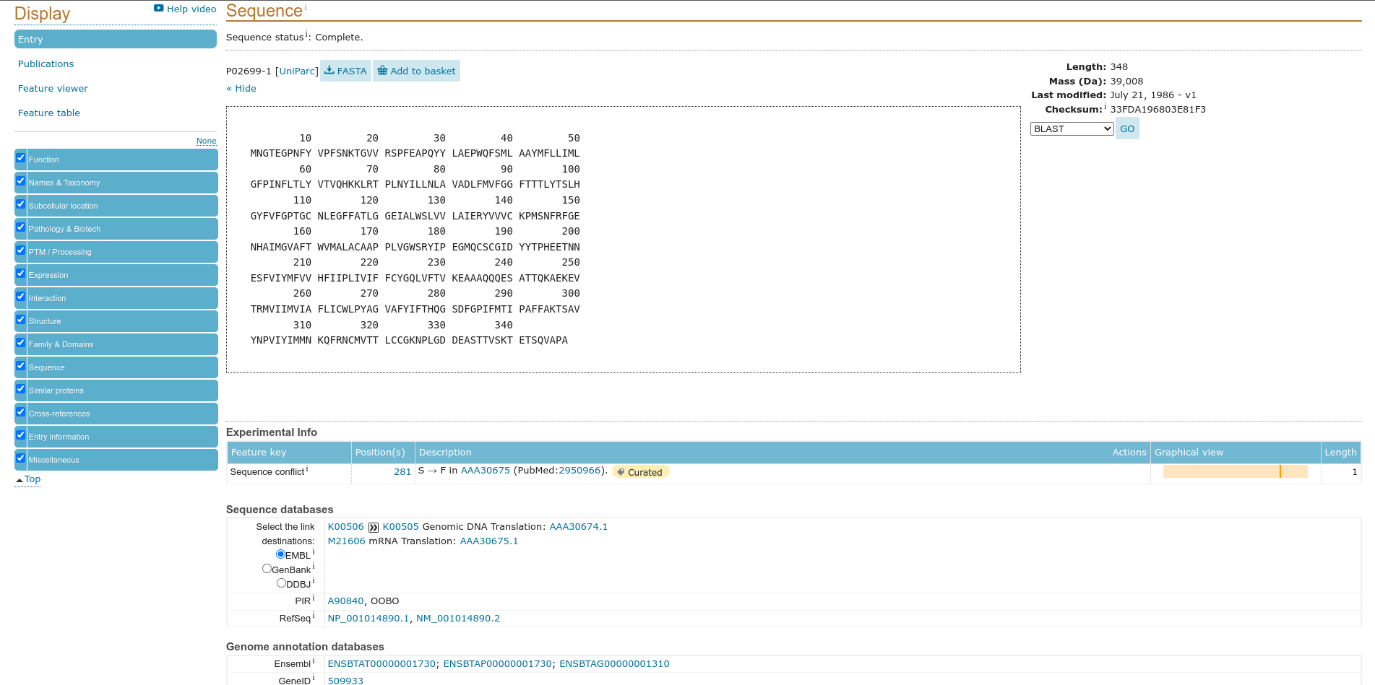**Fig6. Sequences of result for query ‘Rhodopsin’**

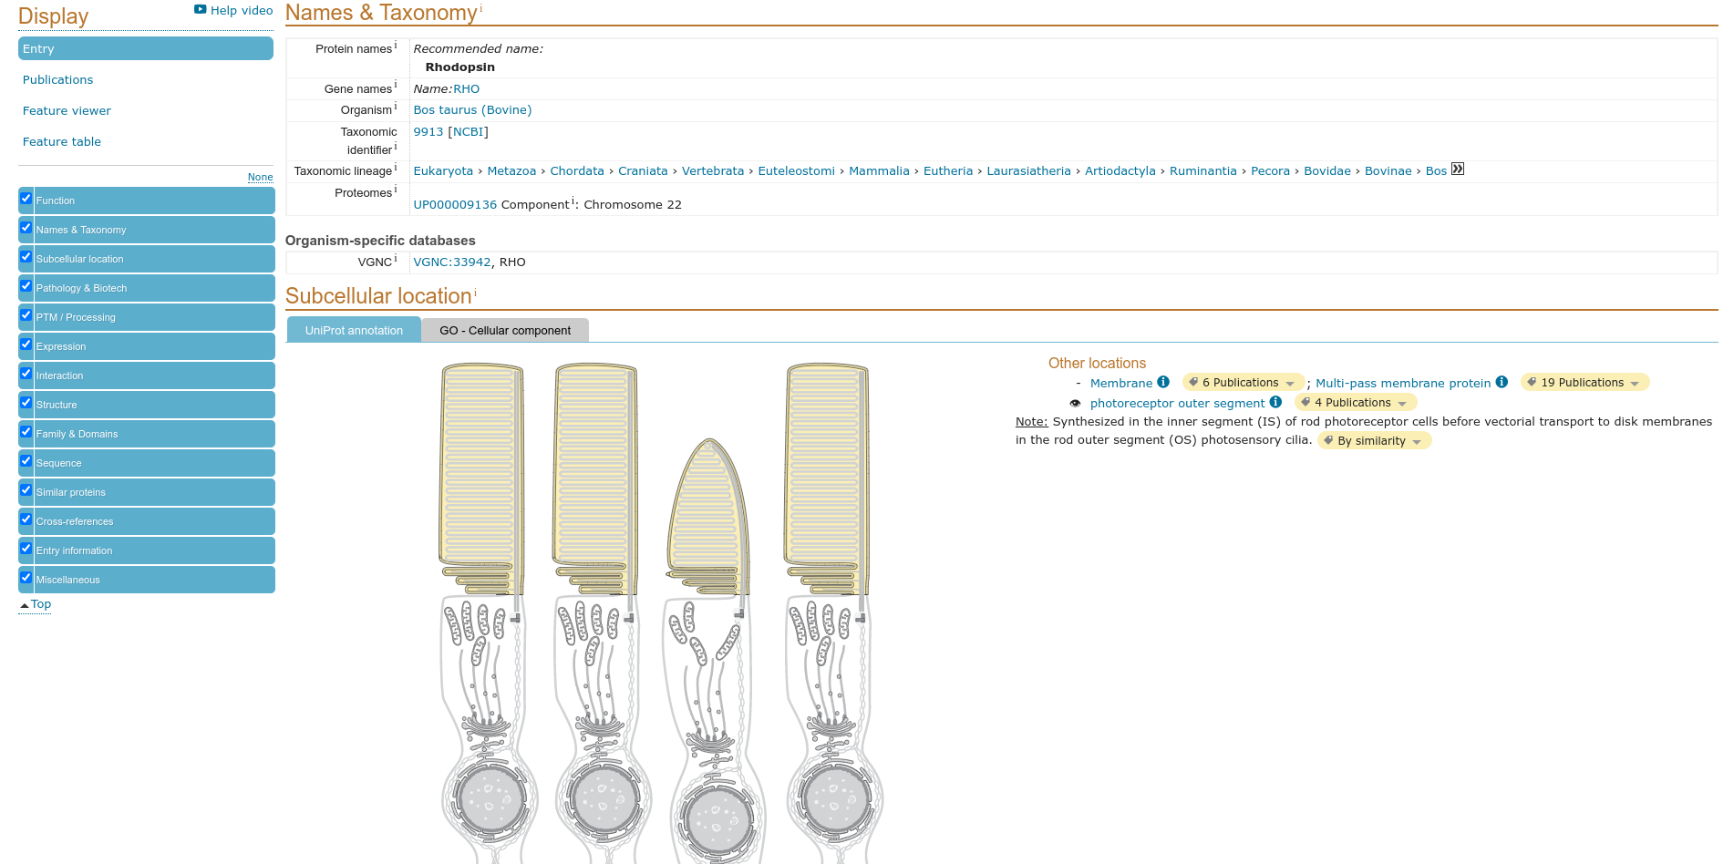**Fig7. Names and taxonomy of result for query ‘Rhodopsin’**

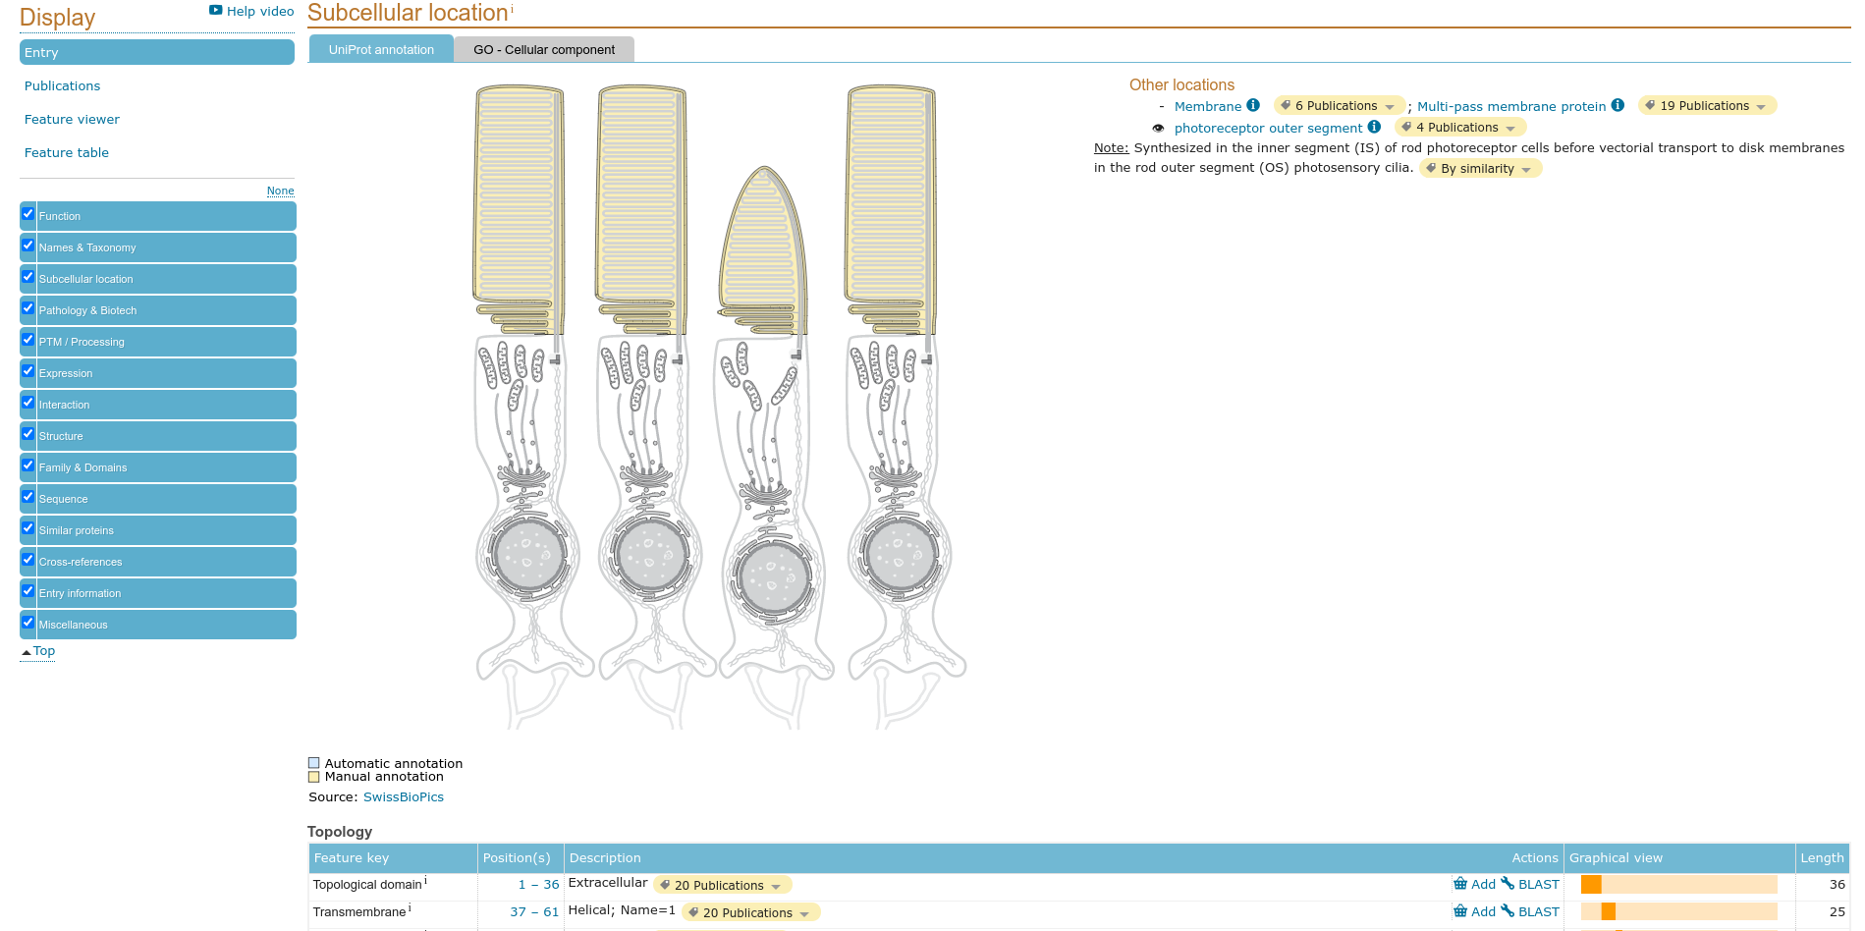**Fig8. Subcellular location of result for query ‘Rhodopsin’**

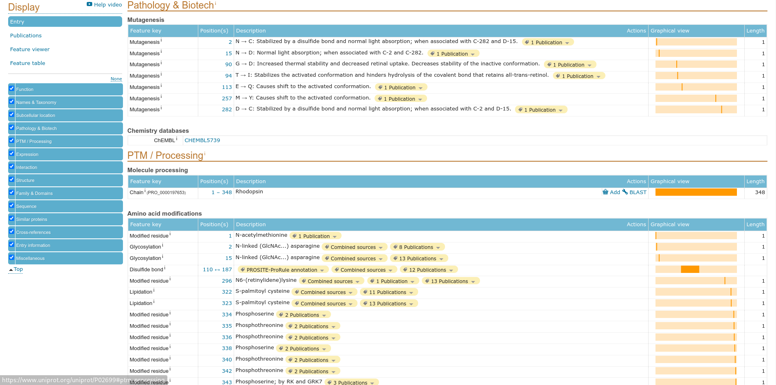**Fig9. Pathology and Biotech of result for query ‘Rhodopsin’**

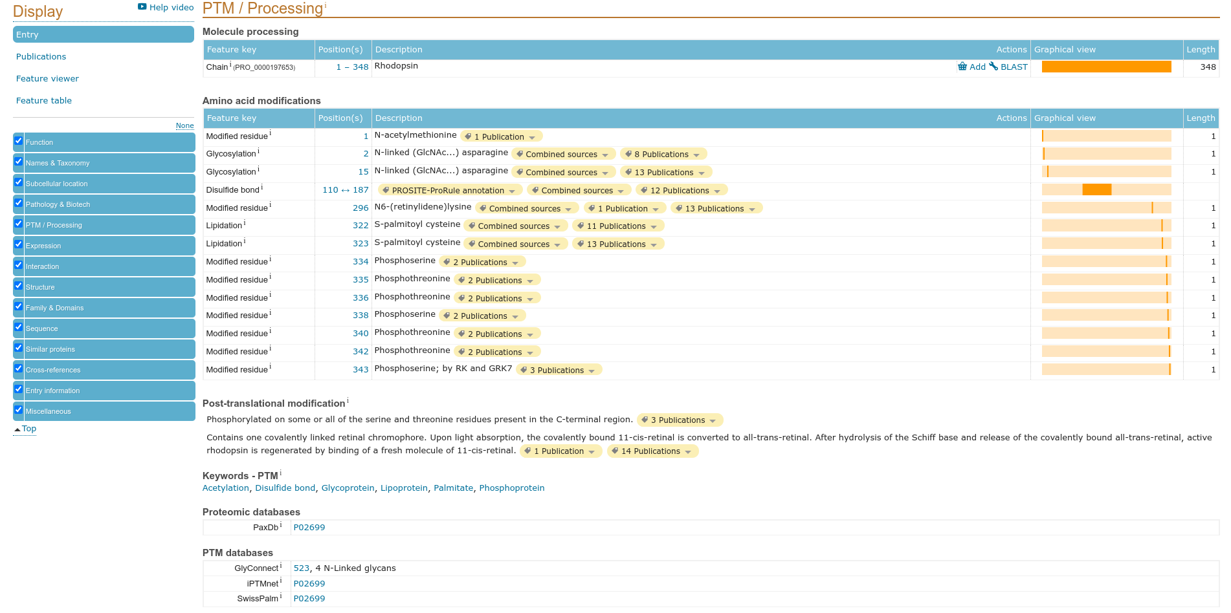**Fig10. PTM/Processing of result for query ‘Rhodopsin’**

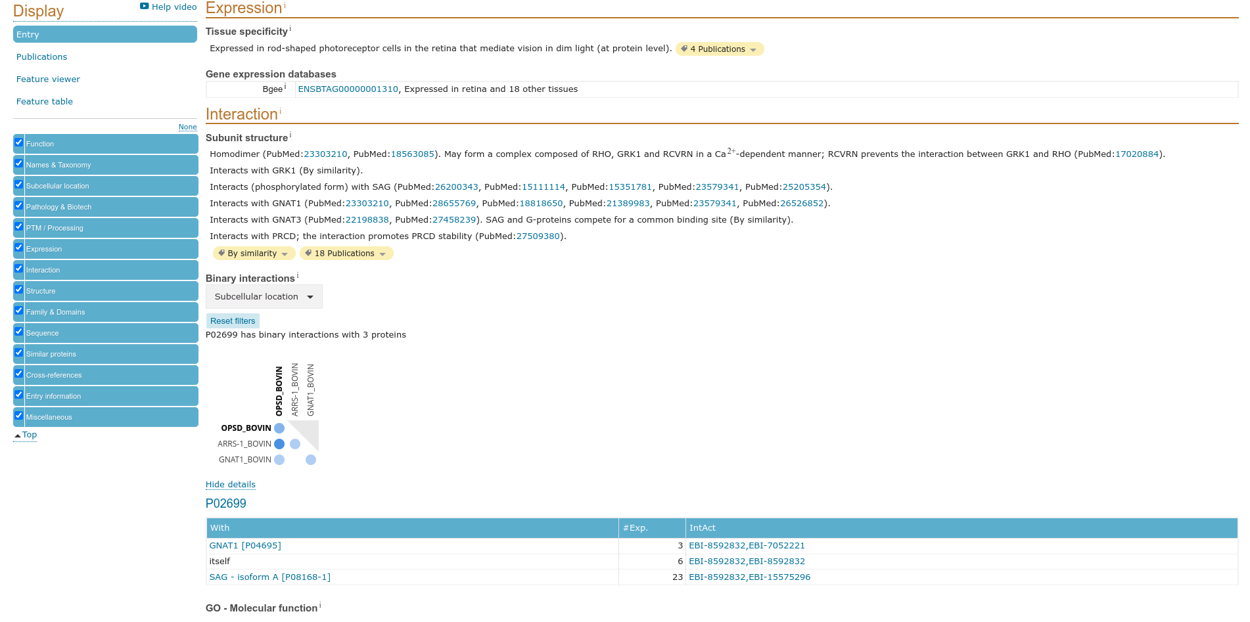**Fig11. Expression / Interaction for result of query ‘Rhodopsin’**

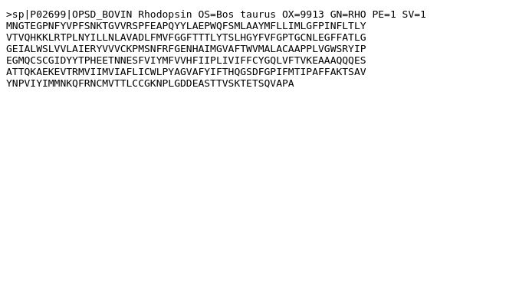**Fig12. Fasta Cananical for result for query ‘Rhodopsin’**

**Results:**

UniProt is a freely accessible database of protein sequence and functional information, many entries being from genome sequence projects. It contains a larga amount of information about the biological function of proteins dereived from the research literatures.

**Conclusions:**

Uniprot is a biological database for protein and it has all information regarding the protein sequences, protein structures and UniProt can use as a cross references.

**References:**

1. UniProt ConsortiumEuropean Bioinformatics InstituteProtein Information ResourceSIB Swiss Institute of Bioinformatics. (2021, September 29). *Rhodopsin*. UniProt ConsortiumEuropean Bioinformatics InstituteProtein Information ResourceSIB Swiss Institute of Bioinformatics. Retrieved November 24, 2021, from https://www.uniprot.org/uniprot/P02699#expression.
2. UniProt ConsortiumEuropean Bioinformatics InstituteProtein Information ResourceSIB Swiss Institute of Bioinformatics. (2021, September 29). *Rhodopsin*. UniProt ConsortiumEuropean Bioinformatics InstituteProtein Information ResourceSIB Swiss Institute of Bioinformatics. Retrieved November 24, 2021, from https://www.uniprot.org/uniprot/P02699#function.
3. UniProt ConsortiumEuropean Bioinformatics InstituteProtein Information ResourceSIB Swiss Institute of Bioinformatics. (2021, September 29). *Rhodopsin*. UniProt ConsortiumEuropean Bioinformatics InstituteProtein Information ResourceSIB Swiss Institute of Bioinformatics. Retrieved November 24, 2021, from https://www.uniprot.org/uniprot/P02699#names_and_taxonomy.
4. UniProt ConsortiumEuropean Bioinformatics InstituteProtein Information ResourceSIB Swiss Institute of Bioinformatics. (2021, September 29). *Rhodopsin*. UniProt ConsortiumEuropean Bioinformatics InstituteProtein Information ResourceSIB Swiss Institute of Bioinformatics. Retrieved November 24, 2021, from https://www.uniprot.org/uniprot/P02699#ptm_processing.
5. UniProt ConsortiumEuropean Bioinformatics InstituteProtein Information ResourceSIB Swiss Institute of Bioinformatics. (2021, September 29). *Rhodopsin*. UniProt ConsortiumEuropean Bioinformatics InstituteProtein Information ResourceSIB Swiss Institute of Bioinformatics. Retrieved November 24, 2021, from https://www.uniprot.org/uniprot/P02699#sequences.
6. UniProt ConsortiumEuropean Bioinformatics InstituteProtein Information ResourceSIB Swiss Institute of Bioinformatics. (2021, September 29). *Rhodopsin*. UniProt ConsortiumEuropean Bioinformatics InstituteProtein Information ResourceSIB Swiss Institute of Bioinformatics. Retrieved November 24, 2021, from https://www.uniprot.org/uniprot/P02699#structure.
7. UniProt ConsortiumEuropean Bioinformatics InstituteProtein Information ResourceSIB Swiss Institute of Bioinformatics. (2021, September 29). *Rhodopsin*. UniProt ConsortiumEuropean Bioinformatics InstituteProtein Information ResourceSIB Swiss Institute of Bioinformatics. Retrieved November 24, 2021, from https://www.uniprot.org/uniprot/P02699#subcellular_location.
8. UniProt ConsortiumEuropean Bioinformatics InstituteProtein Information ResourceSIB Swiss Institute of Bioinformatics. (2021, September 29). *Rhodopsin*. UniProt ConsortiumEuropean Bioinformatics InstituteProtein Information ResourceSIB Swiss Institute of Bioinformatics. Retrieved November 24, 2021, from https://www.uniprot.org/uniprot/P02699.
9. UniProt ConsortiumEuropean Bioinformatics InstituteProtein Information ResourceSIB Swiss Institute of Bioinformatics. (n.d.). *Uniprot Consortium*. UniProt ConsortiumEuropean Bioinformatics InstituteProtein Information ResourceSIB Swiss Institute of Bioinformatics. Retrieved November 24, 2021, from https://www.uniprot.org/.
10. UniProt ConsortiumEuropean Bioinformatics InstituteProtein Information ResourceSIB Swiss Institute of Bioinformatics. (n.d.). *Uniprot Consortium*. UniProt ConsortiumEuropean Bioinformatics InstituteProtein Information ResourceSIB Swiss Institute of Bioinformatics. Retrieved November 24, 2021, from https://www.uniprot.org/uniprot/?query=Rhodopsin&sort=score.
11. Uniprot. (n.d.). Retrieved November 24, 2021, from https://www.uniprot.org/uniprot/P02699.fasta.

**Date: 1-10-21**

**WEBLEM 4b**

**(URL: https://www.uniprot.org/)**

**Aim:**

To study ‘Rhodopsin’ Protein information using SwissProt Database: Reviewed and Manually annotated Database.

**Introduction:**

SWISS-PROT is a curated protein sequence database which strives to provide a high level of annotation (such as the description of the function of a protein, its domains structure, post-translational modifications, variants, etc.), a minimal level of redundancy and high level of integration with other databases.

Rhodopsin is a biological pigment found in the rods of the retina and is a G-protein-coupled receptor (GPCR). It belongs to a group of photoswitchable opsins. Rhodopsin is extremely sensitive to light, and thus enables vision in low-light conditions. When rhodopsin is exposed to light, it immediately photobleaches.

**Methodolgy:**

* Homepage of Uniprot.
* Enter the UniprotKB and search the query ‘Rhodopsin’
* Interpret the results.

**Observations:**

**Fig1. Homepage of Uniprot with query ‘Rhodopsin’**

**Fig2. Hit page of UniprotKB with query ‘Rhodopsin’**

**Fig3. Header page with of result with query ‘Rhodopsin’**

**Fig4. Function page of result for query ‘Rhodopsin’**

**Fig5. Structure of result of query ‘Rhodopsin’**

**Fig6. Sequences of result for query ‘Rhodopsin’**

**Fig7. Names and taxonomy of result for query ‘Rhodopsin’**

**Fig8. Subcellular location of result for query ‘Rhodopsin’**

**Fig9. Pathology and Biotech of result for query ‘Rhodopsin’**

**Fig10. PTM/Processing of result for query ‘Rhodopsin’**

**Fig11. Expression / Interaction for result of query ‘Rhodopsin’**

**Fig12. Fasta Cananical for result for query ‘Rhodopsin’**

**Results:**

In UniprotKB it consist SwissProt that is Reviewed paper and for the query ‘Rhodopsin’ is

contain 511 papers .

**Conclusions:**

Uniprot is a biological database for protein and it has all information regarding the protein sequences, protein structures and UniProt can use as a cross references.

**References:**

1. UniProt ConsortiumEuropean Bioinformatics InstituteProtein Information ResourceSIB Swiss Institute of Bioinformatics. (2021, September 29). *Rhodopsin*. UniProt ConsortiumEuropean Bioinformatics InstituteProtein Information ResourceSIB Swiss Institute of Bioinformatics. Retrieved November 24, 2021, from https://www.uniprot.org/uniprot/P02699#expression.
2. UniProt ConsortiumEuropean Bioinformatics InstituteProtein Information ResourceSIB Swiss Institute of Bioinformatics. (2021, September 29). *Rhodopsin*. UniProt ConsortiumEuropean Bioinformatics InstituteProtein Information ResourceSIB Swiss Institute of Bioinformatics. Retrieved November 24, 2021, from https://www.uniprot.org/uniprot/P02699#function.
3. UniProt ConsortiumEuropean Bioinformatics InstituteProtein Information ResourceSIB Swiss Institute of Bioinformatics. (2021, September 29). *Rhodopsin*. UniProt ConsortiumEuropean Bioinformatics InstituteProtein Information ResourceSIB Swiss Institute of Bioinformatics. Retrieved November 24, 2021, from https://www.uniprot.org/uniprot/P02699#names_and_taxonomy.
4. UniProt ConsortiumEuropean Bioinformatics InstituteProtein Information ResourceSIB Swiss Institute of Bioinformatics. (2021, September 29). *Rhodopsin*. UniProt ConsortiumEuropean Bioinformatics InstituteProtein Information ResourceSIB Swiss Institute of Bioinformatics. Retrieved November 24, 2021, from https://www.uniprot.org/uniprot/P02699#ptm_processing.
5. UniProt ConsortiumEuropean Bioinformatics InstituteProtein Information ResourceSIB Swiss Institute of Bioinformatics. (2021, September 29). *Rhodopsin*. UniProt ConsortiumEuropean Bioinformatics InstituteProtein Information ResourceSIB Swiss Institute of Bioinformatics. Retrieved November 24, 2021, from https://www.uniprot.org/uniprot/P02699#sequences.
6. UniProt ConsortiumEuropean Bioinformatics InstituteProtein Information ResourceSIB Swiss Institute of Bioinformatics. (2021, September 29). *Rhodopsin*. UniProt ConsortiumEuropean Bioinformatics InstituteProtein Information ResourceSIB Swiss Institute of Bioinformatics. Retrieved November 24, 2021, from https://www.uniprot.org/uniprot/P02699#structure.
7. UniProt ConsortiumEuropean Bioinformatics InstituteProtein Information ResourceSIB Swiss Institute of Bioinformatics. (2021, September 29). *Rhodopsin*. UniProt ConsortiumEuropean Bioinformatics InstituteProtein Information ResourceSIB Swiss Institute of Bioinformatics. Retrieved November 24, 2021, from https://www.uniprot.org/uniprot/P02699#subcellular_location.
8. UniProt ConsortiumEuropean Bioinformatics InstituteProtein Information ResourceSIB Swiss Institute of Bioinformatics. (2021, September 29). *Rhodopsin*. UniProt ConsortiumEuropean Bioinformatics InstituteProtein Information ResourceSIB Swiss Institute of Bioinformatics. Retrieved November 24, 2021, from https://www.uniprot.org/uniprot/P02699.
9. UniProt ConsortiumEuropean Bioinformatics InstituteProtein Information ResourceSIB Swiss Institute of Bioinformatics. (n.d.). *Uniprot Consortium*. UniProt ConsortiumEuropean Bioinformatics InstituteProtein Information ResourceSIB Swiss Institute of Bioinformatics. Retrieved November 24, 2021, from https://www.uniprot.org/.
10. UniProt ConsortiumEuropean Bioinformatics InstituteProtein Information ResourceSIB Swiss Institute of Bioinformatics. (n.d.). *Uniprot Consortium*. UniProt ConsortiumEuropean Bioinformatics InstituteProtein Information ResourceSIB Swiss Institute of Bioinformatics. Retrieved November 24, 2021, from https://www.uniprot.org/uniprot/?query=Rhodopsin&sort=score.
11. Uniprot. (n.d.). Retrieved November 24, 2021, from https://www.uniprot.org/uniprot/P02699.fasta.

**Date: 2-10-21**

**WEBLEM 4c**

**(URL: https://www.uniprot.org/)**

**Aim:**

To study ‘Rhodopsin’ Protein information using TrEMBL Database: Unreviewed and manually annotated Database.

**Introduction:**

UniProtKB/TrEMBL is a computer-annotated protein sequence database complementing . UniProtKB/TrEMBL contains the translations of all coding sequences (CDS) present in the EMBL/GenBank/DDBJ Nucleotide Sequence Databases and also protein sequences extracted. The database is enriched with automated classification and annotation.

Rhodopsin is a biological pigment found in the rods of the retina and is a G-protein-coupled receptor (GPCR). It belongs to a group of photoswitchable opsins. Rhodopsin is extremely sensitive to light, and thus enables vision in low-light conditions. When rhodopsin is exposed to light, it immediately photobleaches.

**Methodolgy:**

* Homepage of Uniprot.
* Enter the UniprotKB and search the query ‘Rhodopsin’
* Open Unreviewed paper.
* Interpret the results.

**Observations:**

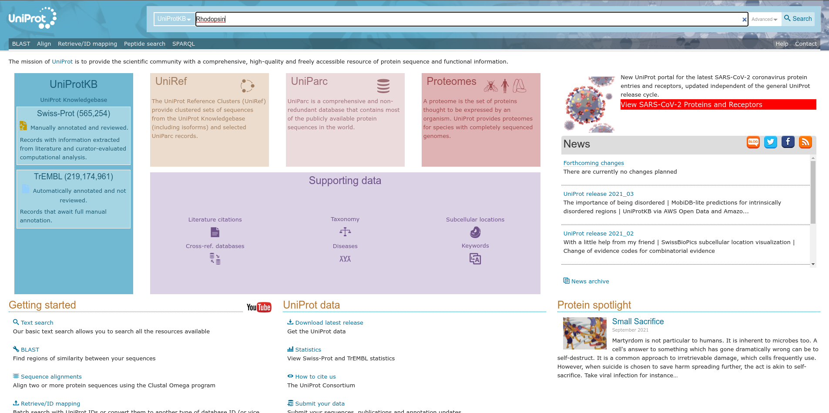**Fig1. Homepage for Uniprot with query Rhodopsin**

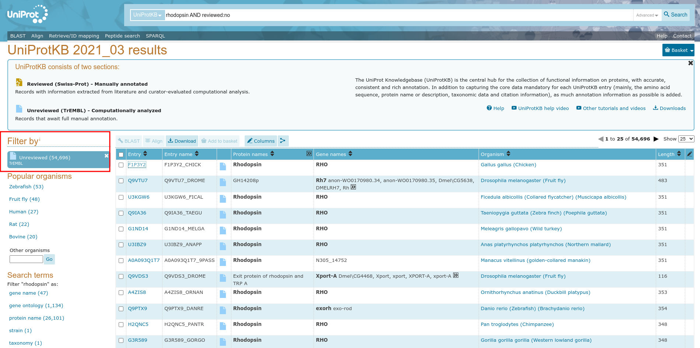**Fig2. Hit page for Unreviewed for query Rhodopsin**

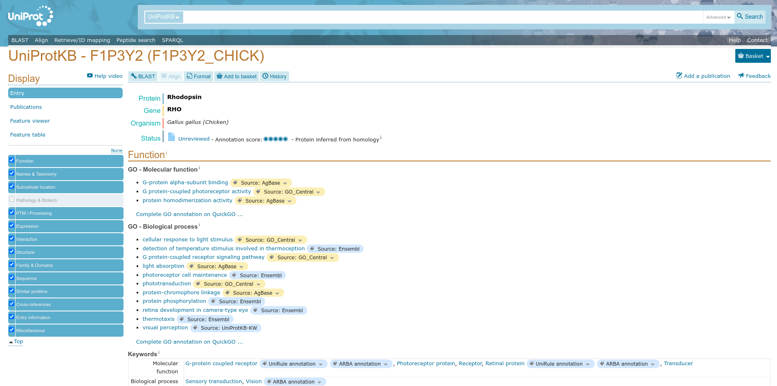**Fig3. Header page for query Rhodopsin**

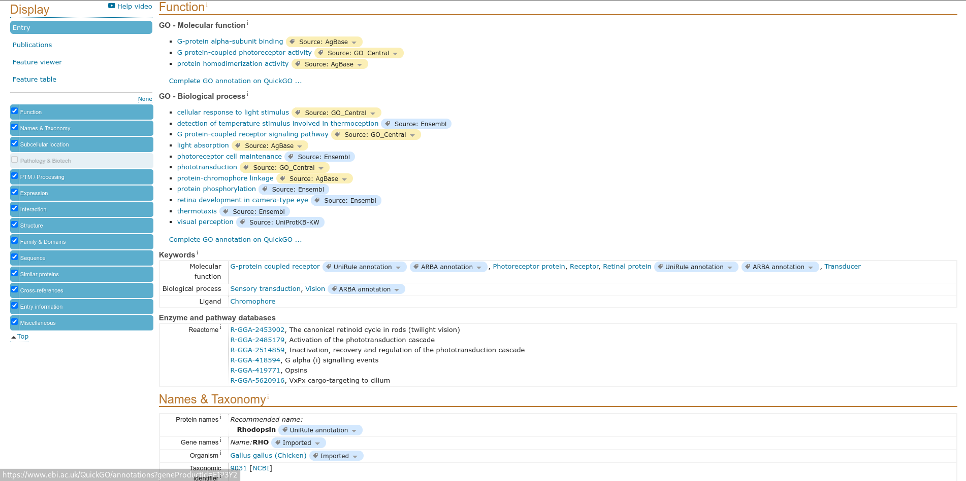**Fig4. Function page for query Rhodopsin**

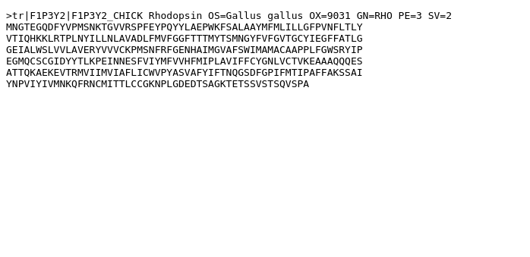**Fig5. FASTA Cananical for result page of query Rhodopsin**

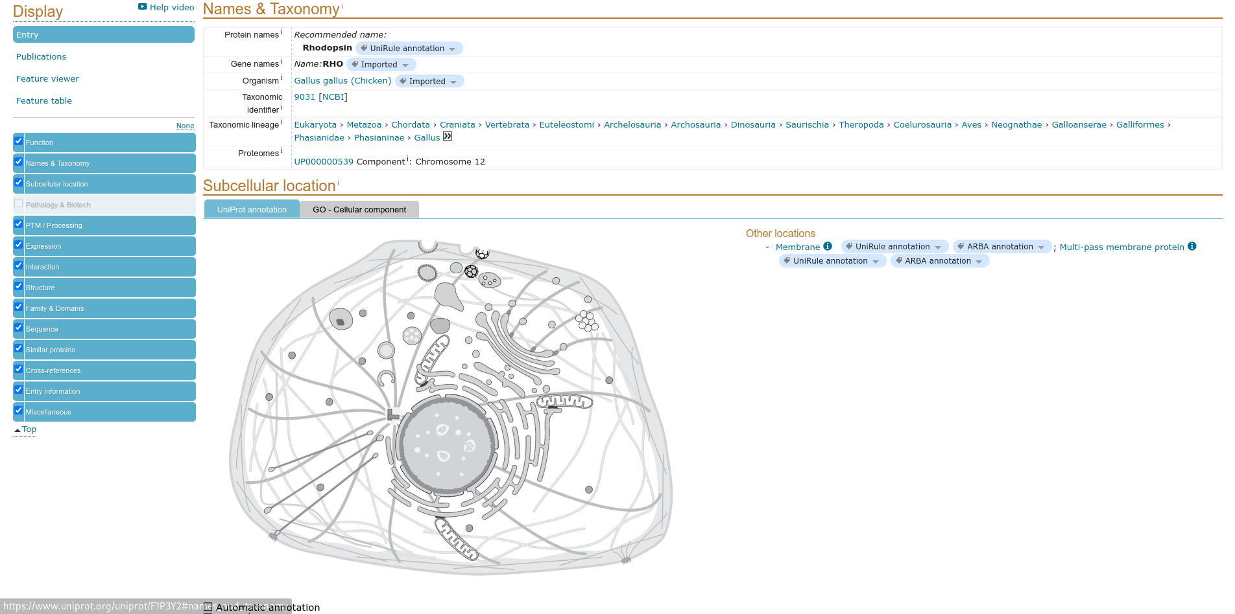**Fig6. Names and Taxonomy of result page for query Rhodopsin**

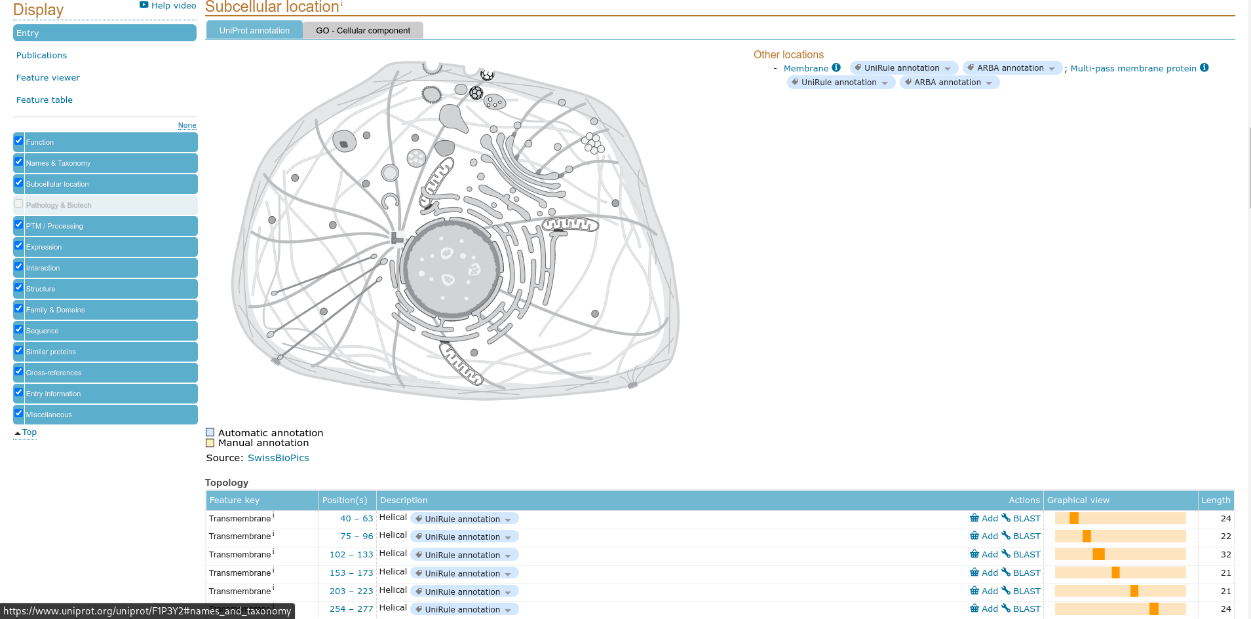**Fig7. Subcellular location of result page for query Rhodopsin**

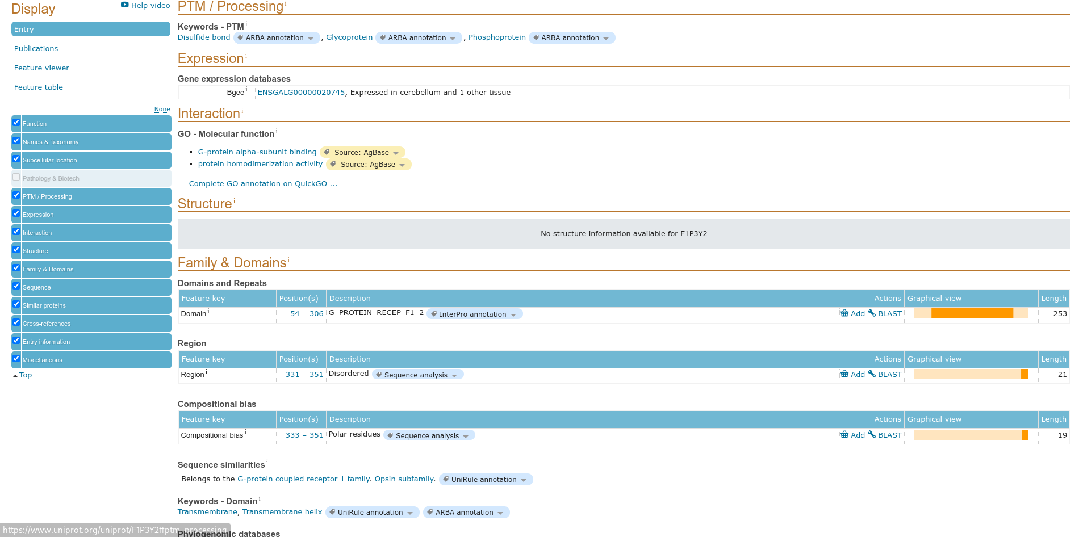**Fig8. PTM processing for result of query Rhodopsin**

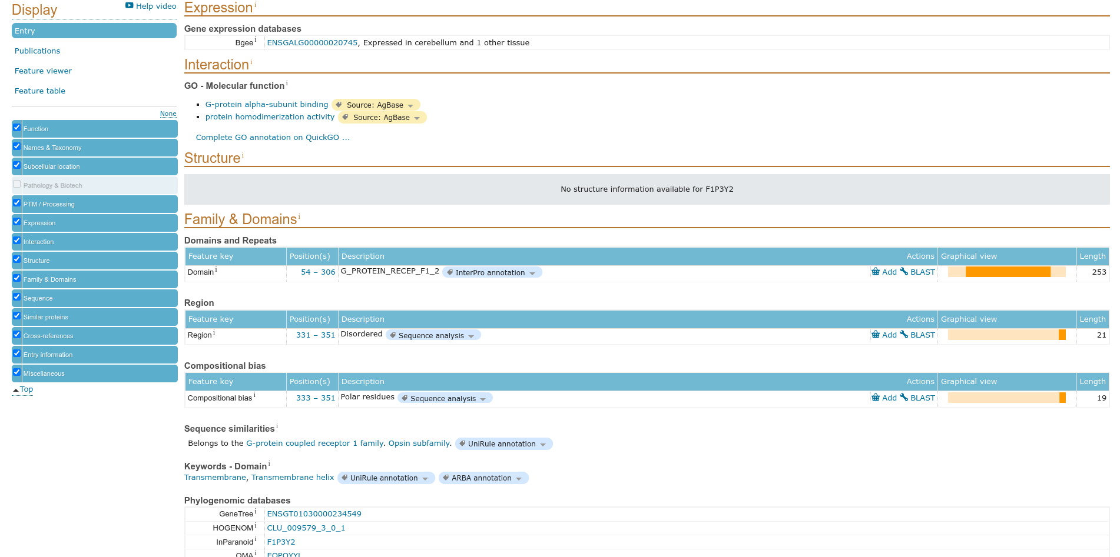**Fig9. Expression for result of query Rhodopsin**

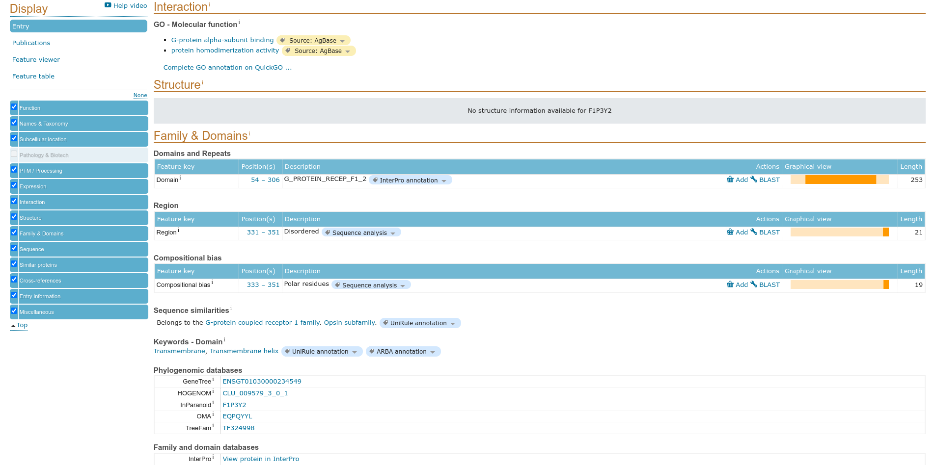**Fig10. Interaction for result of query Rhodopsin**

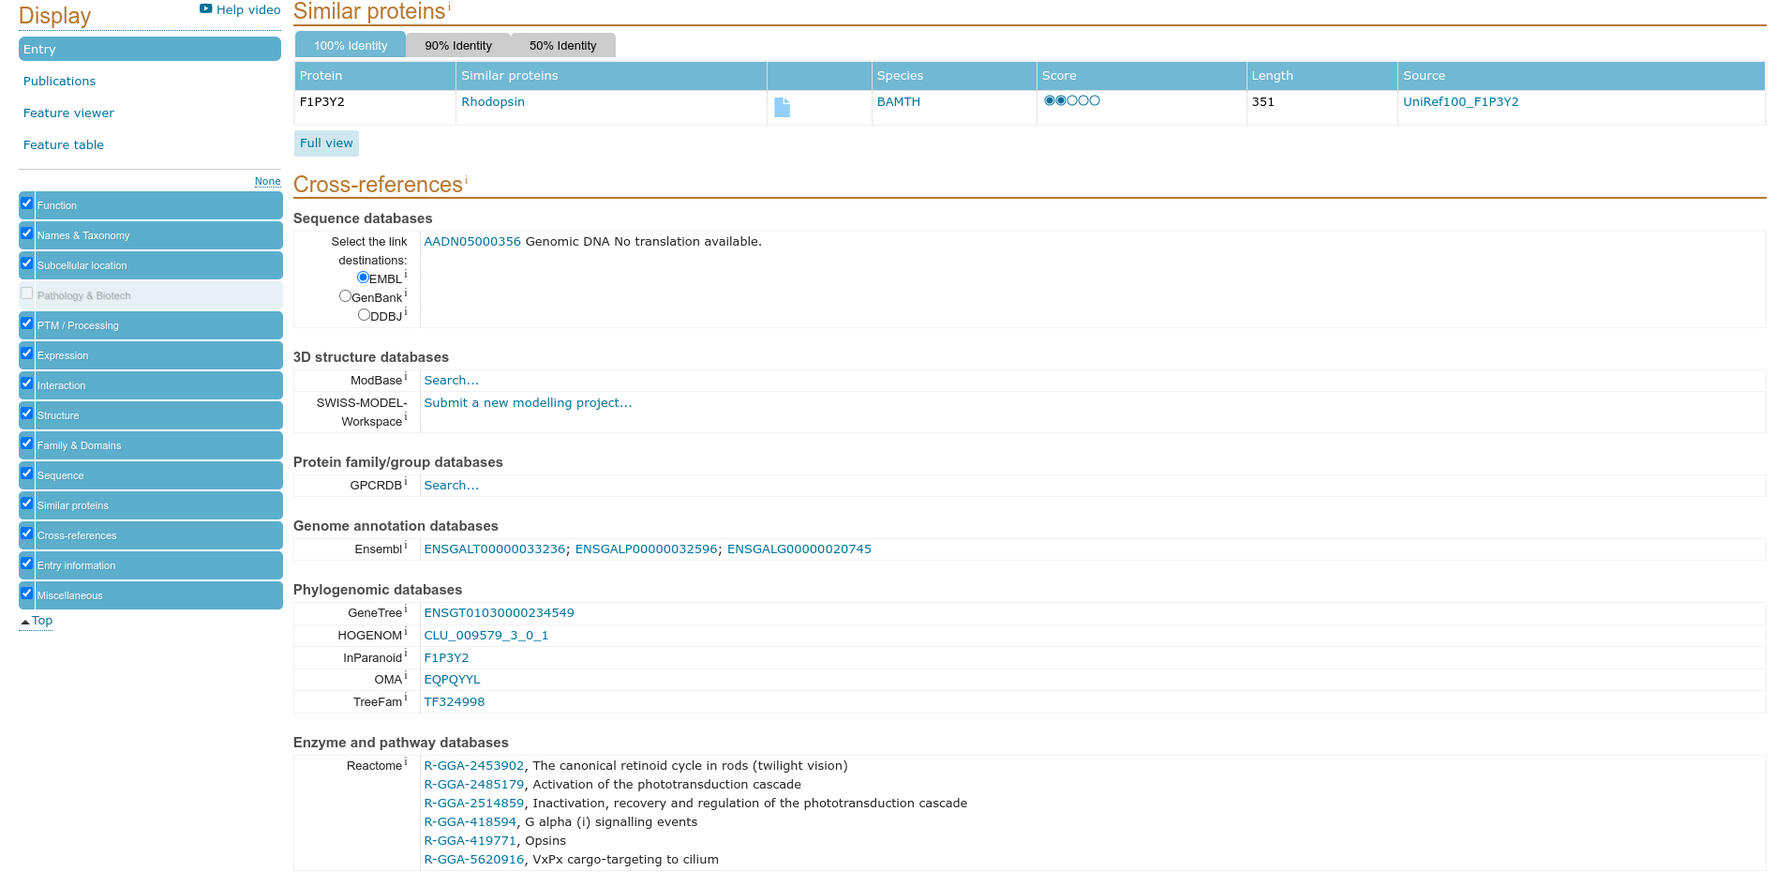**Fig11. Similar proteins for result of query Rhodopsin**

**Results:**

In UniprotKB it consist TrEMBL that is Unreviewed paper and for the query ‘Rhodopsin’ is

contain 54,696 papers

**Conclusions:**

A computer annotated supplement to Swiss-Prot .Contains all the translations of EMBL

nucleotide sequences entries not yet integrated in Swiss-Prot and cross-referenced to many

other databases.

**References:**

1. UniProt ConsortiumEuropean Bioinformatics InstituteProtein Information ResourceSIB Swiss Institute of Bioinformatics. (2021, September 29). *Rhodopsin*. UniProt ConsortiumEuropean Bioinformatics InstituteProtein Information ResourceSIB Swiss Institute of Bioinformatics. Retrieved November 24, 2021, from https://www.uniprot.org/uniprot/F1P3Y2#expression.
2. UniProt ConsortiumEuropean Bioinformatics InstituteProtein Information ResourceSIB Swiss Institute of Bioinformatics. (2021, September 29). *Rhodopsin*. UniProt ConsortiumEuropean Bioinformatics InstituteProtein Information ResourceSIB Swiss Institute of Bioinformatics. Retrieved November 24, 2021, from https://www.uniprot.org/uniprot/ F1P3Y2#function.
3. UniProt ConsortiumEuropean Bioinformatics InstituteProtein Information ResourceSIB Swiss Institute of Bioinformatics. (2021, September 29). *Rhodopsin*. UniProt ConsortiumEuropean Bioinformatics InstituteProtein Information ResourceSIB Swiss Institute of Bioinformatics. Retrieved November 24, 2021, from https://www.uniprot.org/uniprot/ F1P3Y2#names_and_taxonomy.
4. UniProt ConsortiumEuropean Bioinformatics InstituteProtein Information ResourceSIB Swiss Institute of Bioinformatics. (2021, September 29). *Rhodopsin*. UniProt ConsortiumEuropean Bioinformatics InstituteProtein Information ResourceSIB Swiss Institute of Bioinformatics. Retrieved November 24, 2021, from https://www.uniprot.org/uniprot/ F1P3Y2#ptm_processing.
5. UniProt ConsortiumEuropean Bioinformatics InstituteProtein Information ResourceSIB Swiss Institute of Bioinformatics. (2021, September 29). *Rhodopsin*. UniProt ConsortiumEuropean Bioinformatics InstituteProtein Information ResourceSIB Swiss Institute of Bioinformatics. Retrieved November 24, 2021, from https://www.uniprot.org/uniprot/ F1P3Y2#sequences.
6. UniProt ConsortiumEuropean Bioinformatics InstituteProtein Information ResourceSIB Swiss Institute of Bioinformatics. (2021, September 29). *Rhodopsin*. UniProt ConsortiumEuropean Bioinformatics InstituteProtein Information ResourceSIB Swiss Institute of Bioinformatics. Retrieved November 24, 2021, from https://www.uniprot.org/uniprot/ F1P3Y2#structure.
7. UniProt ConsortiumEuropean Bioinformatics InstituteProtein Information ResourceSIB Swiss Institute of Bioinformatics. (2021, September 29). *Rhodopsin*. UniProt ConsortiumEuropean Bioinformatics InstituteProtein Information ResourceSIB Swiss Institute of Bioinformatics. Retrieved November 24, 2021, from https://www.uniprot.org/uniprot/P02699#subcellular_location.
8. UniProt ConsortiumEuropean Bioinformatics InstituteProtein Information ResourceSIB Swiss Institute of Bioinformatics. (2021, September 29). *Rhodopsin*. UniProt ConsortiumEuropean Bioinformatics InstituteProtein Information ResourceSIB Swiss Institute of Bioinformatics. Retrieved November 24, 2021, from https://www.uniprot.org/uniprot/ F1P3Y2.
9. UniProt ConsortiumEuropean Bioinformatics InstituteProtein Information ResourceSIB Swiss Institute of Bioinformatics. (n.d.). *Uniprot Consortium*. UniProt ConsortiumEuropean Bioinformatics InstituteProtein Information ResourceSIB Swiss Institute of Bioinformatics. Retrieved November 24, 2021, from https://www.uniprot.org/.
10. UniProt ConsortiumEuropean Bioinformatics InstituteProtein Information ResourceSIB Swiss Institute of Bioinformatics. (n.d.). *Uniprot Consortium*. UniProt ConsortiumEuropean Bioinformatics InstituteProtein Information ResourceSIB Swiss Institute of Bioinformatics. Retrieved November 24, 2021, from https://www.uniprot.org/uniprot/?query=Rhodopsin&sort=score.
11. Uniprot. (n.d.). Retrieved November 24, 2021, from https://www.uniprot.org/uniprot/ F1P3Y2.fasta.

**Date: 2-10-21**

**WEBLEM 4d**

**(URL: https://www.uniprot.org/)**

**Aim:**

To study ‘Rhodopsin’ Protein information using PIR Database: An Integrated Protein Informatics Database.

**Introduction:**

The Protein Information Resource (PIR) is an integrated public bioinformatics resource to support genomic, proteomic and systems biology research and scientific studies (Wu et al., 2003). PIR was established in 1984 by the National Biomedical Research Foundation (NBRF) as a resource to assist researchers in the identification and interpretation of protein sequence information.

Rhodopsin is a biological pigment found in the rods of the retina and is a G-protein-coupled receptor (GPCR). It belongs to a group of photoswitchable opsins. Rhodopsin is extremely sensitive to light, and thus enables vision in low-light conditions. When rhodopsin is exposed to light, it immediately photobleaches.

**Methodolgy:**

* Homepage of Uniprot.
* Enter the UniprotKB and search the query ‘Rhodopsin’
* Interpret the results.

**Observations:**

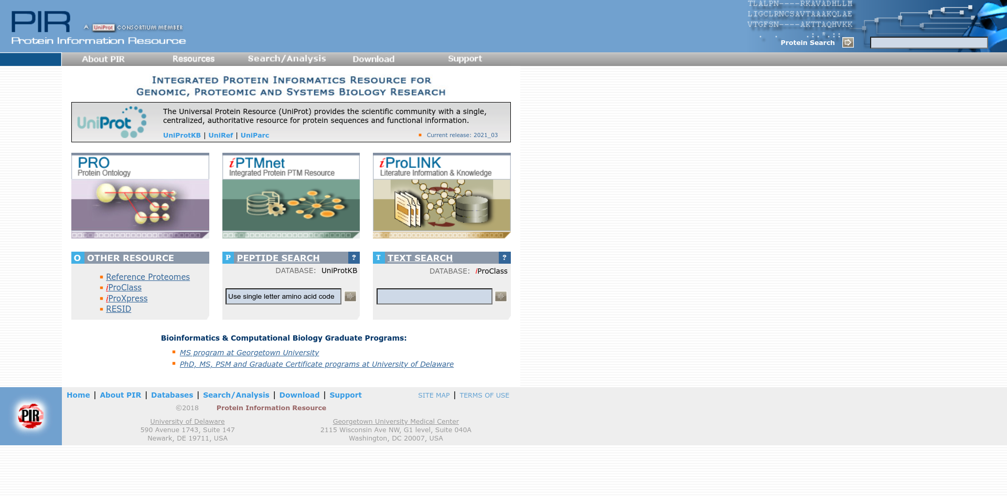**Fig1. Homepage of PIR**

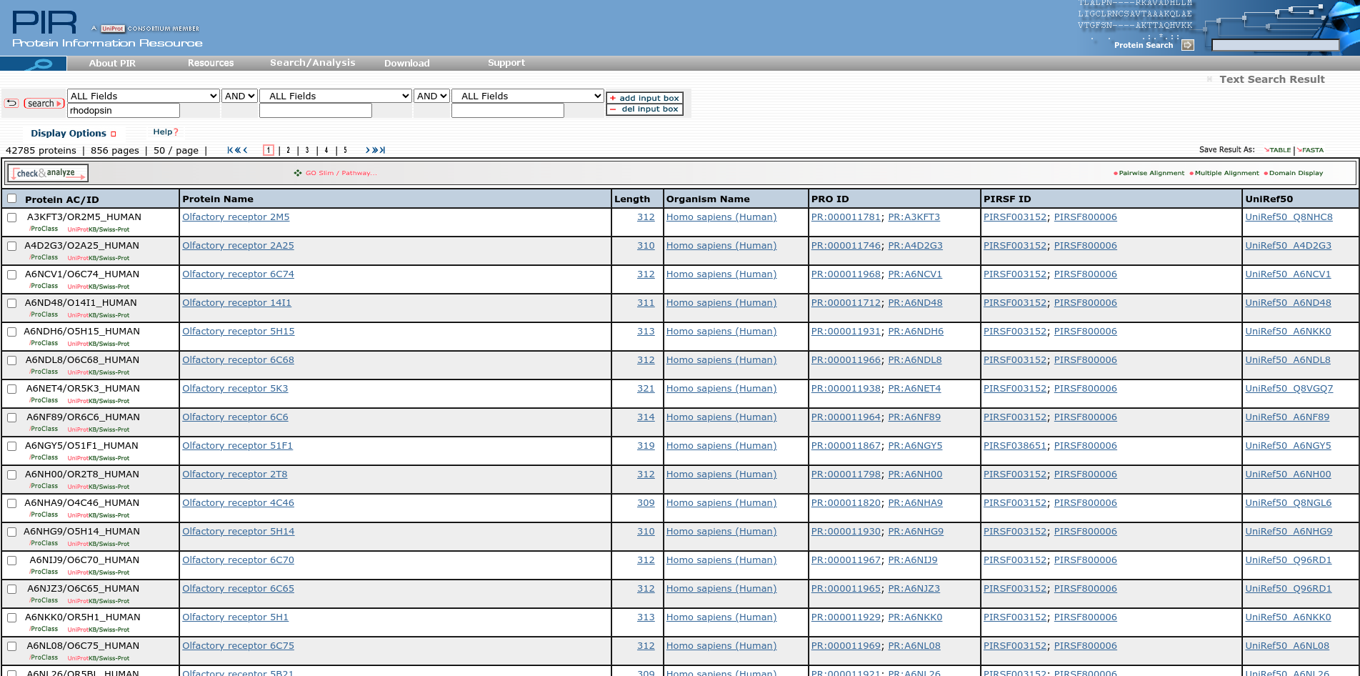**Fig2. Hit page for PIR for query Rhodopsin**

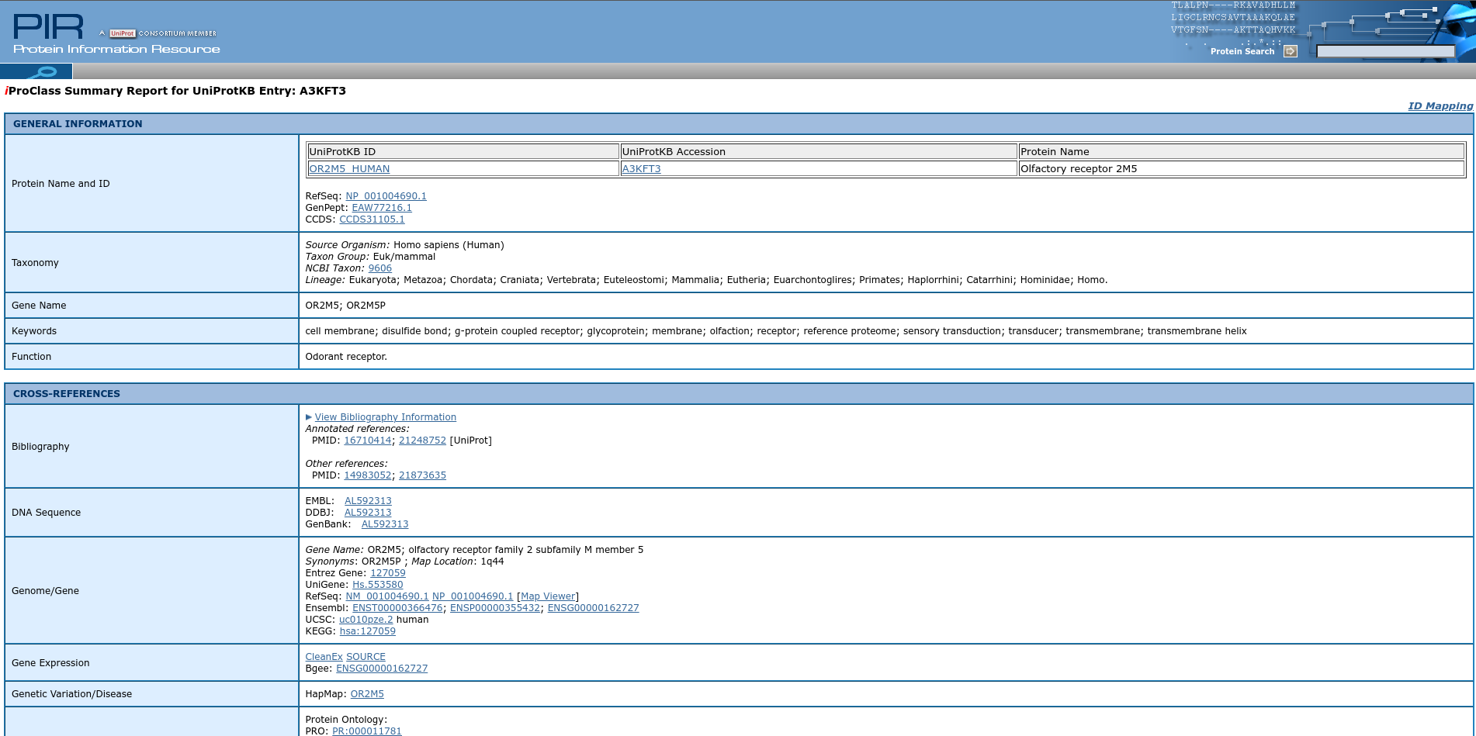**Fig3. Result page for query Rhodopsin**

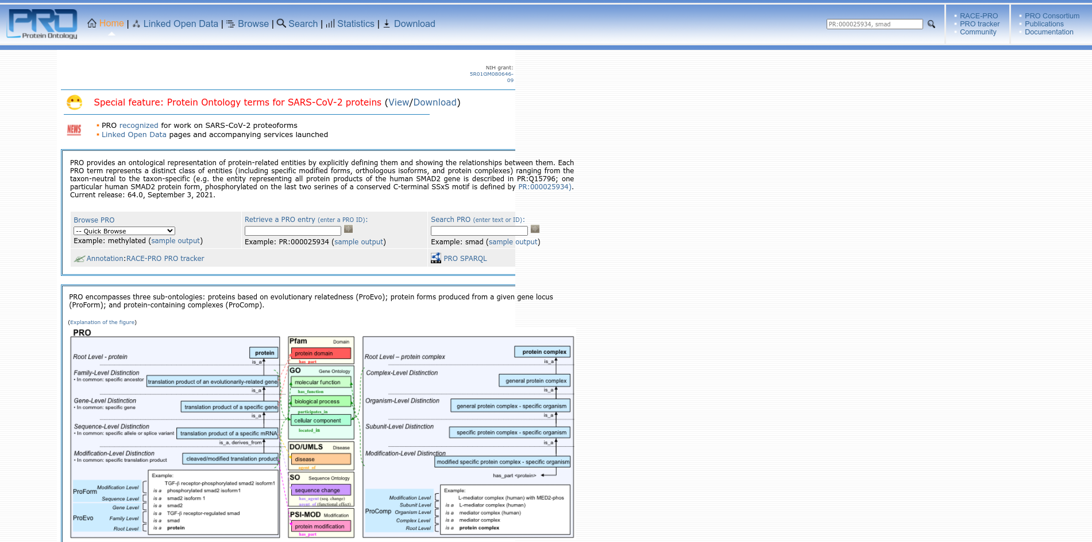**Fig4. Home page of PRO with PR ID**

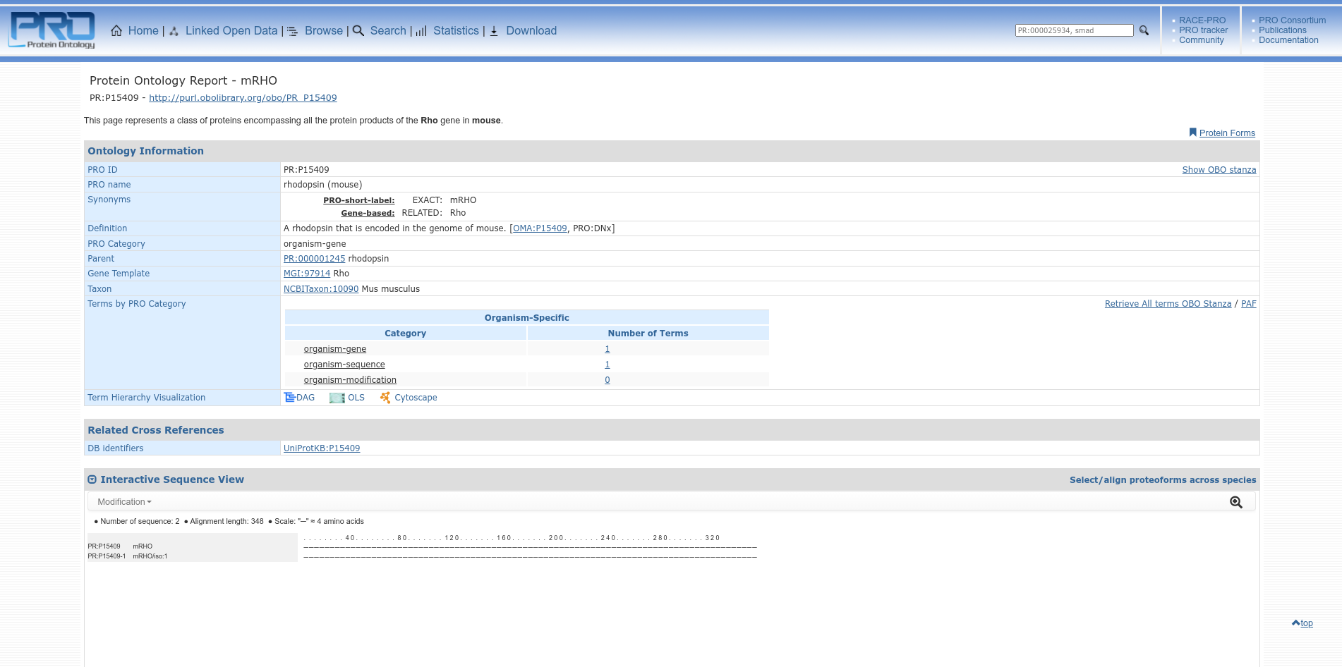**Fig5. Result page of PRO for query rhodopsin**

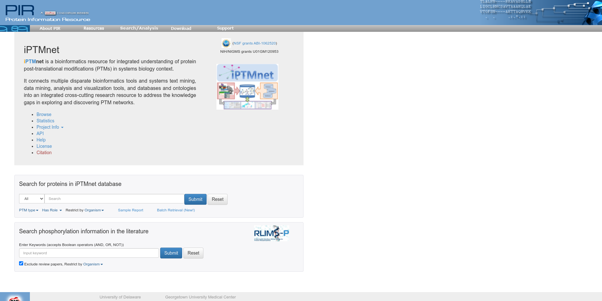**Fig6. Home page of iPTMnet for query Rhodopsin**

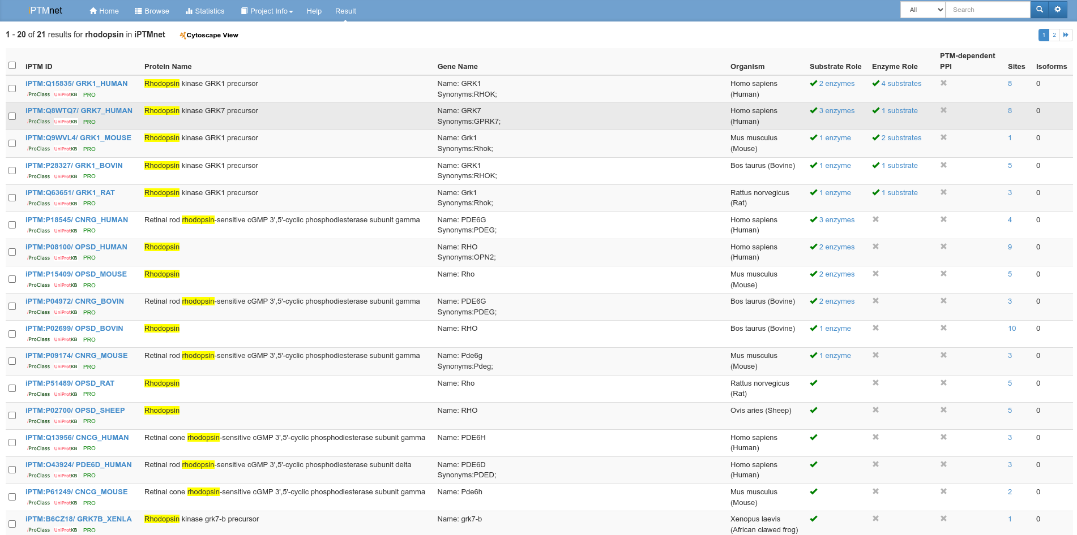**Fig7. Hit page for query Rhodopsin in iPTMnet**

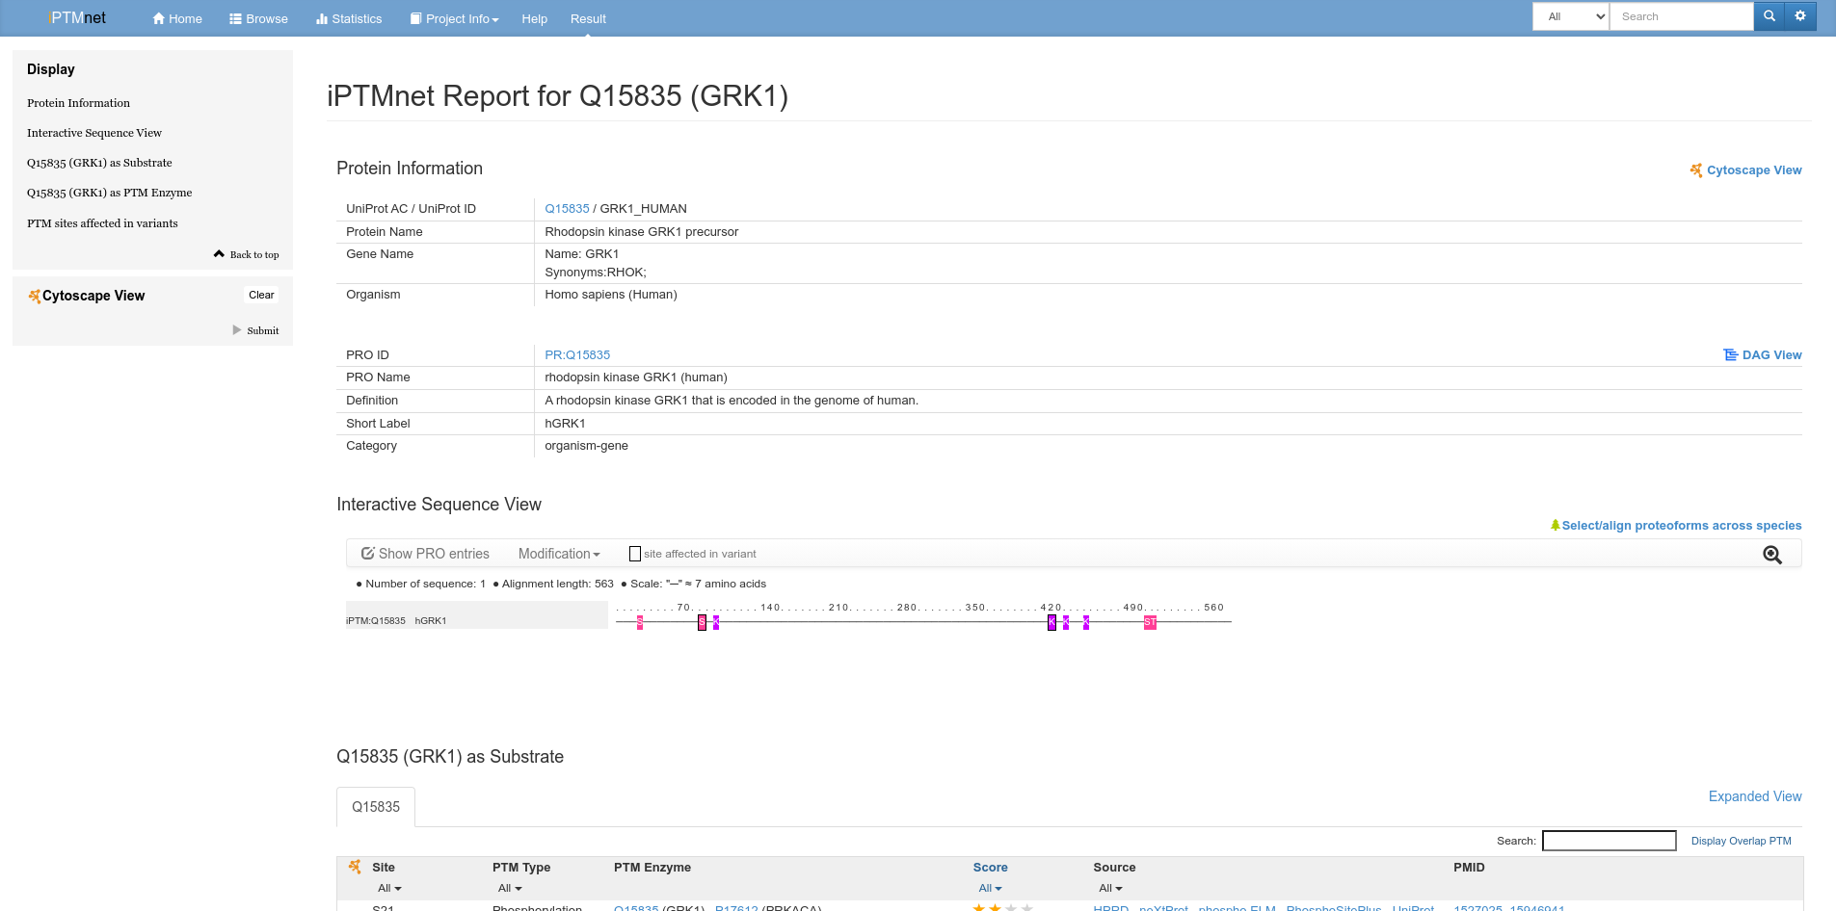**Fig8. Result page for query Rhodopsin in iPTMnet**

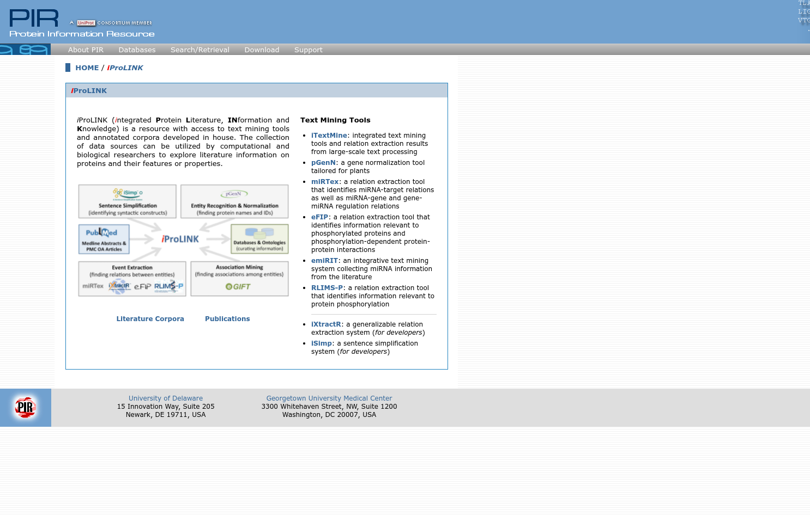**Fig9. Home page for iProLINK**

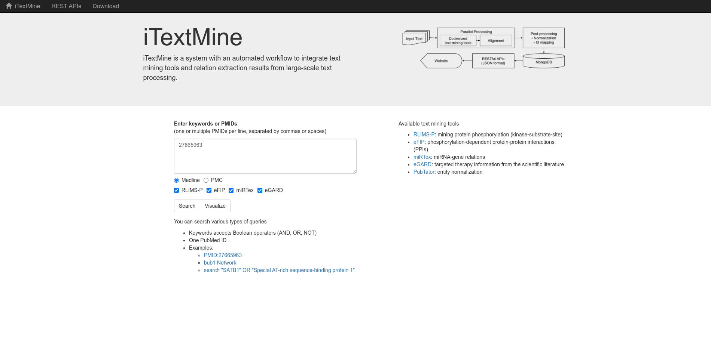**Fig10. ItextMine page for iProLINK with PMID.**

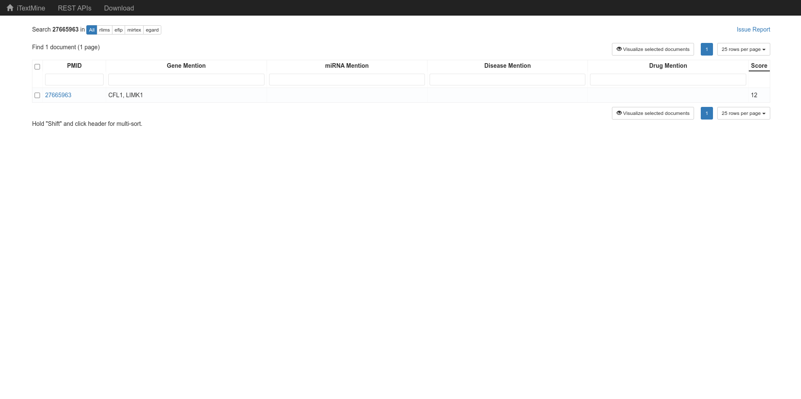**Fig11. Hit page for query Rhodopsin with PMID**

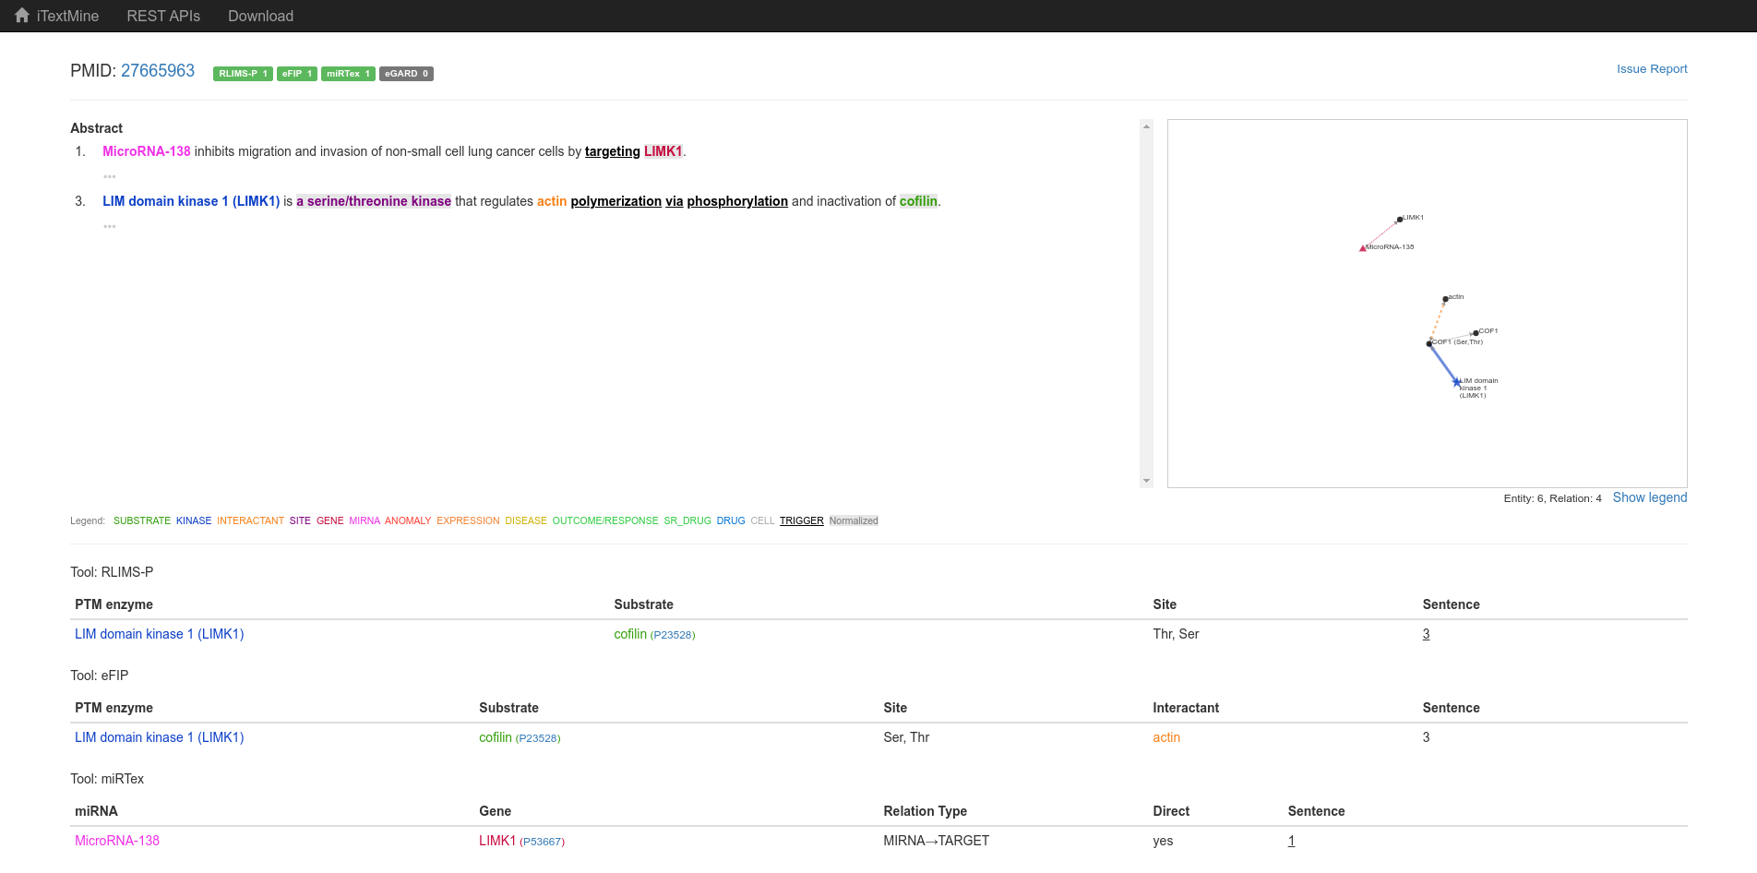**Fig12. Result of query Rhodopsin in iTextMine with PMID**

**Results:**

PIR has similar database but from different resources and integrated resources . In one domain can read all resources and it can be use as a cross references . In PRO entring the PRO ID can search the paper and from iProLink in iTextMine can search the paper by entring the PubMed ID .

**Conclusion:**

The PIR(Protein Information Resources) maintains several databases about proteins. Its integrated public bioinformatics resources to support genomic and proteomic research , and scientific studies.

**References:**

1. Entry report [Pir - protein information resource]. (n.d.). Retrieved November 24, 2021, from https://proteininformationresource.org/cgi-bin/ipcEntry?id=A3KFT3.
2. IProLINK [Pir - protein information resource]. (n.d.). Retrieved November 24, 2021, from https://research.bioinformatics.udel.edu/iprolink/.
3. IPTMnet report Q15835 GRK1. (n.d.). Retrieved November 24, 2021, from https://research.bioinformatics.udel.edu/iptmnet/entry/Q15835/.
4. IPTMnet search. (n.d.). Retrieved November 24, 2021, from https://research.bioinformatics.udel.edu/iptmnet/search/all/rhodopsin/mod-ac%2Cgn%2Cgo%2Cgc%2Cgs%2Cme%2Cmy%2Cp%2Csu%2Cub%2Csno/.
5. IPTMnet. (n.d.). Retrieved November 24, 2021, from https://research.bioinformatics.udel.edu/iptmnet/.
6. *Pro entry report - PR:P15409*. PR. (n.d.). Retrieved November 24, 2021, from https://proconsortium.org/app/entry/PR:P15409/.
7. Protein ontology. (n.d.). Retrieved November 24, 2021, from https://proconsortium.org/cgi-bin/textsearch_pro?search=search&field0=ALLFLDS&query0=rhodopsin&search.x=0&search.y=0.
8. Protein ontology. (n.d.). Retrieved November 24, 2021, from https://proconsortium.org/pro.shtml.
9. *Similar articles - scripts.iucr.org*. (n.d.). Retrieved November 24, 2021, from https://scripts.iucr.org/cgi-bin/similar?wordList=rcsb%20or%20protein%20or%20data%20or%20bank%20or%20integrated%20or%20searching%20or%20efficient%20or%20access%20or%20macromolecular%20or%20structure%20or%20pdb%20or%20archive&from=a59513.
10. Text mining integration system. (n.d.). Retrieved November 24, 2021, from https://research.bioinformatics.udel.edu/itextmine/integrate/doc/rlims-efip-mirtex-egard/medline/27665963.
11. Welcome to PIR [protein information resource]. (n.d.). Retrieved November 24, 2021, from https://proteininformationresource.org/itextmine/.

**Date: 16-10-21**

**WEBLEM 5**

**Introduction to Domain Databases**

**1. Prosite:** PROSITE is a method of determining what is the function of uncharacterized proteins translated from genomic or cDNA sequences. It consists of a database of biologically significant sites and patterns formulated in such a way that with appropriate computational tools it can rapidly and reliably identify which known family of protein (if any) the new sequence belongs to.

The PROSITE database uses two kinds of signatures or descriptors to identify conserved regions, i.e. patterns and generalized profiles, which both have their own strengths 30 and weaknesses defining their area of optimum application.

PROSITE is complemented by ProRule , a collection of rules based on profiles and patterns, which increases the discriminatory power of profiles and patterns by providing additional information about functionally and/or structurally critical amino acids. The ProRule section of PROSITE is constituted of manually created rules that can automatically generate annotation in the UniProtKB/Swiss-Prot format based on PROSITE motifs.

**2. Pfam:** Pfam is a database of protein domain families. Pfam contains curated multiple sequence alignments for each family, as well as profile hidden Markov models (profile HMMs) for finding these domains in new sequences. Pfam contains functional annotation, literature references and database links for each family. There are two multiple alignments for each Pfam family, the seed alignment that contains a relatively small number of representative members of the family and the full alignment that contains all members in the database that can be detected. All alignments use sequences taken from pfamseq, which is a non-redundant protein set composed of SWISS-PROT and SP-TrEMBL. The profile HMM is built from the seed alignment using the HMMER package, which is then used to search the pfamseq sequence database.

**3. InterPro:** InterPro is an integrative database which was founded 10 years ago when the PROSITE, PRINTS, Pfam and ProDom databases formed a consortium to amalgamate the predictive signatures they individually produced into a single resource. Since then, six other member databases have also joined and their data has been integrated: SMART, TIGRFAMs, PIRSF, SUPERFAMILY PANTHERand Gene3D.

**4. PRINTS:** The last two decades have seen remarkable advances in molecular biology: 20 years ago sequencing a single gene was considered a monumental technical achievement; today, the sequencing of whole genomes has become almost routine. Advances in the fundamental techniques of sequencing, in concert with advances in laboratory automation and robotics, have led to the rapid and unprecedented accumulation of macromolecular sequence data. The challenge resides not just in the management of this huge quantity of information, but also in its analysis. One of the main goals of bioinformatics is to uncover the knowledge implicit within the data.

The decisive step in this knowledge-discovery process is often the identification of the family to which a newly-identified gene belongs; from this devolves a wealth of insights into function. With its links to 3D structure and post-translational modifications, and thus biological function, it is generally thought that the amino acid sequence, rather than the nucleic acid sequence, is the most appropriate level at which to seek such relationships.

**Reference:**

1. <https://prosite.expasy.org/prosuser.html>
2. Bateman, A. (2000). The Pfam Protein Families Database. *Nucleic Acids Research*, *28*(1), 263–266. <https://doi.org/10.1093/nar/28.1.263>
3. Hulo, N. (2006a). The PROSITE database. *Nucleic Acids Research*, *34*(90001), D227–D230. <https://doi.org/10.1093/nar/gkj063>
4. Hulo, N. (2006b). The PROSITE database. *Nucleic Acids Research*, *34*(90001), D227–D230. <https://doi.org/10.1093/nar/gkj063>
5. Hunter, S., Apweiler, R., Attwood, T. K., Bairoch, A., Bateman, A., Binns, D., Bork, P., Das, U., Daugherty, L., Duquenne, L., Finn, R. D., Gough, J., Haft, D., Hulo, N., Kahn, D., Kelly, E., Laugraud, A., Letunic, I., Lonsdale, D., . . . Yeats, C. (2009). InterPro: the integrative protein signature database. *Nucleic Acids Research*, *37*(Database), D211–D215. <https://doi.org/10.1093/nar/gkn785>

**Date: 16-10-21**

**WEBLEM 5a**

**Prosite**

**(URL:** [**https://prosite.expasy.org**](https://prosite.expasy.org/)**)**

**ssssss**

To study Prothrombin domain information using Prosite database.

**Introduction:**

PROSITE is a method of determining what is the function of uncharacterized proteins translated from genomic or cDNA sequences. It consists of a database of biologically significant sites and patterns formulated in such a way that with appropriate computational tools it can rapidly and reliably identify which known family of protein (if any) the new sequence belongs to.

The PROSITE database uses two kinds of signatures or descriptors to identify conserved regions, i.e. patterns and generalized profiles, which both have their own strengths 30 and weaknesses defining their area of optimum application.

Cadherins (named for "calcium-dependent adhesion") are a type of cell adhesion molecule(CAM) that are important in the formation of adherens junctions to allow cells to adhere to each other .Cadherins are a class of type-1 transmembrane proteins, and they are dependent on calcium (Ca2+) ions to function, hence their name. Cell-cell adhesion is mediated by extracellular cadherin domains, whereas the Intracellular cytoplasmic tail associates with numerous adaptors and signaling proteins, collectively referred as the cadherin adhesome.

**Methodology:**

1. Open homepage for Prosite database.
2. Search for query “Prothrombin” using quick scan more of Prosite with help of FASTA sequence.
3. Observe the result for hits by profile and hits by pattern.
4. Interpret the results.

**Observation:**

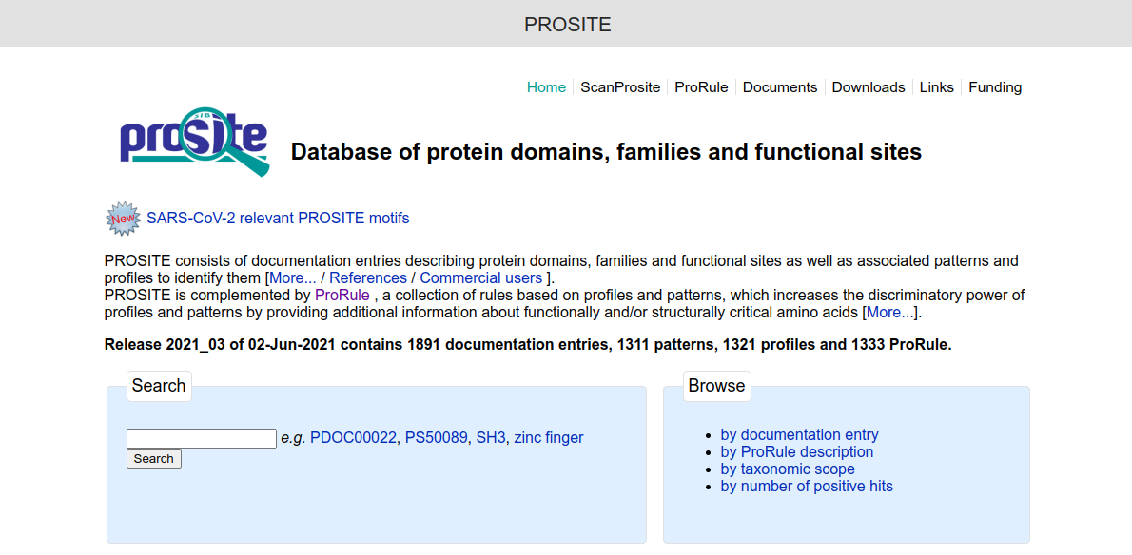**Fig1. Homepage of Prosite Database**

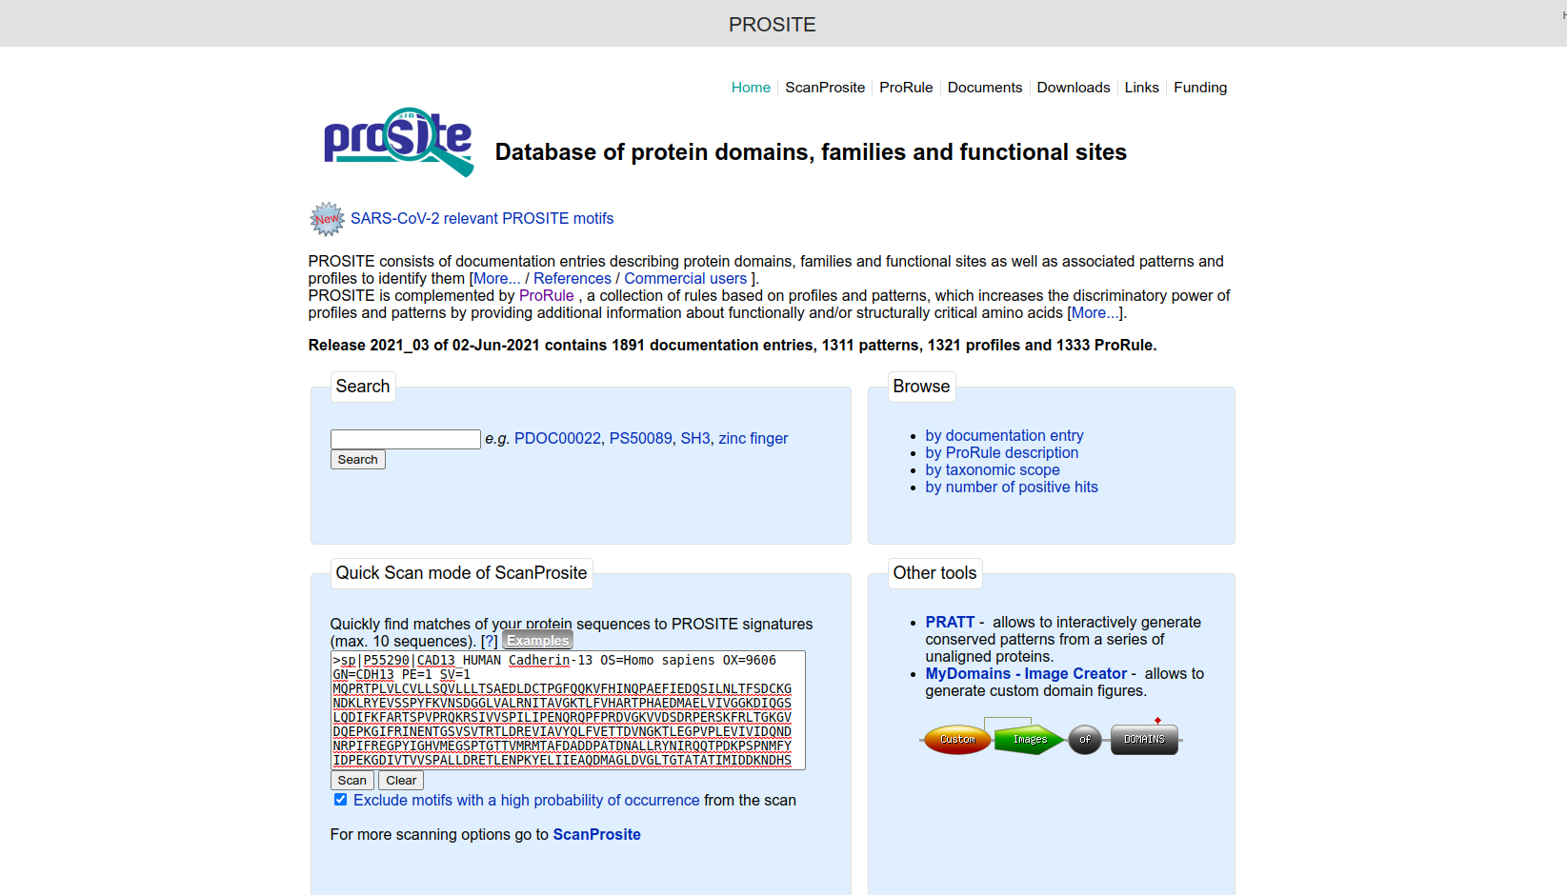**Fig2. Search page for query “Cadherin” using quick scan mode of ScanProsite in Prosite database.**

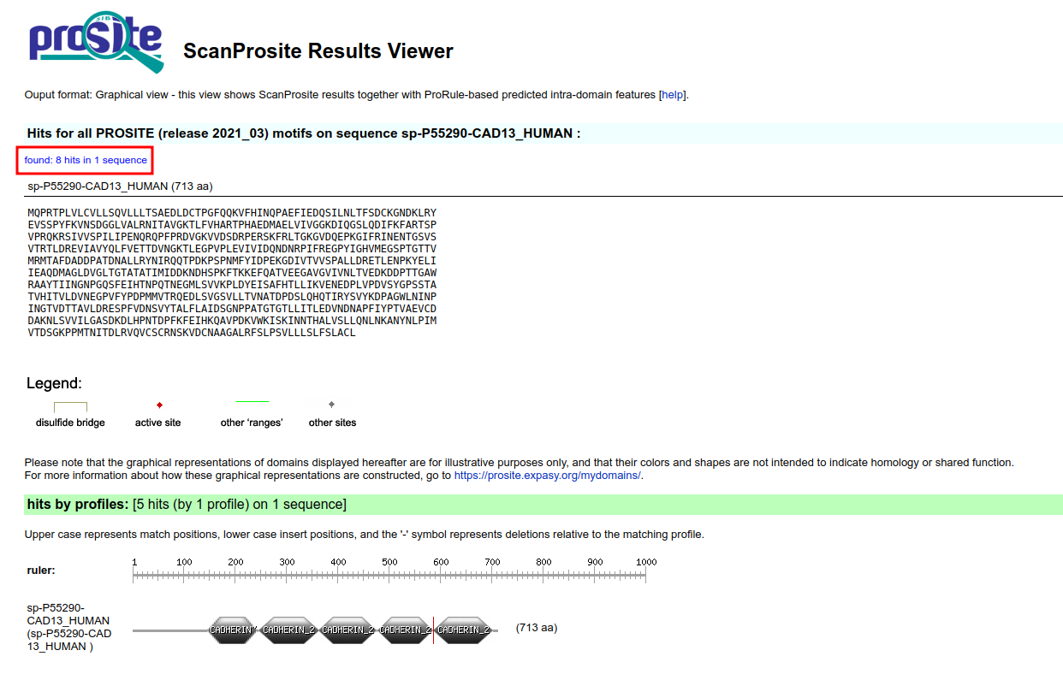**Fig3. Result page for query “Cadherin” in Prosite database.**

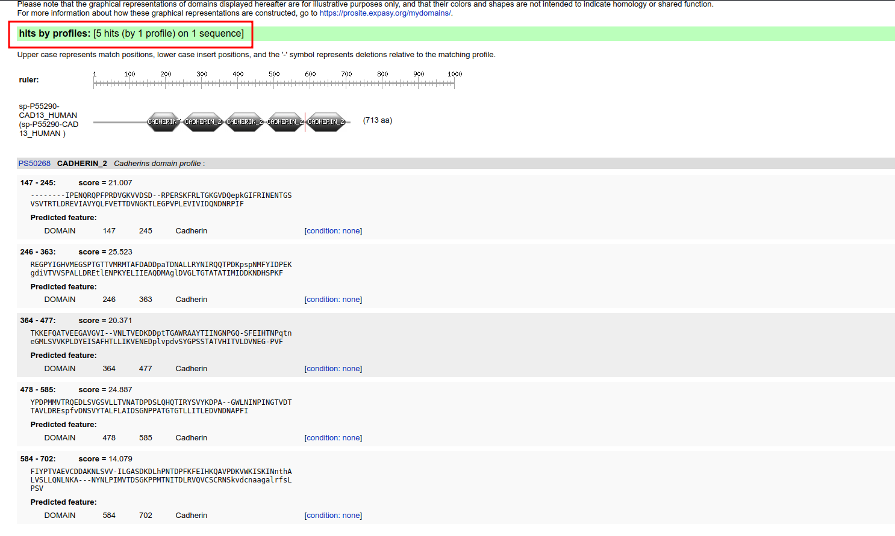**Fig4. Result page for query “Cadherin” in Prosite database showing hits by profiles.**

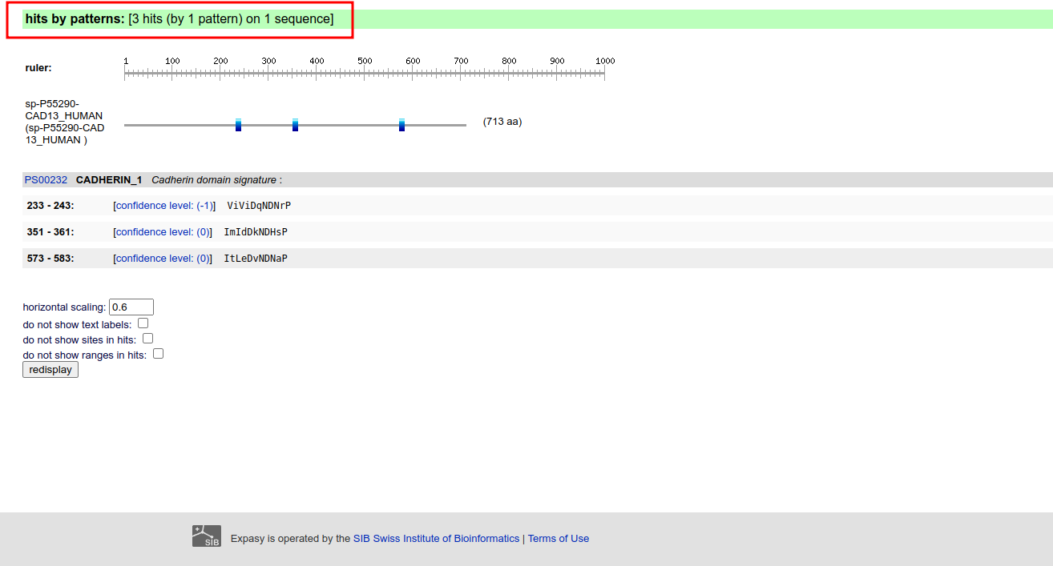**Fig5. Result page for query “Cadherin” in Prosite showing hits by profiles.**

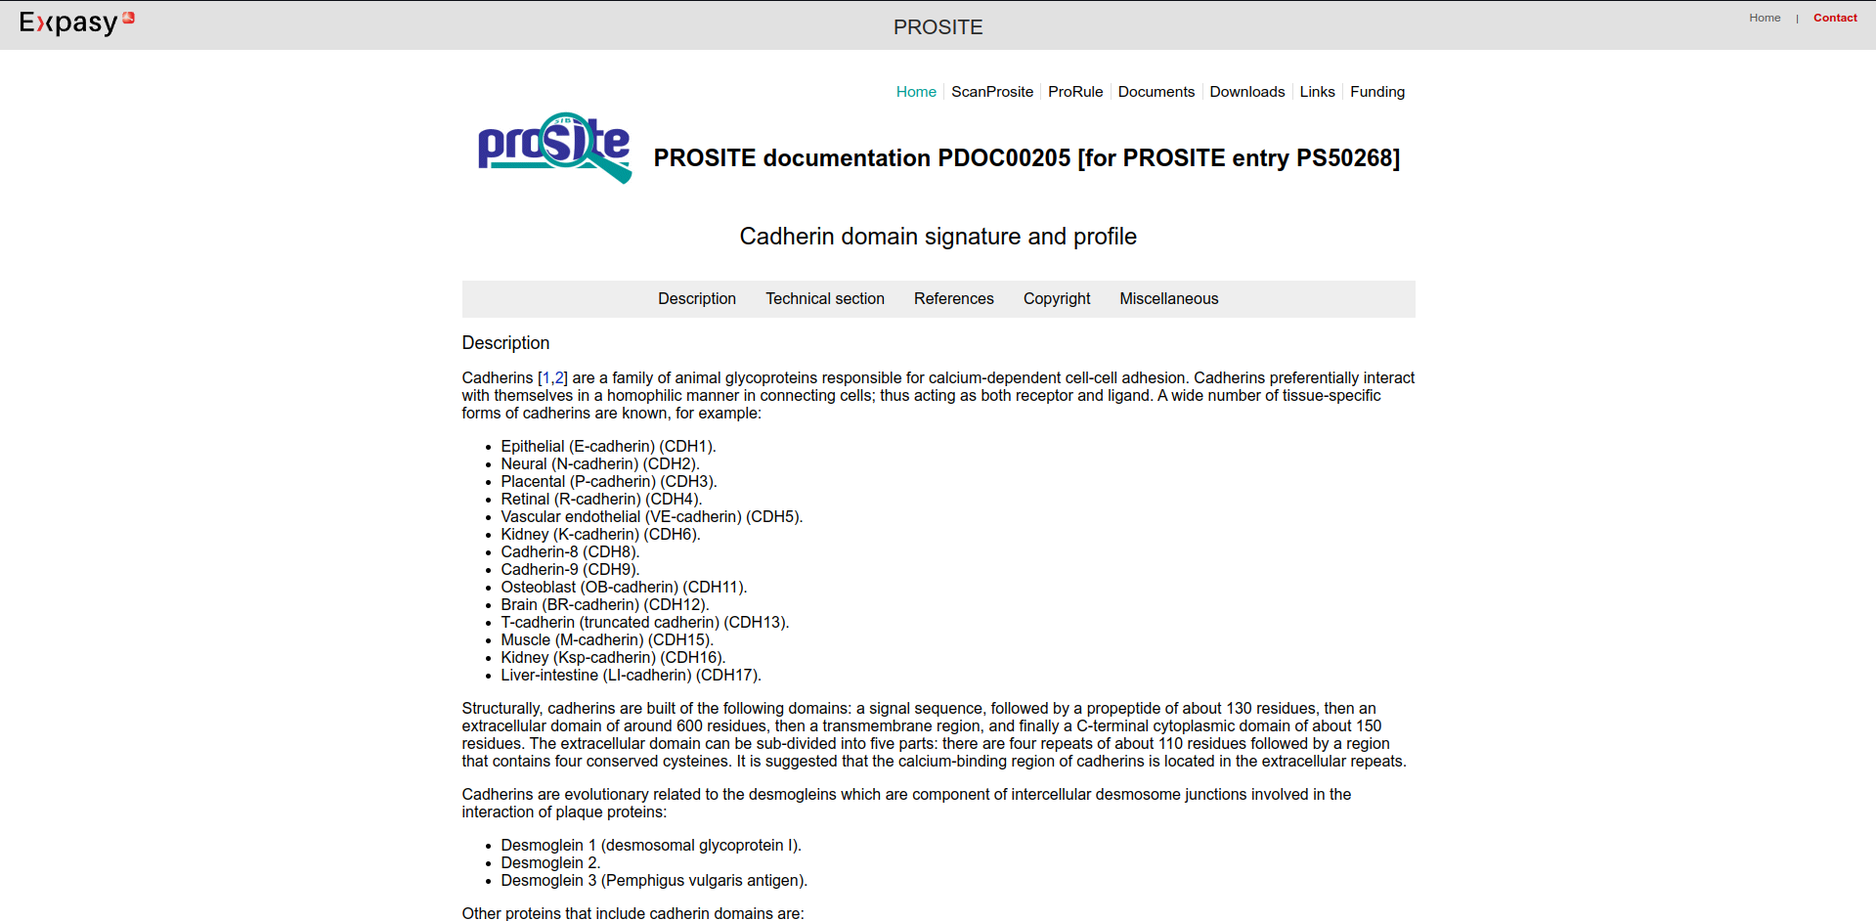**Fig6. Result page for “Cadherin Domain signature” and profile**

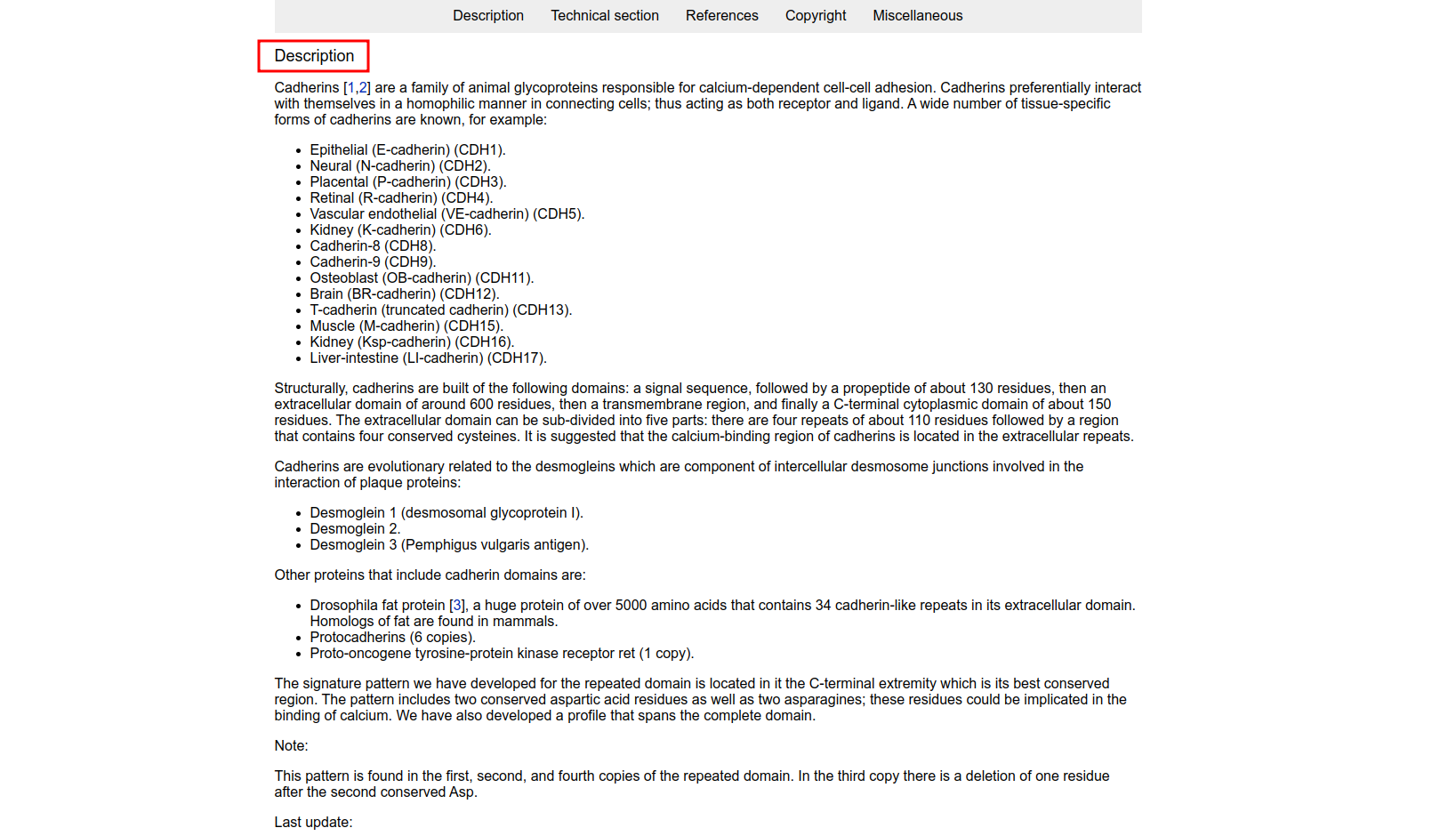**Fig7. Description page for “Cadherin Domain signature”**

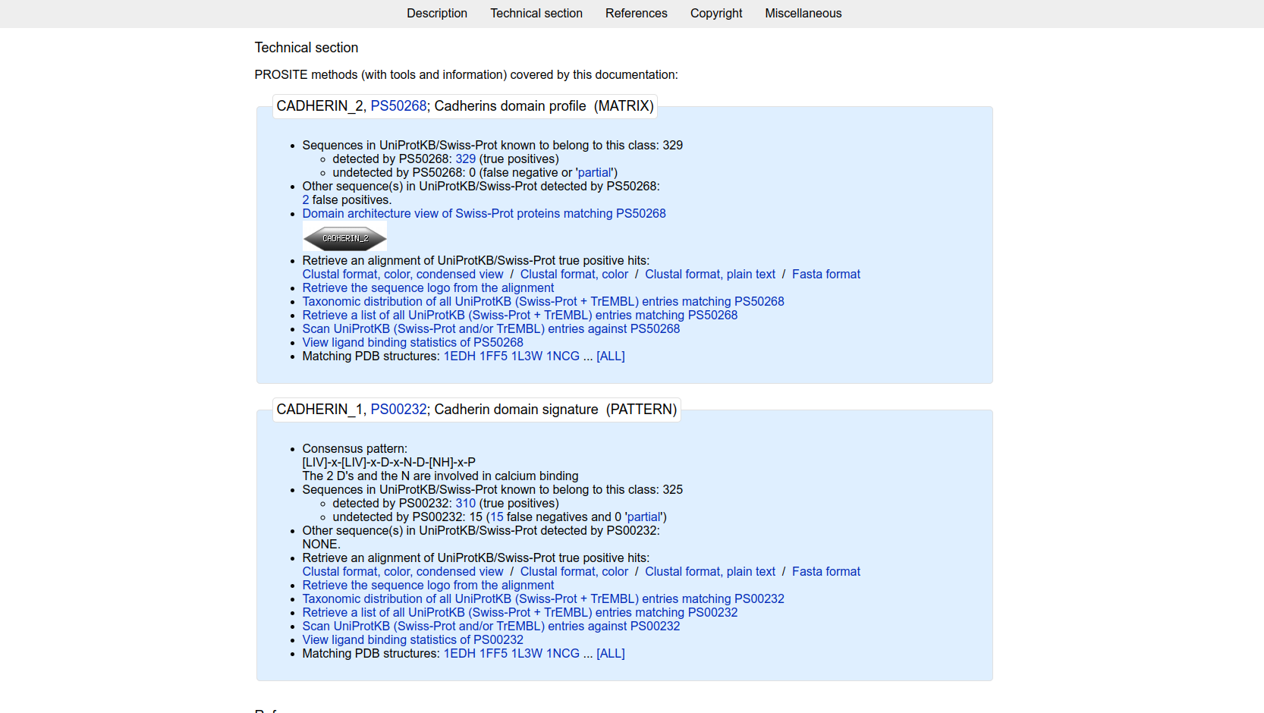**Fig8. Result page showing Technical section for “Cadherin_2:PS50268”**

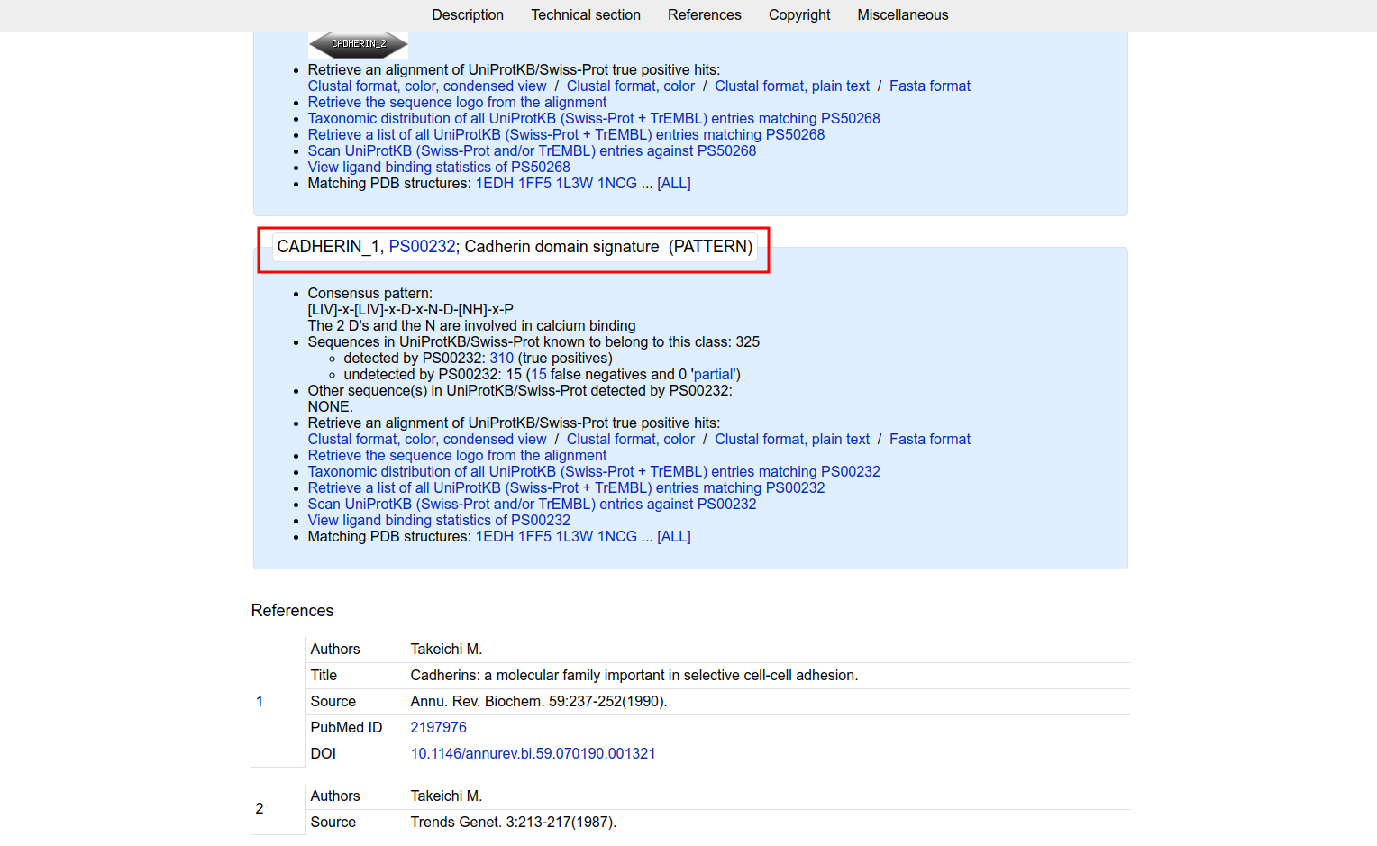**Fig9. Result page for “Cadherin” which shows consensus patthern for Cadherin Domain signature**

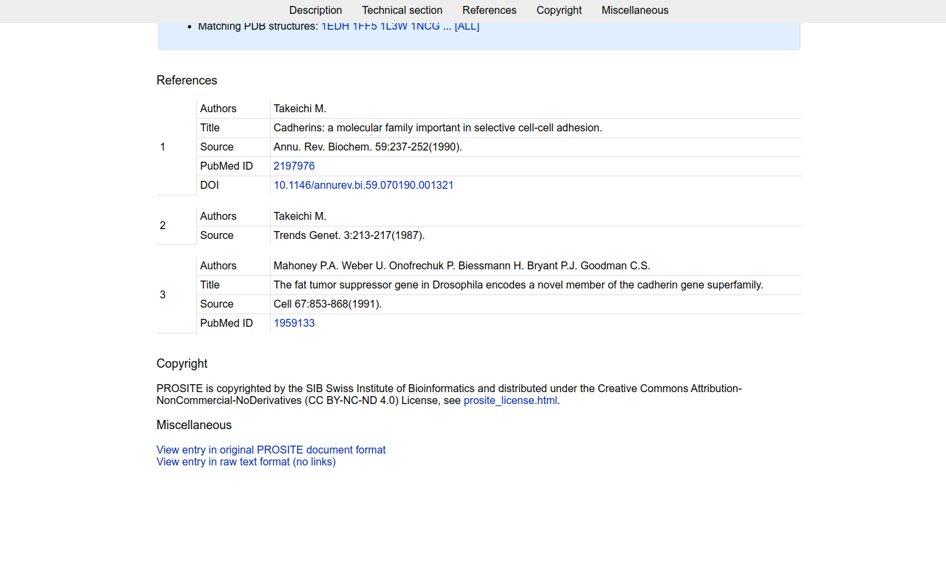**Fig10. Result page for “Cadherin” showing references**

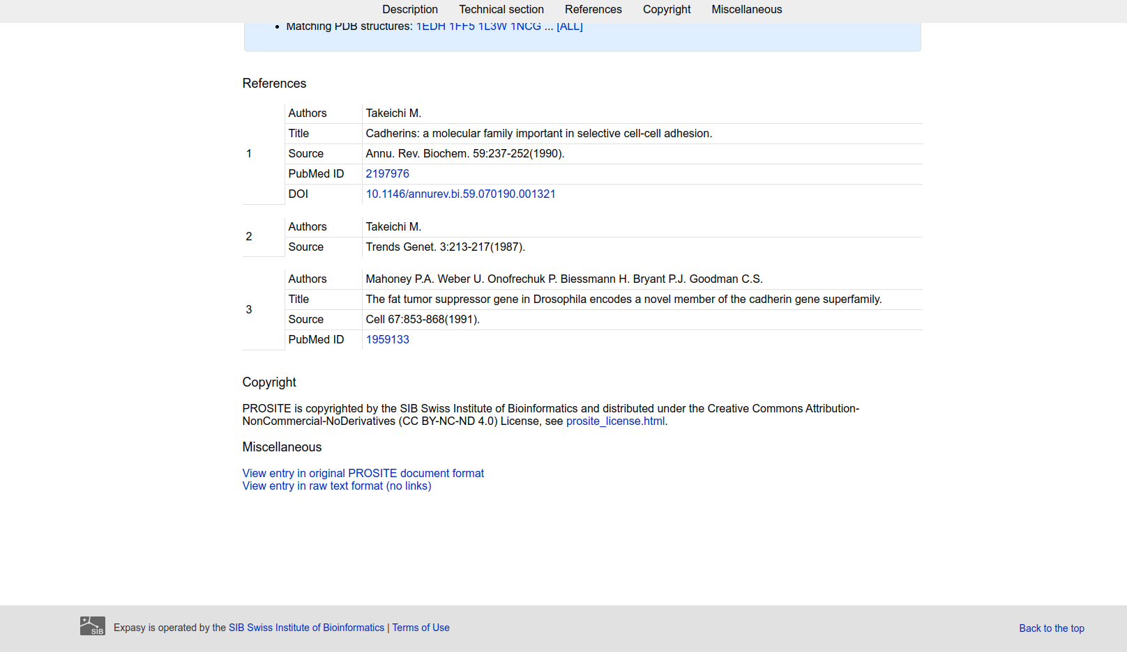**Fig11. Result page for Cadherin domain showing Copyright and miscellaneous**

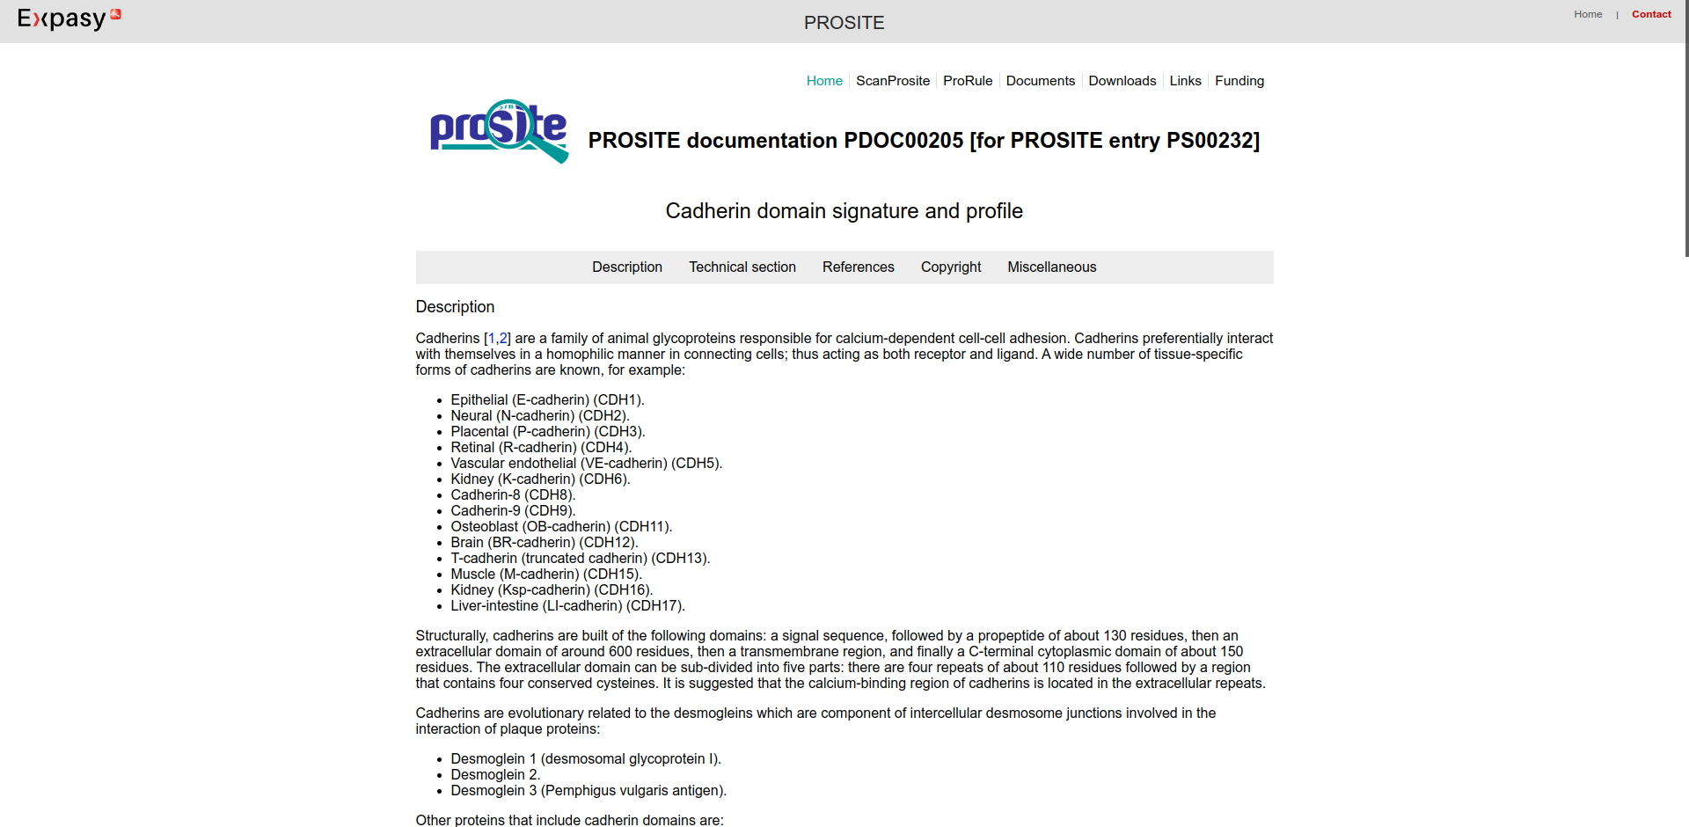**Fig12.Result page for Cadherin domain signature and profile**

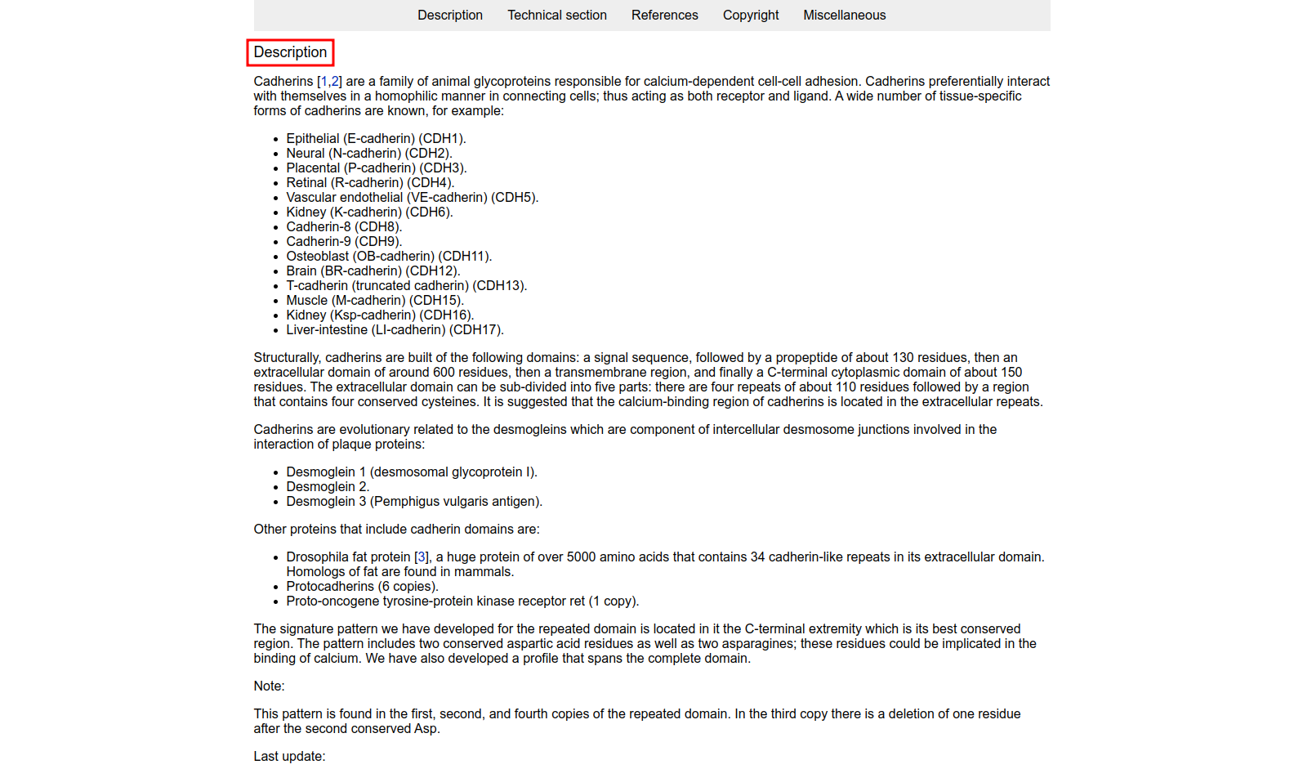**Fig13. Result page for Cadherin domain signature and profile showing Description**

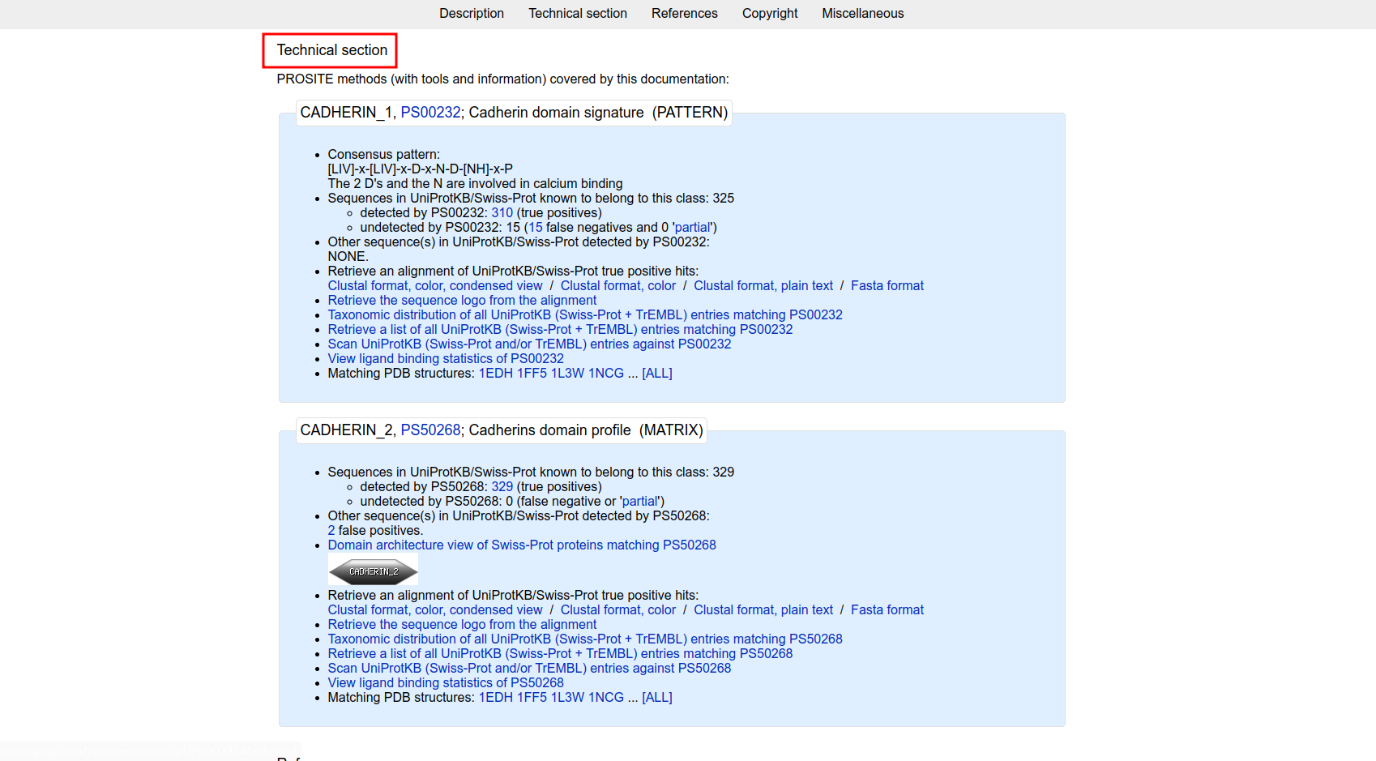**Fig14. Result page for Cadherin domain signature and profile showing Technical Section and consensus atther**

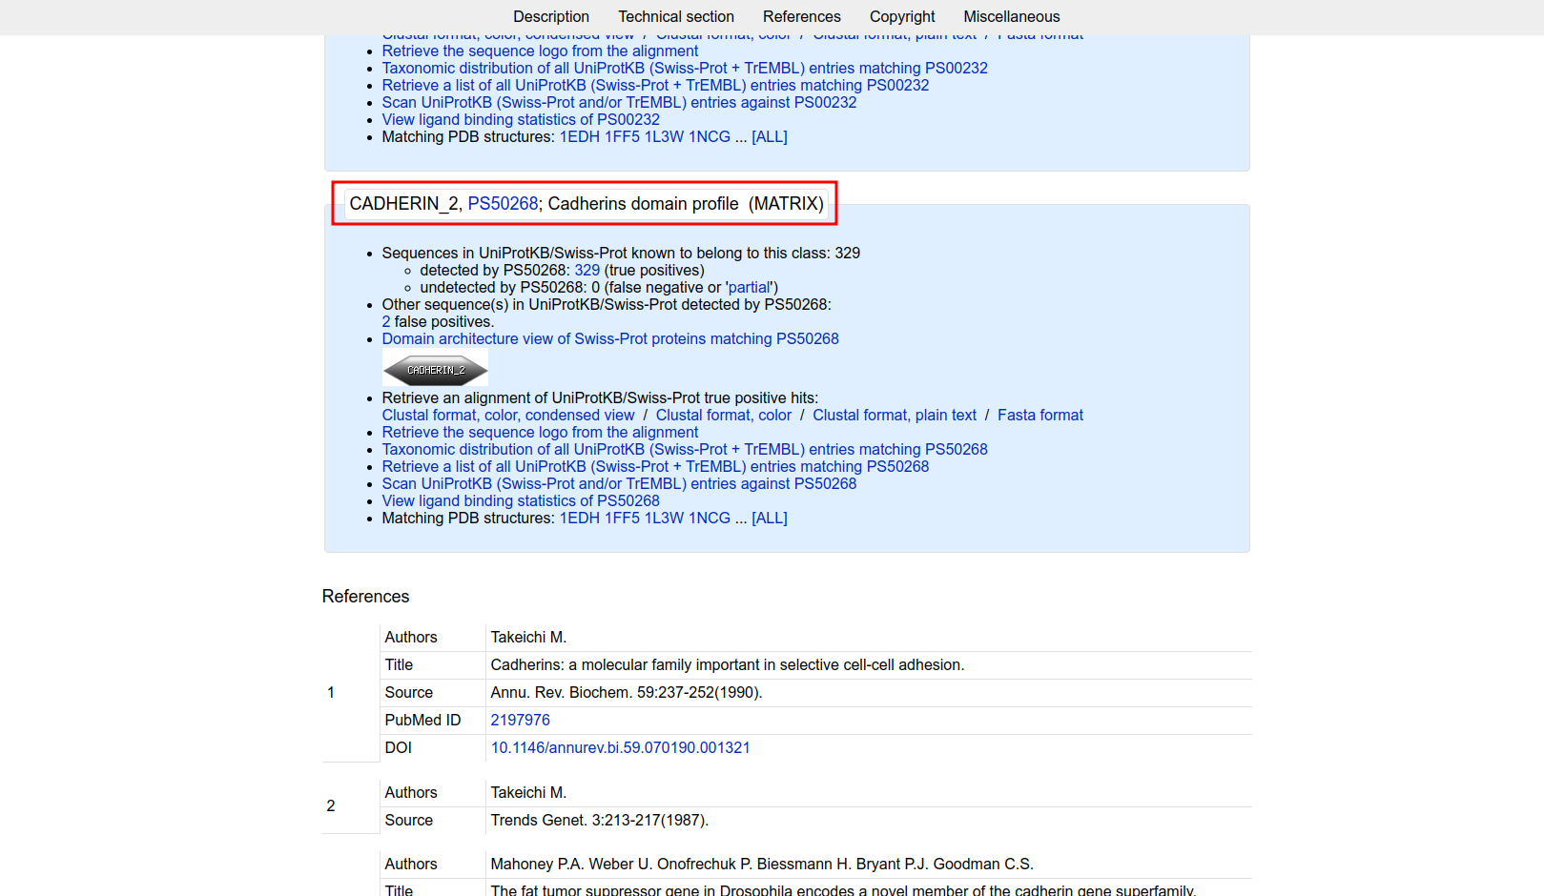**Fig15. Result page for Cadherin domain signature showing CADHERIN_2**

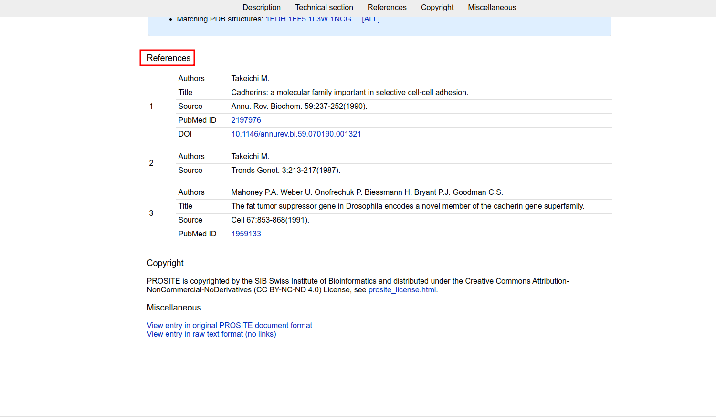**Fig16. Result page for Cadherin domain signature showing References**

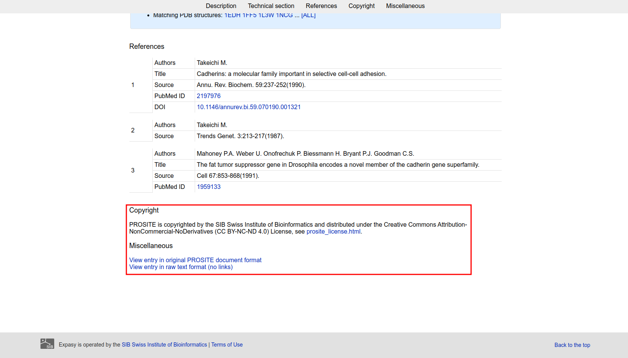**Fig17. Result page for Cadherin Domain signature showing Copyright and miscellaneous**

**Result:**

The profile and patthern information for CADHERIN_1 and CADHERIN_2 was retrieved

**Conclusion:**

PROSITE database provides resources and tools for easy retrieval of profiles and patterns of various protein domains.

**References:**

1. Maître, J. L., & Heisenberg, C. P. (2013). Three Functions of Cadherins in Cell Adhesion. Current Biology, 23(14), R626–R633. https://doi.org/10.1016/j.cub.2013.06.019
2. (n.d.). Retrieved from https://www.uniprot.org/uniprot/P55290.fasta
3. M., T., P.A., M., U., W., P., O., H., B., P.J., B., & C.S., G. (2004, May 01). Cadherin domain signature and profile. Retrieved from https://prosite.expasy.org/cgi-bin/prosite/nicedoc.pl?PS50268
4. M., T., P.A., M., U., W., P., O., H., B., P.J., B., & C.S., G. (2004, May 01). Cadherin domain signature and profile. Retrieved from https://prosite.expasy.org/cgi-bin/prosite/nicedoc.pl?PS00232

**Date: 16-10-21**

**WEBLEM 5b**

**Pfam**

**(http://pfam.xfam.org/)**

**Aim:**

To study Cadherin domain information using Pfam database.

**Introduction:**

Pfam is a database of protein domain families. Pfam contains curated multiple sequence alignments for each family, as well as profile hidden Markov models (profile HMMs) for finding these domains in new sequences. Pfam contains functional annotation, literature references and database links for each family. There are two multiple alignments for each Pfam family, the seed alignment that contains a relatively small number of representative members of the family and the full alignment that contains all members in the database that can be detected. All alignments use sequences taken from pfamseq, which is a non-redundant protein set composed of SWISS-PROT and SP-TrEMBL. The profile HMM is built from the seed alignment using the HMMER package, which is then used to search the pfamseq sequence database.

Cadherins (named for "calcium-dependent adhesion") are a type of cell adhesion molecule(CAM) that are important in the formation of adherens junctions to allow cells to adhere to each other .Cadherins are a class of type-1 transmembrane proteins, and they are dependent on calcium (Ca2+) ions to function, hence their name. Cell-cell adhesion is mediated by extracellular cadherin domains, whereas the Intracellular cytoplasmic tail associates with numerous adaptors and signaling proteins, collectively referred as the cadherin adhesome.

**Methodology:**

1. Open homepage for Pfam database. (URL: <http://pfam.xfam.org/>)
2. Search for query “Cadherin” using keyword search.
3. Select a domain and observe the results.
4. Interpet the results.

**Observation:**

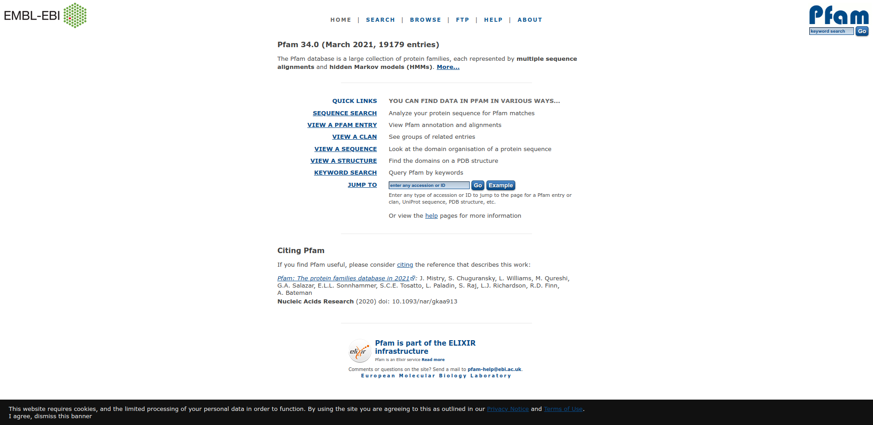**Fig1. Homepage of Pfam database**

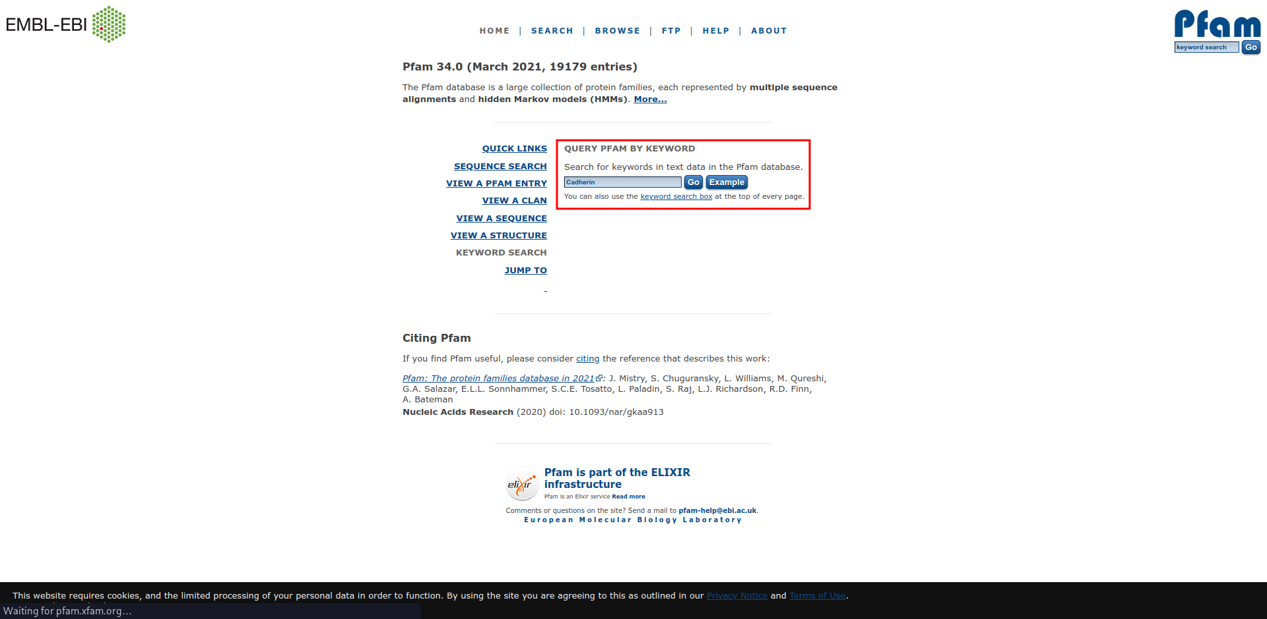**Fig2. Search page for query “Cadherin” Using Keyword search in Pfam database.**

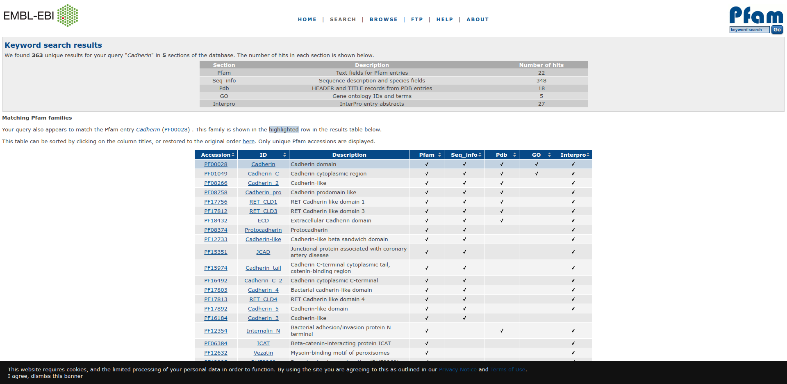**Fig3. Hit page for query “Cadherin” in Pfam database.**

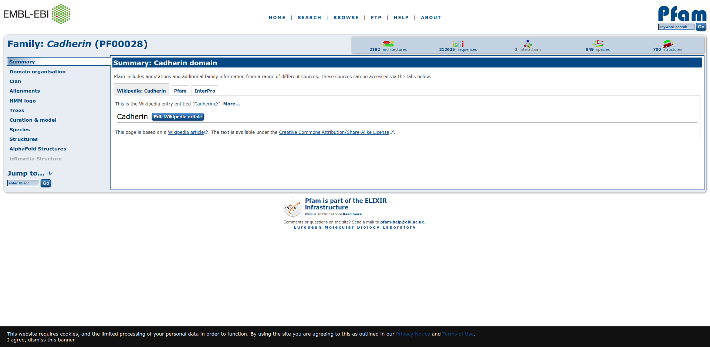**Fig4. Result page for Cadherin Domain showing summary**

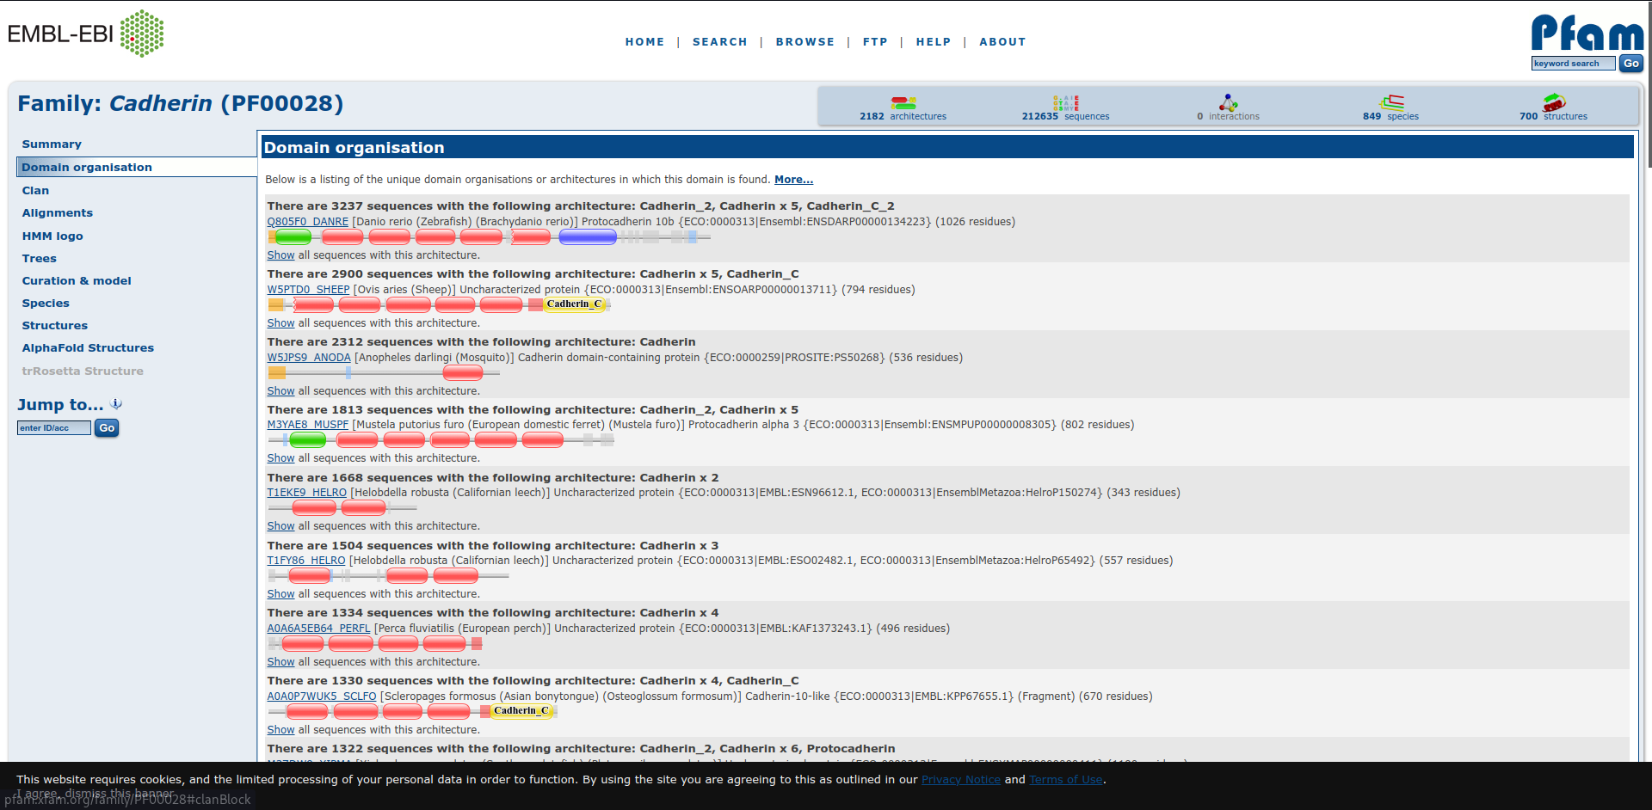**Fig5. Result page for Cadherin Domain showing domain organisation**

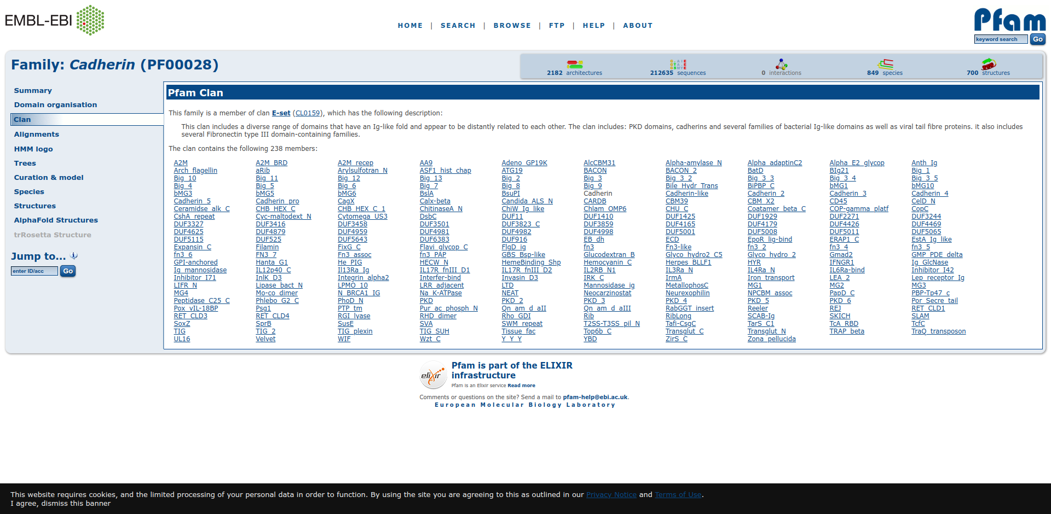**Fig6. Result page showing Cadherin Domain showing its clan**

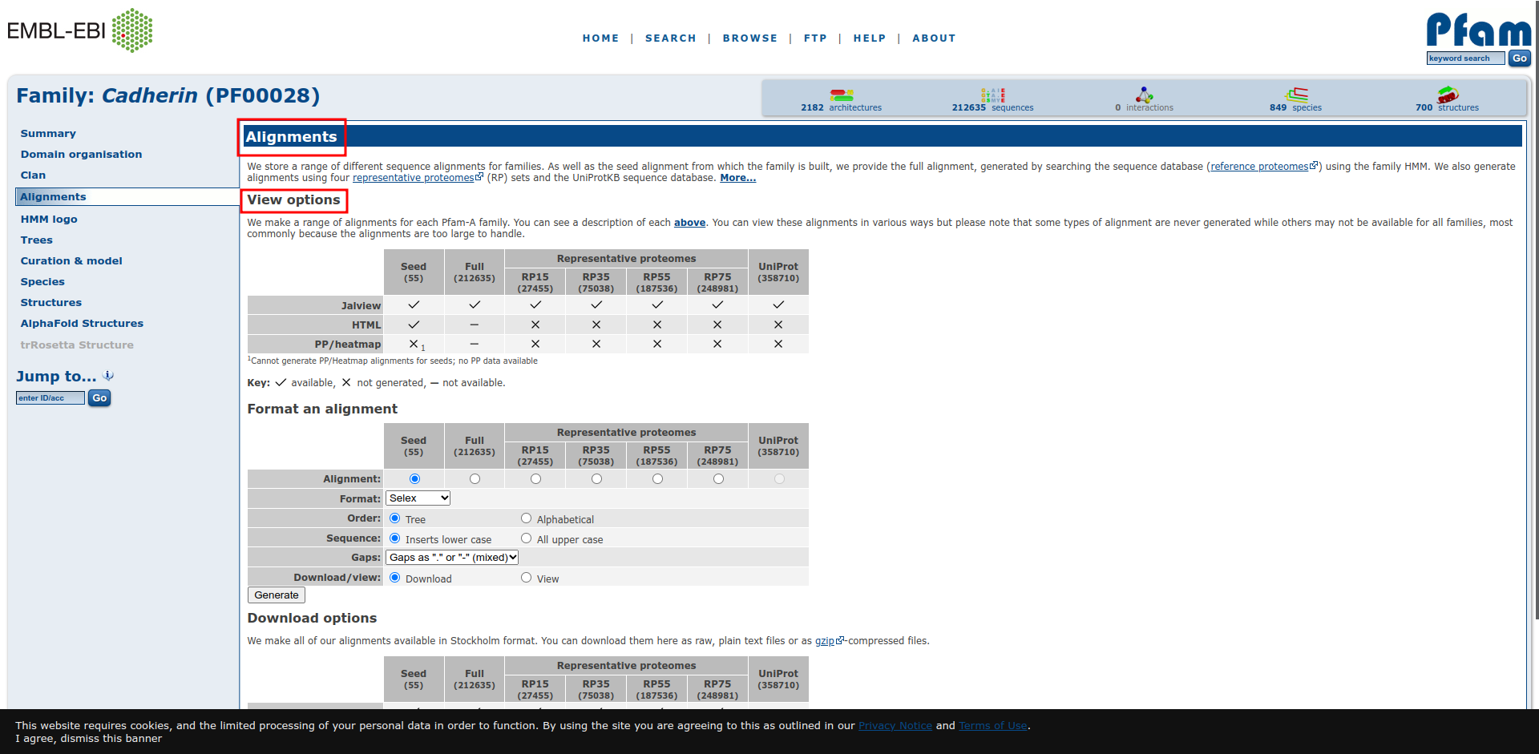**Fig7. Result page for Cadherin Domain Showing Alignments view options.**

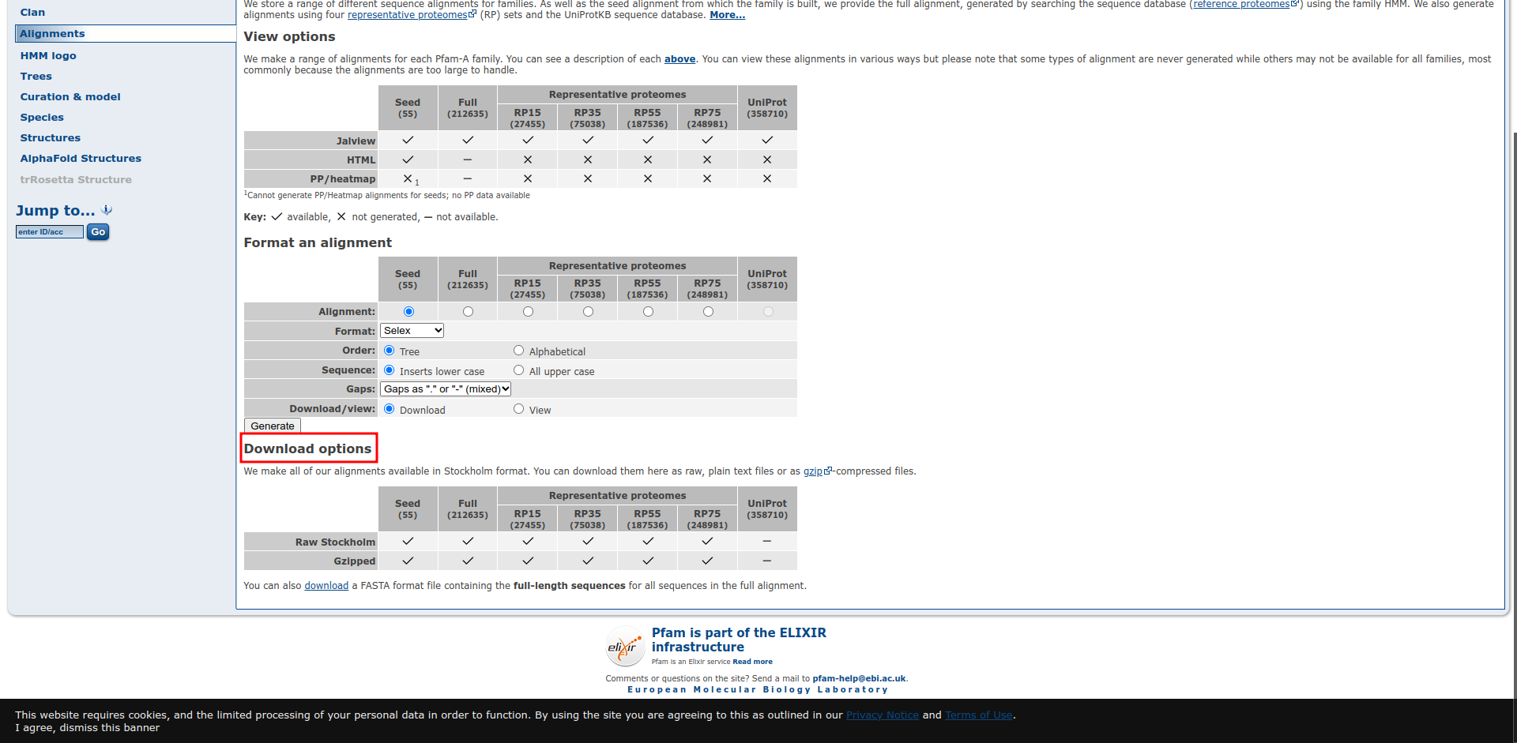**Fig8. Result page for Cadherin Domain showing download options for alignments.**

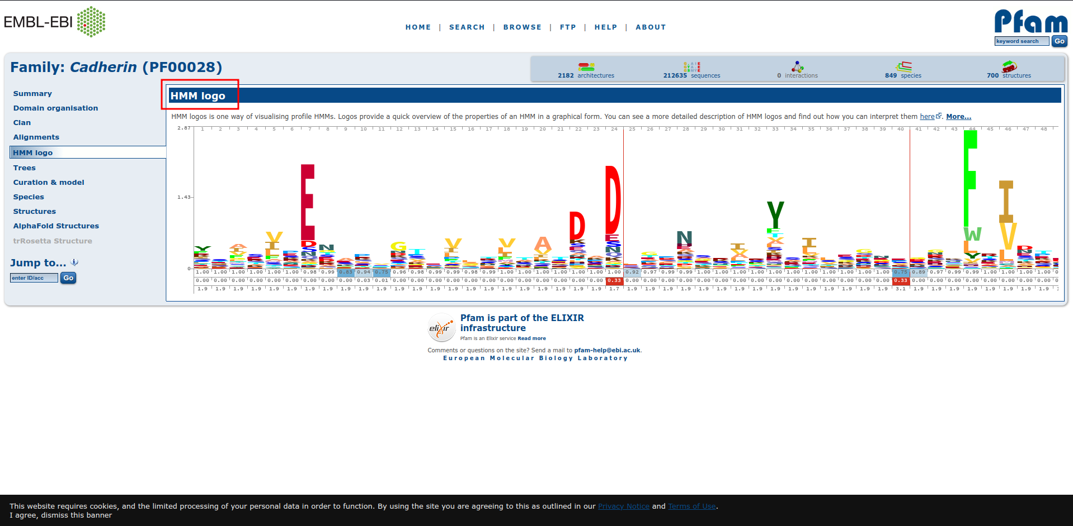**Fig9. Result page for Cadherin Domain showing HMM logo**

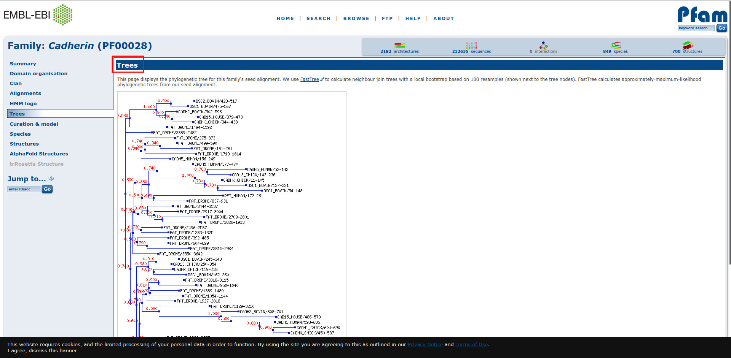**Fig10. Result page for Cadherin Domain showing Phylogenetic tree.**

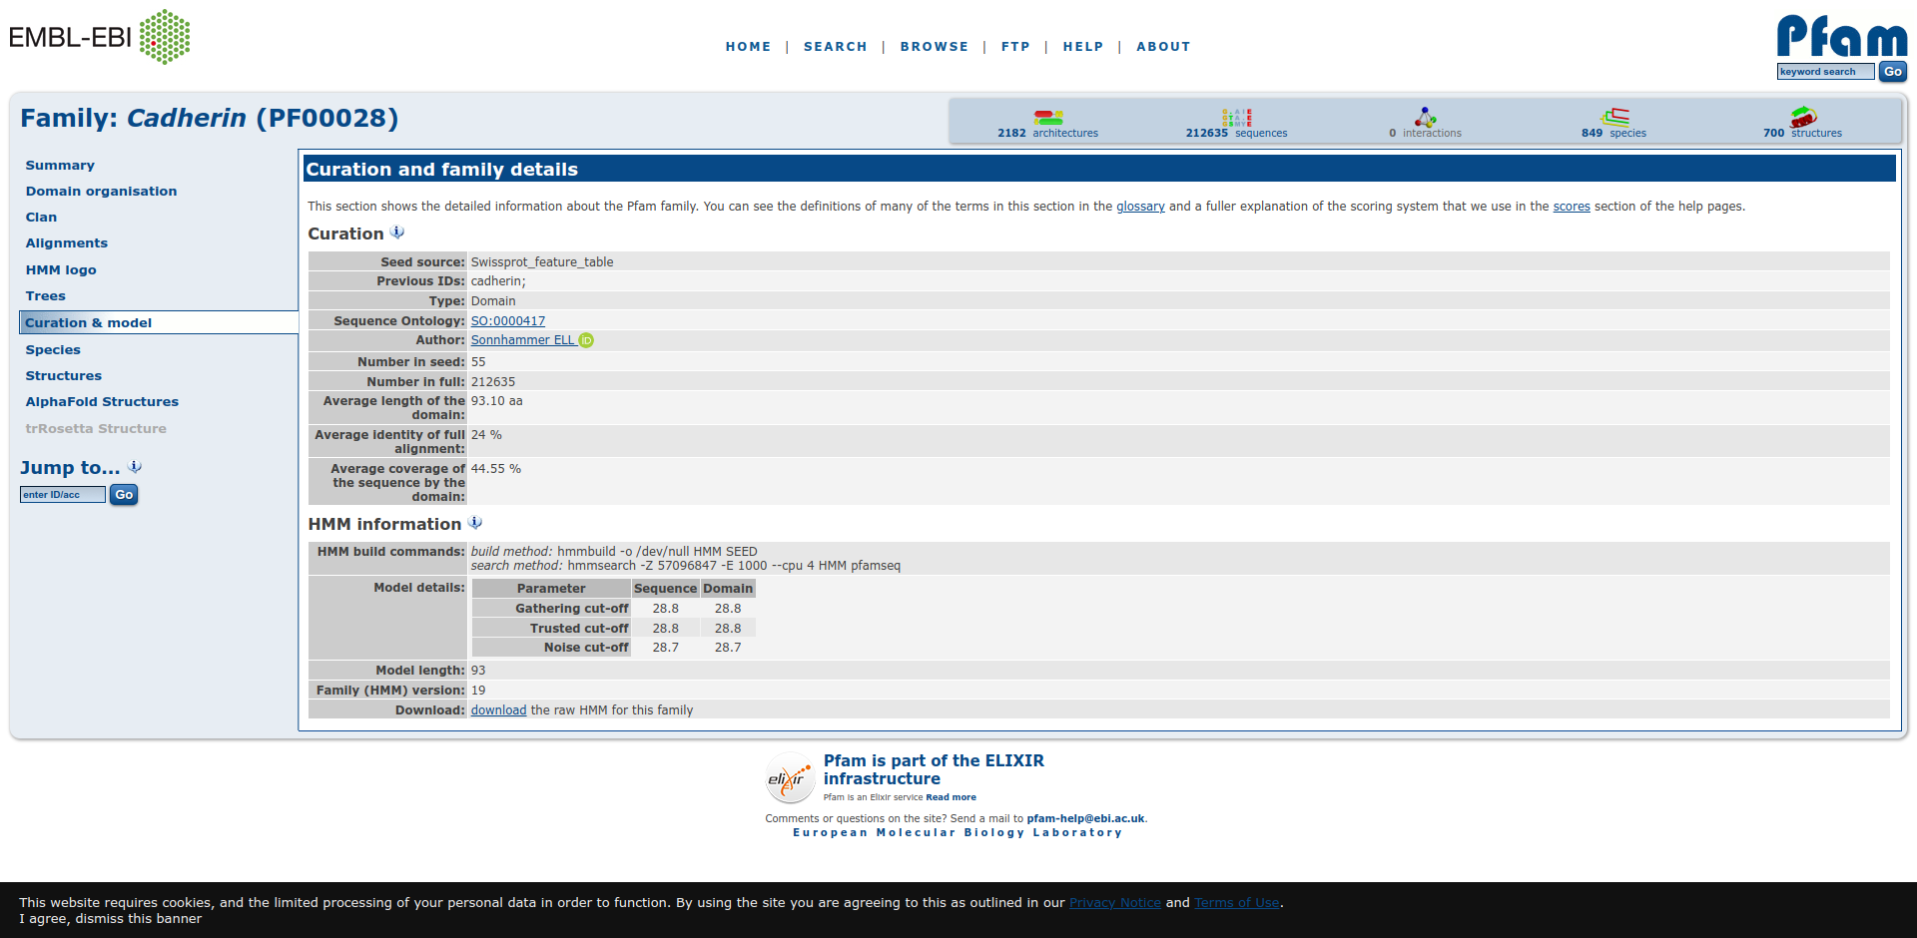**Fig11. Result page for Cadherin Domain showing curation and family details.**

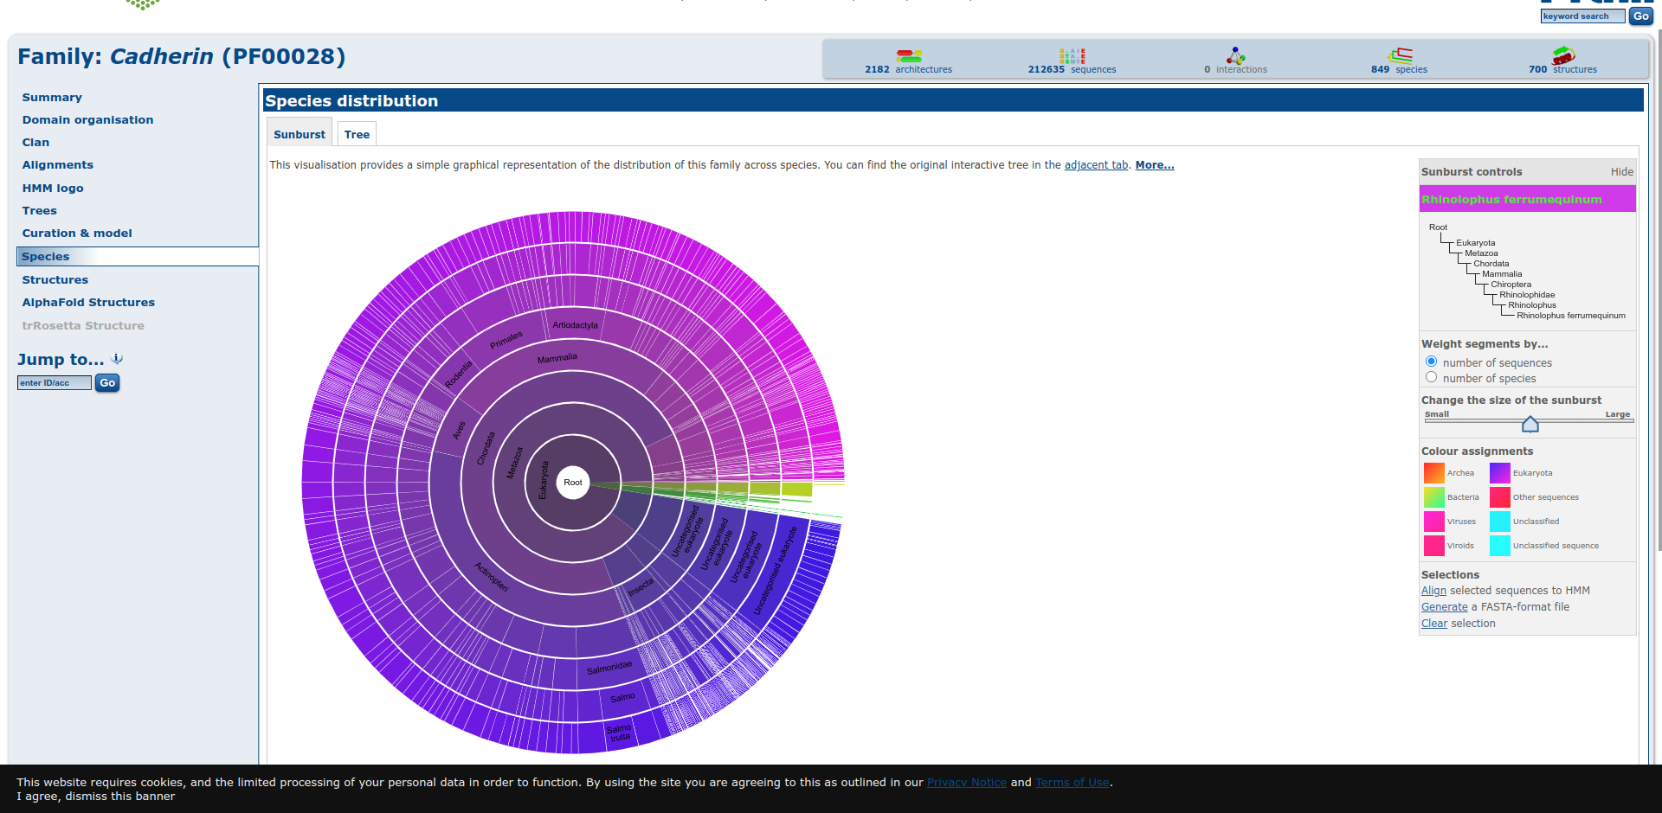**Fig12. Result page for Cadherin Domain showing species distribution in suburst format**

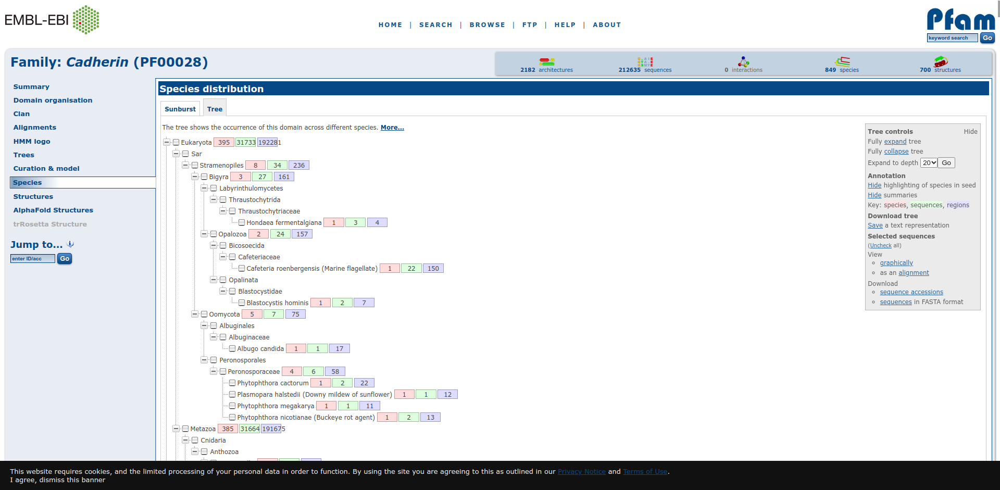**Fig13. Result page for Cadherin Domain showing species distribution in tree format**

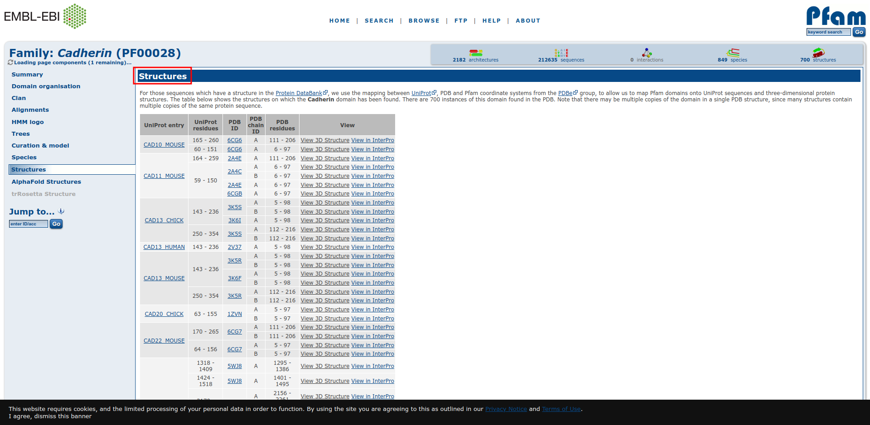**Fig14. Result page for Cadherin Domain showing structures of various chains.**

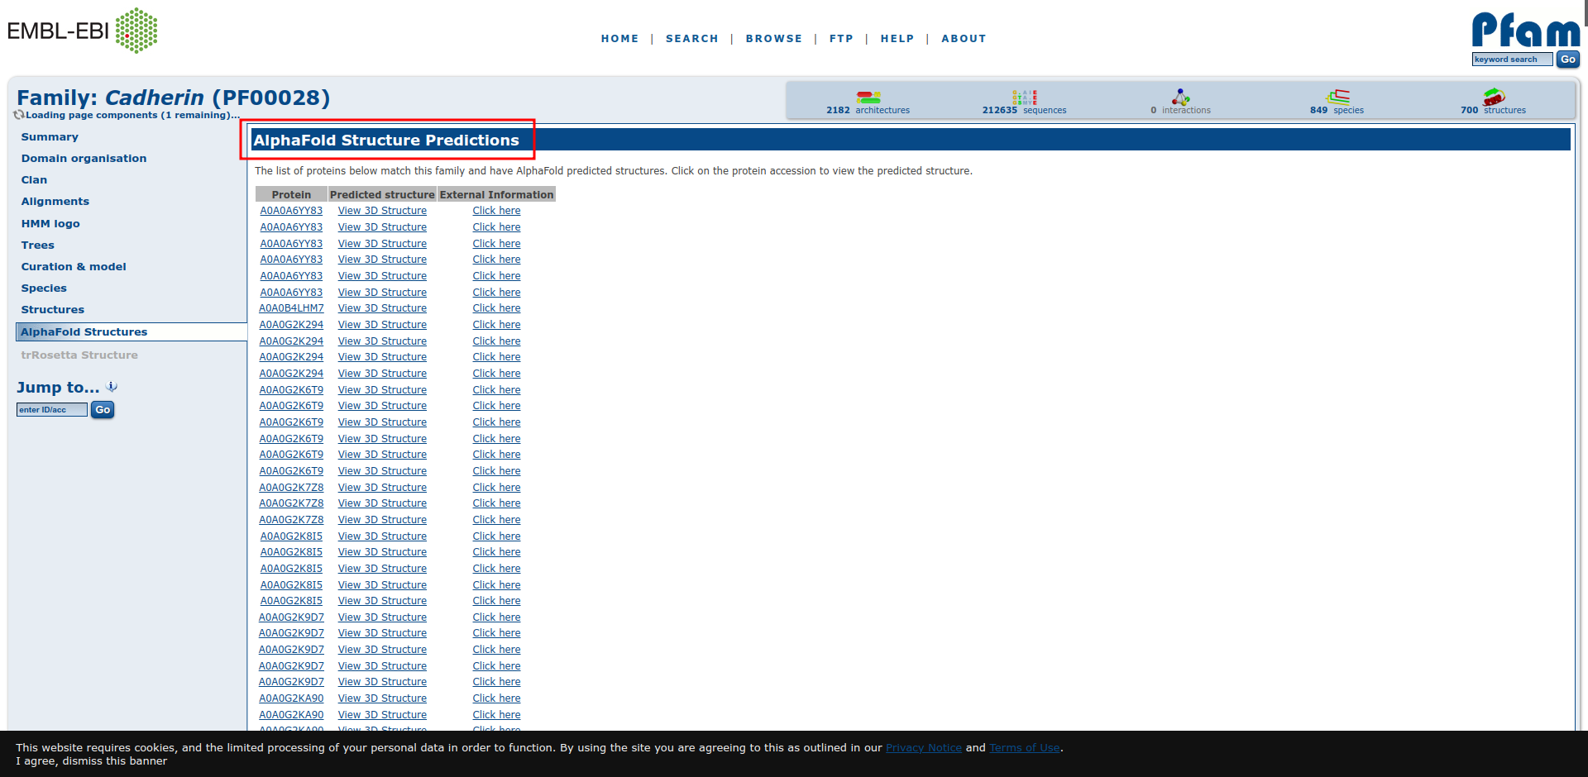**Fig15. Result page for Cadherin Domain showing AlphaFold structure predictions**

**Result:**

The domain organisation, clan, alignment, HMM logo, trees, curation and model, species, structure and AlphaFold structure information related to Cadherin Domain was retrieved using Pfam database.

**Conclusion:**

Pfam database provides protein domain family information which includes sequence alignments, profile

Hidden Markov models which helps understand how much an amino acid is conserved. It also provides

functional annotations and literature references. All this information can be easily retrieved from Pdam

database by its users.

**References:**

1. Maître, J. L., & Heisenberg, C. P. (2013). Three Functions of Cadherins in Cell Adhesion. Current Biology, 23(14), R626–R633. <https://doi.org/10.1016/j.cub.2013.06.019>
2. Keyword search results. (n.d.). Retrieved from http://pfam.xfam.org/search/keyword?query=Cadherin
3. Keyword search results. (n.d.). Retrieved from <http://pfam.xfam.org/family/PF00028#tabview=tab1>
4. Keyword search results. (n.d.). Retrieved from <http://pfam.xfam.org/family/PF00028#tabview=tab2>
5. Keyword search results. (n.d.). Retrieved from <http://pfam.xfam.org/family/PF00028#tabview=tab3>
6. Keyword search results. (n.d.). Retrieved from <http://pfam.xfam.org/family/PF00028#tabview=tab4>
7. Keyword search results. (n.d.). Retrieved from <http://pfam.xfam.org/family/PF00028#tabview=tab5>
8. Keyword search results. (n.d.). Retrieved from <http://pfam.xfam.org/family/PF00028#tabview=tab6>
9. Keyword search results. (n.d.). Retrieved from <http://pfam.xfam.org/family/PF00028#tabview=tab7>
10. Keyword search results. (n.d.). Retrieved from <http://pfam.xfam.org/family/PF00028#tabview=tab8>
11. Keyword search results. (n.d.). Retrieved from <http://pfam.xfam.org/family/PF00028#tabview=tab9>

**Date: 16-10-21**

**WEBLEM 5c**

**BLOCK**

**(URL:** [**https://www.ebi.ac.uk/interpro/**](https://www.ebi.ac.uk/interpro/)**)**

**Aim:**

To study Cadherin domain information using InterPro database.

**Introduction:**

InterPro is an integrative database which was founded 10 years ago when the PROSITE, PRINTS, Pfam and ProDom databases formed a consortium to amalgamate the predictive signatures they individually produced into a single resource. Since then, six other member databases have also joined and their data has been integrated: SMART, TIGRFAMs, PIRSF, SUPERFAMILY PANTHERand Gene3D.

Cadherins (named for "calcium-dependent adhesion") are a type of cell adhesion molecule(CAM) that are important in the formation of adherens junctions to allow cells to adhere to each other .Cadherins are a class of type-1 transmembrane proteins, and they are dependent on calcium (Ca2+) ions to function, hence their name. Cell-cell adhesion is mediated by extracellular cadherin domains, whereas the Intracellular cytoplasmic tail associates with numerous adaptors and signaling proteins, collectively referred as the cadherin adhesome.

**Methodology:**

1. Open Homepafe for InterPro database. (URL: <https://www.ebi.ac.uk/interpro/>)
2. Search for query “Cadherin” Using search by sequence.
3. Observe the resutls.
4. Interpret the results.

**Observation:**

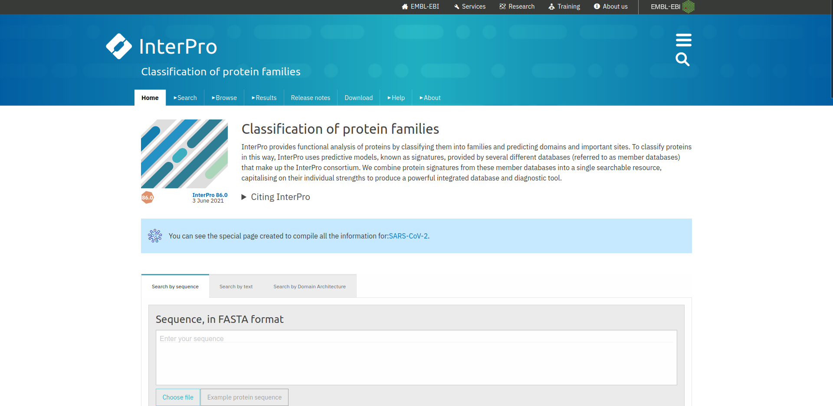**Fig1. Homepage for InterPro database.**

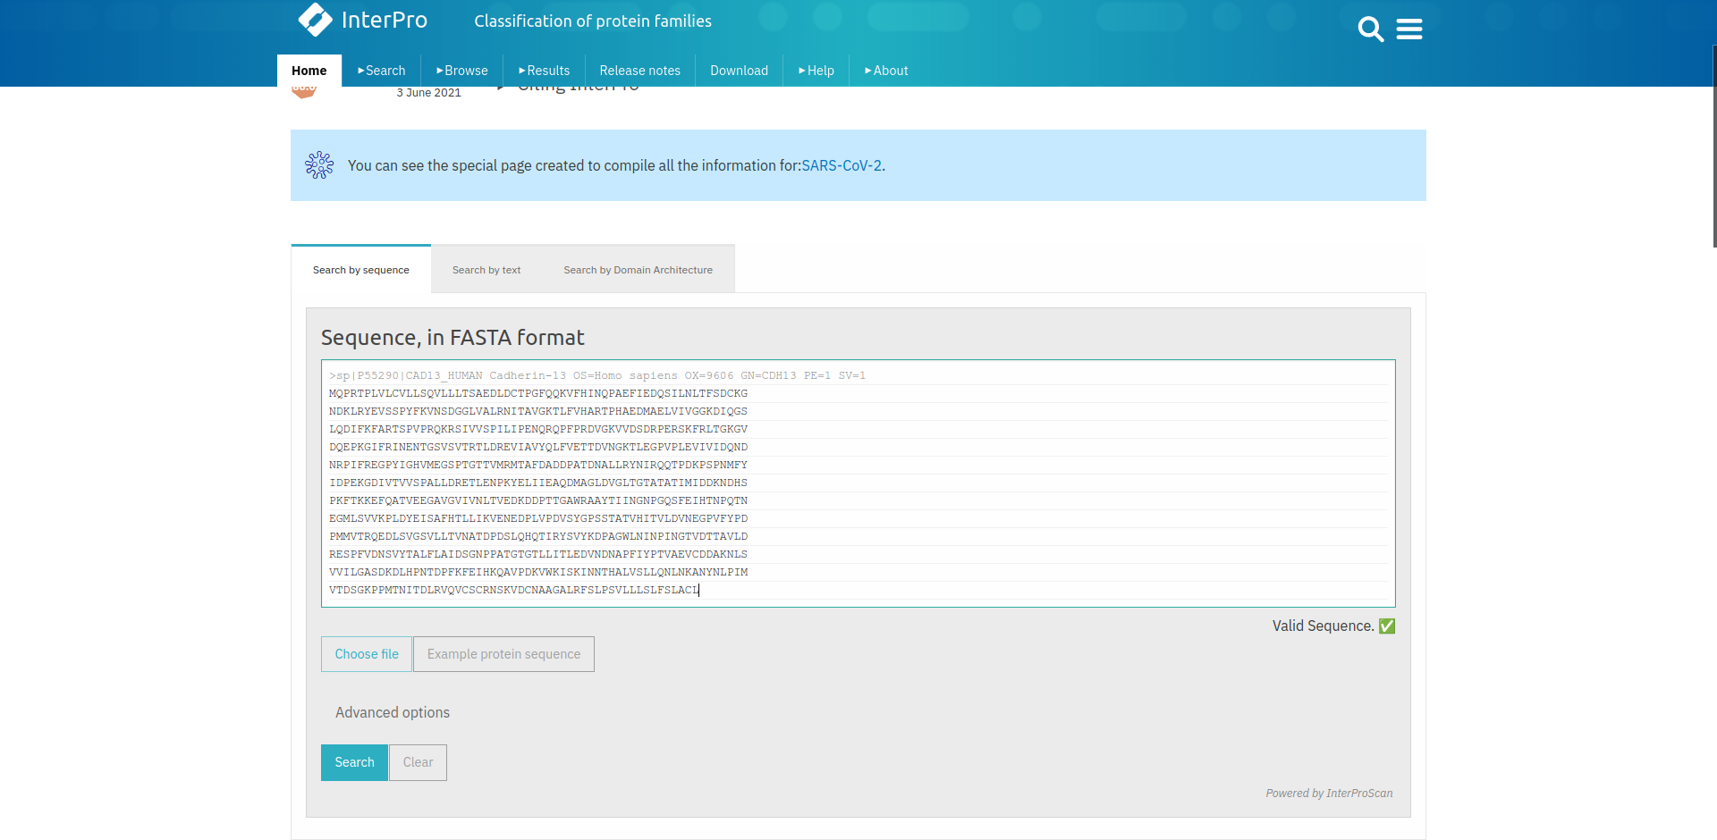**Fig2. Search page for query “Cadherin” using search by sequence**

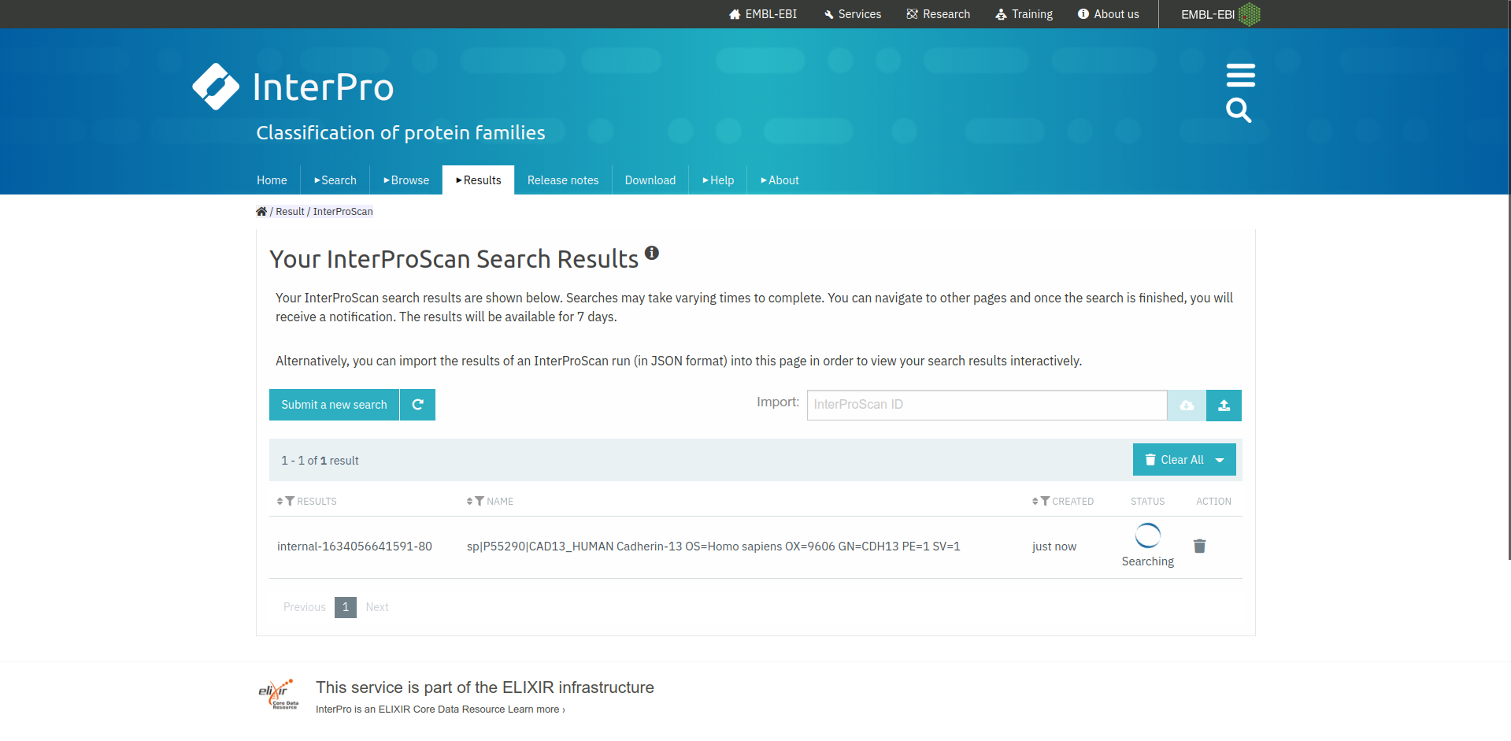**Fig3. Hit page for query “Cadherin” in InterPro database.**

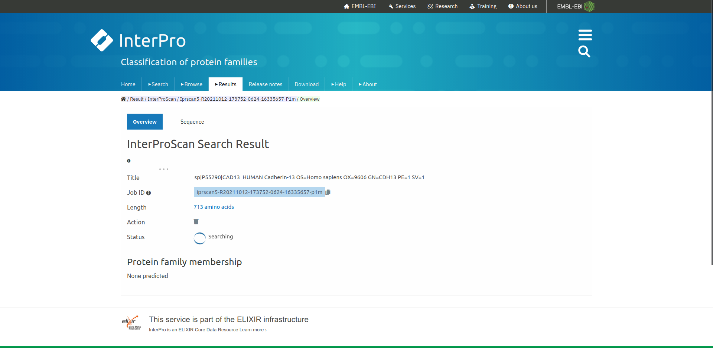**Fig4. Result page for query “Cadherin”**

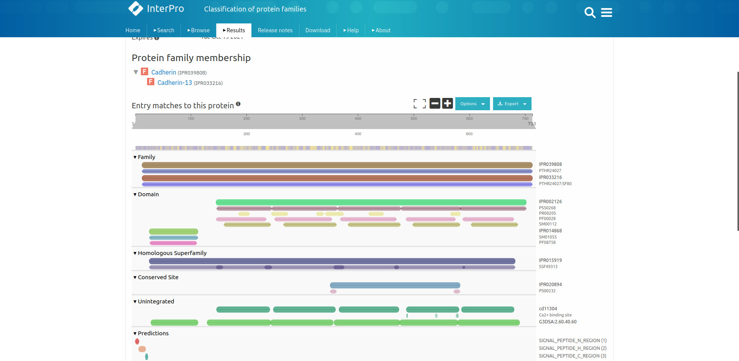**Fig5. Result page for query “Cadherin” showing its family information**

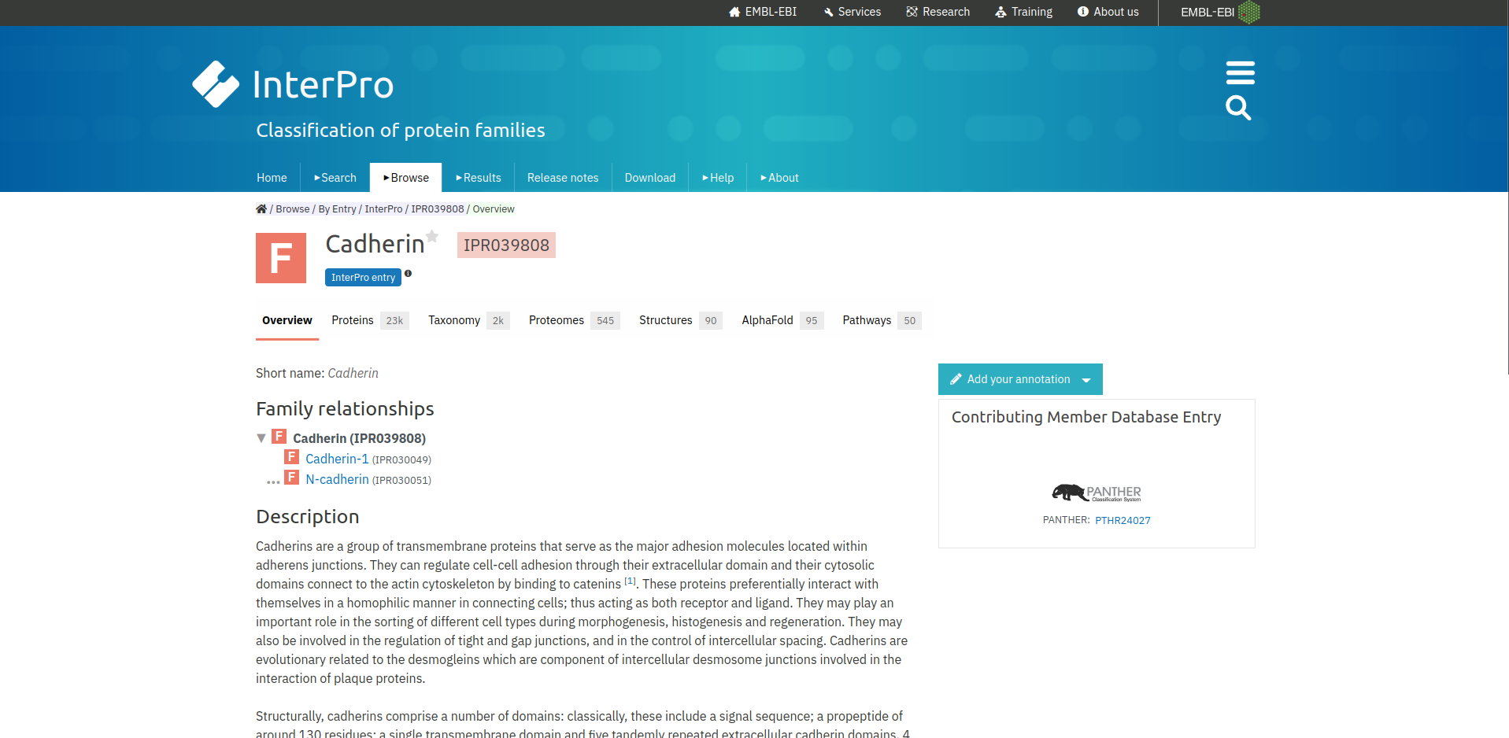**Fig5.1. Result page for Cadherin family.**

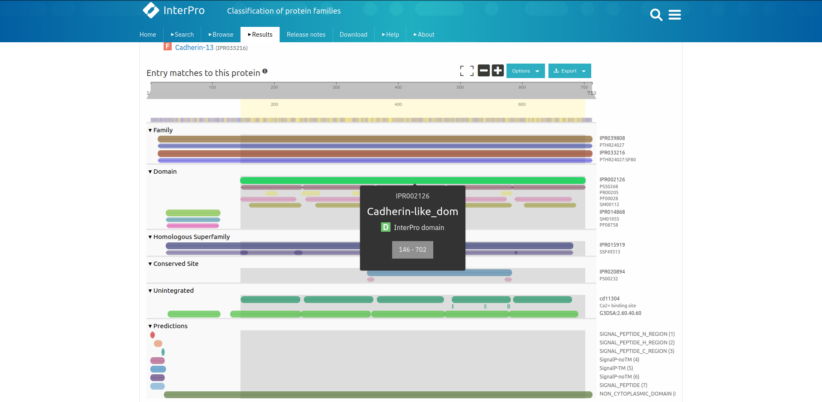**Fig6. Result page for query “Cadherin” showing its domain information**

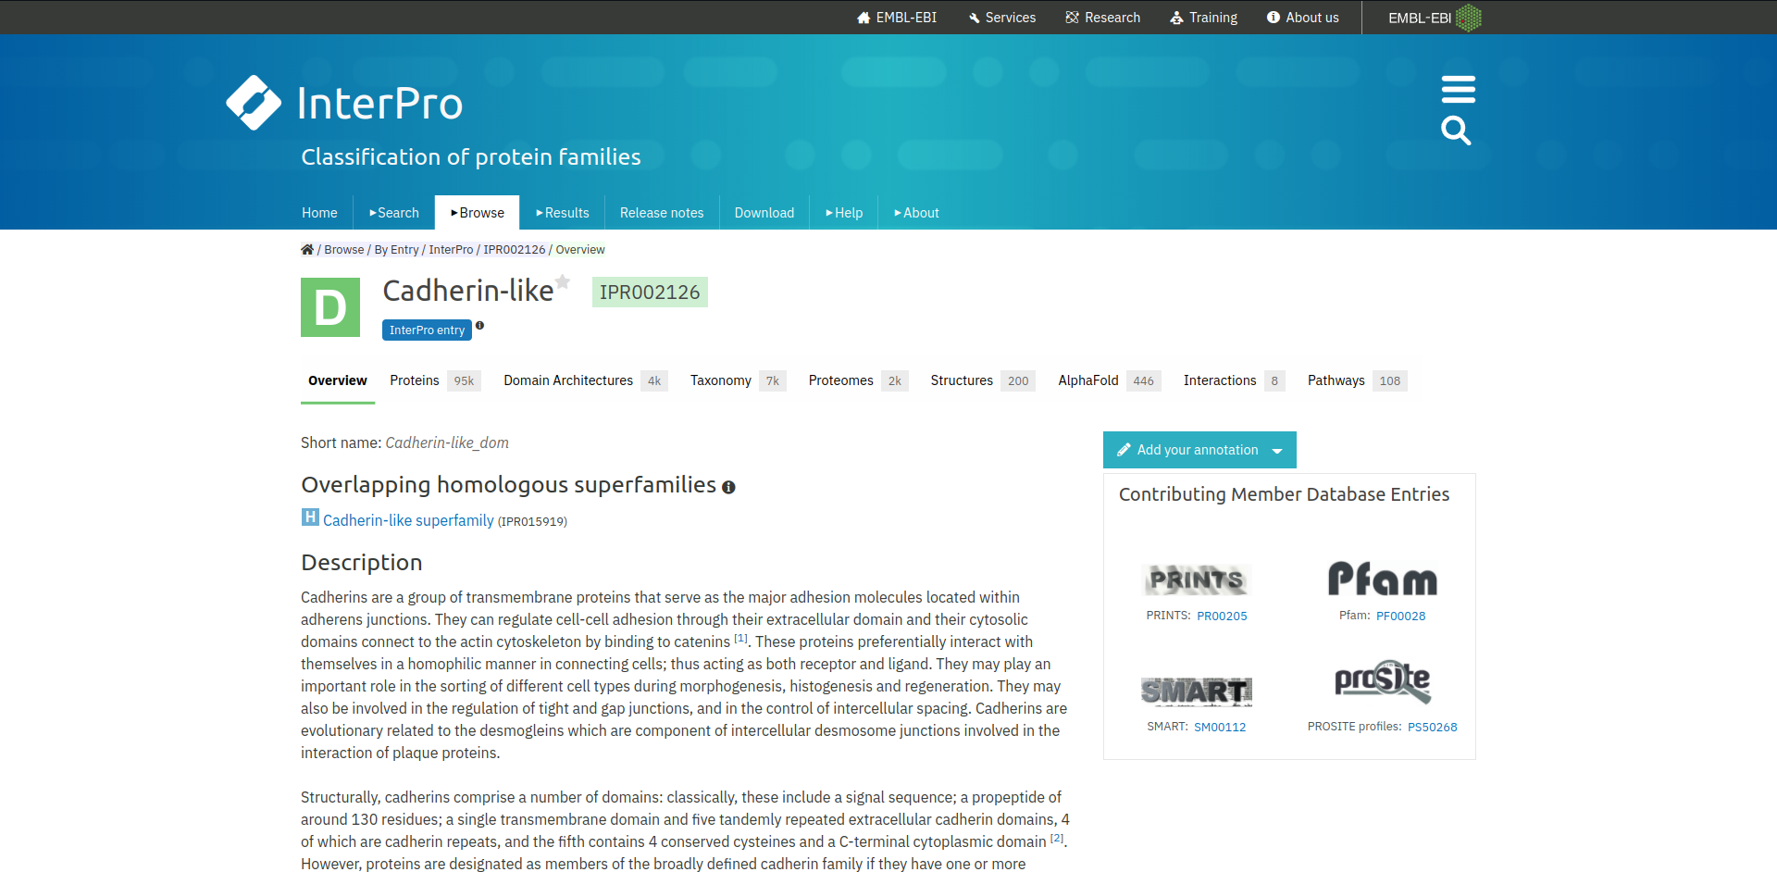**Fig6.1 Result page for Cadherin-like domain**

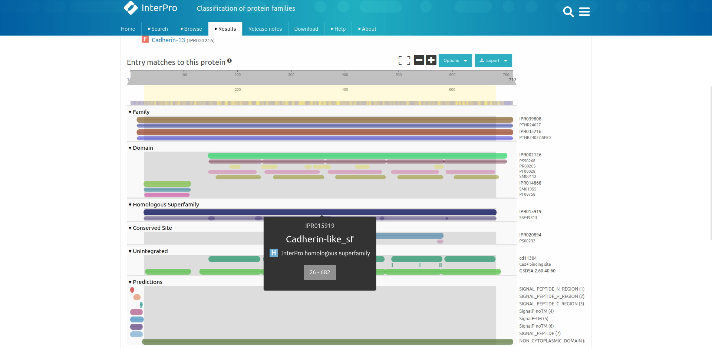**Fig7. Result page for query “Cadherin” Showing its homologous superfamily information**

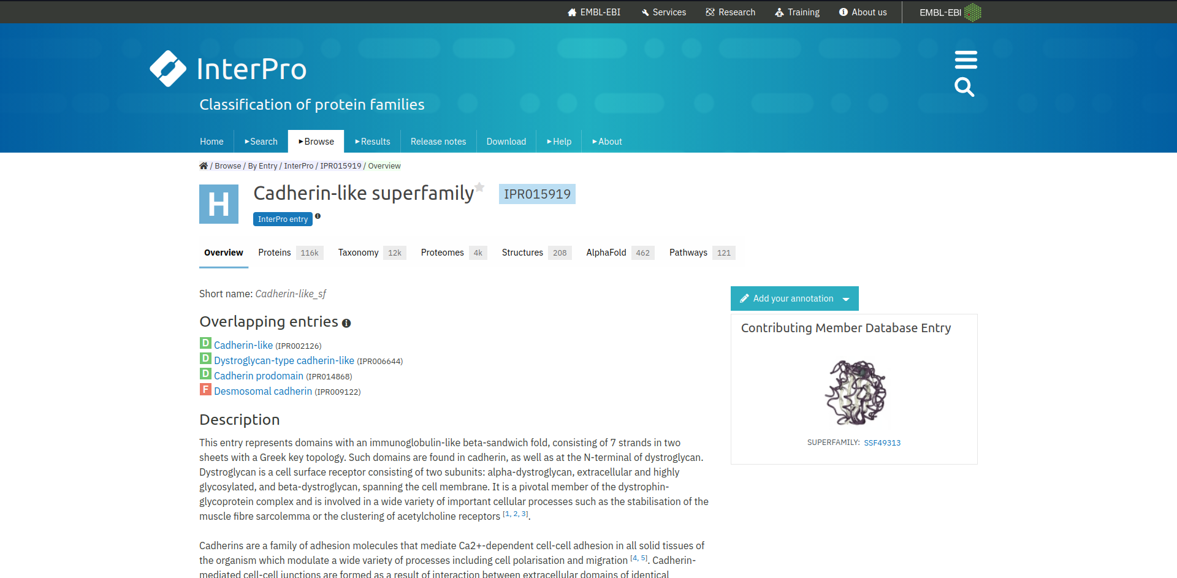**Fig7.1 Result page for Cadherin-Like superfamily**

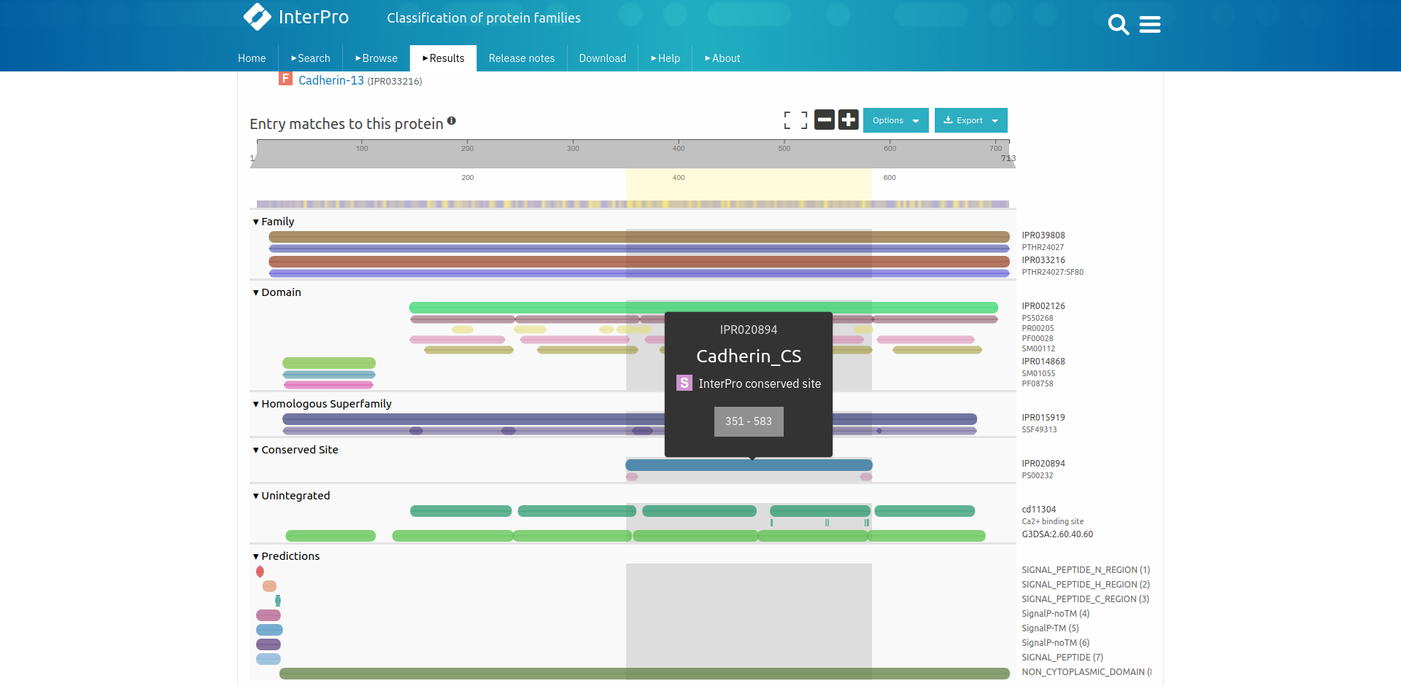**Fig8. Result page for query “Cadherin” Showing conserved site information**

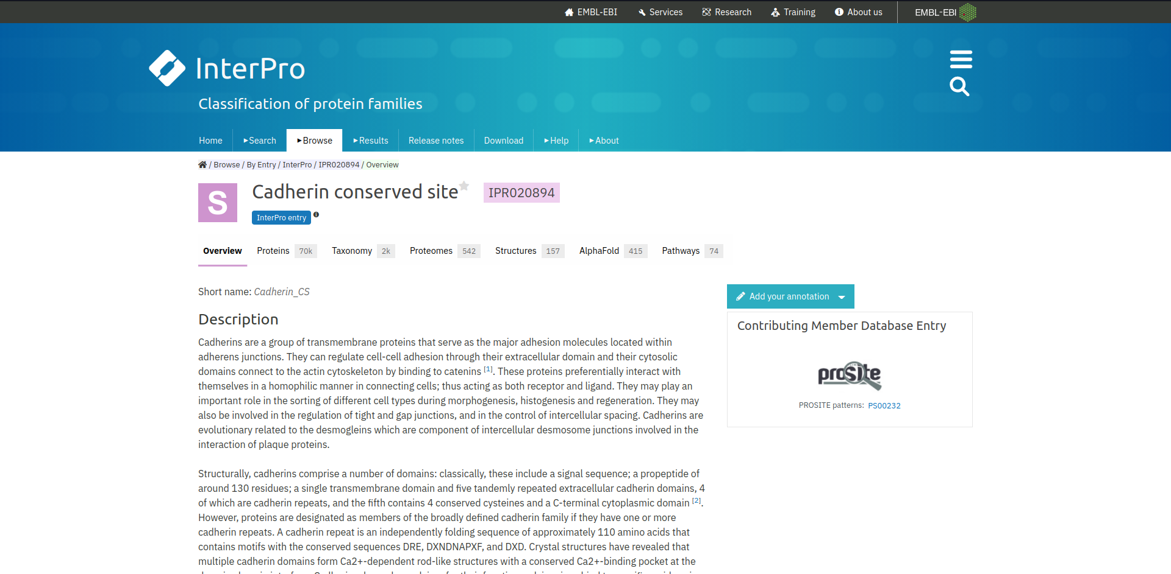**Fig8.1 Result page for Cadherin conserved site**

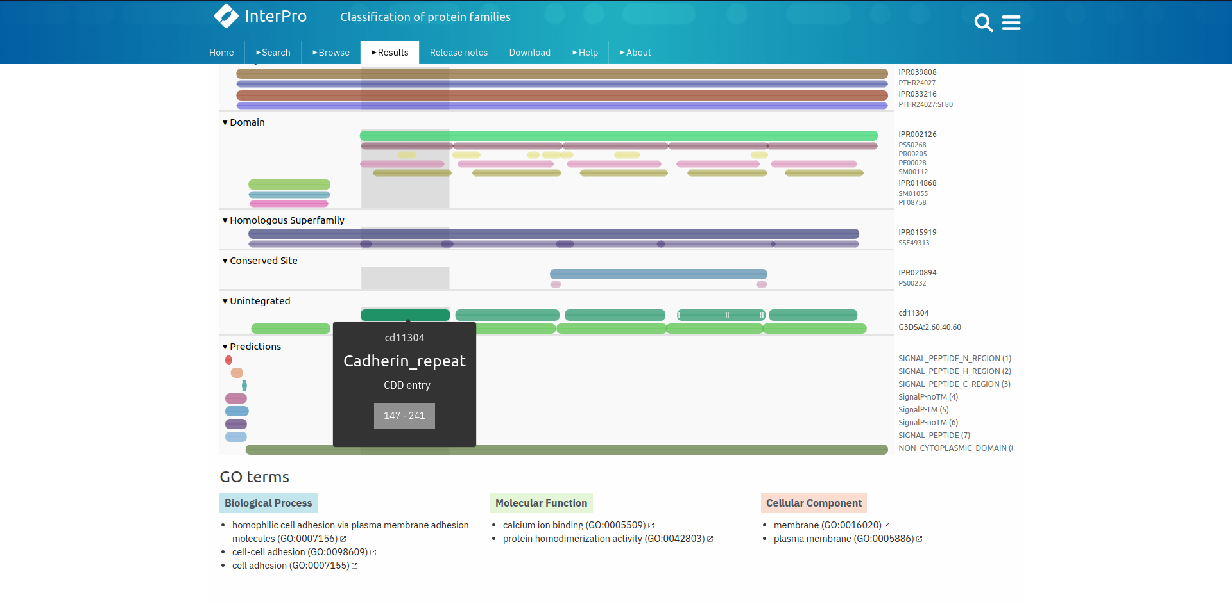**Fig9. Result page for query “Cadherin” showing Unintegrated information**

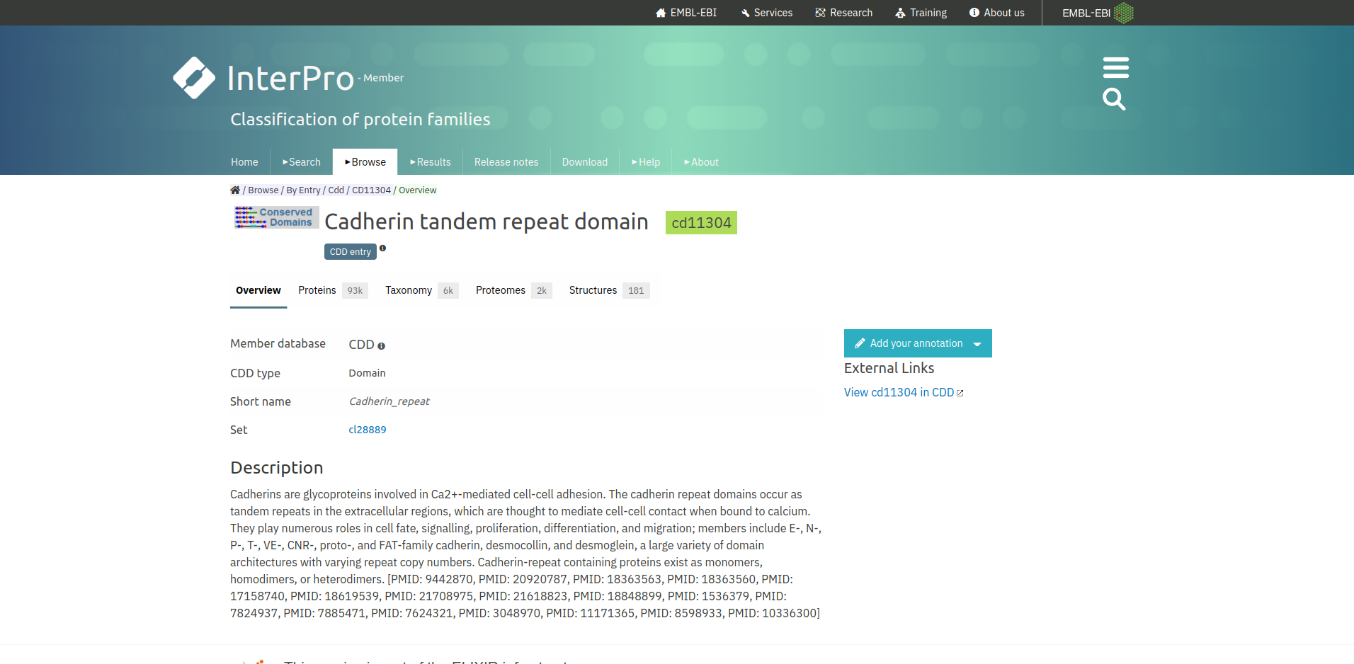**Fig9.1 Result page for Cadherin tandem repeat domain Unintegrated information**

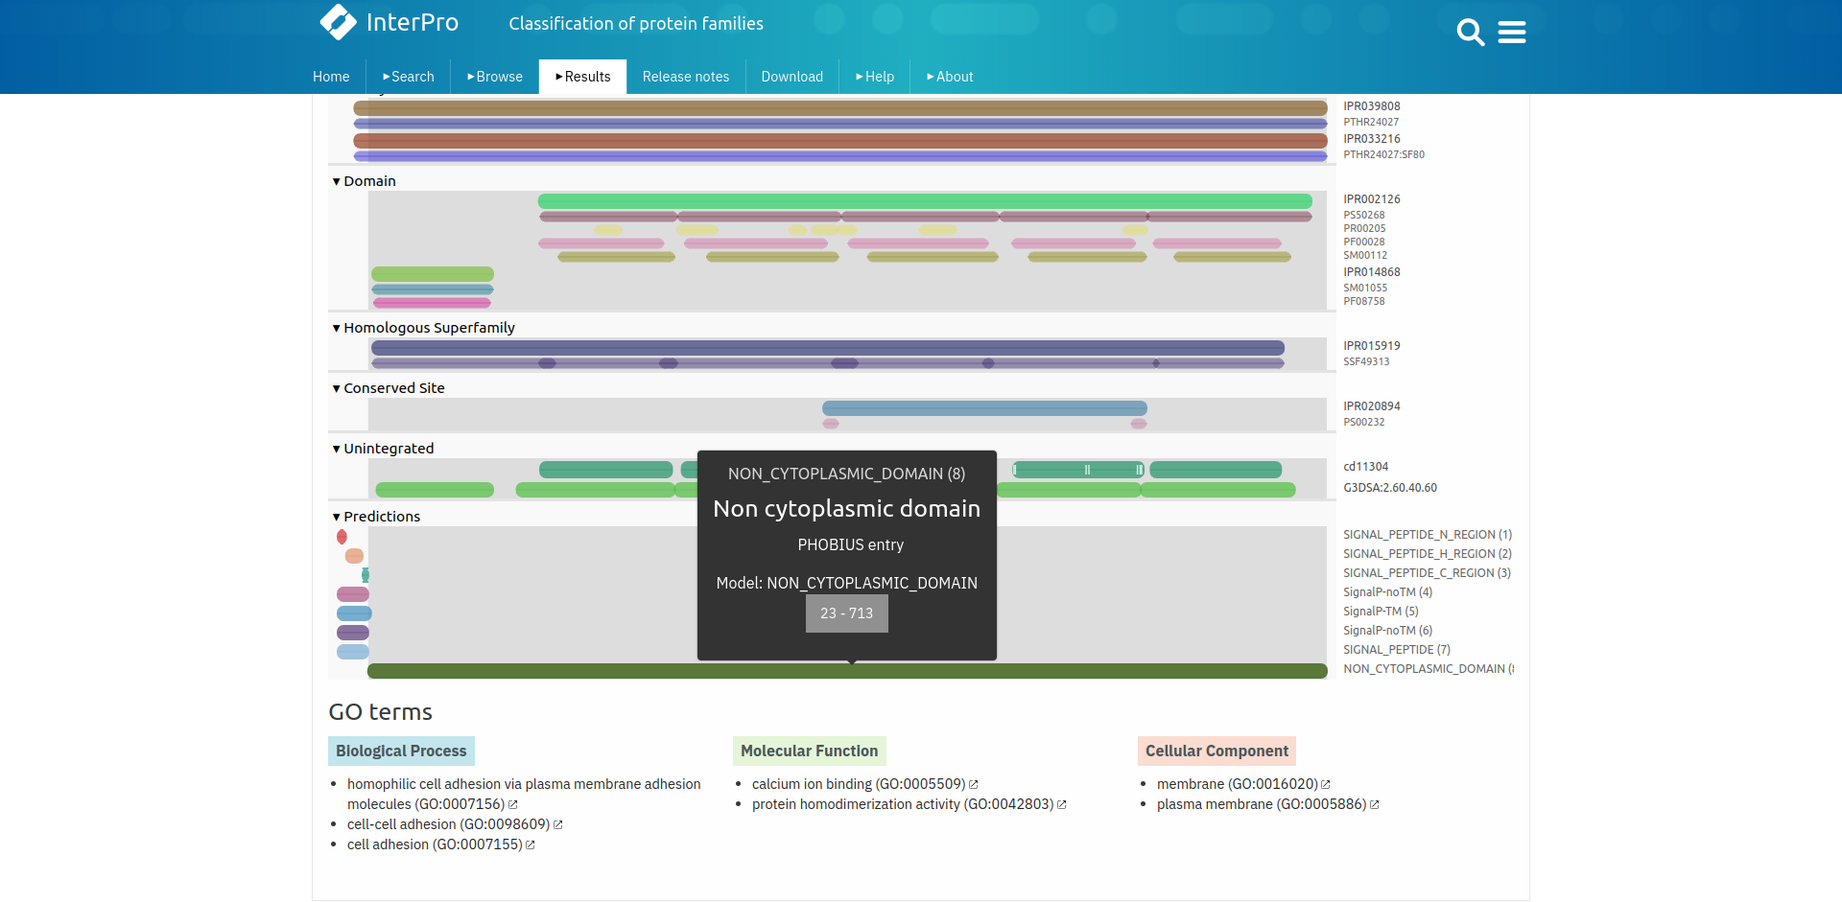**Fig10. Result page for query “Cadherin” Showing predications**

**Result:**

The family, domains, conserved sites, unintegrated information and predictions for Cadherin protein was retrieved from InterPro database

**Conclusion:**

InterPro database provides its users functional analysis of protein which are classified using predictive models into families and predictive domains. It provides information of protein family, domains, conserved and active sites. This database is useful for cross referencing protein domain information with other databases.

**References:**

1. Maître, J. L., & Heisenberg, C. P. (2013). Three Functions of Cadherins in Cell Adhesion. Current Biology, 23(14), R626–R633. <https://doi.org/10.1016/j.cub.2013.06.019>
2. (n.d.). Retrieved from <https://www.ebi.ac.uk/interpro/>
3. (n.d.). Retrieved from <https://www.ebi.ac.uk/interpro/result/InterProScan/#table>
4. (n.d.). Retrieved from <https://www.ebi.ac.uk/interpro/result/InterProScan/iprscan5-R20211012-173752-0624-16335657-p1m/>
5. (n.d.). Retrieved from <https://www.ebi.ac.uk/interpro/entry/InterPro/IPR039808/>
6. (n.d.). Retrieved from <https://www.ebi.ac.uk/interpro/entry/InterPro/IPR002126/>
7. (n.d.). Retrieved from <https://www.ebi.ac.uk/interpro/entry/InterPro/IPR015919/>
8. (n.d.). Retrieved from <https://www.ebi.ac.uk/interpro/entry/InterPro/IPR020894/>
9. (n.d.). Retrieved from <https://www.ebi.ac.uk/interpro/entry/cdd/CD11304/>

**Date: 13-10-21**

**WEBLEM 6**

**Introduction to Specialized Databases**

**Specialized Databases:**

Specialized databases are a collection of focused information on one or more specific fields of study. This information or data is arranged or indexed so that the user can locate and retrieve it quickly and easily.

Features of specialized databases:

* Guaranteed Authoritative information
  + Specialized databases often have strict guidelines on the types of articles and journal sources that are accepted. By searching a database, the articles you find are more likely to be both accurate and reliable.
* They’re Tailored to specific subjects and fields of study
  + The databases outlined in this module are geared towards specific subjects (i.e) medicine, nursing, etc.). When you use these for your research, the articles you find are more likely to be relevant towards your area of study.
* They Provide Full-text and diagrammatic access
  + When accessing these databases you get full text and diagrammatic representation of data available in simple and easy to chunks.

**KEGG:**

While the genome sequencing projects rapidly determine gene catalogs for an increasing number of organisms, functional annotation of individual genes is still largely incomplete. KEGG (Kyoto Encyclopedia of Genes and Genomes) is an effort to link genomic information with higher order functional information by computerizing current knowledge on cellular processes and by standardizing gene annotations.

Generally speaking, the biological function of the living cell is a result of many interacting molecules; it cannot be attributed to just a single gene or a single molecule. The functional assignment in KEGG is a process of linking a set of genes in the genome with a network of interacting molecules in the cell, such as a pathway or a complex, representing a higher order biological function.

**OMIM:**

Online Mendelian Inheritance in Man (OMIM), a continuation of Dr Victor A. McKusick’s Mendelian Inheritance in Man (MIM) (1), is the primary repository of comprehensive, curated information on genes and genetic phenotypes and the relationships between them. MIM was published through 12 editions between 1966 and 1998, and OMIM has been online and searchable since 1987.

With the advent of new sequencing technologies, there is a rapid increase in the reports of presumed gene-phenotype relationships. OMIM.org was created to provide a user-friendly and easily searchable portal to a curated compilation of the literature to aid in clinical and molecular genetic research.

**References:**

1. Hamosh, A. (2004). Online Mendelian Inheritance in Man (OMIM), a knowledgebase of human genes and genetic disorders. *Nucleic Acids Research*, *33*(Database issue), D514–D517. https://doi.org/10.1093/nar/gki033
2. Kanehisa, M. (2000). KEGG: Kyoto Encyclopedia of Genes and Genomes. *Nucleic Acids Research*, *28*(1), 27–30. https://doi.org/10.1093/nar/28.1.27

**Date: 13-10-21**

**WEBLEM 6a**

**(url: https://www.genome.jp/kegg/)**

**Aim:**

To study the AKT Pathway using KEGG Database:

Introduction:

The KEGG database project was initiated in 1995 under the Japanese Human Genome Project, foreseeing the need for a reference resource that would enable understanding of the biological systems, such as the cell and the organism, from genome sequence data. Major efforts have been undertaken to represent the biological systems in terms of molecular networks (molecular wiring diagrams), especially in the form of KEGG pathway maps that are manually created by capturing knowledge from published literature. Continuous efforts have also been made to develop and improve the KO (KEGG Orthology) system for representation of gene/protein functional orthologs in molecular networks.

* **KEGG PATHWAY** is a collection of manually drawn pathway maps representing our knowledge of the molecular interaction, reaction and relation networks for:
* **KEGG BRITE** is a collection of hierarchical classification systems capturing functional hierarchies of various biological objects, especially those represented as KEGG objects. They are represented as BRITE hierarchy files, also called hierarchical text (htext) files, supplemented with BRITE table files using html tables.
* The **KEGG MODULE** database consists of KEGG modules identified by M numbers and KEGG reaction modules identified by RM numbers, which are manually defined functional units of gene sets and reaction sets, respectively. KEGG modules are further divided into pathway modules and signature modules as shown below.
  + Pathway modules – functional units of gene sets in metabolic pathways, including molecular complexes.
  + Signature modules – functional units of gene sets that characterize phenotypic features.
  + Reaction modules – functional units of successive reaction steps in metabolic pathways.

Protein kinase B (Akt), similar to many other protein kinases, is at the crossroads of cell death and survival, playing a pivotal role in multiple interconnected cell signaling mechanisms implicated in cell metabolism, growth and division, apoptosis suppression and angiogenesis. Akt protein kinase displays important metabolic effects, among which are glucose uptake in muscle and fat cells or the suppression of neuronal cell death.

Disruptions in the Akt-regulated pathways are associated with cancer, diabetes, cardiovascular and neurological diseases. The regulation of the Akt signaling pathway renders Akt a valuable therapeutic target. The discovery process of Akt inhibitors using various strategies has led to the identification of inhibitors with great selectivity, low side-effects and toxicity. The usefulness of Akt emerges beyond cancer therapy and extends to other major diseases, such as diabetes, heart diseases, or neurodegeneration.

**Methodology:**

* Open the homepage of KEGG.
* Enter the pathway in search bar.
* Interpret the result.

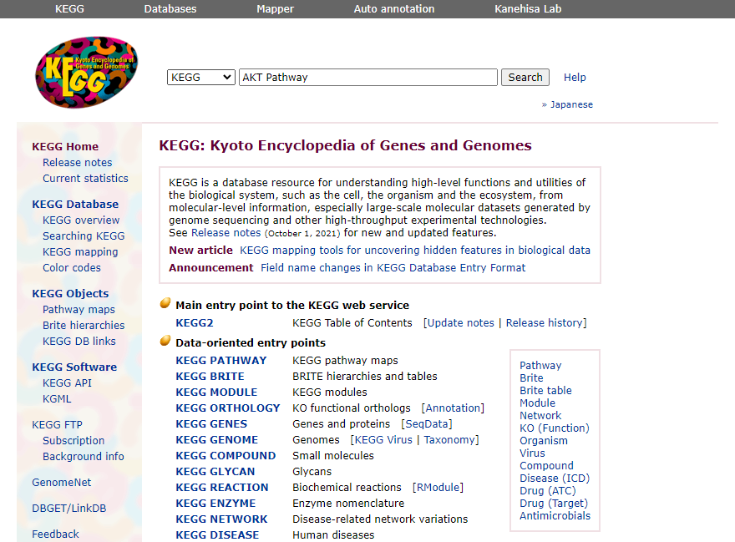**Fig1. Homepage of Kegg with query AKT Pathway**

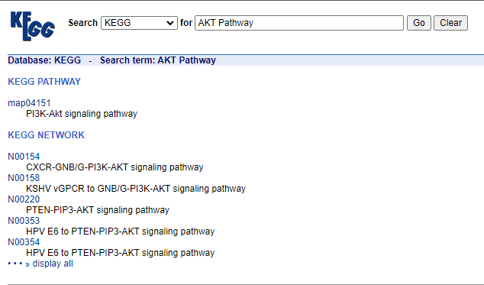**Fig2. Hit page of query AKT Pathway**

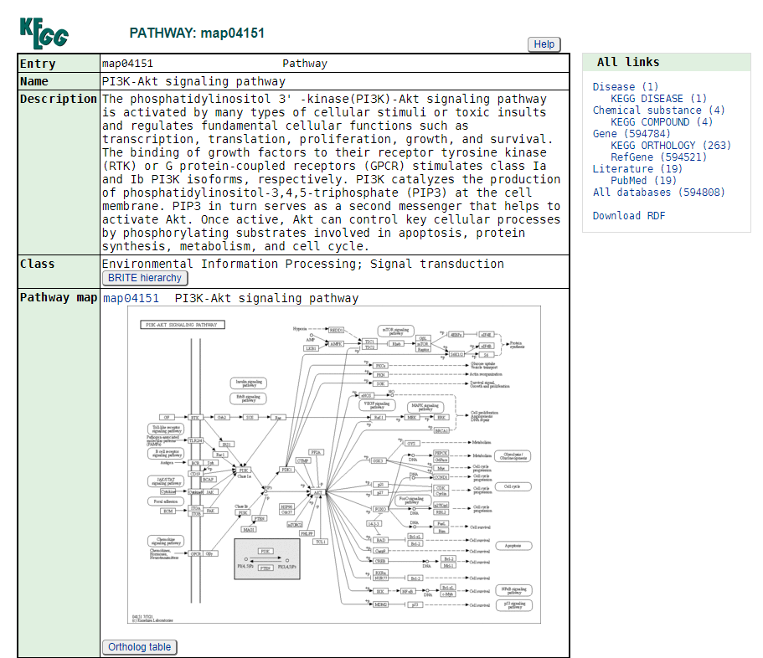**Fig3. Result page for Pathway: map04151**

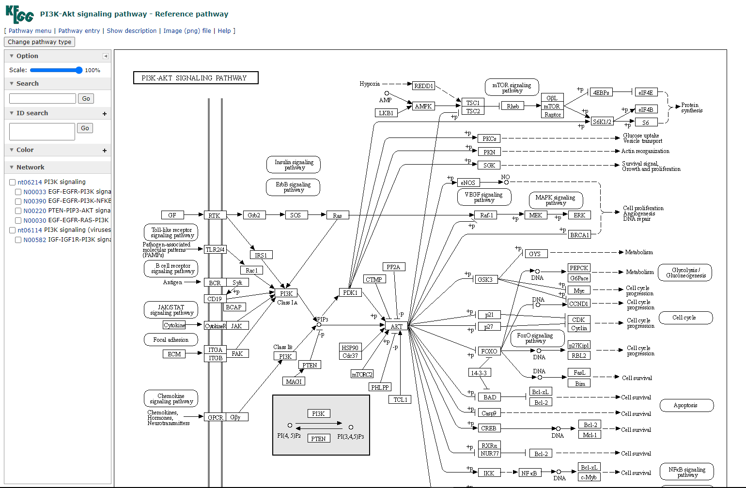**Fig4. AKT signalling pathway – Reference pathway.**

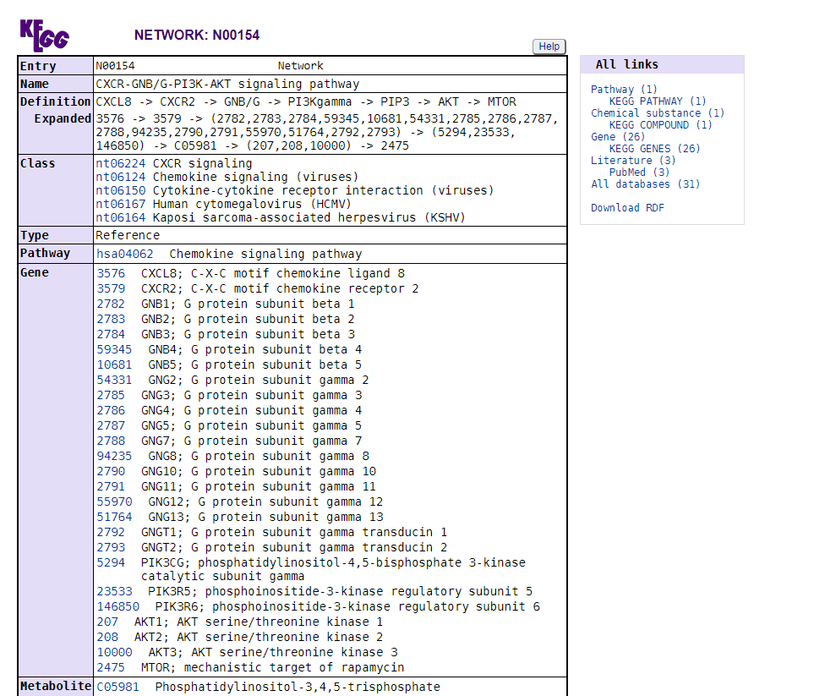**Fig5. KEGG network: N00154**

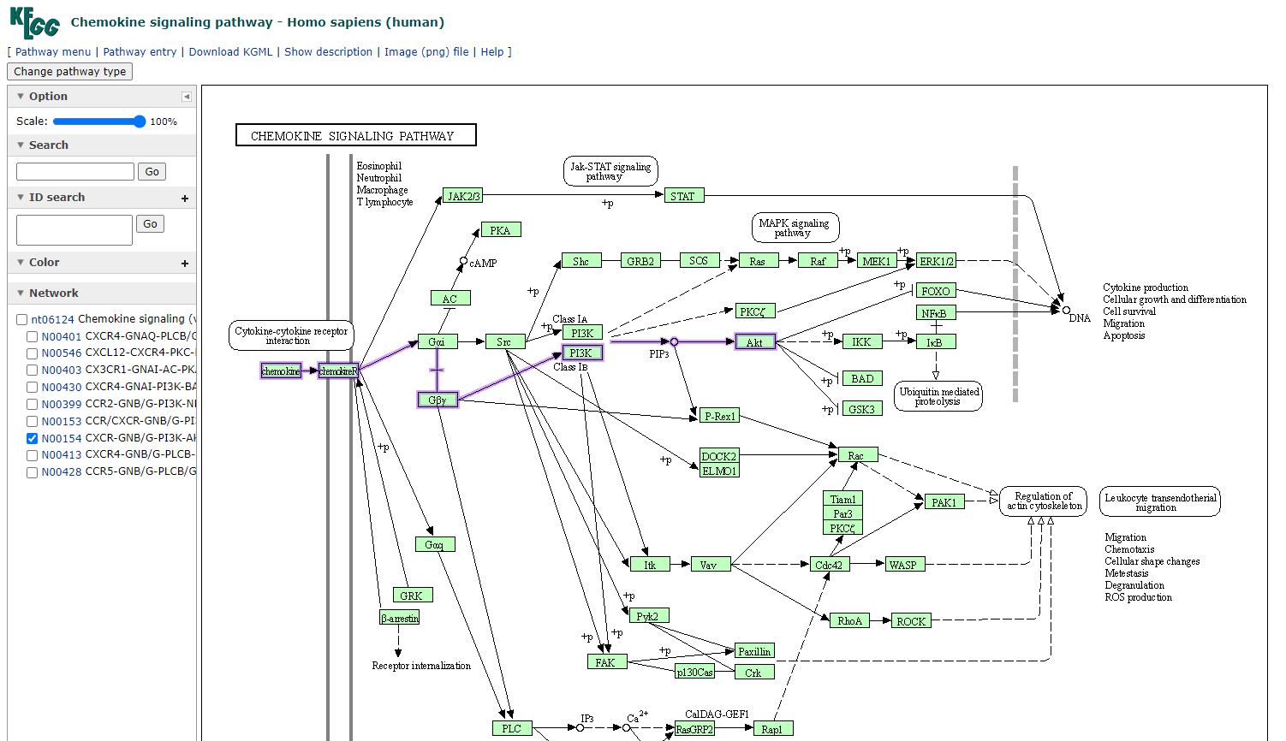**Fig6. KEGG chemokine signalling pathway homo sapiens**

**Results:**

KEGG pathway is a great collection of manually drawn pathway maps representing our knowledge on the molecular interaction and reaction networks.

**Conclusion:**

KEGG is a great resource for the collection and cross checking of manually drawn pathways and information related to the same.

**References:**

1. The Akt Pathway in Oncology Therapy and Beyond (review) George Nitulescu-Maryna Van De Venter-Georgiana Nitulescu-Anca Ungurianu-Petras Juzenas-Qian Peng-Octavian Olaru-Daniela Grădinaru-Aristides Tsatsakis-Dimitris Tsoukalas-Demetrios Spandidos-Denisa Margina - https://www.spandidos-publications.com/10.3892/ijo.2018.4597
2. <https://www.genome.jp/kegg/pathway.html>
3. <https://www.genome.jp/kegg/brite.html>
4. <https://www.genome.jp/kegg/module.html>
5. <https://www.genome.jp/entry/map04151>
6. <https://www.genome.jp/pathway/map04151>
7. <https://www.genome.jp/entry/N00154>
8. <https://www.genome.jp/pathway/hsa04062+N00154>

**Date: 13-10-21**

**WEBLEM 6b**

**(url:** [**https://www.omim.org/**](https://www.omim.org/)**)**

**Aim:**

To study the disease Sickle Cell anemia using OMIM database.

**Introduction:**

Online Mendelian Inheritance in Man (OMIM), a continuation of Dr Victor A. McKusick’s Mendelian Inheritance in Man (MIM) (1), is the primary repository of comprehensive, curated information on genes and genetic phenotypes and the relationships between them. MIM was published through 12 editions between 1966 and 1998, and OMIM has been online and searchable since 1987.

With the advent of new sequencing technologies, there is a rapid increase in the reports of presumed gene-phenotype relationships. OMIM.org was created to provide a user-friendly and easily searchable portal to a curated compilation of the literature to aid in clinical and molecular genetic research.

Advanced Search : In advanced search we can find history for our Entry.

Phenotype MIM Number : Main entry.

Genelocus MIM Number : Gene Information.

**Symbols:**

1. Phenotype Description , molecular basis known
2. Gene Discription
3. Phenotype & Gene Combine
4. No Symbol: Other , mainly phenotype with suspected mendelian basis.

Sickle cell anemia is one of a group of disorders known as sickle cell disease. Sickle cell anemia is an inherited red blood cell disorder in which there aren't enough healthy red blood cells to carry oxygen throughout your body. Normally, the flexible, round red blood cells move easily through blood vessels. In sickle cell anemia, the red blood cells are shaped like sickles or crescent moons. These rigid, sticky cells can get stuck in small blood vessels, which can slow or block blood flow and oxygen to parts of the body.

**Methodology:**

1. Open the homepage of OMIM.
2. Entry the query in search bar.
3. Open the Result page.
4. Interpret the Result.

**Observation:**

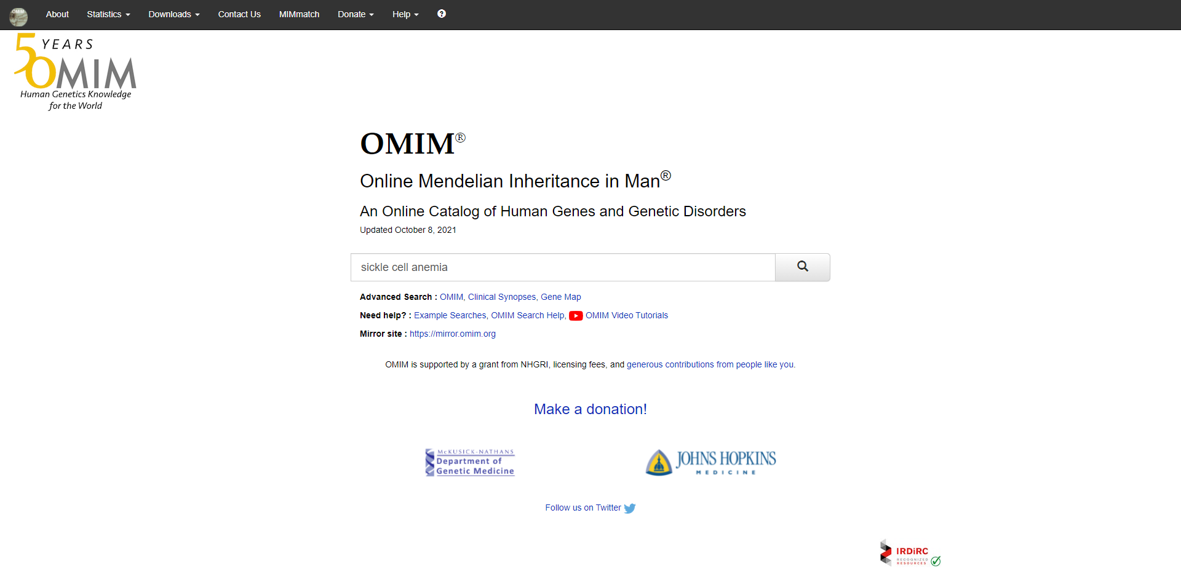**Fig1. Homepage of OMIM with query Sickle cell anemia**

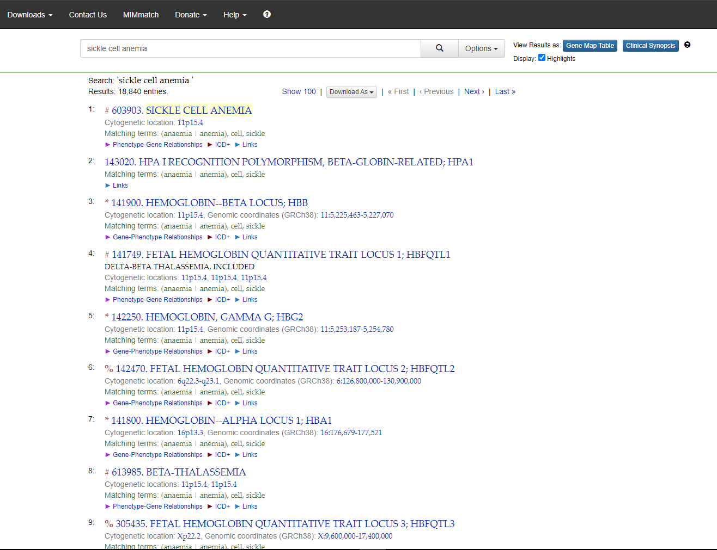**Fig2. Hit page for query Sickle cell anemia showing 18,840 entries**

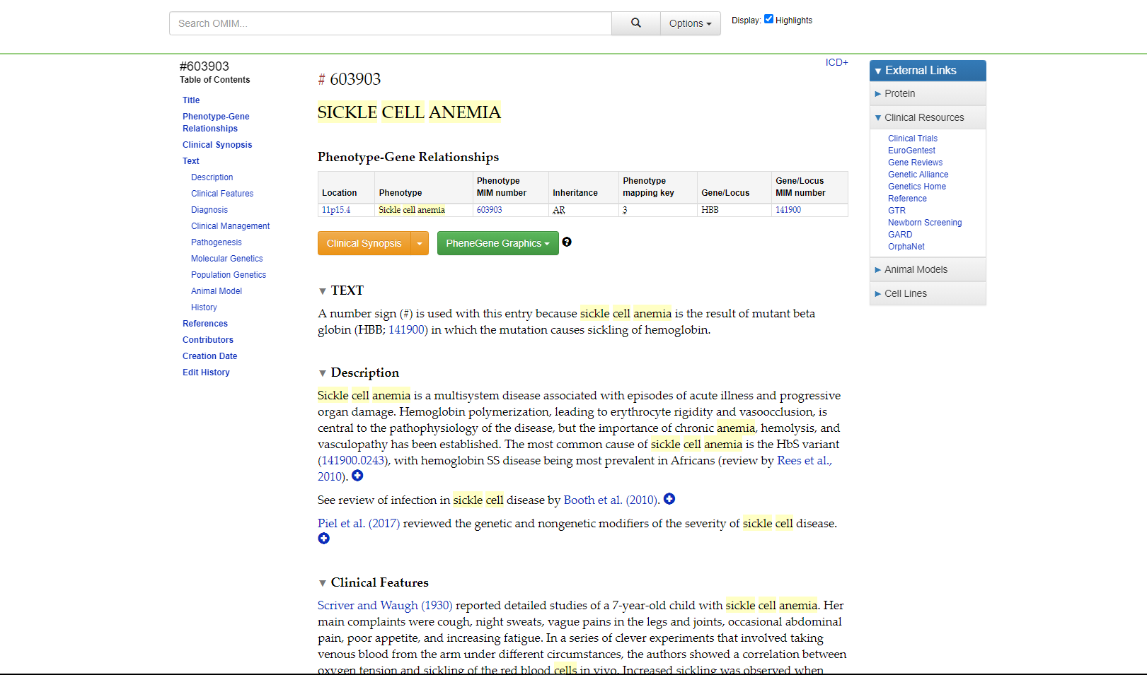**Fig3. Result page for Sickle cell anemia**

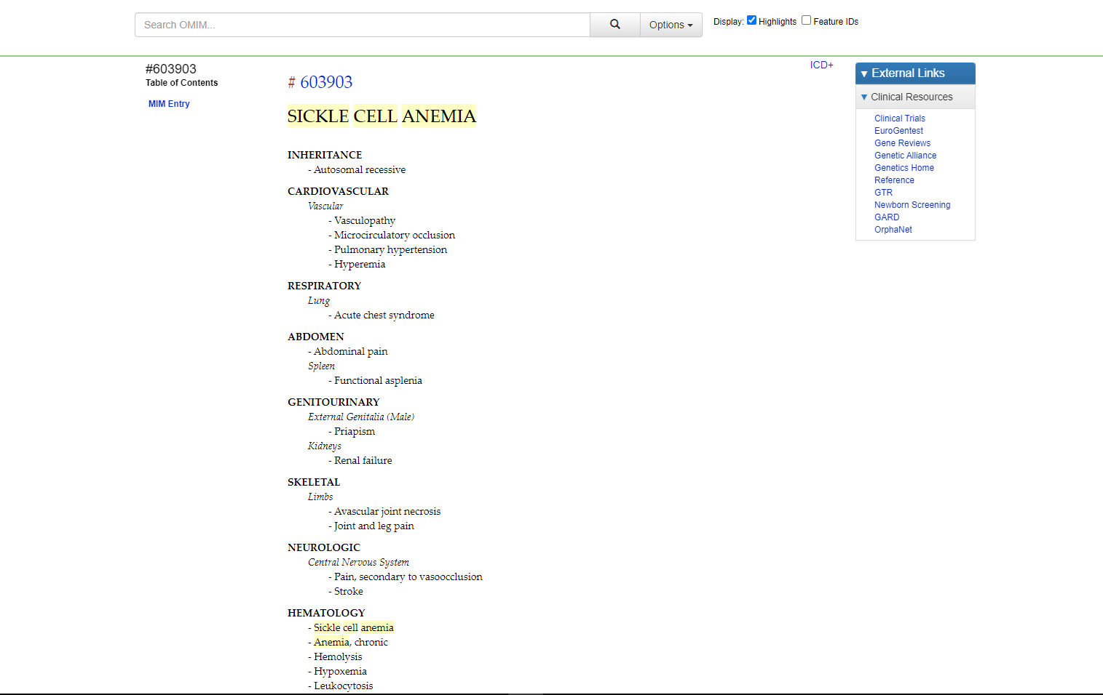**Fig4. Clinical synopsis for sickle cell anemia**

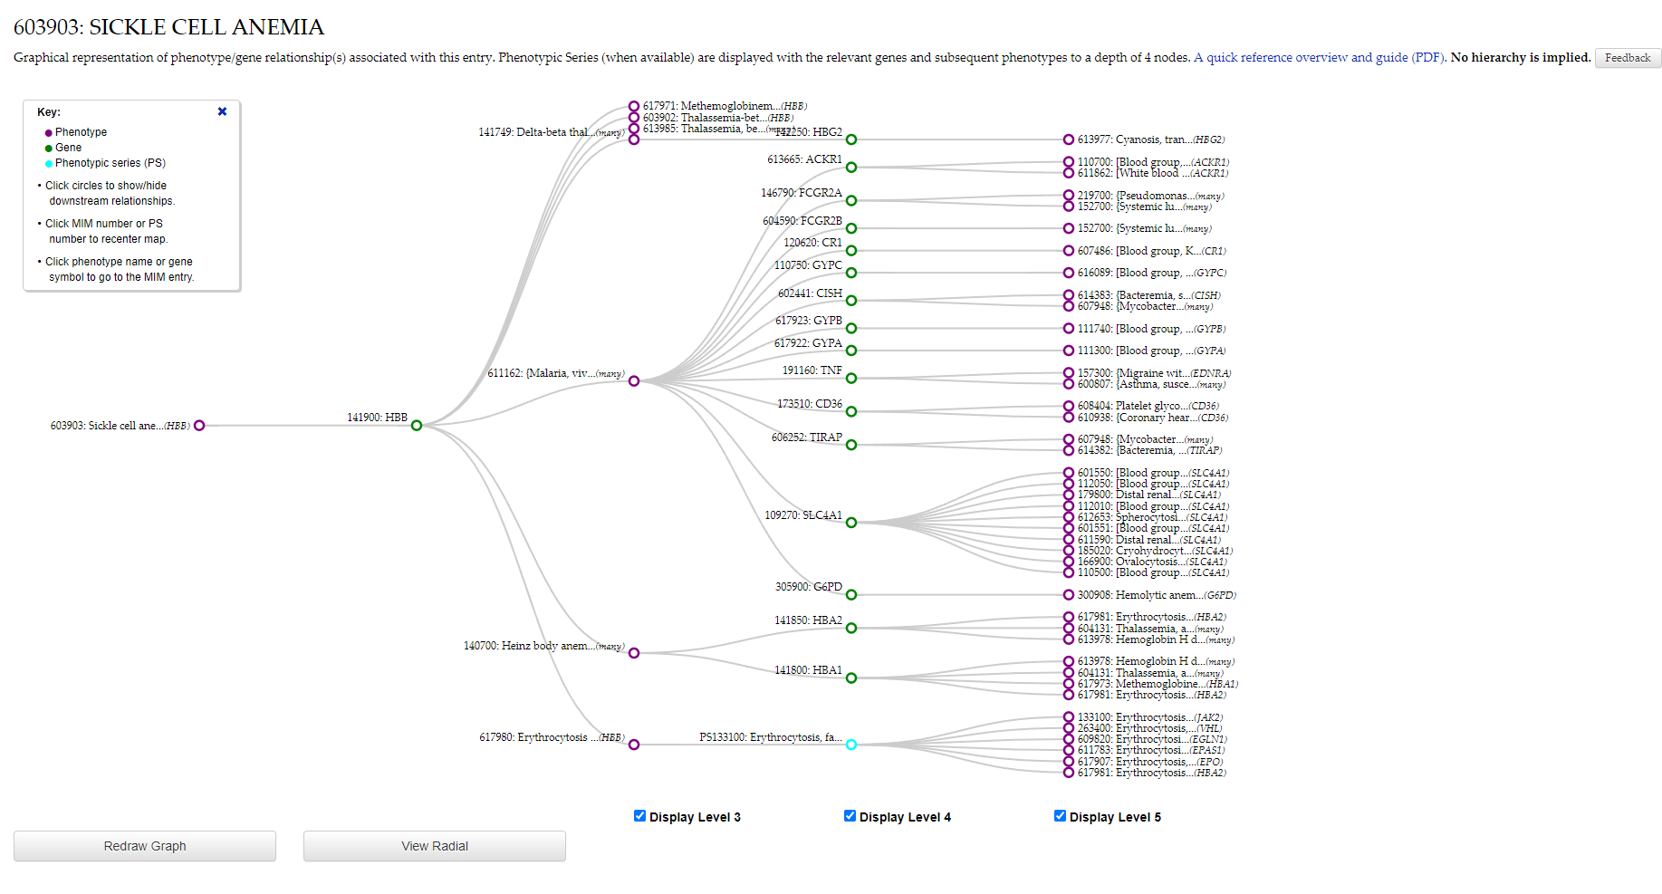**Fig5. Phenegene linear graphics**

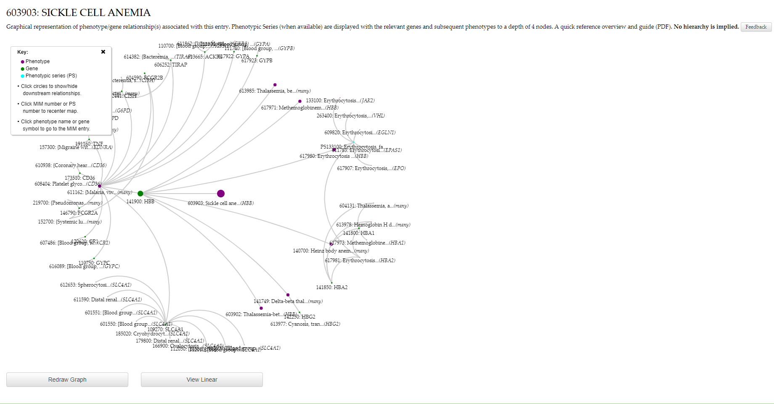**Fig6. Phenegene radial graphics**

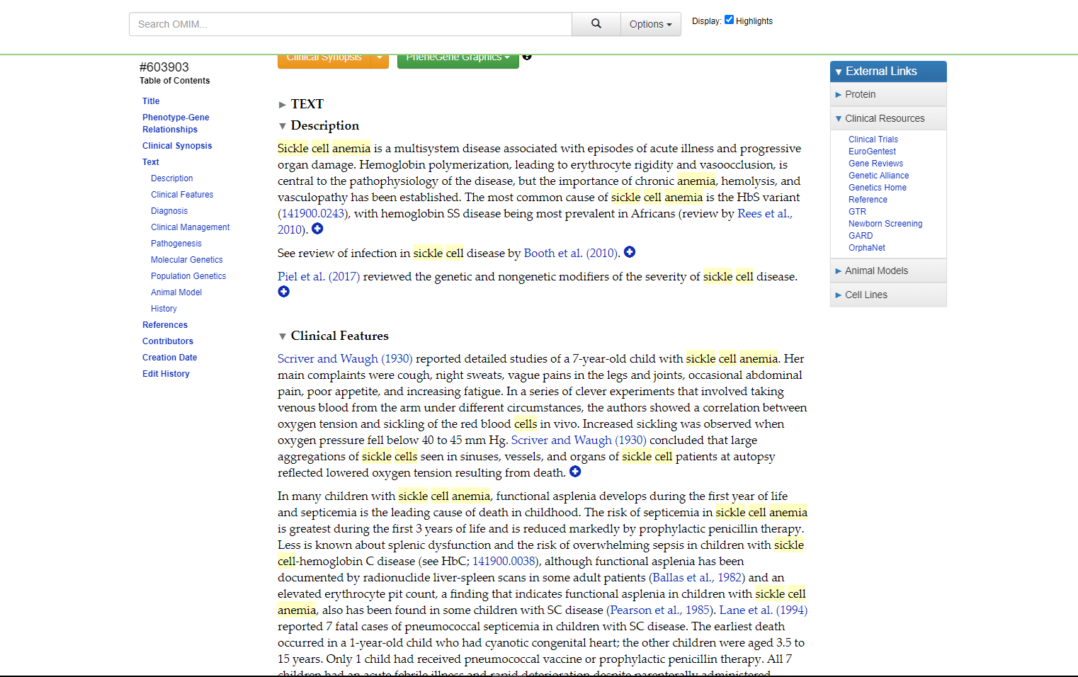**Fig7. Description for query sickle cell anemia**

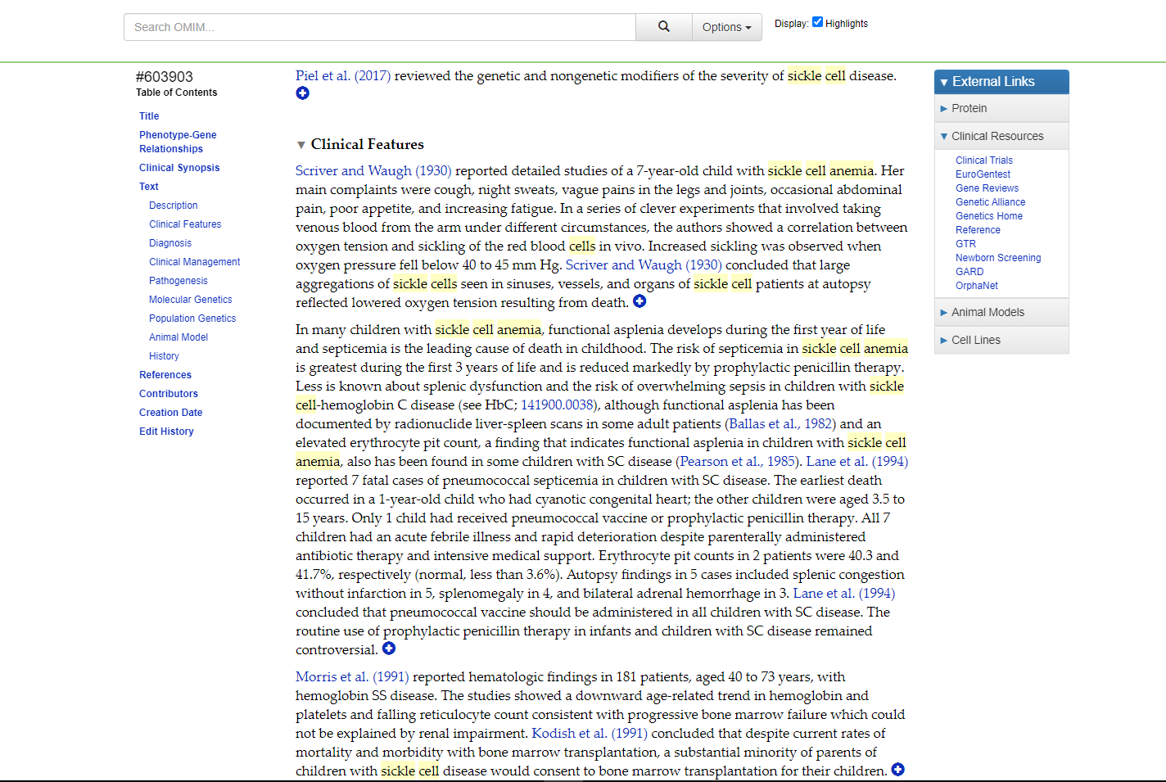**Fig8. Clinical Features for query sickle cell anemia**

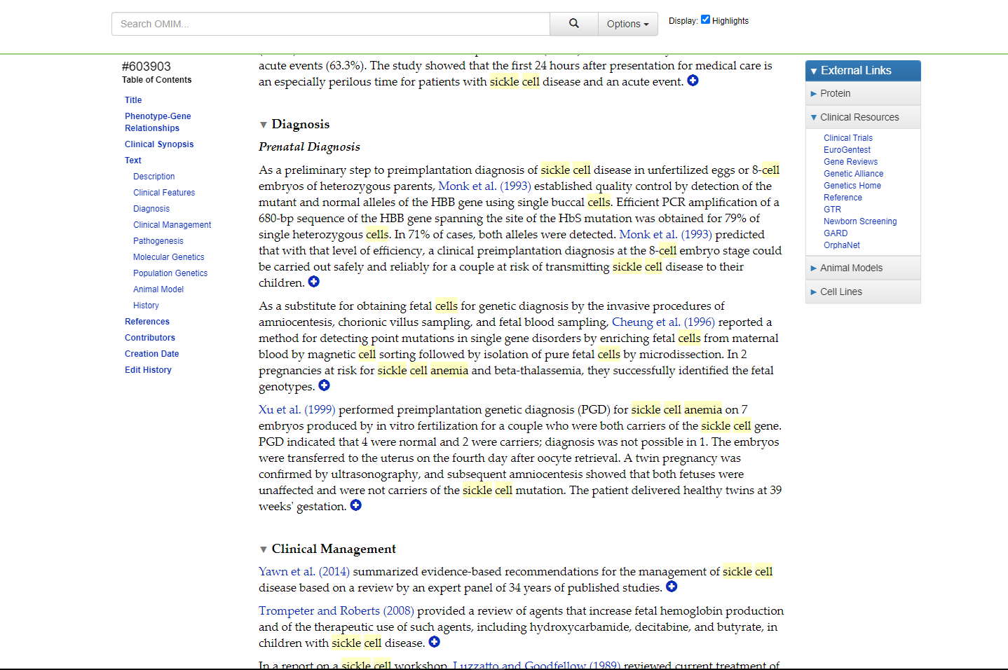**Fig9. Diagnosis for query sickle cell anemia**

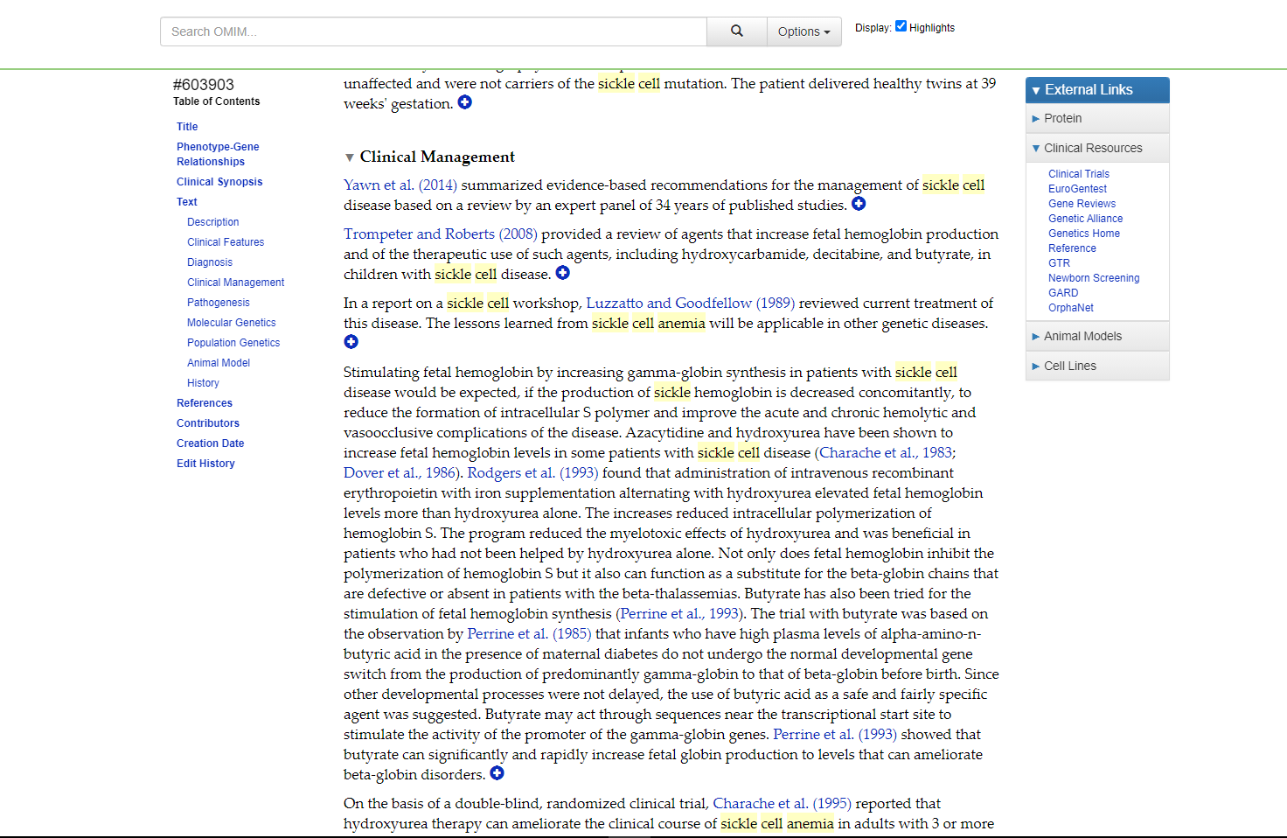**Fig10. Clinical Management for query sickle cell anemia**

**Results:**

In OMIM database the query sickle cell anemia shows 18,841 entries. It gives information regarding Human Genes & Genetic Disorders

**Conclusions:**

OMIM is a very easy to use and accessible database of human genes and genetic disorders compiled to support human genetics research and education and the practice of clinical genetics.

**References:**

1. <https://www.mayoclinic.org/diseases-conditions/sickle-cell-anemia/symptoms-causes/syc-20355876#:~:text=Sickle%20cell%20anemia%20is%20one,move%20easily%20through%20blood%20vessels>.
2. <https://www.omim.org/>
3. <https://www.omim.org/search?index=entry&sort=score+desc%2C+prefix_sort+desc&start=1&limit=10&search=Sickle+cell+anemia>
4. [https://www.omim.org/entry/603903?search=sickle%20cell%20anemia&highlight=%28anaemia%7Canemia%29%20cell%20sickle](https://www.omim.org/entry/603903?search=sickle%20cell%20anemia&highlight=%28anaemia|anemia%29%20cell%20sickle)
5. <https://www.omim.org/clinicalSynopsis/603903?highlight=(anaemia>|anemia)%20cell%20sickle
6. <https://www.omim.org/graph/linear/603903>
7. <https://www.omim.org/graph/radial/603903>
8. [https://www.omim.org/entry/603903?search=sickle%20cell%20anemia&highlight=%28anaemia%7Canemia%29%20cell%20sickle#description](https://www.omim.org/entry/603903?search=sickle%20cell%20anemia&highlight=%28anaemia|anemia%29%20cell%20sickle#description)
9. [https://www.omim.org/entry/603903?search=sickle%20cell%20anemia&highlight=%28anaemia%7Canemia%29%20cell%20sickle#diagnosis](https://www.omim.org/entry/603903?search=sickle%20cell%20anemia&highlight=%28anaemia|anemia%29%20cell%20sickle#diagnosis)
10. [https://www.omim.org/entry/603903?search=sickle%20cell%20anemia&highlight=%28anaemia%7Canemia%29%20cell%20sickle#clinicalFeatures](https://www.omim.org/entry/603903?search=sickle%20cell%20anemia&highlight=%28anaemia|anemia%29%20cell%20sickle#clinicalFeatures)
11. [https://www.omim.org/entry/603903?search=sickle%20cell%20anemia&highlight=%28anaemia%7Canemia%29%20cell%20sickle#clinicalManagement](https://www.omim.org/entry/603903?search=sickle%20cell%20anemia&highlight=%28anaemia|anemia%29%20cell%20sickle#clinicalManagement)

**Date: 17-10-21**

**WEBLEM 7**

**Introduction of Structure Database**

The Protein Data Bank (PDB) at Brookhaven National Laboratory (BNL), is a database containing experimentally determined three-dimensional structures of proteins, nucleic acids and other biological macromolecules (Abola et al., 1987, 1997; Bernstein et al., 1977).

The PDB has a 26-year history of service to a global community of researchers, educators and students in a wide variety of scientific disciplines.

The archives contain atomic coordinates, citations, primary and secondary structure information, crystallographic structure experimental data, as well as hyperlinks to many other scienti®c databases.

Scientists around the world contribute structures to the PDB and use it on a daily basis. The common interest shared by this community is a need to access information that can relate the biological functions of macromolecules to their three-dimensional structures.

RCSB PDB (Research Collaboratory for Structural Bioinformatics PDB) operates the US data center for the global PDB archive, and makes PDB data available at no charge to all data consumers without limitations on usage (Policies).

**Observations:**

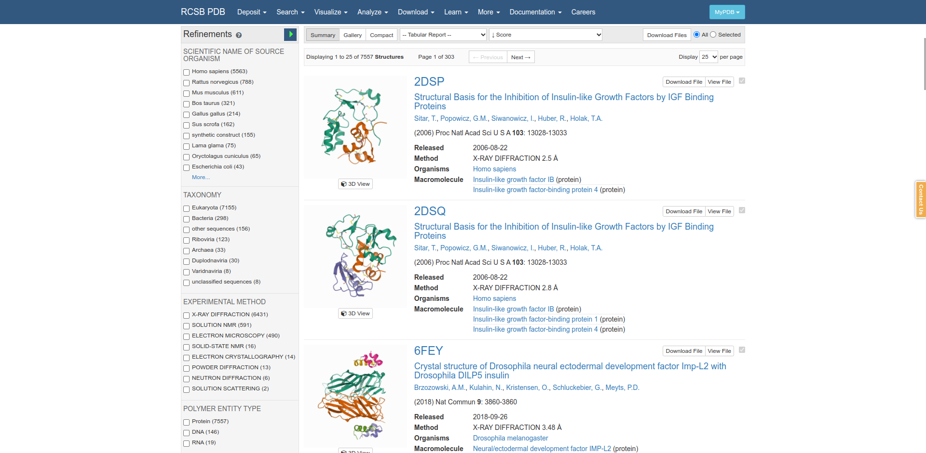**Fig1. Summary form in PDB Database**

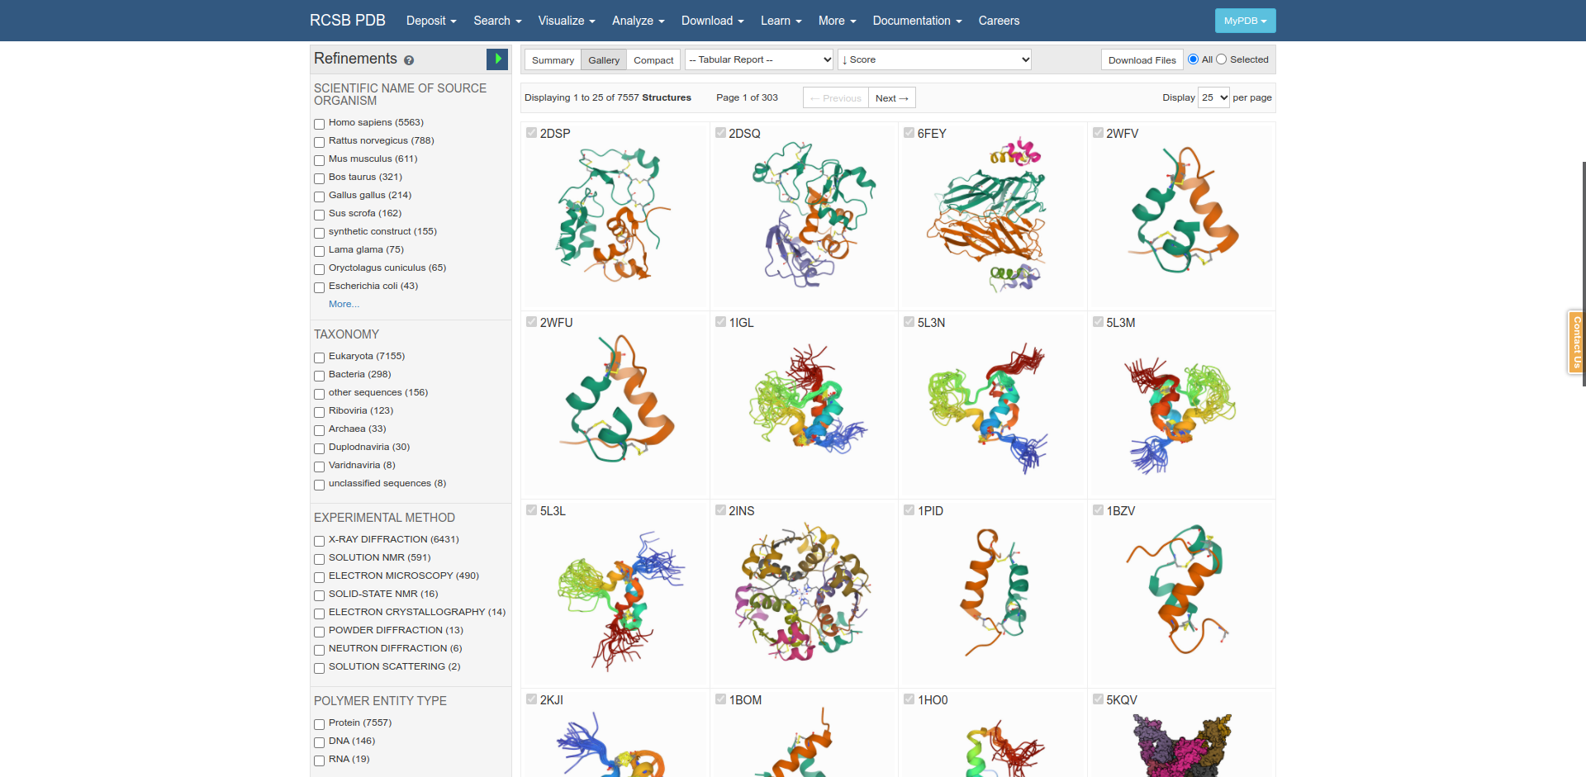**Fig2. Gallery form in PDB database**

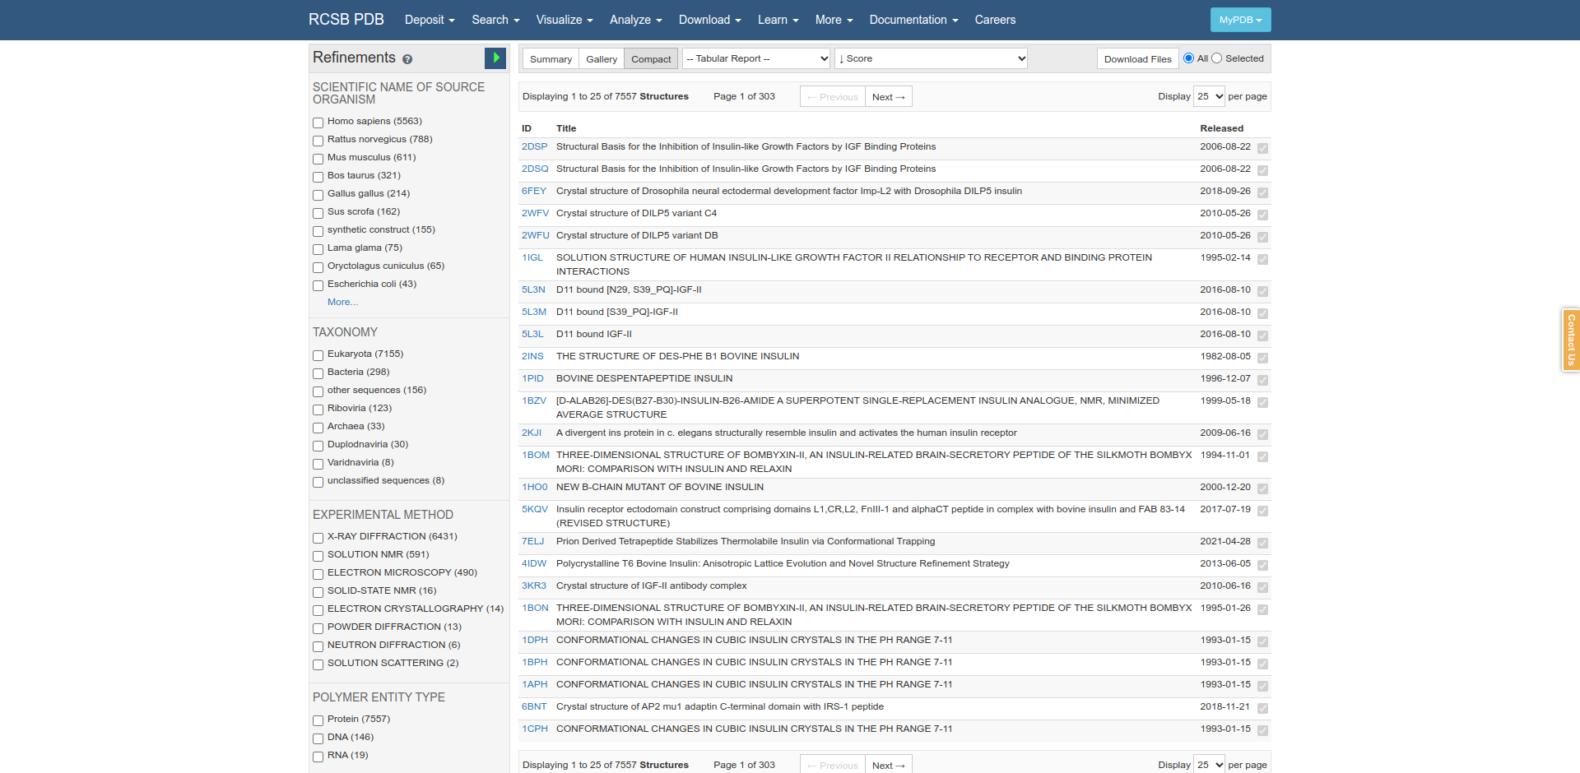**Fig3. Compact form in PDB database**

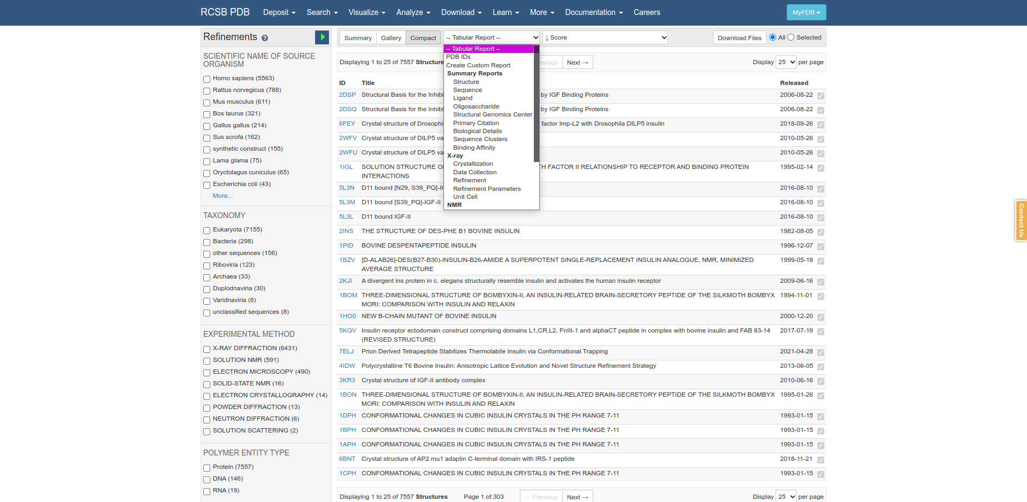**Fig4. Tabular Report form in PDB Database**

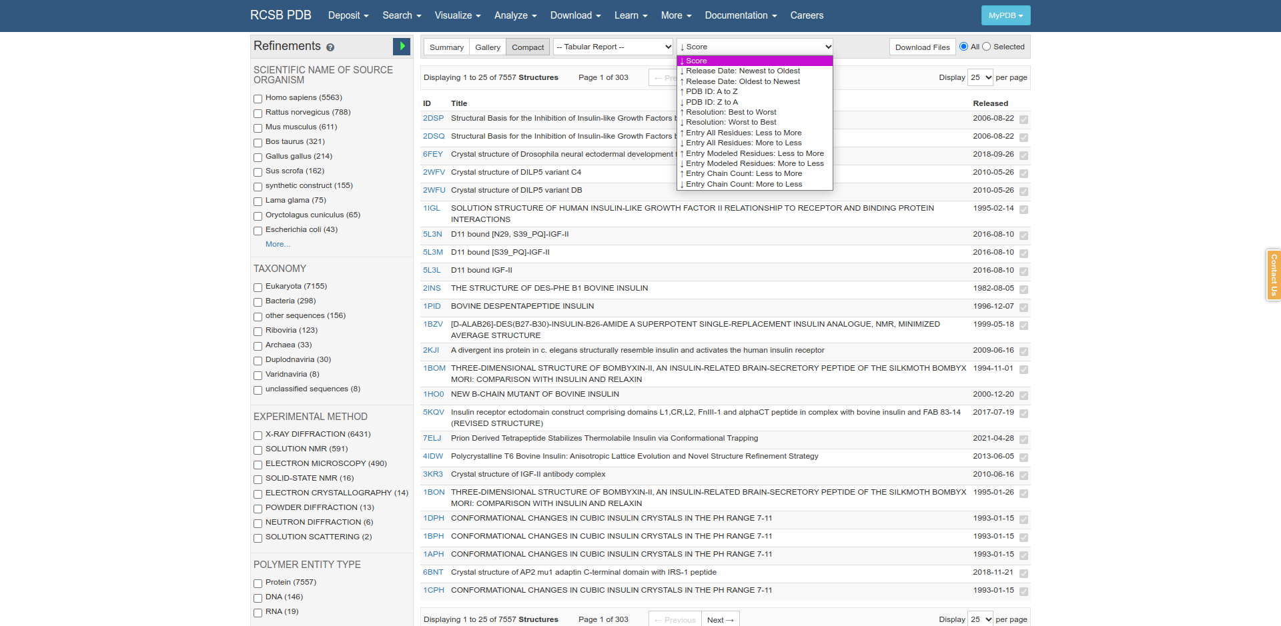**Fig5. Score form in PDB Database.**

**References:**

1. Sussman, J. L., Lin, D., Jiang, J., Manning, N. O., Prilusky, J., Ritter, O., & Abola, E. E. (1998). Protein Data Bank (PDB): Database of Three-Dimensional Structural Information of Biological Macromolecules. Acta Crystallographica Section D Biological Crystallography, 54(6), 1078–1084. https://doi.org/10.1107/s0907444998009378
2. Bank, R. P. (n.d.). Homepage. Retrieved from <https://www.rcsb.org/>

**Date: 8-11-21**

**WEBLEM 7a**

**(URL:** [**https://www.rcsb.org/**](https://www.rcsb.org/)**)**

**Aim:**

To study “Insulin” Query in Structure Database PDB.

**Introduction:**

The Protein Data Bank (PDB) at Brookhaven National Laboratory (BNL), is a database containing experimentally determined three-dimensional structures of proteins, nucleic acids and other biological macromolecules (Abola et al., 1987, 1997; Bernstein et al., 1977).

The PDB has a 26-year history of service to a global community of researchers, educators and students in a wide variety of scientific disciplines.

The archives contain atomic coordinates, citations, primary and secondary structure information, crystallographic structure experimental data, as well as hyperlinks to many other scientific databases.

Insulin is a medication used in the treatment and management of diabetes mellitus type-1 and sometimes diabetes mellitus type-2, both of which are significant risk factors for coronary artery disease, stroke, peripheral vascular disease, and a host of other vascular conditions. This activity reviews the indications, contraindications, activity, adverse events, and other key elements of Insulin therapy in the clinical setting related to the essential points needed by members of an interprofessional team managing the care of patients with diabetes and its related conditions and sequelae.

**Methodology:**

1. Open the Homepage of PDB.
2. Enter the Query “Insulin”
3. Open the Result page for the query
4. Interpret the results.

**Observation:**

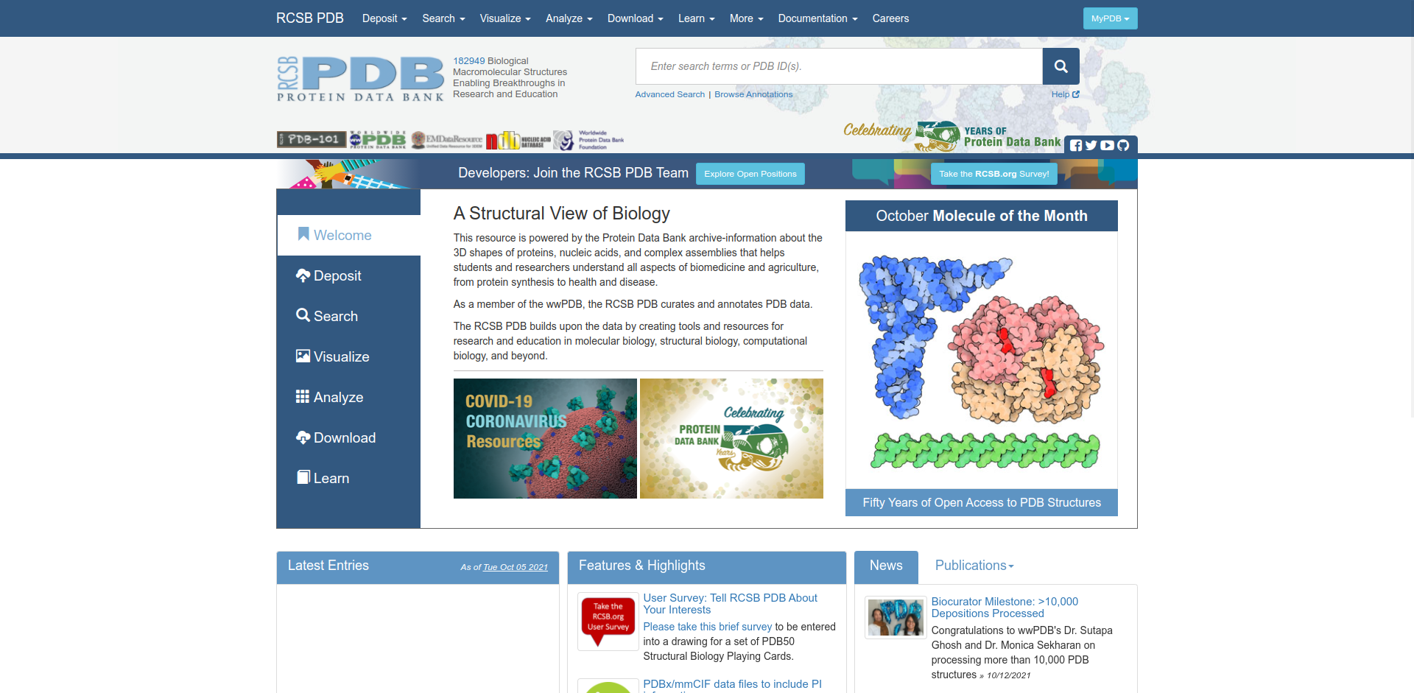**Fig1. Homepage of PDB Database**

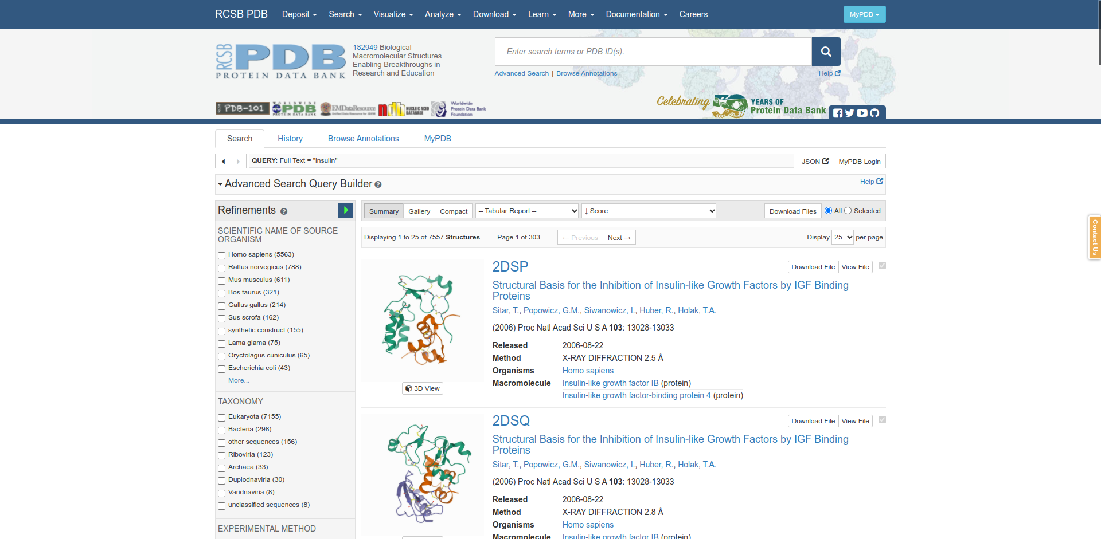**Fig2. Hitpage for query “Insulin”**

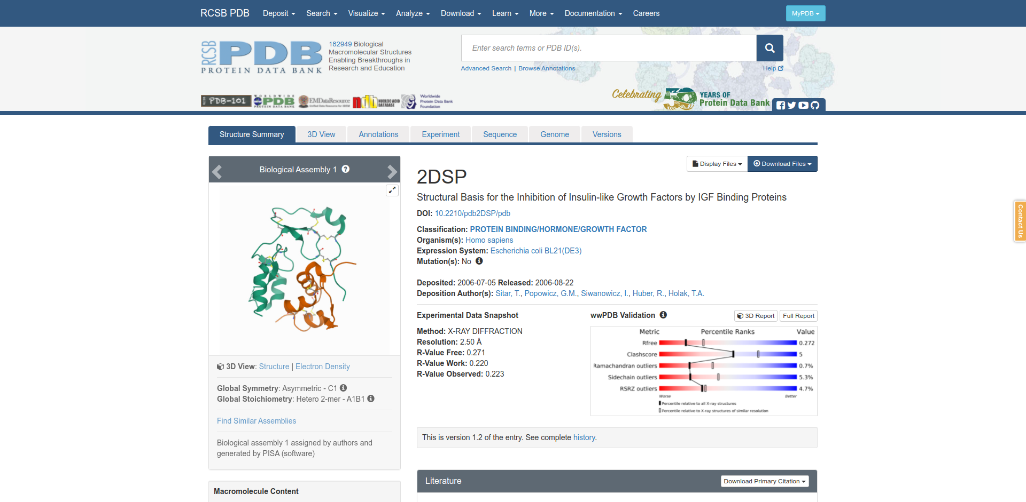**Fig3. Result page for query “Insulin”**

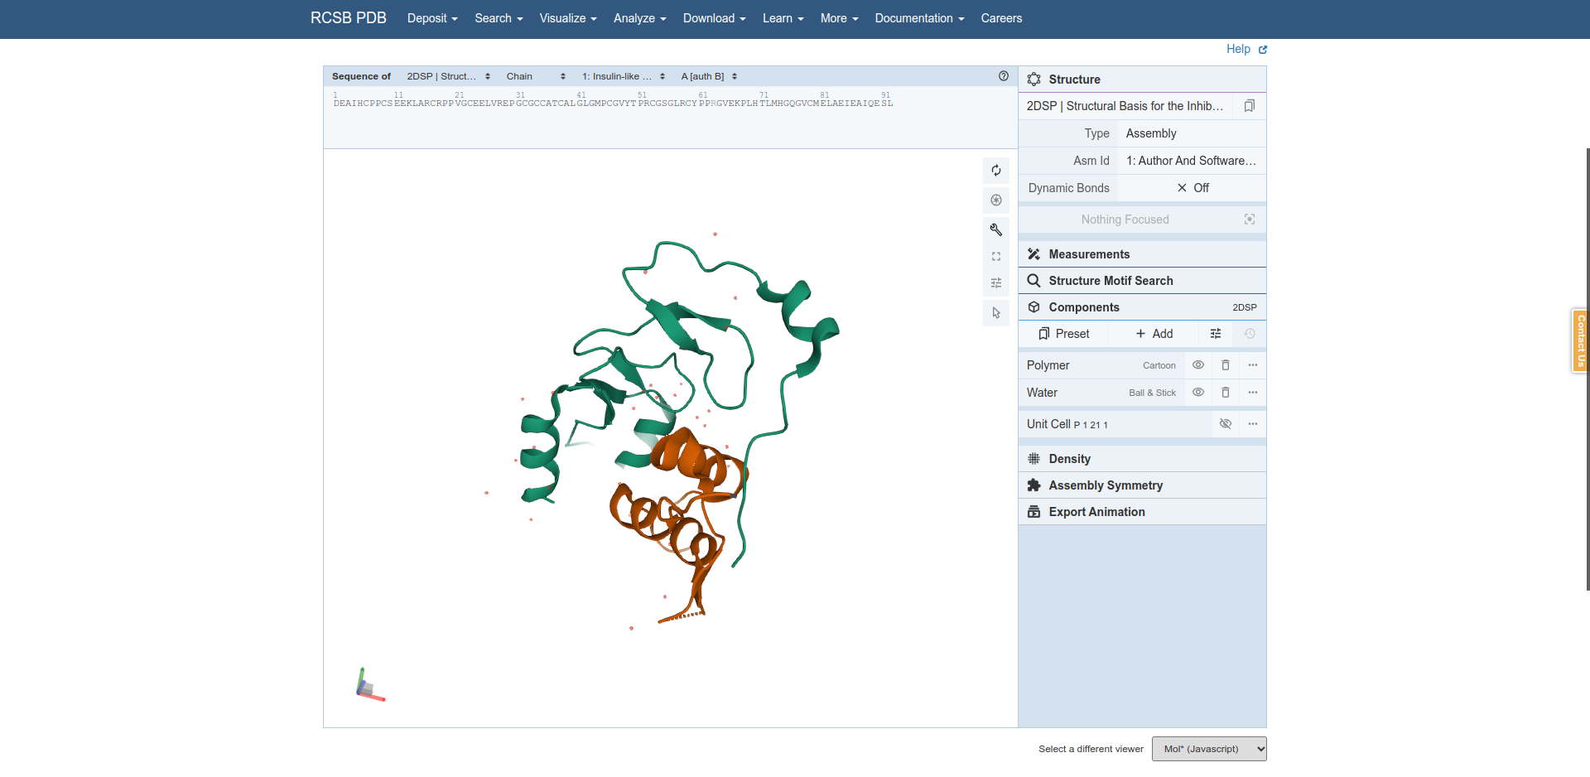**Fig4. 3D view for my Insulin.**

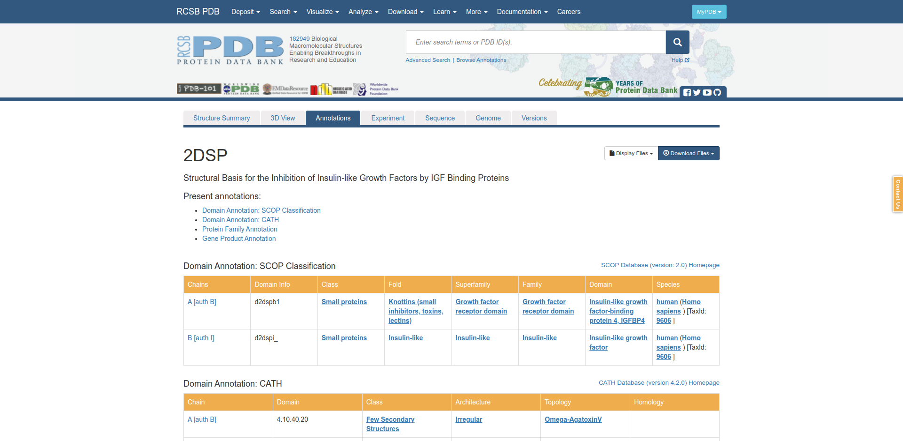**Fig5. Annotions for my query Insulin**

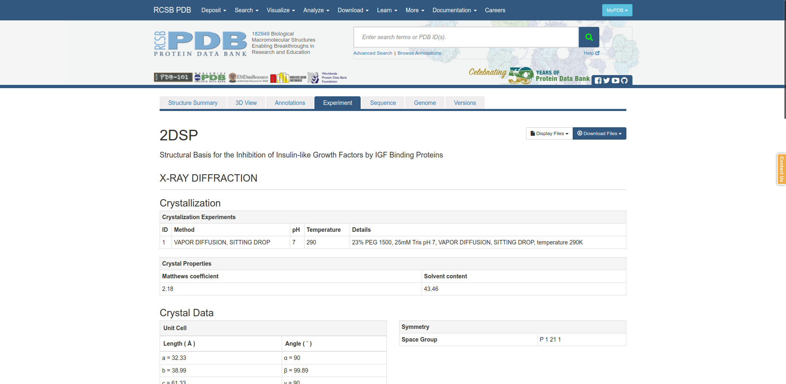**Fig6. Experiment for my query Insulin**

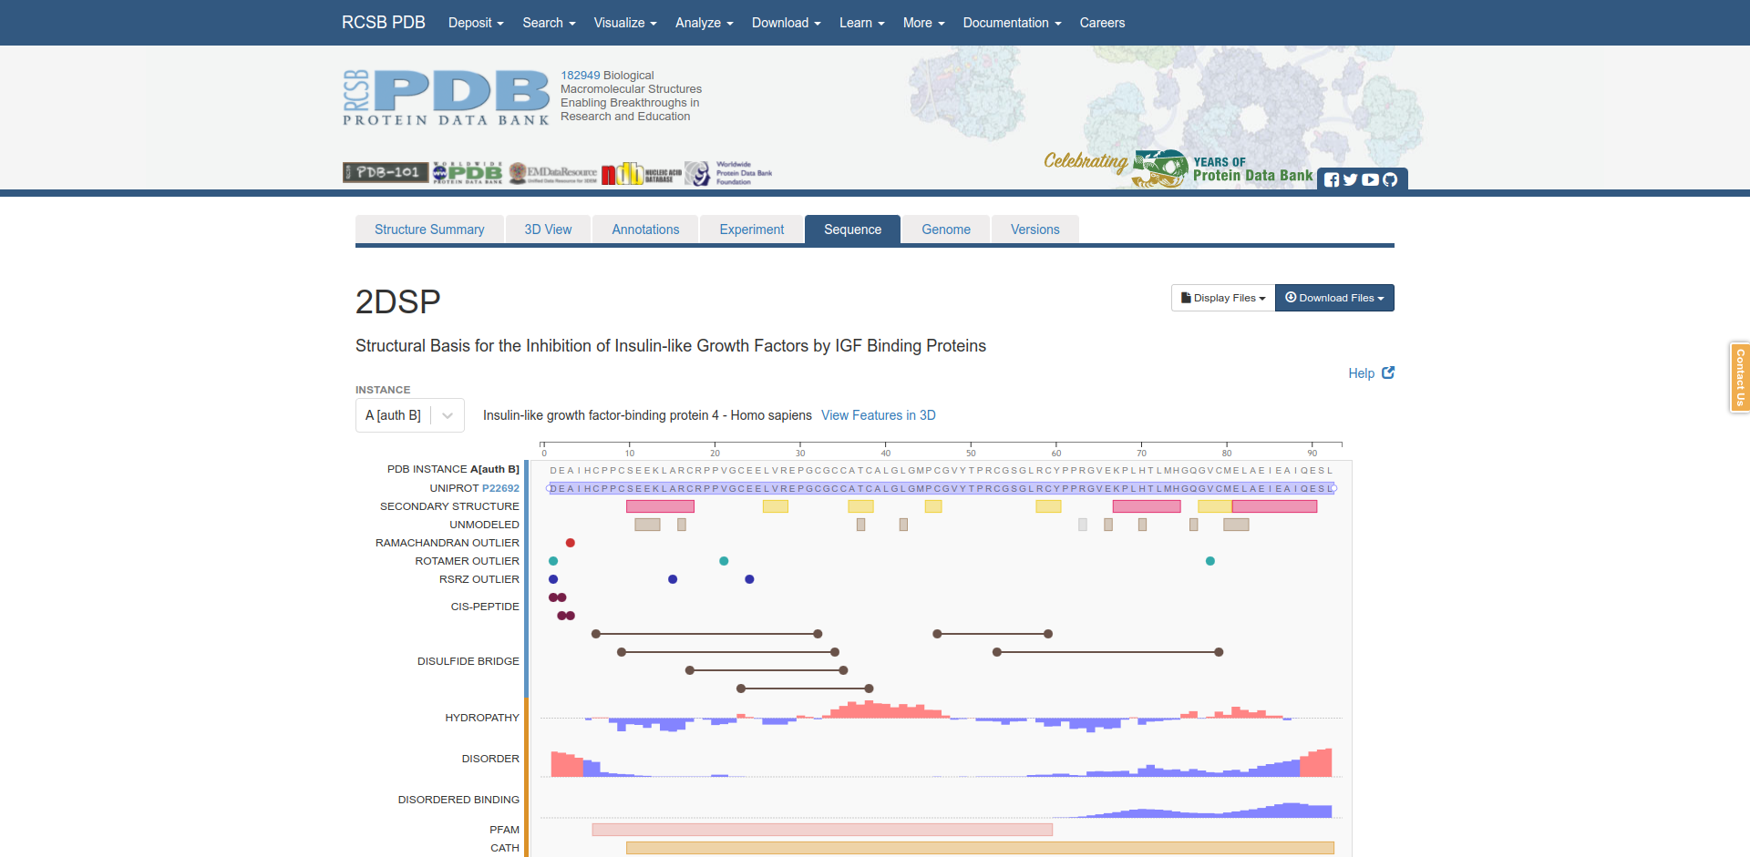**Fig7. Sequence for my query Insulin**

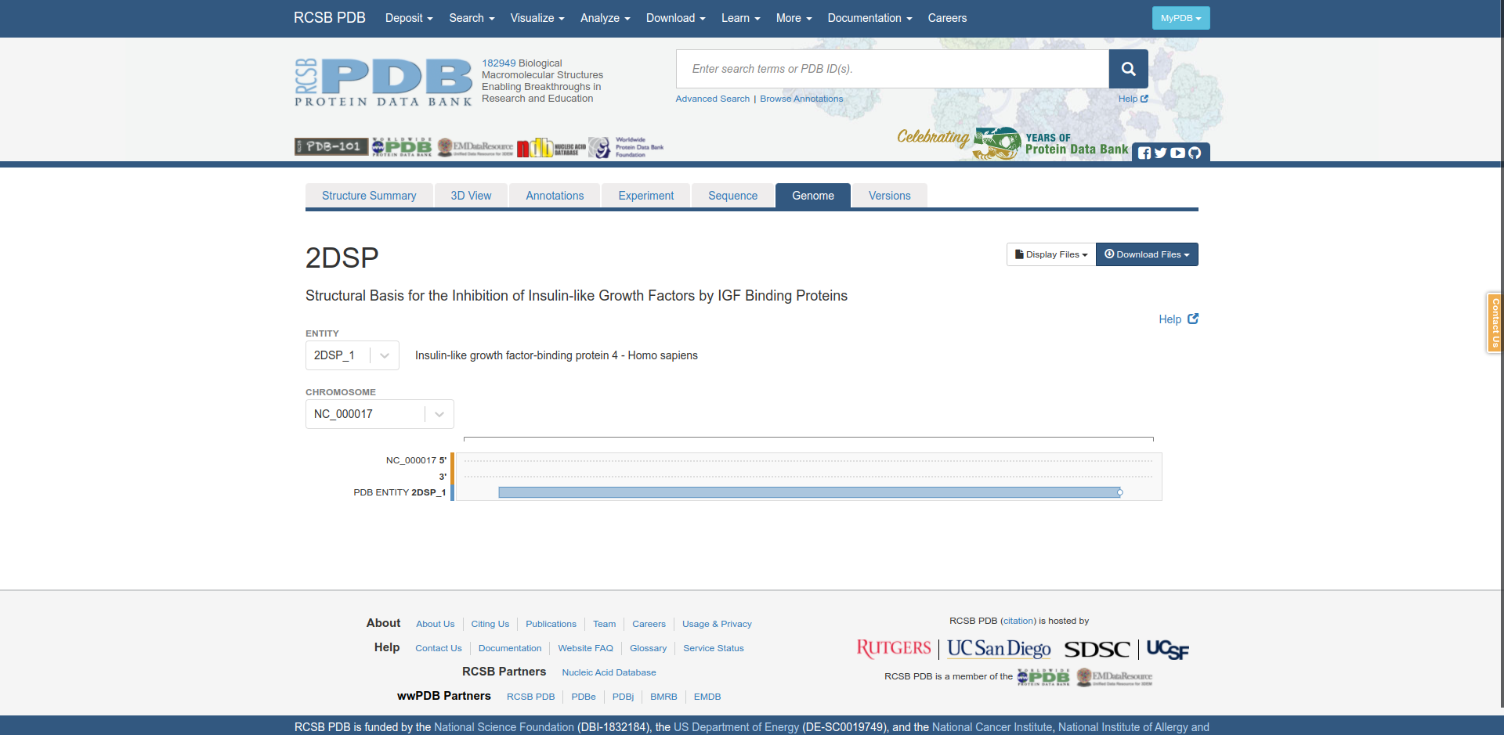**Fig8. Genome for my query Insulin**

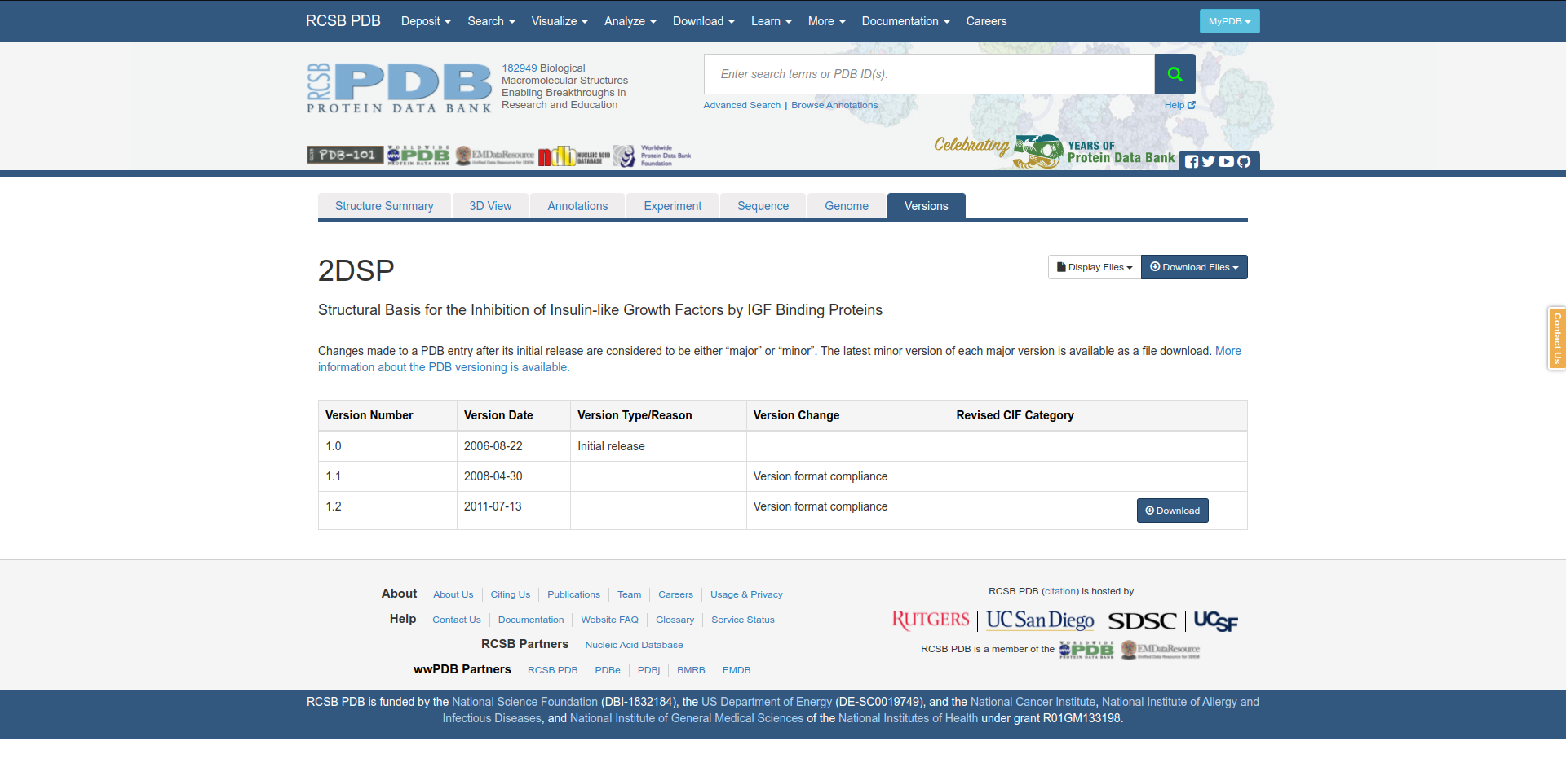**Fig9. Versons for my query Insulin**

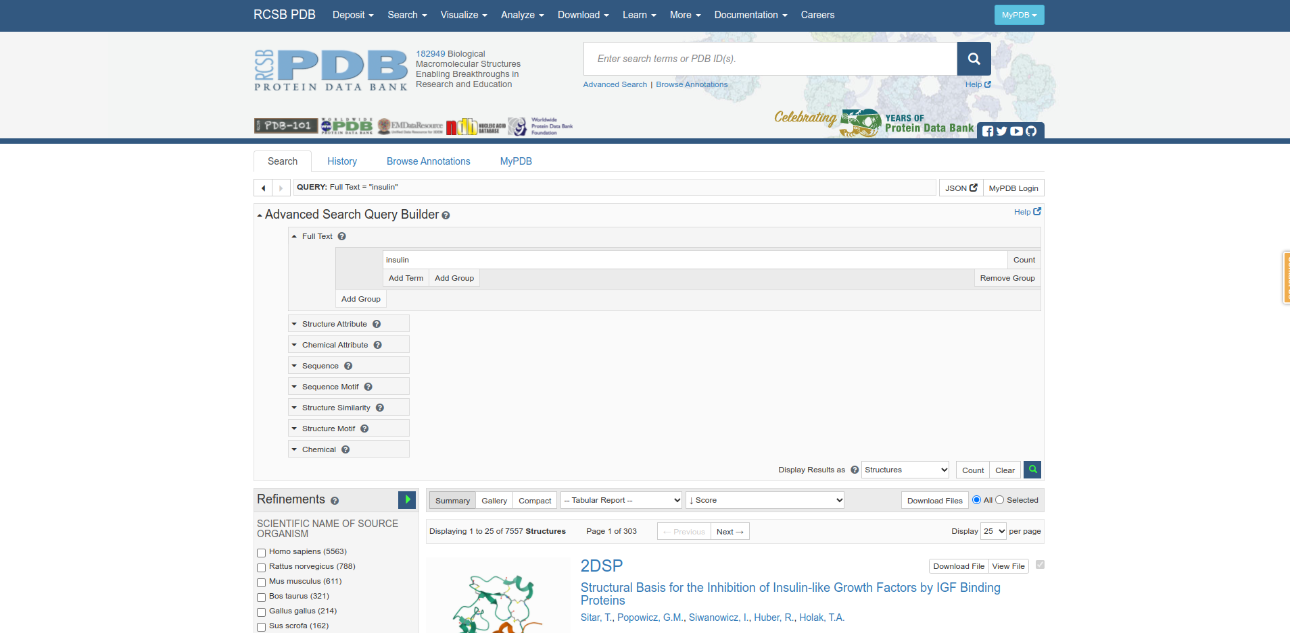**Fig10. Advanced Search query builder for my query Insulin**

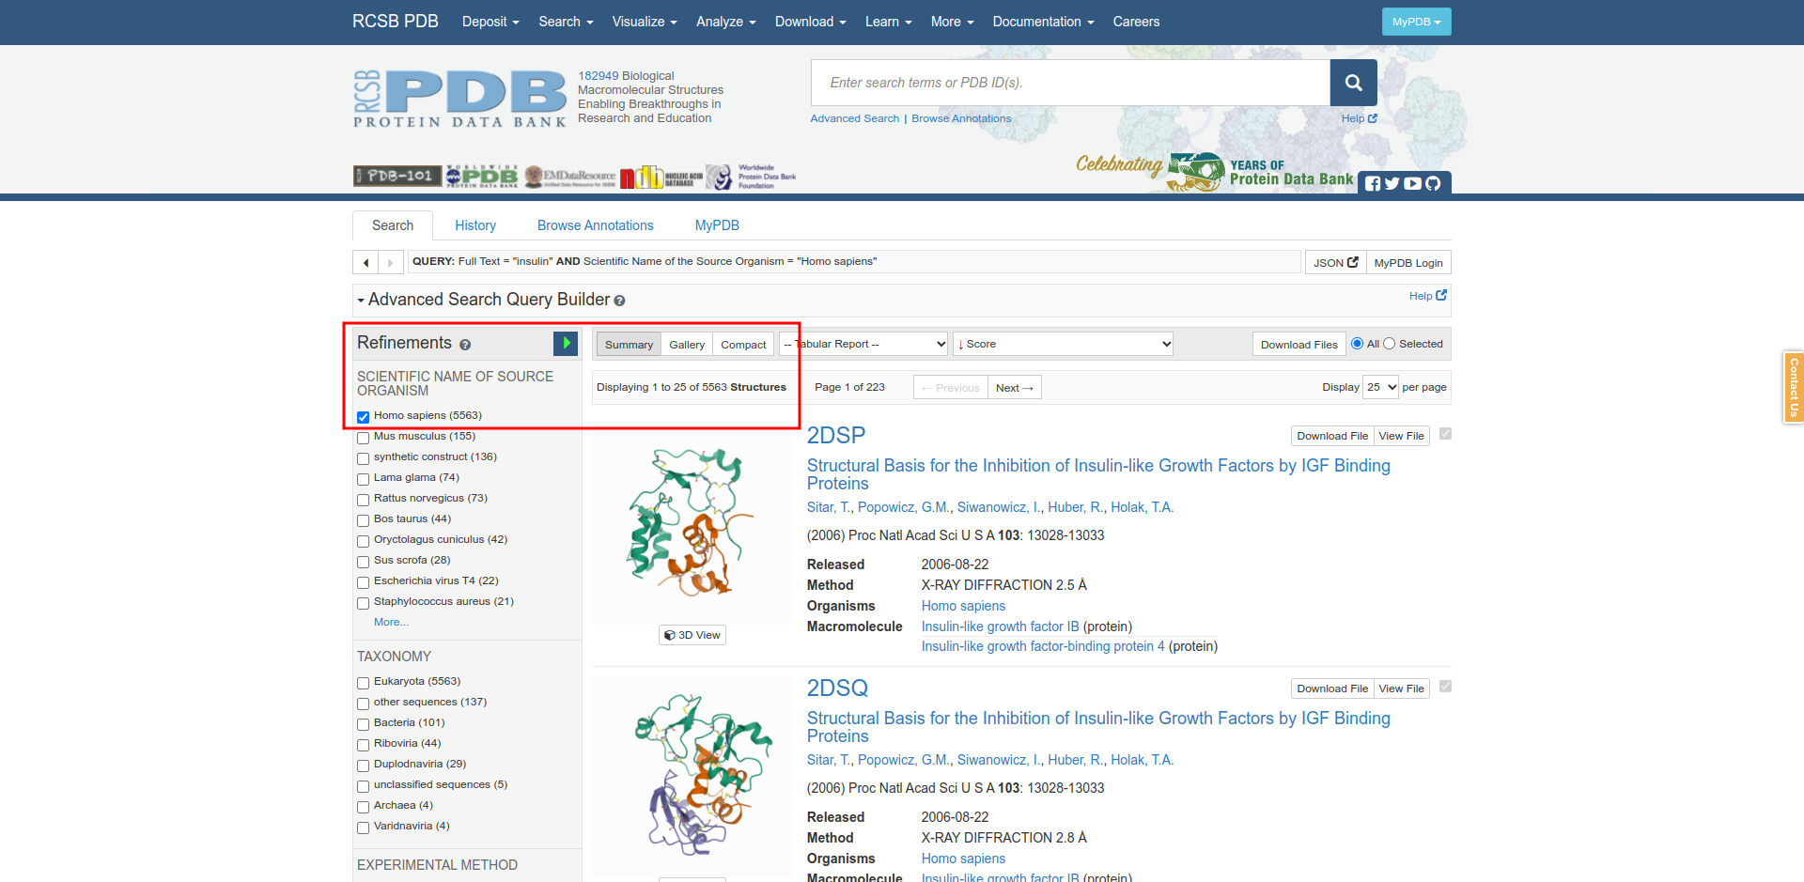**Fig11. Refinement filtering for homo sapiens for query Insulin**

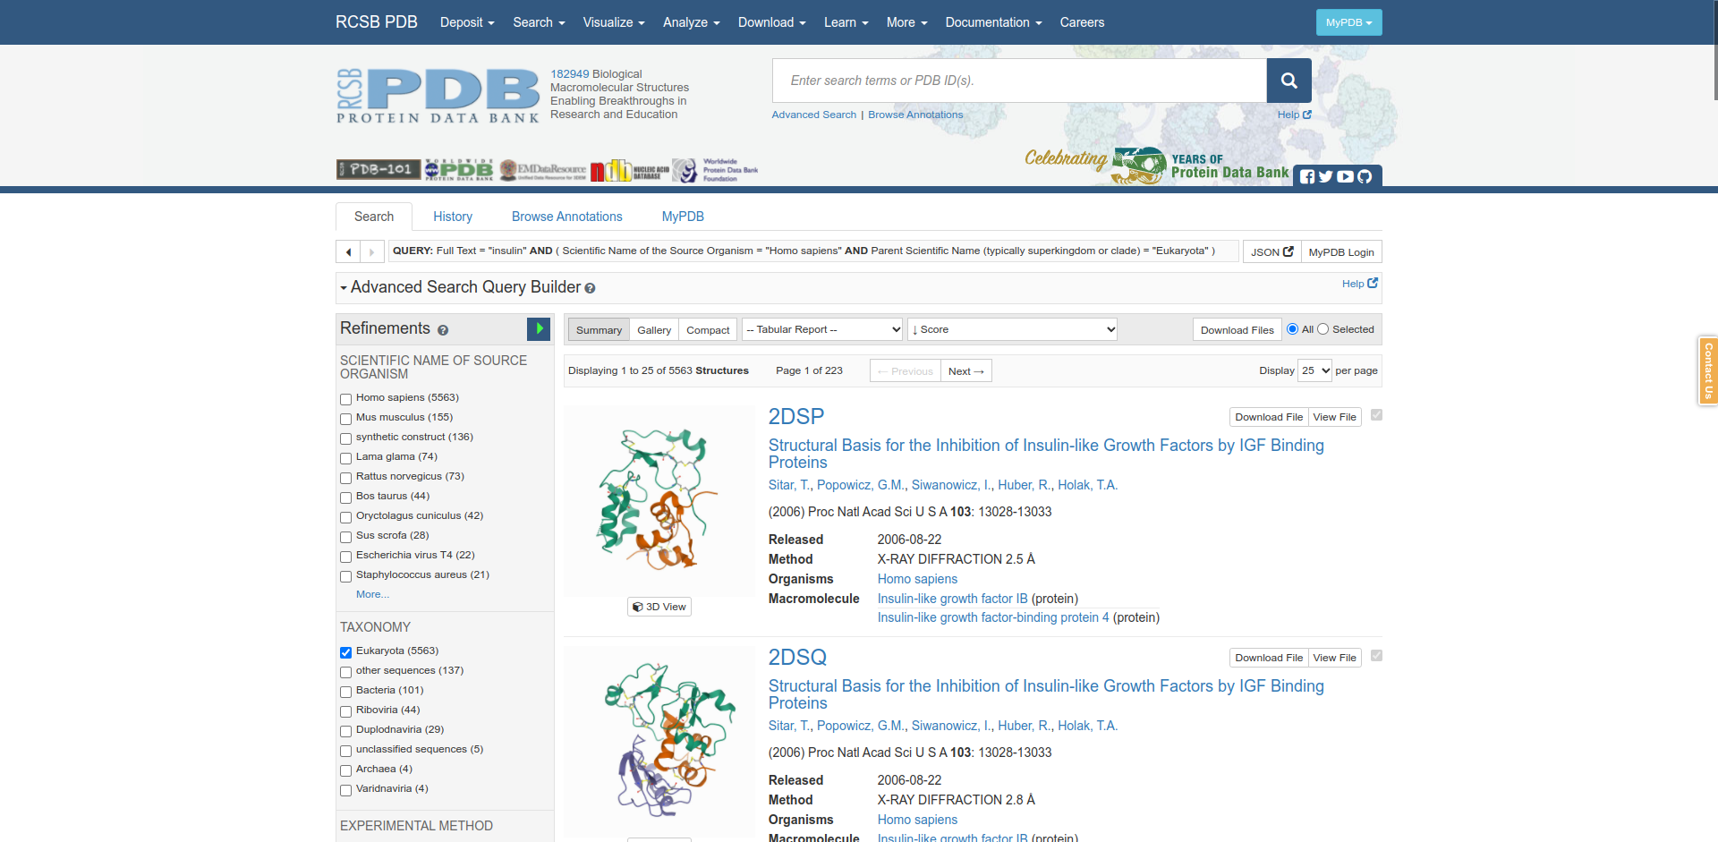**Fig12. Refinements filtering for Taxonomy Eukaryota.**

**Results:**

|  |  |  |
| --- | --- | --- |
| Sr. No | Refinements Filter | No. of structures |
| 1 | Unfiltered | 7557 |
| 2 | Homo sapiens | 5563 |
| 3 | Taxonomy | 5563 |

**Conclusion:**

PDB is taken care of by RCSB( Research Collaboratory for Structural Bioinformatics PDB) . PDB Form is most use & Accepted formed. Every month they upload mocelular structure. Its provides access to 3D structure data for large biological molecules ( proteins, DNA & RNA ). These are the molecules of life, found in all organisms on the planet.

**References:**

1. Mathieu C, Gillard P, Benhalima K. Insulin analogues in type 1 diabetes mellitus: getting better all the time. Nat Rev Endocrinol. 2017 Jul;13(7):385-399
2. Bank, R. P. (n.d.). Homepage. Retrieved from https://www.rcsb.org/
3. Retrieved from https://www.rcsb.org/structure/2DSP
4. Retrieved from https://www.rcsb.org/3d-view/2DSP
5. Retrieved from https://www.rcsb.org/annotations/2dsp
6. Retrieved from https://www.rcsb.org/experimental/2DSP
7. Retrieved from https://www.rcsb.org/sequence/2DSP
8. Retrieved from https://www.rcsb.org/genome/2DSP
9. Retrieved from https://www.rcsb.org/versions/2DSP

**Date: 8-11-21**

**WEBLEM 8**

**(URL:** [**https://www.expasy.org/**](https://www.expasy.org/)**)**

**Aim:**

To explore the ExPasy Tools.

**Introduction:**

* **ExPasy:**

Expasy is the bioinformatics resource portal of the SIB Swiss Institute of Bioinformatics. It is an extensible and integrative portal which provides access to over 160 databases and software tools, developed by SIB Groups and supporting a range of life science and clinical research domains, from genomics, proteomics and structural biology, to evolution and phylogeny, systems biology and medical chemistry.

Thanks to a user-friendly search engine:

1. Expasy allows you to seamlessly query in parallel a subset of SIB databases through a single search, and to
2. Surface related information and knowledge from the complete set of >160 resources on the portal.

Expasy provides information that is automatically aligned with the most recent release of each resources, thereby ensuring up-to-date information.

**1. String**

STRING is the knowledgebase and software tool for known and predicted protein-protein interactions. It includes direct (physical) and indirect (functional) associations derived from various sources, such as genomic context, high-throughput experiments, (conserved) co-expression and the literature.

STRING, each protein-protein interaction is annotated with one or more 'scores'. Importantly, these scores do not indicate the strength or the specificity of the interaction. Instead, they are indicators of confidence, i.e. how likely STRING judges an interaction to be true, given the available evidence. All scores rank from 0 to 1, with 1 being the highest possible confidence. A score of 0.5 would indicate that roughly every second interaction might be erroneous (i.e., a false positive).

For most types of evidence, there are two types of scores: the 'normal' score, and the 'transferred' score. The latter is computed from data that is not originally observed in the organism of interest, but instead in some other organism and then transferred via homology/orthology. All potential source organisms are searched for evidence, but the actual transfers to the receiving organism are made non-redundant (according to 'clades' of closely related organisms in the tree of life).

1. **UniProtKB/Swiss-Prot**

Until 2002, the EBI/SIB Swiss-Prot + TrEMBL databases and the PIR Protein Sequence Database (PIR-PSD) coexisted as protein databases with differing protein sequence coverage and annotation priorities. In 2002, EBI, SIB, and PIR (at the Georgetown University Medical Center and National Biomedical Research Foundation) joined forces as the UniProt consortium. The primary mission of the consortium is to support biological research by maintaining a high quality database that serves as a stable, comprehensive, fully classified, richly and accurately annotated protein sequence knowledgebase, with extensive cross-references and querying interfaces freely accessible to the scientific community.

The UniProt Knowledgebase (UniProtKB) provides the central database of protein sequences with accurate, consistent, rich sequence and functional annotation. The UniProt Knowledgebase consists of two sections: Swiss-Prot - a section containing manually-annotated records with information extracted from literature and curator-evaluated computational analysis, and TrEMBL - a section with computationally analyzed records that await full manual annotation.

Swiss-Prot is an annotated protein sequence database. It was established in 1986 and maintained collaboratively, since 1987, by the group of Amos Bairoch first at the Department of Medical Biochemistry of the University of Geneva and now at the SIB Swiss Institute of Bioinformatics and the EMBL Data Library (now the EMBL Outstation - The European Bioinformatics Institute (EBI)). The Swiss-Prot Protein Knowledgebase consists of sequence entries. Sequence entries are composed of different line types, each with their own format. For standardization purposes the format of Swiss-Prot follows as closely as possible that of the EMBL Nucleotide Sequence Database.

1. **EPD**

This resource allows the access to several databases of experimentally validated promoters: EPD and EPDnew databases. They differ by the validation technique used and the coverage. EPD is a collection of eukaryotic promoters derived from published articles. Instead, the EPDnew databases (HT-EPD) are the result of merging EPD promoters whith in-house analysis of promoter-specific high-throughput data for selected organisms only.

The Eukaryotic Promoter Database is an annotated non-redundant collection of eukaryotic POL II promoters, for which the transcription start site has been determined experimentally. Access to promoter sequences is provided by pointers to positions in nucleotide sequence entries. The annotation part of an entry includes description of the initiation site mapping data, cross-references to other databases, and bibliographic references. EPD is structured in a way that facilitates dynamic extraction of biologically meaningful promoter subsets for comparative sequence analysis. This database contains 4806 promoters from several species.

**Methodology:**

* 1. Open the homepage of ExPasy tools.
  2. Explore the tools like UniProtKB/Swiss-Prot, String, EPD

**Observation:**

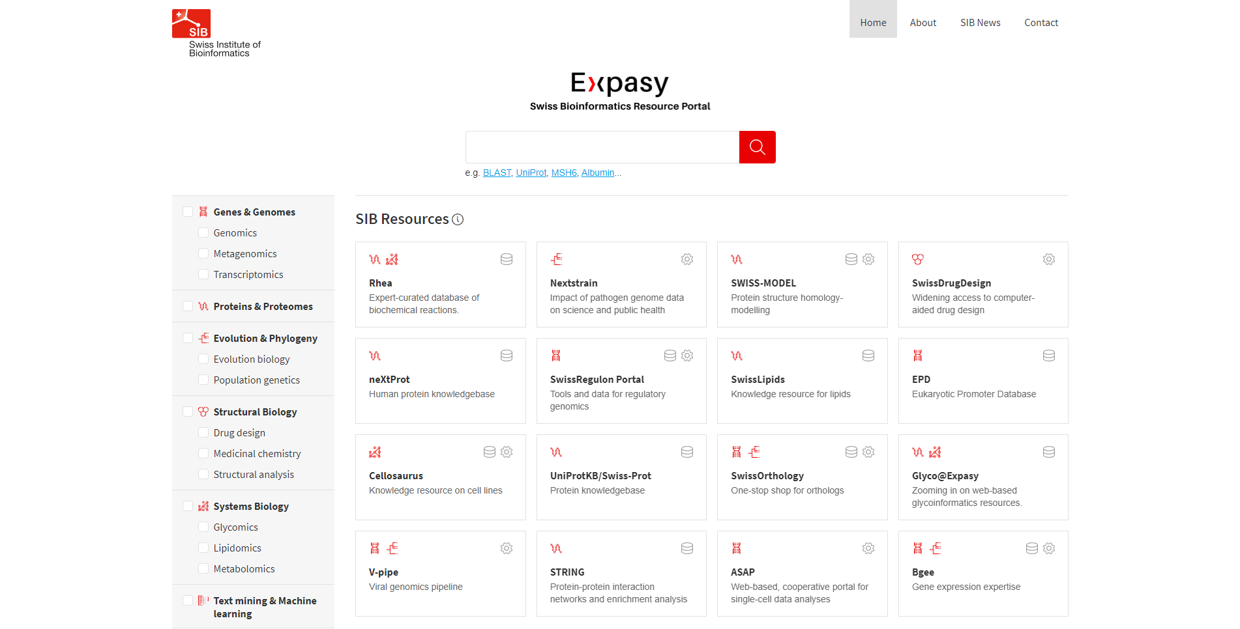**Fig1: Homepage of ExPasy Tools.**

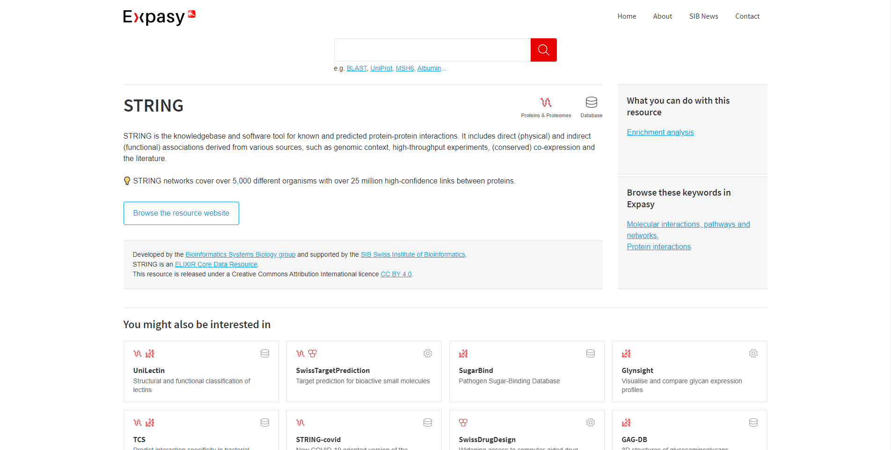**Fig2. Hit page of String**

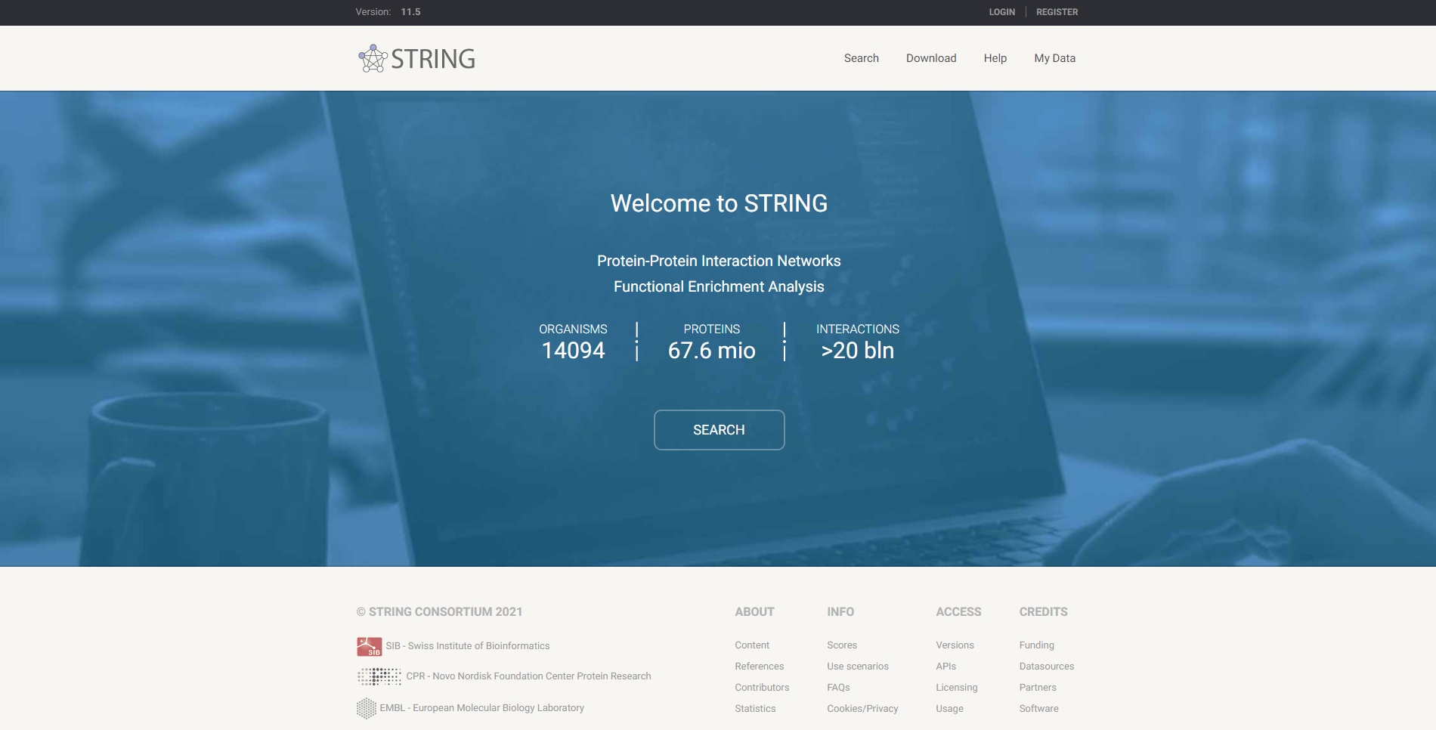**Fig3: Homepage for String**

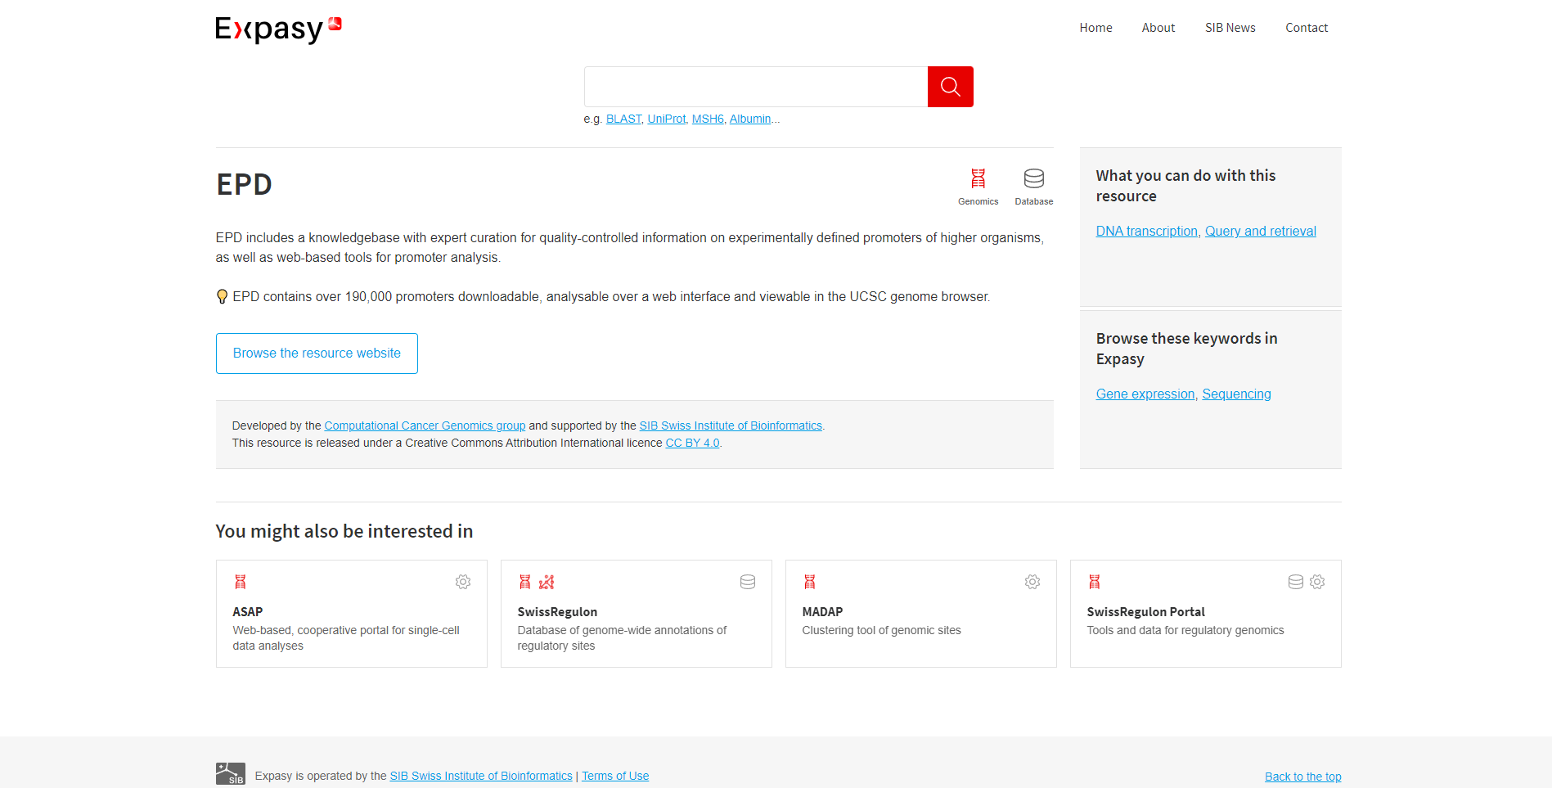**Fig4: Hit page for EPD**

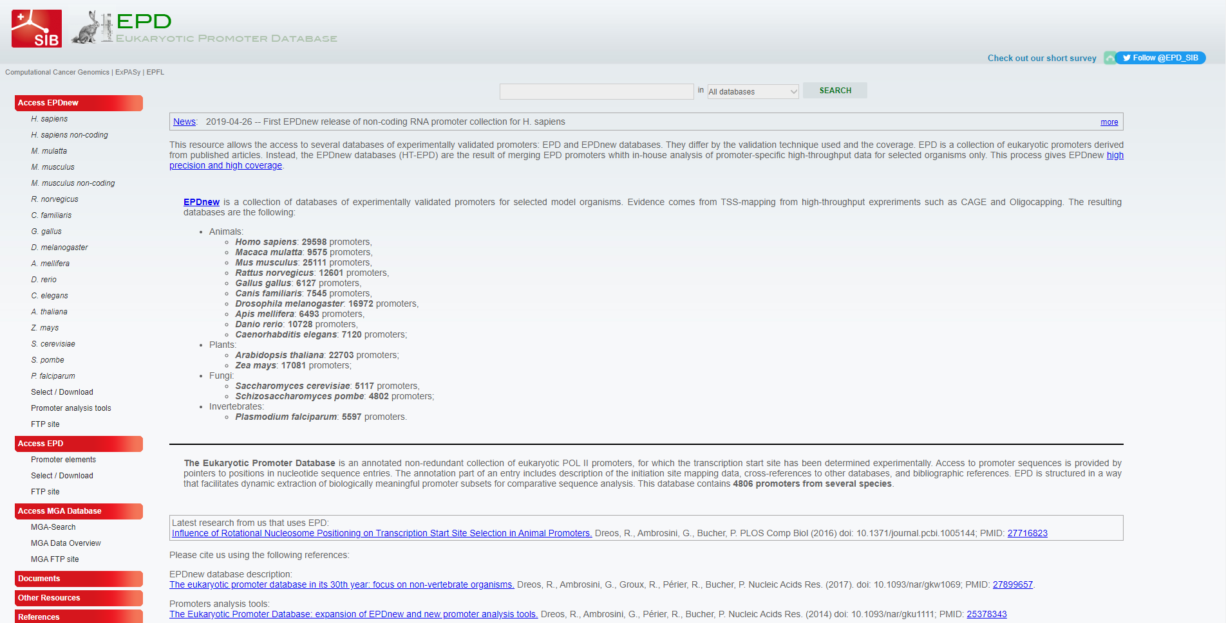**Fig5: Homepage for EPD**

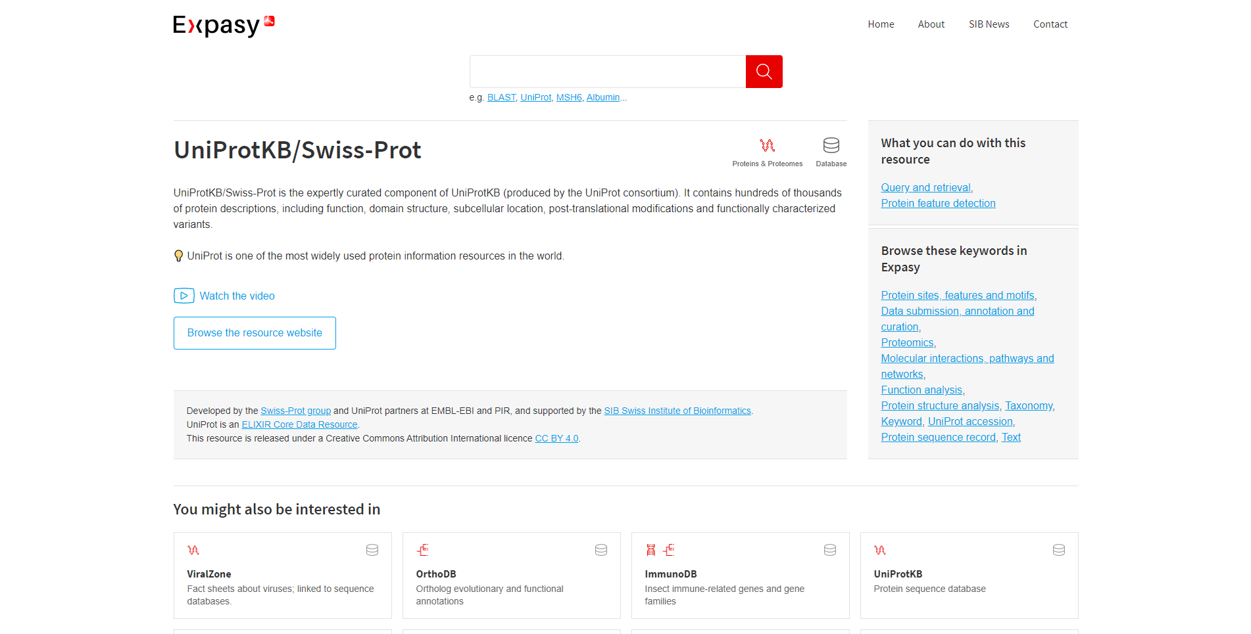**Fig6: Hit page for UniProtKB/SwissProt**

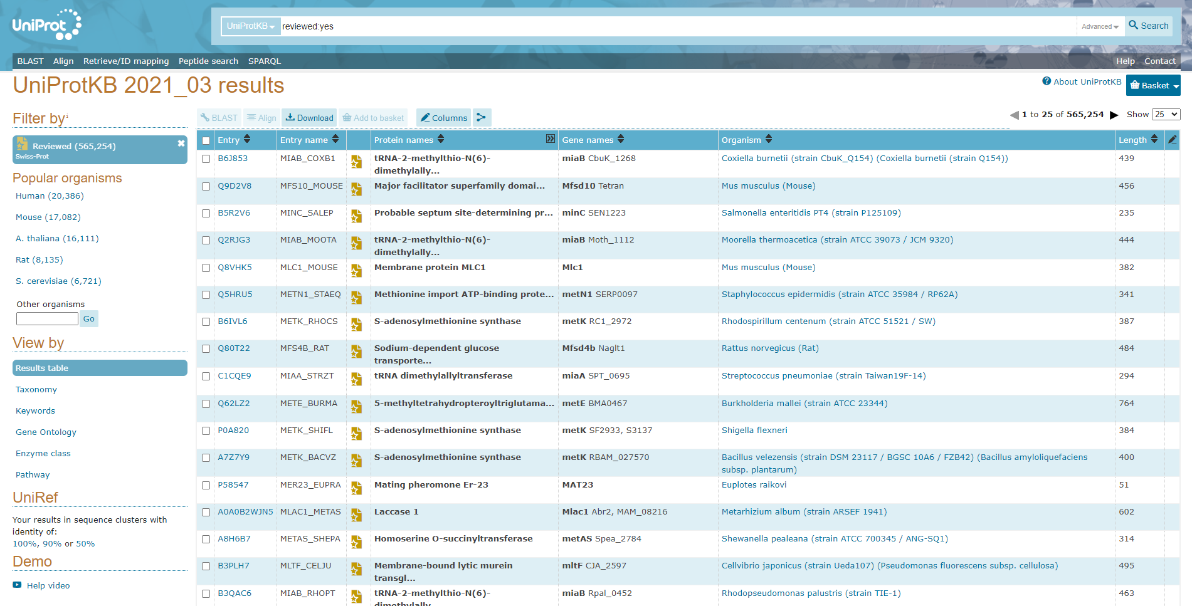**Fig7: Homepage of UniProtKB**

**Results:**

**Expasy Tools:**

It is an extensible and integrative portal which provides access to over 160 databases and software tools, developed by SIB Groups and supporting a range of life science and clinical research domains, from genomics, proteomics and structural biology, to evolution and phylogeny, systems biology and medical chemistry.

1. **STRING:**

The STRING database contains information from numerous sources, including experimental data, computational prediction methods and public text collections. It is freely accessible and it is regularly updated. The resource also serves to highlight functional enrichments in user- provided lists of proteins, using a number of functional classification systems such as GO, Pfam and KEGG. The latest version 11b contains information on about 24,5 million proteins from more than 5000 organisms.

1. **EPD:**

The Eukaryotic Promoter Database (EPD) is an annotated, non-redundant collection of eukaryotic Pol II promoters, for which the transcription start site has been determined experimentally. Access to promoter sequences is provided by pointers to positions in nucleotide sequence entries.

1. **UniProtKB:**

Uniprot is a freely accessible database of protein sequence and functional information, many entries being from genome sequencing projects. It contains a large a large amount of information about the biological fuction of proteins derived from the research literatures.

**Conclusion:**

Expasy is an online bioinformatics resource operated by the SIB Swiss Institute of Bioinformatics. The individual resources (databases, web-based and downloadable software tools) are hosted in a decentralised way by different groups of the SIB Swiss Institute of Bioinformatics and partner institutions.

**References:**

* 1. (n.d.). Retrieved from [https://epd.epfl.ch//index.php](https://epd.epfl.ch/index.php)
  2. EPD. (n.d.). Retrieved from <https://www.expasy.org/resources/epd>
  3. SIB Swiss Institute of Bioinformatics. (n.d.). Retrieved from <https://www.expasy.org/>
  4. STRING. (n.d.). Retrieved from <https://www.expasy.org/resources/string>
  5. UniProt ConsortiumEuropean Bioinformatics InstituteProtein Information ResourceSIB Swiss Institute of Bioinformatics. (n.d.). UniProt Consortium. Retrieved from <https://www.uniprot.org/uniprot/?query=reviewed:yes>
  6. UniProtKB/Swiss-Prot. (n.d.). Retrieved from <https://www.expasy.org/resources/uniprotkb-swiss-prot>
  7. Welcome to STRING. (n.d.). Retrieved from <https://string-db.org/>

**DATE: 8-11-21**

**WEBLEM 9**

**Introduction of Genome Database**

* **Genome Database:**

The Genome Database (GDB) is a public repository of data on human genes, clones, STSs, polymorphisms and maps. GDB entries are highly cross-linked to each other, to literature citations and to entries in other databases, including the sequence databases, OMIM, and the Mouse Genome Database. Mapping data from large genome centers and smaller mapping efforts are added to GDB on an ongoing basis. The database can be searched by a variety of methods, ranging from keyword searches to complex queries. Major functionality extensions in the last year include the ongoing computation of integrated human genome maps, called Comprehensive Maps, and the use of those maps to support positional queries and graphic

displays. The capabilities of the GDB map viewer (Mapview) have been extended to include map printing and the graphical display of ad hoc query results. The HUGO Nomenclature Committee continues to curate the proposed and official gene symbols and related data in collaboration with GDB. As genome research shifts its emphasis from mapping to sequencing and functional analysis, the scope of the GDB schema is being extended. We are in the process of adding representations of gene function and expression, and improving our representation of human polymorphism and mutation.

1. **Genome Databases in NCBI:**

The Genome database contains sequence and map data from the whole genomes of over 1000 species or strains. The genomes represent both completely sequenced genomes and those with sequencing in-progress. All three main domains of life (bacteria, archaea, and eukaryota) are represented, as well as many viruses, phages, viroids, plasmids, and organelles.This resource organizes information on genomes including sequences, maps, chromosomes, assemblies, and annotations.

1. **GOLD:**

Genomes OnLine Database (GOLD) is an open-access repository of genome and metagenome sequencing projects with their associated metadata. Login-free access is provided to a growing catalogue of manually curated public projects from all over the world. Starting from whole genome sequencing of cultured bacteria, uncultured single cells, complex eukaryotes or metagenome sequencing of environmental samples, the world of sequencing is advancing at a rapid pace. In overcoming the limitations of culturing microbial isolates, improved sequencing and analysis methods have broadened our understanding of the microbial world. Metagenome- assembled genomes (MAGs) and single-amplified genomes (SAGs) (1,2) are two such examples of genomes of uncultivated organisms that have recently expanded our knowledge about microorganisms. In any sequencing project, metadata or accessory information about the sample being sequenced plays a key role.In order to interpret raw sequence data and make accurate scientific predictions, the presence of a wide variety of metadata is extremely important. For example, comparative analyses of the microbial community of soil samples from multiple locations would be very difficult if the geographic location information or soil type is not recorded. On the other hand, the scientific value of the same sequence will likely increase several-fold if detailed environmental and physicochemical properties of the soil are collected.

**Date: 8-11-21**

**WEBLEM 9/a**

**(URL:** [**https://www.ncbi.nlm.nih.gov/genome/**](https://www.ncbi.nlm.nih.gov/genome/)**)**

**Aim:**

To study the Staphylococcus epidermidis in NCBI genome browser

**Introduction:**

The Genome database contains sequence and map data from the whole genomes of over 1000 species or strains. The genomes represent both completely sequenced genomes and those with sequencing in-progress. All three main domains of life (bacteria, archaea, and eukaryota) are represented, as well as many viruses, phages, viroids, plasmids, and organelles.This resource organizes information on genomes including sequences, maps, chromosomes, assemblies, and annotations.

Staphylococci are common bacterial colonizers of the skin and mucous membranes of humans and other mammals. S. epidermidis in particular is the most frequently isolated species from human epithelia. It colonizes predominantly the axillae, head, and nares. Analysis of the S. epidermidis genome indicated that the species is well equipped with genes assumed to provide protection from the harsh conditions encountered in its natural habitat. For example, to cope with extremes of salt concentration and osmotic pressure, S. epidermidis has eight sodium ion/proton exchangers and six transport systems for osmoprotectants.

**Methodology:**

1. Open The homepage of Genome in NBCI
2. Enter the query in Search bar.
3. Open any one of the result page.
4. Interpret the Result.

**Observation:**

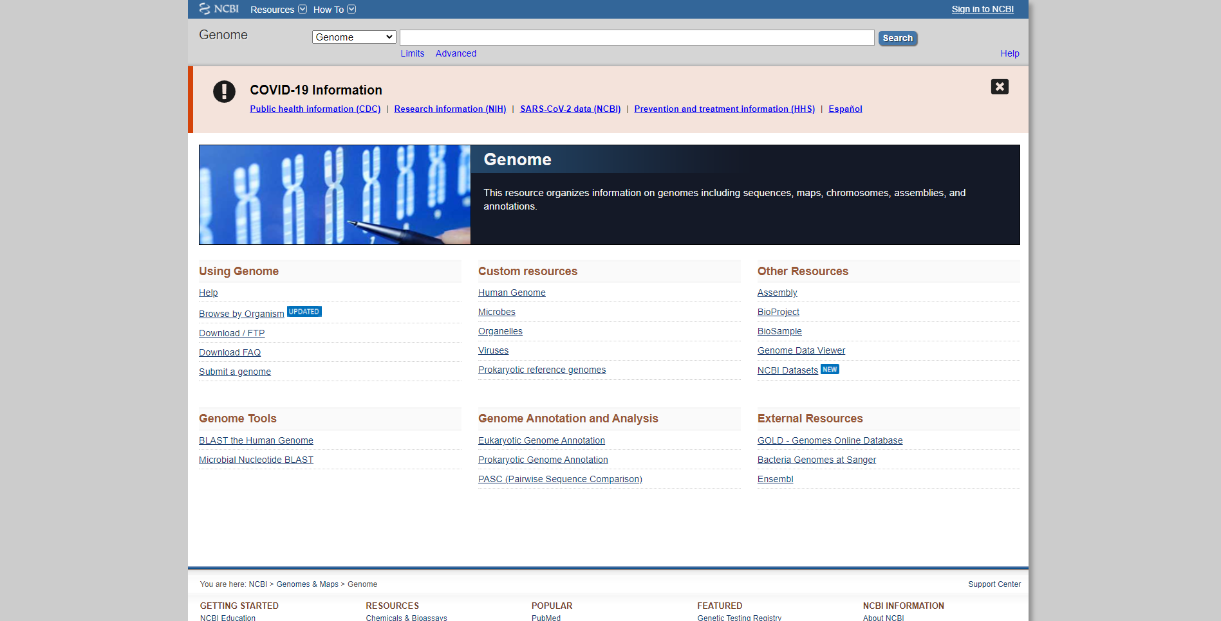 **Fig1. Homepage of Genome in NCBI**

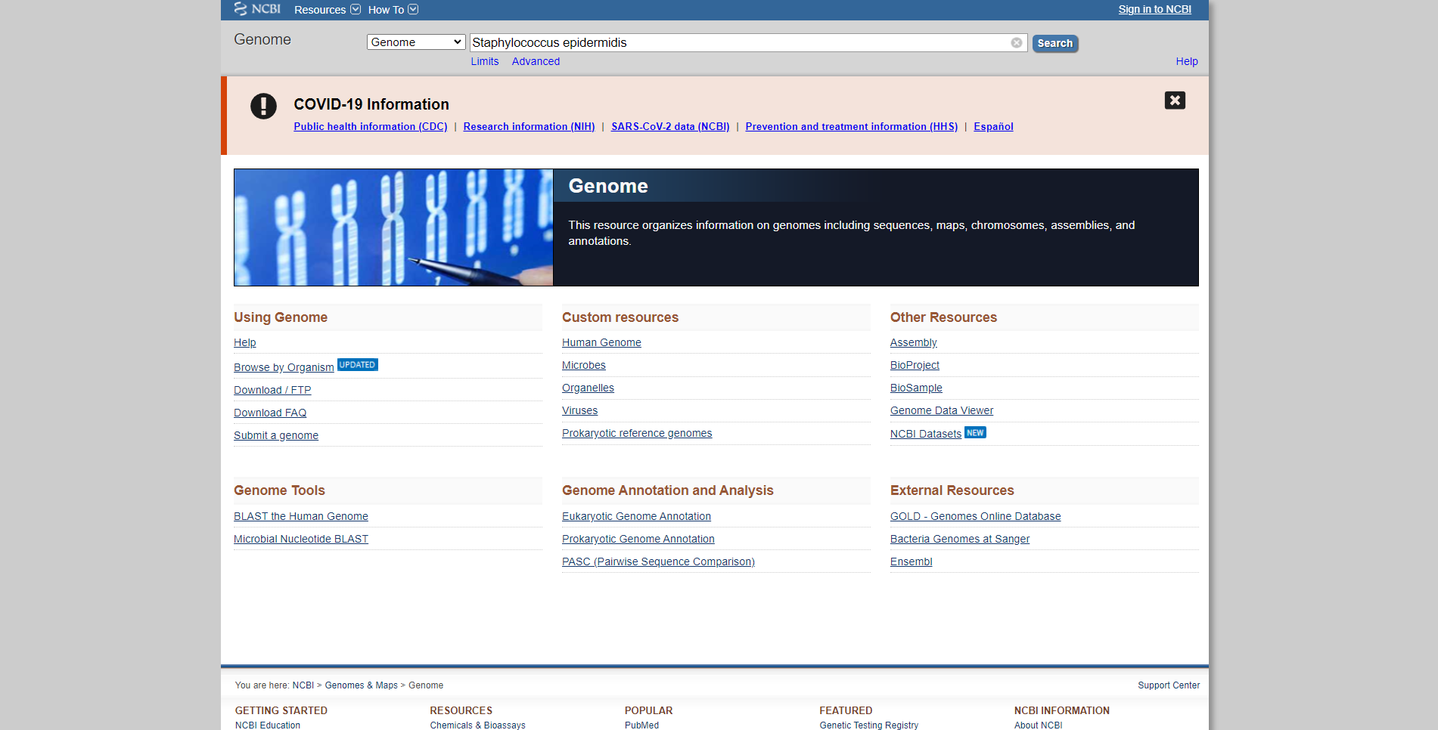

**Fig2. Search page of Genome in NCBI with query Staphylococcus epidermidis**

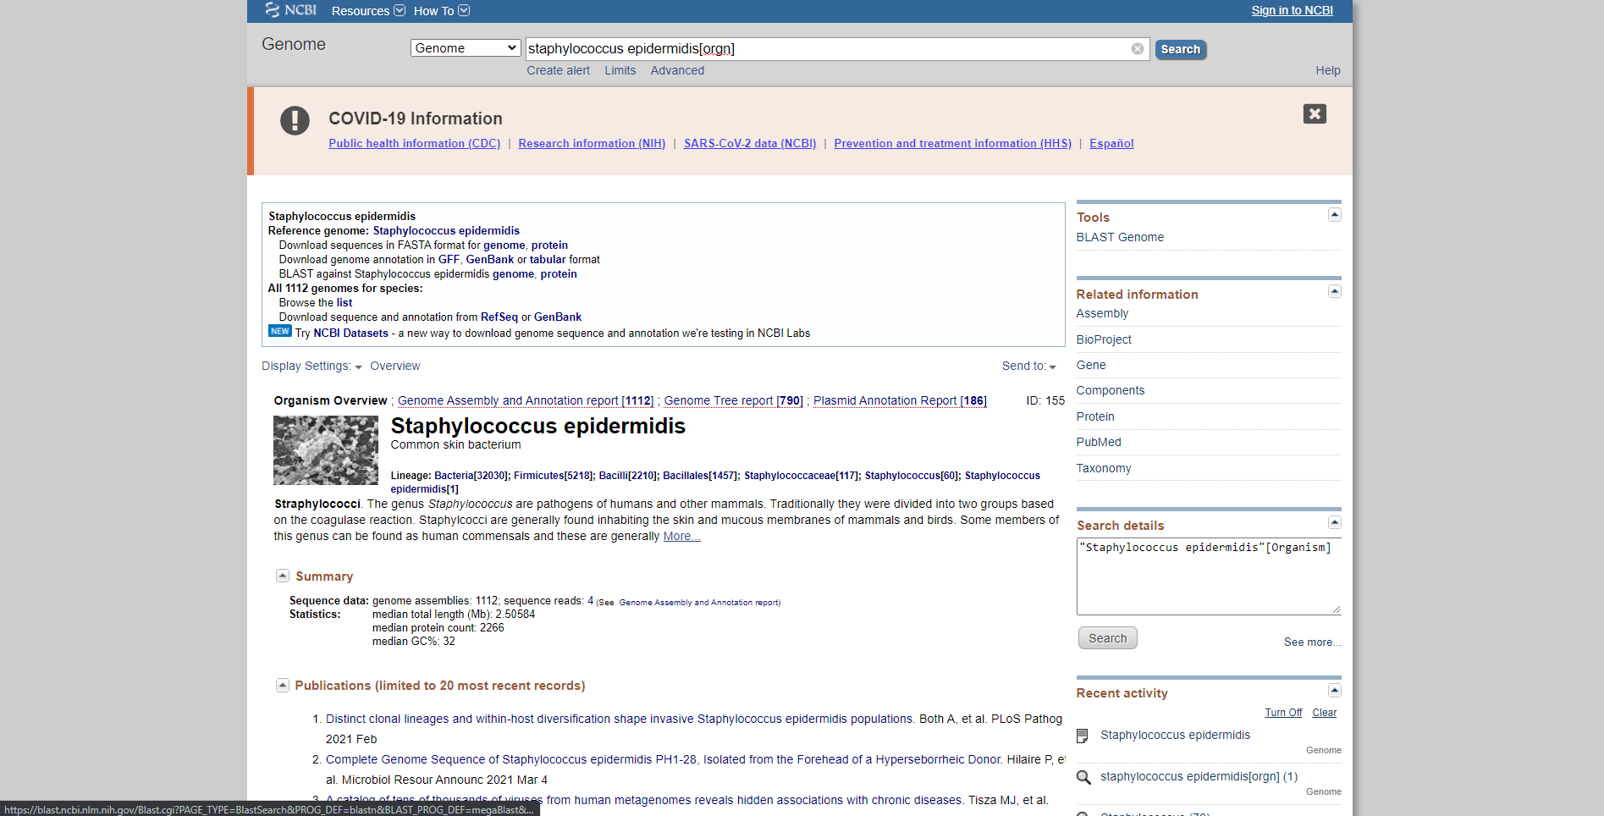 **Fig3. Result page of Genome in NCBI for query Staphylococcus epidermidis.**

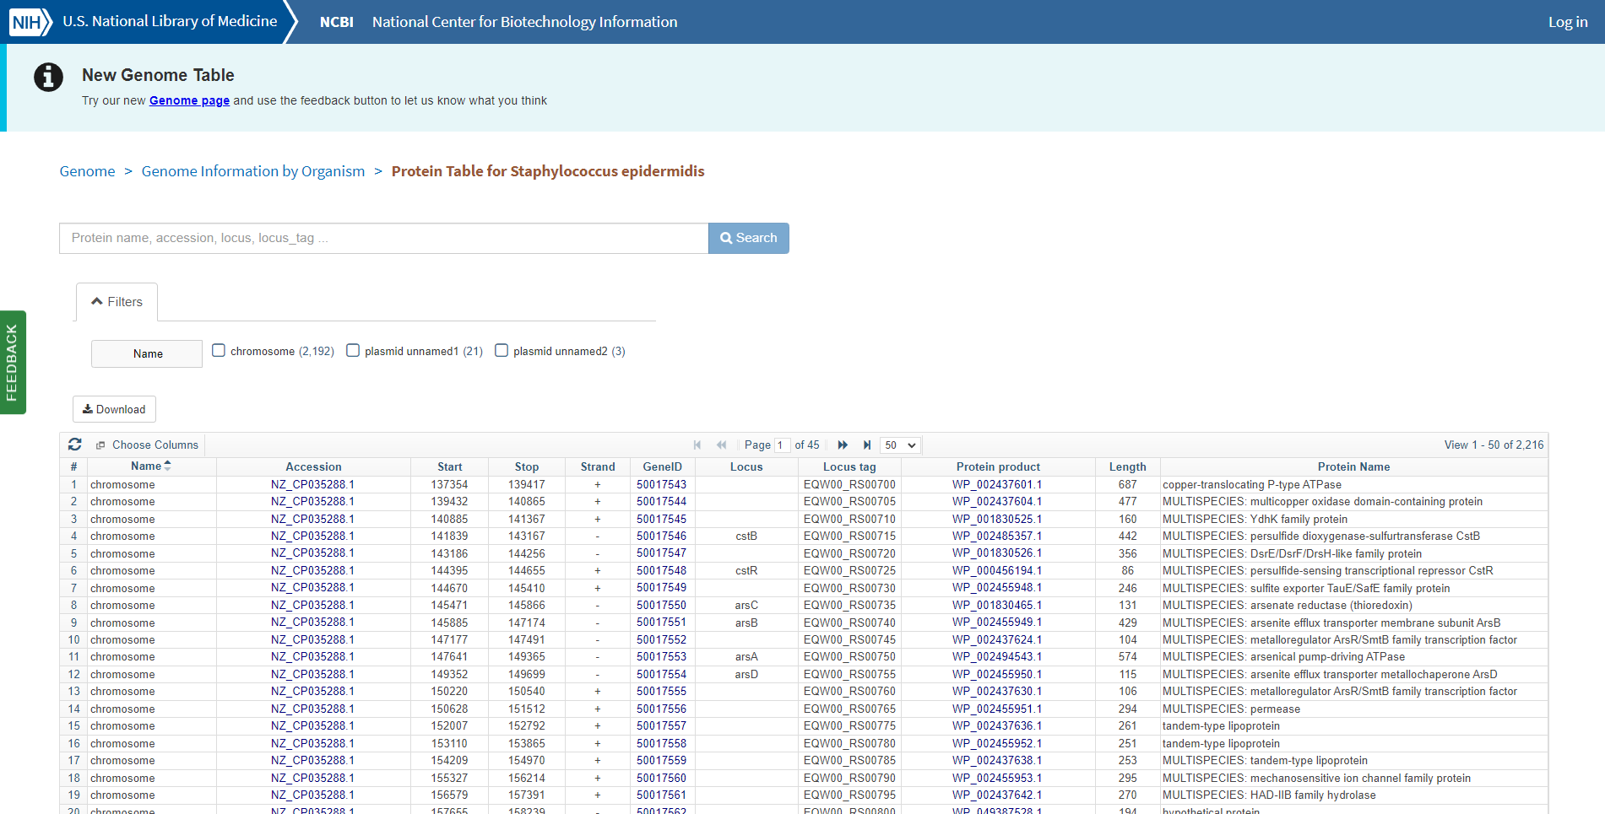**Fig4. Genome annotation Table with query Staphylococcus epidermidis**

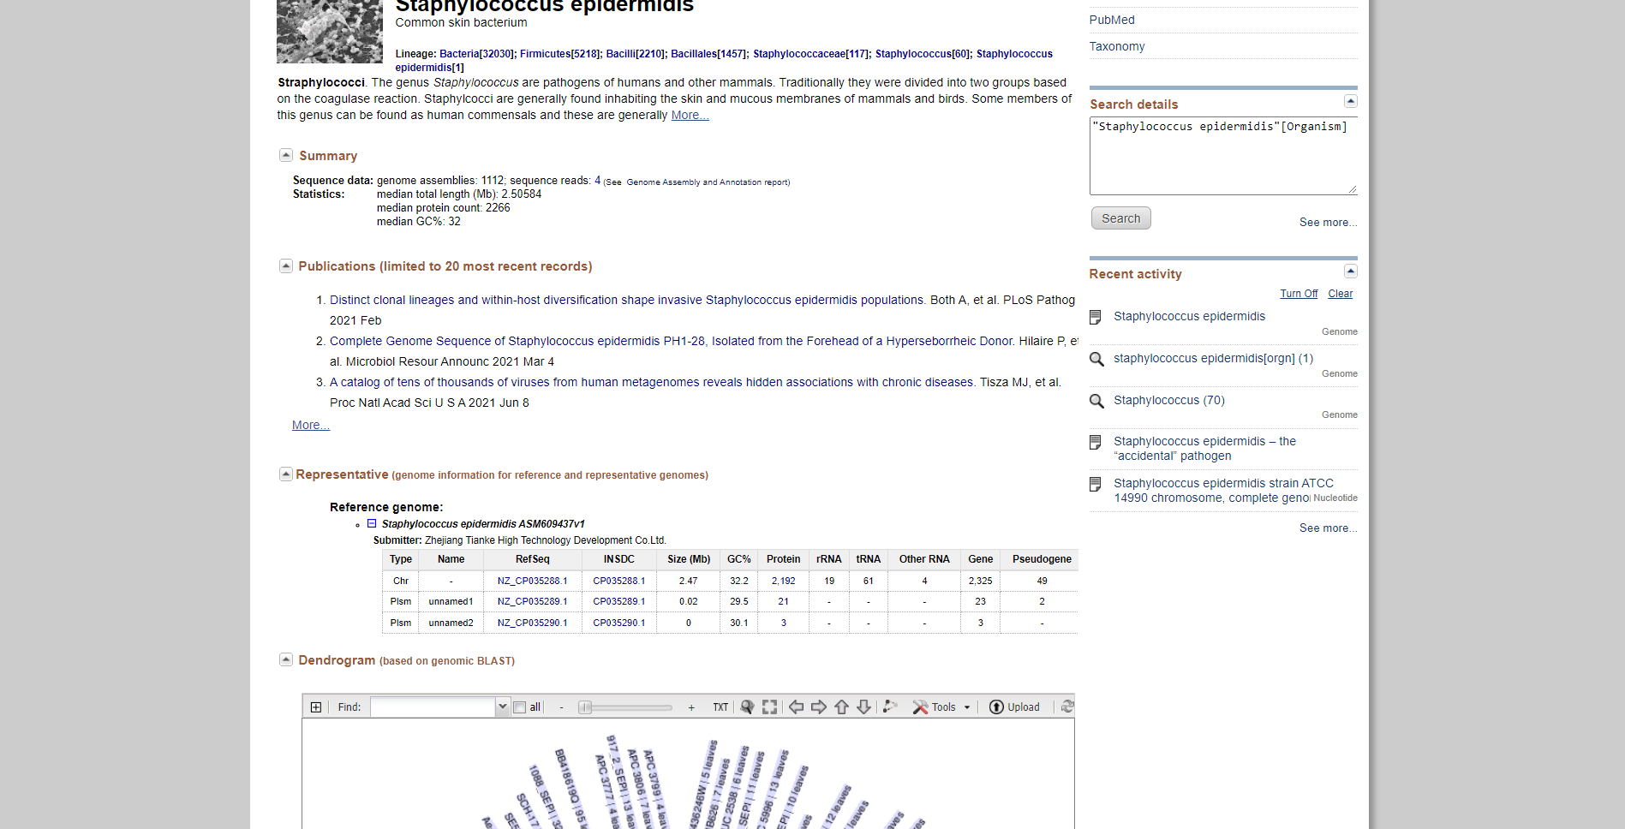 **Fig5. Result page for query “Staphylococcus epidermidis” showing publications and genome information for reference and representative genomes.**

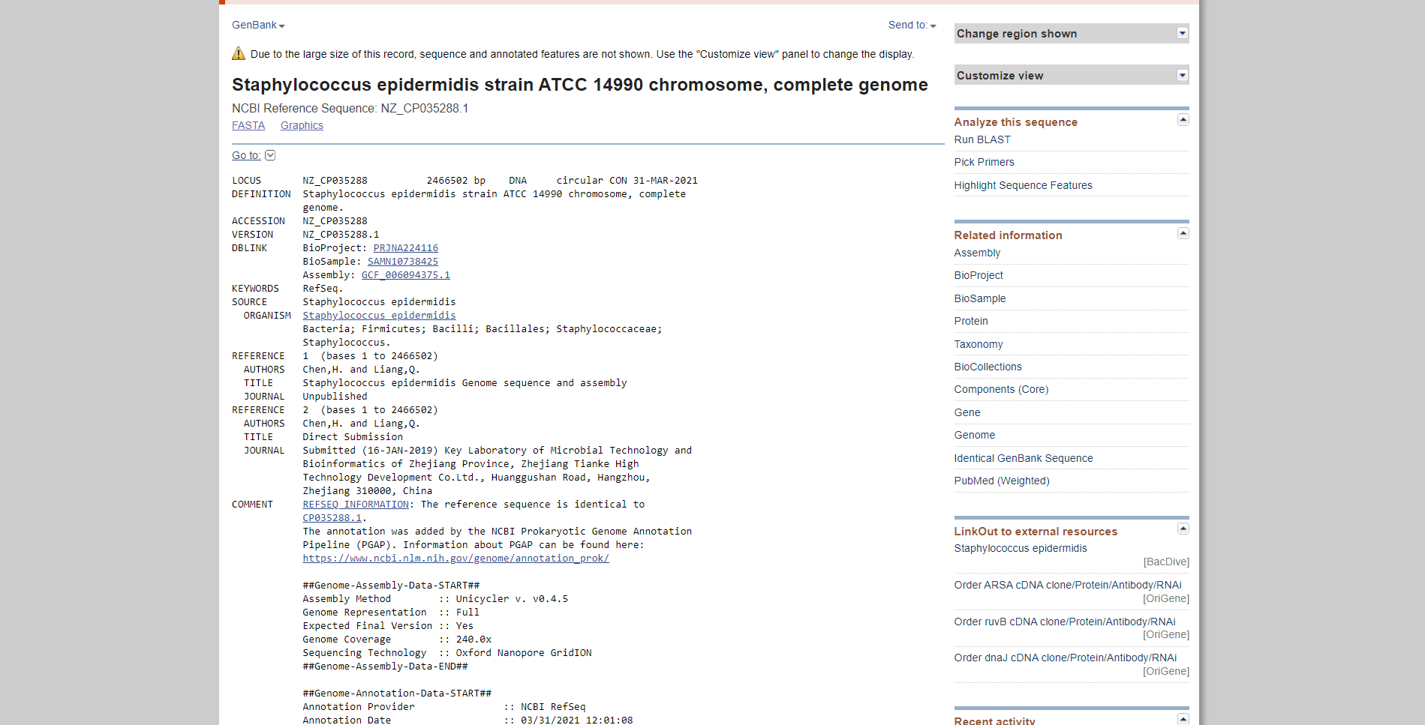**Fig6. Reference sequence information for query “Staphylococcus epidermidis” in NCBI GenBank database.**

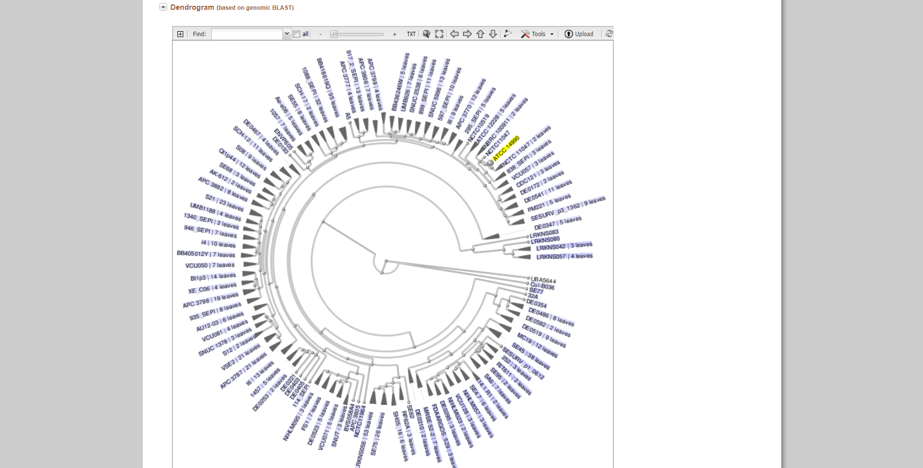**Fig7. Result page for query “Staphylococcus epidermidis” showing dendrogram on genomic BLAST**

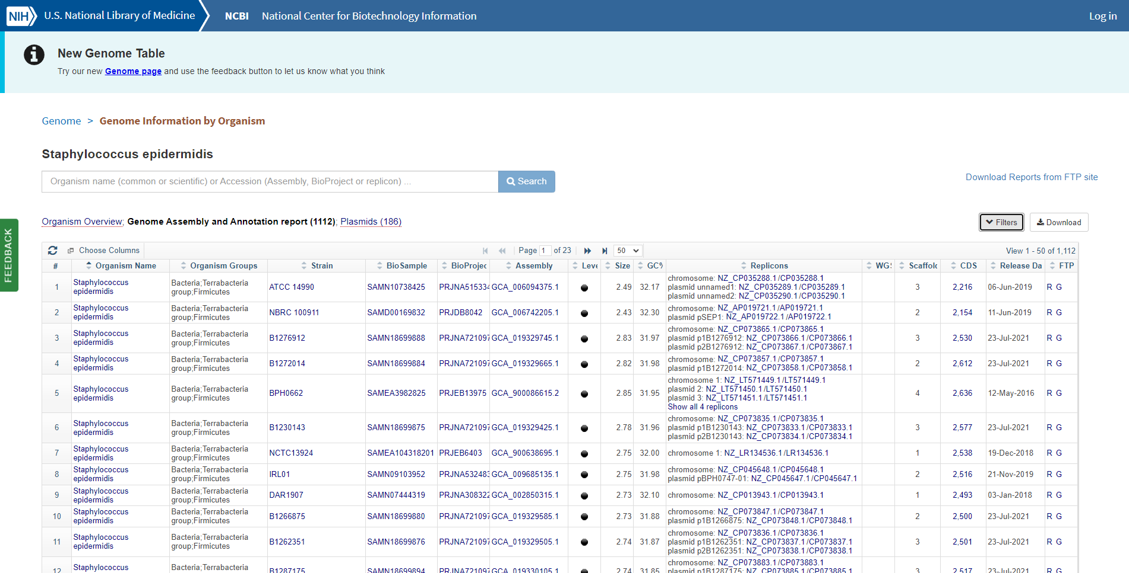**Fig8. Genome assembly and annotation report for query “Staphylococcus epidermidis”**

**Result:**

The genome information for *“Staphylococcus epidermidis”* was retrieved using the NCBI genome browser. 2216 genome annotation results were observed. Genome assembly and annotation report gave 1112 results. Genome information for reference and representative genomes and dendrogram information was also observed.

**Conclusion:**

NCBI genome browser can be used to study genome information on various organisms (highly effective for bacteria and other microorganisms). It provides sequences, maps, chromosomes, assemblies and annotations.

**References:**

1. Genome List - Genome - NCBI. (n.d.). Retrieved from https://www.ncbi.nlm.nih.gov/genome/browse/#!/proteins/155/570875|Staphylococcus epidermidis/
2. Genome List - Genome - NCBI. (n.d.). Retrieved from <https://www.ncbi.nlm.nih.gov/genome/browse/#!/prokaryotes/155/>
3. Home - Genome - NCBI. (n.d.). Retrieved from <https://www.ncbi.nlm.nih.gov/genome/>
4. Otto, M. (2009, August). Staphylococcus epidermidis--the 'accidental' pathogen. Retrieved from <https://www.ncbi.nlm.nih.gov/pmc/articles/PMC2807625/>
5. Staphylococcus epidermidis (ID 155). (n.d.). Retrieved from https://www.ncbi.nlm.nih.gov/genome/?term=Staphylococcus epidermidis/
6. Staphylococcus epidermidis (ID 155). (n.d.). Retrieved from https://www.ncbi.nlm.nih.gov/genome/?term=Staphylococcus epidermidis/
7. Staphylococcus epidermidis strain ATCC 14990 chromosome, complete geno - Nucleotide - NCBI. (n.d.). Retrieved from <https://www.ncbi.nlm.nih.gov/nuccore/NZ_CP035288.1>

**DATE: 8-11-21**

**WEBLEM 9/b**

**GOLD**

**(URL:** [**https://gold.jgi.doe.gov/**](https://gold.jgi.doe.gov/)**)**

Genomes OnLine Database (GOLD) is an open-access repository of genome and metagenome sequencing projects with their associated metadata. Login-free access is provided to a growing catalogue of manually curated public projects from all over the world. Starting from whole genome sequencing of cultured bacteria, uncultured single cells, complex eukaryotes or metagenome sequencing of environmental samples, the world of sequencing is advancing at a rapid pace. In overcoming the limitations of culturing microbial isolates, improved sequencing and analysis methods have broadened our understanding of the

microbial world. Metagenome-assembled genomes (MAGs) and single-amplified genomes (SAGs) are two such examples of genomes of uncultivated organisms that have recently expanded our knowledge about microorganisms.

There are three different ways in which projects and their associated metadata are entered into GOLD:

* Projects that are added by individual GOLD users.
* Projects for samples sequenced at the Joint Genome Institute (JGI) as part of the JGI User Programs and
* Projects sourced from public databases such as the NCBI GenBank and Sequence Read Archive (SRA).

Well-defined genome and metagenome projects in GOLD are a prerequisite for submitting sequence data to the Integrated Microbial Genomes with Microbiome (IMG/M) system for annotation and analysis. GOLD and IMG work closely to provide a seamless experience to our broad user base of scientists, students, and policy makers as well as novice science enthusiasts. Users can browse through several metadata fields in GOLD and take advantage of the multiple filters and advanced search tools to identify a subset of genomes or metagenomes of interest. They can then use the IMG identifiers from GOLD and directly go to the IMG user interface and conduct further research and comparative analyses.

**GOLD Organization and Current Status:**

GOLD is organized in a four-level hierarchical system to describe the overall proposal, samples or organisms studied, sequencing projects undertaken and their analysis process. These levels include Study, Organism or Biosample, Sequencing Project (SP), and Analysis Project (AP). All four levels, along with their complex list of metadata fields and controlled vocabulary (CV) terms, are connected to each other in a lucid framework to enhance scientific discovery.

A brief description of each of these four levels is provided below:

**Study:** The overall research objectives and goals are captured in a Study, which lies at the helm of the four-level organization structure. Studies can vary in the type of samples collected. Subsequently, a single Study may have several Sequencing and Analysis Projects that differ in their methodology and application such as Whole Genome Sequencing (WGS) and analysis, metagenome analysis or a combination of both.

**Organism/Biosample:** A GOLD Organism or Biosample contains descriptive information about the biological or physical material that is being sequenced. Any living entity such as bacteria, archaea, fungi, virus, plant or animal may constitute an Organism in GOLD. An Organism may be cultured, uncultured (such as single cells) or even bioinformatically predicted (such as Metagenome-Assembled Genomes or MAGs). The most important metadata feature of a GOLD Organism is its Taxonomic assignment including phylum, genus, species, strain etc. To promote interconnectedness with other databases, all GOLD Organisms have the NCBI Taxonomy ID.

**Sequencing Project:** The process of generating sequencing data from a Biosample or Organism is described in a Sequencing Project (SP). GOLD currently has 15 different types of SPs, from which whole-genome sequencing (WGS) and metagenome are most commonly used. The input material for an SP can either be DNA or RNA corresponding to a genome or transcriptome project, respectively. This material can come fromeither an organism, in the case of WGS and transcriptomes, or from a Biosample, in the case of metagenomesand metatranscriptomes.

**Analysis project:** The information about the processing of sequence data and its analysis is captured in a

GOLD Analysis Project (AP). A GOLD AP is required in order to submit the corresponding sequence data to IMG for annotation. There are 13 different types of Analysis Projects that can be defined in the current version, namely: Genome, Metagenome, Metagenome––Cell Enrichment, Metagenome––Single Particle Sort, Metatranscriptome, Single Cell (Unscreened), Single Cell (Screened), Metagenome-Assembled Genome, as well as five different types of Combined Assembly.

**BROWSING AND SEARCHING GOLD:**

Public data in GOLD are freely accessible through the website (https://gold.jgi.doe.gov). The homepage provides key statistics on different entities, along with links to related metadata.

**Search:** The Search tab has two options: Advanced Search and Metadata Search. While there are different ways to search the database, one of the most popular and commonly used features is the ‘Advanced Search.’ It provides a quick and easy way to search across all the different levels using several metadata fields.

**Distribution Graphs:** The Distribution Graphs section gives a top-down view of different fields in which the user receives a snapshot of the metadata scale and their diversity. A brief summary of the different types of Sequencing Projects for genome and metagenome projects and their sequencing statuses are displayed as piecharts in the Distribution Graphs section. Additionally, a user can look at the phylogenetic distribution of projects both as pie charts and in hyperlinked expandable table formats. Finally, it also shows the breakdown of Biosamples by each of the five different Ecosystem levels.

**Biogeographical Metadata:** The Biogeographical Metadata section shows the isolation location of Biosamples and Organisms as placeholders on interactive maps.

**Ecosystem classification:** GOLD Ecosystem Classification paths describe the surroundings from which an environmental sample or an organism is collected. This five-level hierarchical classification system shown below, was originally described by Ivanova et. al. in a paper titled “A call for standardized classification of metagenome projects.”

To facilitate the annotation and classification of a large number of diverse environmental samples and

organisms we need a simple, versatile and adaptable classification system. GOLD ecosystem classification

provides a simple but powerful framework to describe samples from environmental, host associated as well

as engineered or built environments.

This classification system is not a comprehensive list of all possible paths from any given environment, host or engineered setting. Instead it is primarily driven by the samples we curate. Within this framework we periodically review and revise these paths based on existing as well as the new samples we encounter.

The Five Levels of the classification system are as follows:

Ecosystem -> Ecosystem Category -> Ecosystem Type -> Ecosystem Subtype -> Specific Ecosystem

**SRA Explorer:** NCBI Sequence Read Archive (SRA) stores a collection of sequence data from all forms of life including metagenomic samples. The NCBI SRA Explorer provides a way to search SRA data. Using a combination of free text fields (such as organism name or SRA Experiment Title) and fields with predefined or controlled vocabulary based values (such as sequencing technologies or library strategies), the different types of data available in SRA can be reviewed. The SRA Explorer also has a filter where users can see which SRA data are currently present in GOLD.

**Statistics:** The Statistics tab contains graphical descriptions of several Sequencing Project metadata fields.

This ranges from the phylogenetic distribution and relevance of bacterial genome projects, breakdown of

projects by sequencing centers or the yearly growth of sequencing projects by organism domain.

**Downloads:** The Downloads page gives users the ability to access different types of data, ranging from a list of several controlled vocabulary terms, pubic metagenome and metatranscriptome projects from SRA that were annotated in IMG or a data dump of GOLD-containing select fields from various database entities. These files can be downloaded in Excel format and the underlying data is updated daily.

GOLD database thus can be used to retrieve genome and metagenome sequencing projects with their associated metadata information. It consists of organized four-level hierarchical system which includes study, organism or biosample, sequencing project, and analysis project and it provides various browsing and searching resources the makes it easier for the users to access information.

REFERENCES:

1. Mukherjee, S., Stamatis, D., Bertsch, J., Ovchinnikova, G., Sundaramurthi, J., Lee, J., . . . Reddy,T.
   1. (2020). Genomes OnLine Database (GOLD) v.8: Overview and updates. Nucleic Acids Research, 49(D1). doi:10.1093/nar/gkaa983
2. JGI gold: Home. JGI GOLD | Home. (n.d.). Retrieved October 20, 2021, from https://gold.jgi.doe.gov/

**Date: 31-10-21**

**WEBLEM 10**

**Introduction to Pairwise Alignment**

**Pairwise Alignment:**

Sequence comparison lies at the heart of bioinformatics analysis. It is an important first step toward structural and functional analysis of newly determined sequences. As new biological sequences are being generated at exponential rates, sequence comparison is becoming increasingly important to draw functional and evolutionary inference of a new protein with proteins already existing in the database. The most fundamental process in this type of comparison is sequence alignment. This is the process by which sequences are compared by searching for common character patterns and establishing residue-residue correspondence among related sequences. Pairwise sequence alignment is the process of aligning two sequences and is the basis of database similarity searching and multiple sequence alignment. This chapter introduces the basics of pairwise alignment.

**Sequence Similarty vs Sequence Identity:**

Another set of related terms for sequence comparison are sequence similarity and sequence identity. Sequence similarity and sequence identity are synonymous for nuclotide sequences. For protein sequences, however, the two concepts are very differenct. In a protein sequence alignment, sequence identitty refers to the percentage of matches of the same animo acid residues between two aligned sequences. Similarity refers to the percentage of aligned residues that have similar physicochemical characteristics and can be more readily substituted for each other.

**Needleman-Wunsch Algorithm:**

Needleman-Wunsch Algorithm developed by Saul B. Needleman and Christian D. Wunsch in 1970. It was designed to compare biological sequences and was one of the first applications of dynamic programming to the biological sequence comparison. This algorithm is usually used for global alignment of two sequences (nucleotide or amino acids). For the purpose of explanation, first summarizing the algorithm in five steps and then I will move forwards with examples and explanations.

1. Consider all the possible pairs of residues from two sequences, the best way is to generate a 2D matrix of two sequences. We will need 2 such matrices one for sequence and one for scores.
2. Initialize the score matrix. Scoring matrices are used to determine the relative score made by matching two characters in a sequence alignment. There are many flavors of scoring matrices for amino acid sequences, nucleotide sequences, and codon sequences, and each is derived from the alignment of "known" homologous sequences. These alignments are then used to determine the likelihood of one character being at the same position in the sequence as another character.
3. Gap penalty: Usually there are high chances of insertions and deletions (indels) in biological sequences but one large indels is more likely rather than multiple small indels in a given sequences. In order to tackle this issue we give two kind of penalities; Gap opening penalty (relatively higher) and gap extension penalty (relatively lower)
4. Calculate scores and fill the traceback matrix
5. Deduce the alignment from the traceback matrix

**Smith-Waterman alignment algorithm:**

Over a decade after the initial publication of the Needleman-Wunsch algorithm, a modification was made to allow for local alignments (Smith and Waterman, 1981). Today, the Smith-Waterman alignment algorithm is the one used by the Basic Local Alignment Search Tool (BLAST) which is the most cited resource in biomedical literature. In this adaptation, the alignment path does not need to reach the edges of the search graph, but may begin and end internally. In order to accomplish this, 0 was added as a term in the score calculation described by Needleman and Wunsch.

Recall that for global alignments the value at any point is:

M(i,j) = MAX(Mi-1,j-1 + S(Ai, Bj)

Mi-1,j + gap. Mi,j-1 + gap)

However for local alignments the score calculation becomes:

M(I,j) = MAX(Mi-1,j-1 + S(Ai, Bj)

Mi-1,j + gap. Mi,j-1 + gap 0)

The implication of this is that there are no values below zero in a local alignment scoring matrix.

**Date: 31-10-21**

**WEBLEM 10a**

**(URL:**[**https://www.ebi.ac.uk/Tools/psa/**](https://www.ebi.ac.uk/Tools/psa/)**)**

**Aim:**

To Study the query “Actin Sequence” in Needleman-Wunsch algorithm

**Introduction:**

Needleman-Wunsch Algorithm developed by Saul B. Needleman and Christian D. Wunsch in 1970. It was designed to compare biological sequences and was one of the first applications of dynamic programming to the biological sequence comparison. This algorithm is usually used for global alignment of two sequences (nucleotide or amino acids). For the purpose of explanation, first summarizing the algorithm in five steps and then I will move forwards with examples and explanations.

Actin is the most abundant protein in most eukaryotic cells. It is highly conserved and participates in more protein-protein interactions than any known protein. These properties, along with its ability to transition between monomeric (G-actin) and filamentous (F-actin) states under the control of nucleotide hydrolysis, ions, and a large number of actin-binding proteins, make actin a critical player in many cellular functions, ranging from cell motility and the maintenance of cell shape and polarity to the regulation of transcription. Moreover, the interaction of filamentous actin with myosin forms the basis of muscle contraction.

**Methodology:**

1. Open the homepage of Pair-Wise Alignment.
2. After that open the Needle-Wusch algorithm.
3. Enter the protein sequence.
4. Open the result.
5. Interpret the result.

**Observation:**

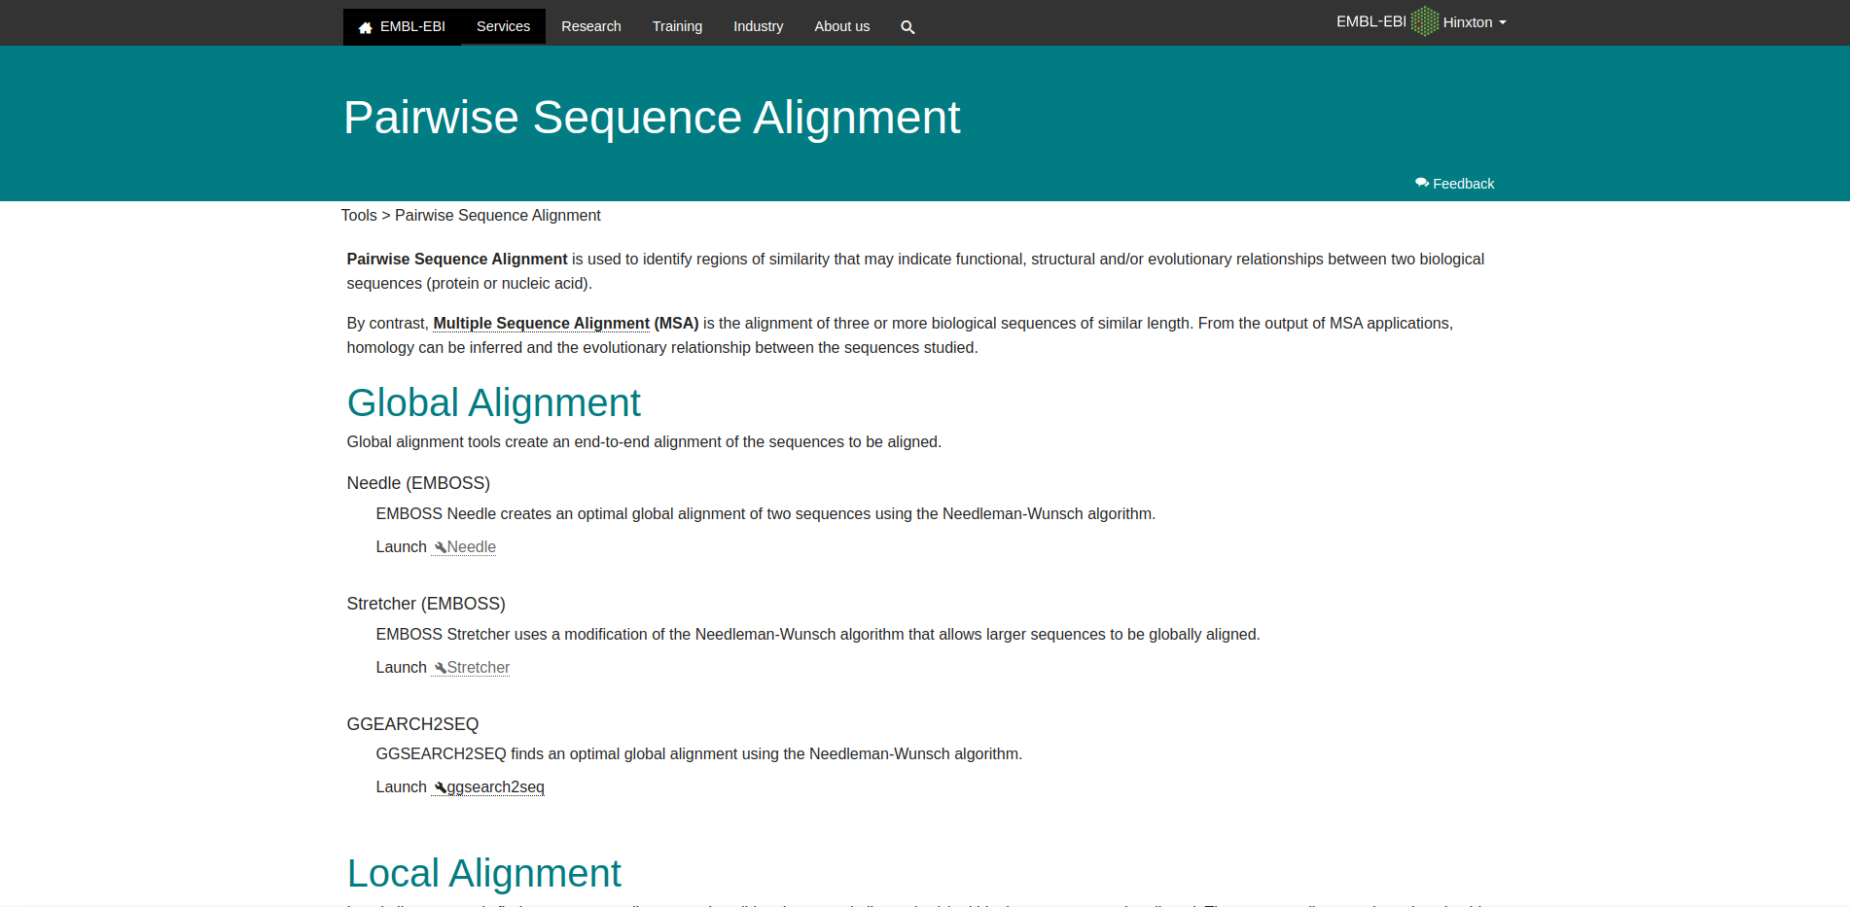**Fig1: Homepage of pairwise Sequence Alignment**

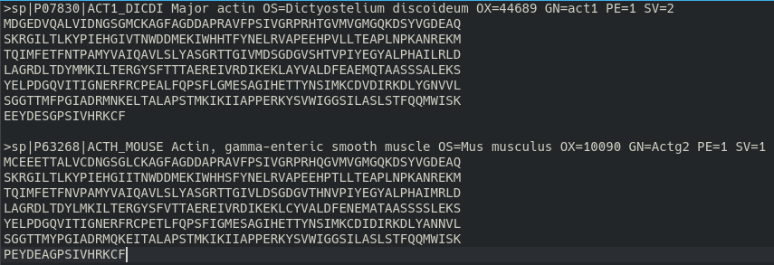**Fig2: Two FASTA sequence for actin from uniprot**

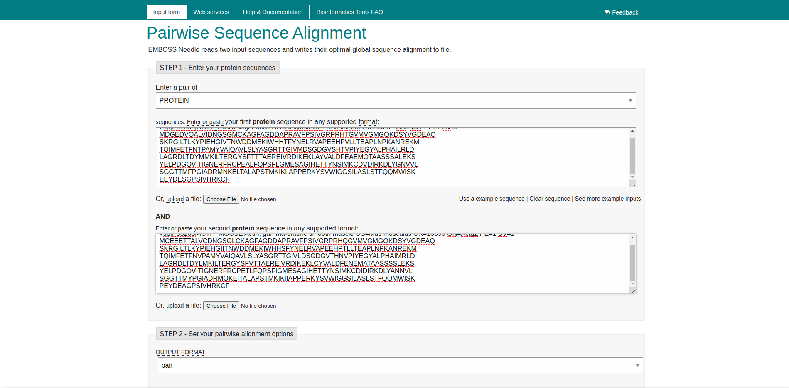**Fig3: Needleman-Wunsch algorith search bar with two actin sequences**

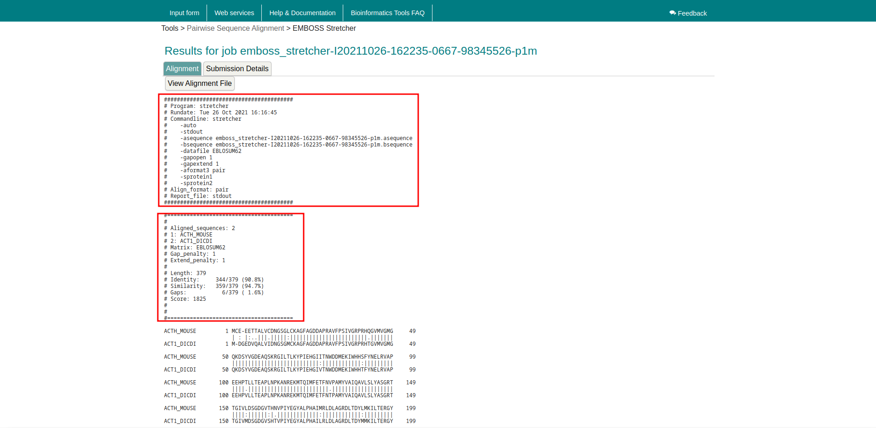**Fig4: Result page for actin Two Sequences**

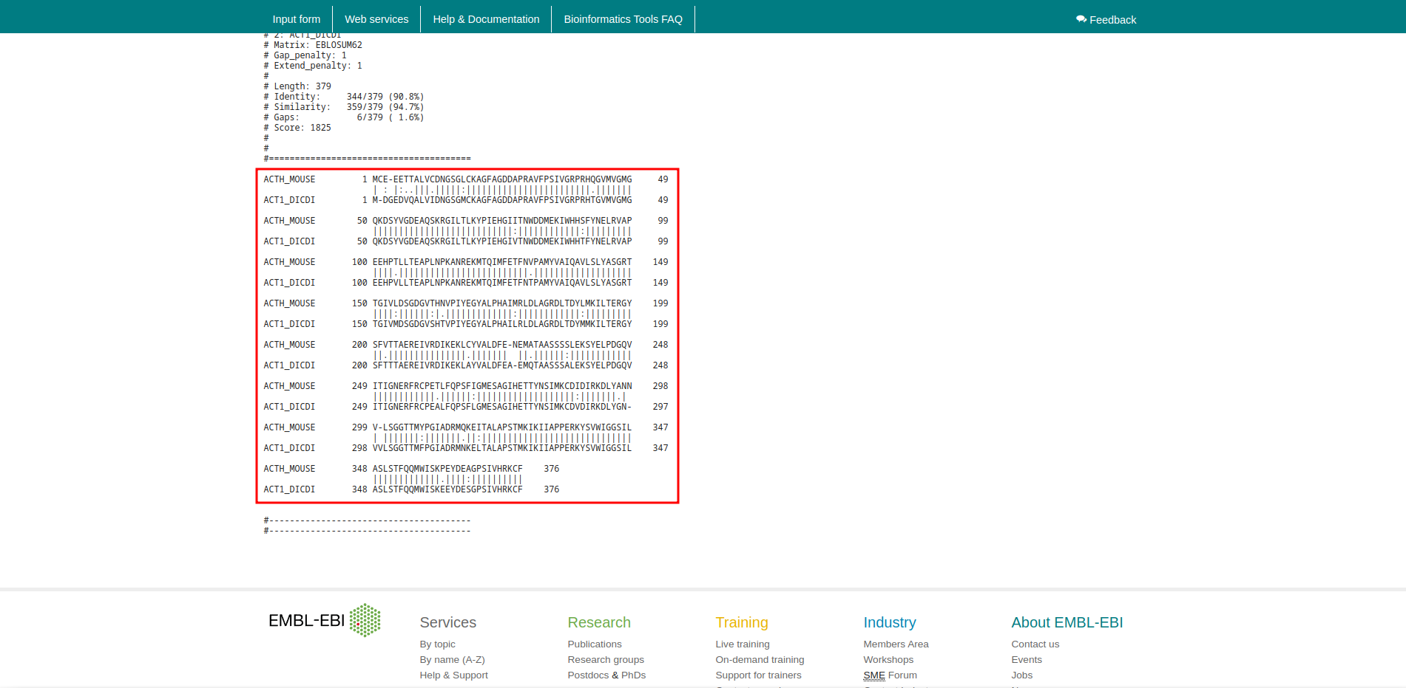**Fig5: Two Sequences Alignment for Actin**

**Results:**

In Needleman-Wunsch algorithm for actin sequences it showing score 1825. It has length 379, Identity 344/379 (90.8%), Similarity 359/379 (94.7%), Gaps 6/379 (1.6%). At matrix EBLOSUM62 with gap penalty 1 and extend penalty 0.5

**Conclusion:**

Needleman-Wunsch algorithm in bioinformatics to align protein or nucleotide sequences. It was one of the first applications of dynamic programming to compare biological sequences. The Needleman-Wunsch algorithm is stil widely used fro optimal global alignment, particularly when the quelity of the global alignment is of the utmost importance. The algorithm assigns a score to every possible alignment, and the purpose of the alogrithm is to find all possible alignment having the highest score.

**References:**

1. Xiong, J. (2006). Essential Bioinformatics (1st ed.). Cambridge University Press.
2. (n.d.). Retrieved from <https://www.uniprot.org/uniprot/P63268.fasta>
3. (n.d.). Retrieved from <https://www.uniprot.org/uniprot/P07830.fasta>
4. Dominguez, R., & Holmes, K. C. (2011). Actin structure and function. Retrieved from <https://www.ncbi.nlm.nih.gov/pmc/articles/PMC3130349/>
5. Embl-Ebi. (n.d.). Pairwise Sequence Alignment. Retrieved from <https://www.ebi.ac.uk/Tools/psa/>
6. Embl-Ebi. (n.d.). EMBOSS Needle. Retrieved from <https://www.ebi.ac.uk/Tools/psa/emboss_needle/>
7. Embl-Ebi. (n.d.). EMBOSS Stretcher. Retrieved from <https://www.ebi.ac.uk/Tools/services/web/toolresult.ebi?jobId=emboss_stretcher-I20211026-162235-0667-98345526-p1m>
8. Embl-Ebi. (n.d.). EMBOSS Stretcher. Retrieved from <https://www.ebi.ac.uk/Tools/services/web/toolresult.ebi?jobId=emboss_stretcher-I20211026-162235-0667-98345526-p1m>

**Date: 31-10-21**

**WEBLEM 10b**

**(URL:** [**https://www.ebi.ac.uk/Tools/psa/**](https://www.ebi.ac.uk/Tools/psa/)**)**

**Aim:**

To study the query “Actin” in Smith-Waterman alignment algorithm

**Introduction:**

Over a decade after the initial publication of the Needleman-Wunsch algorithm, a modification was made to allow for local alignments (Smith and Waterman, 1981). Today, the Smith-Waterman alignment algorithm is the one used by the Basic Local Alignment Search Tool (BLAST) which is the most cited resource in biomedical literature. In this adaptation, the alignment path does not need to reach the edges of the search graph, but may begin and end internally. In order to accomplish this, 0 was added as a term in the score calculation described by Needleman and Wunsch.

Actin is the most abundant protein in most eukaryotic cells. It is highly conserved and participates in more protein-protein interactions than any known protein. These properties, along with its ability to transition between monomeric (G-actin) and filamentous (F-actin) states under the control of nucleotide hydrolysis, ions, and a large number of actin-binding proteins, make actin a critical player in many cellular functions, ranging from cell motility and the maintenance of cell shape and polarity to the regulation of transcription. Moreover, the interaction of filamentous actin with myosin forms the basis of muscle contraction.

**Methodology:**

1. Open the homepage of Pair-Wise Alignment.
2. After that open the Smith-Waterman alignment algorithm.
3. Enter the protein sequence.
4. Open the result.
5. Interpret the result.

**Observation:**

**Fig1. Homepage of pairwise Sequence alignement**

**Fig2. Two FASTA sequence for actin from uniprot**

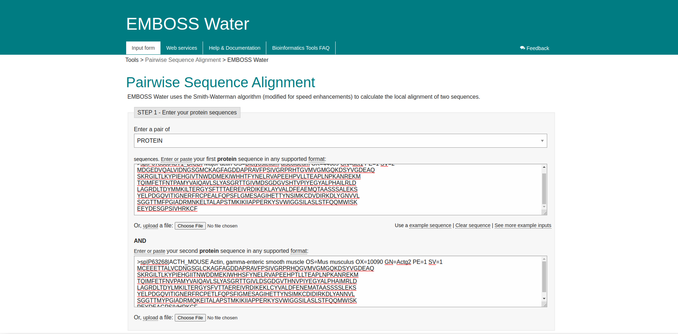**Fig.3 Smith-Waterman alignment algorithm search bar with 2 actin sequences**

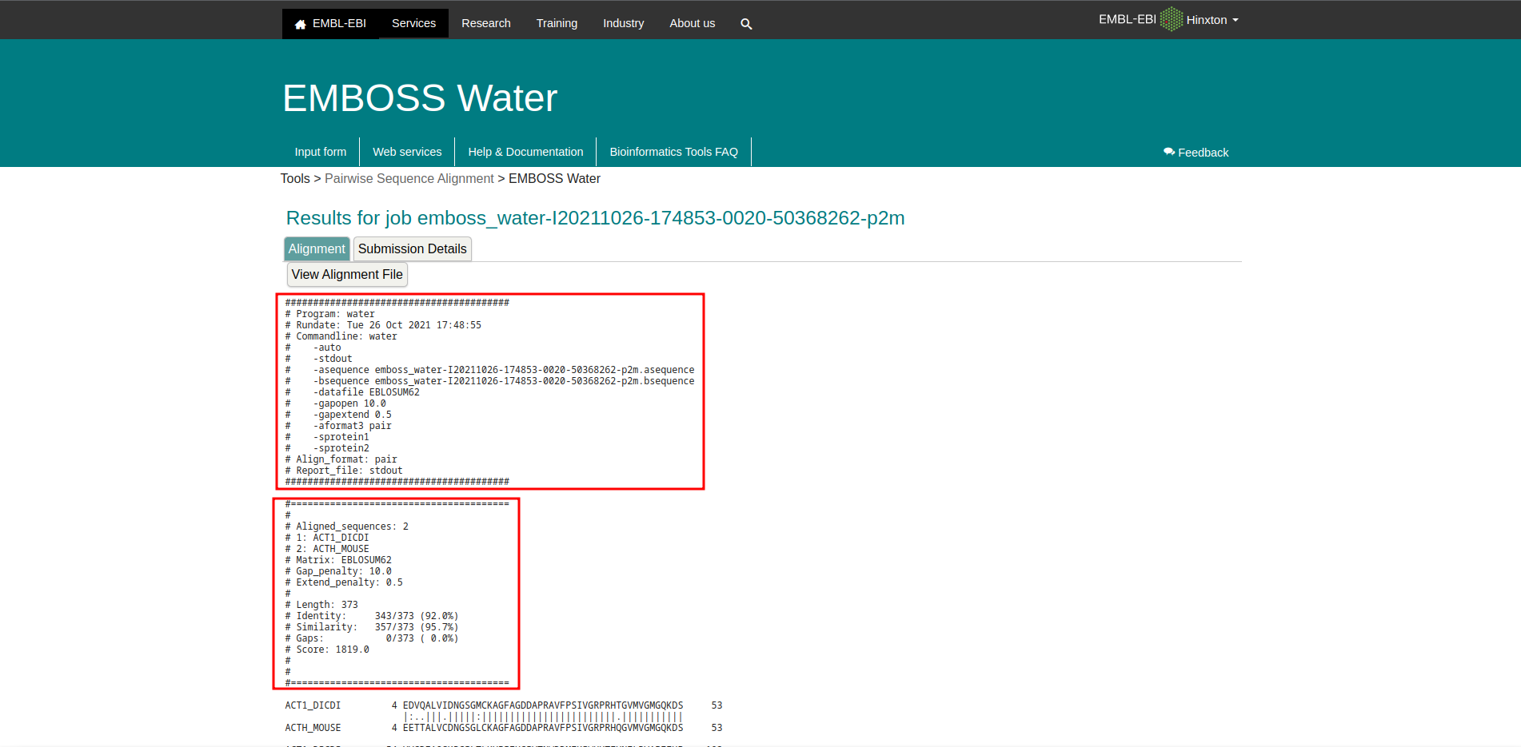**Fig4. Result page for 2 actin sequences**

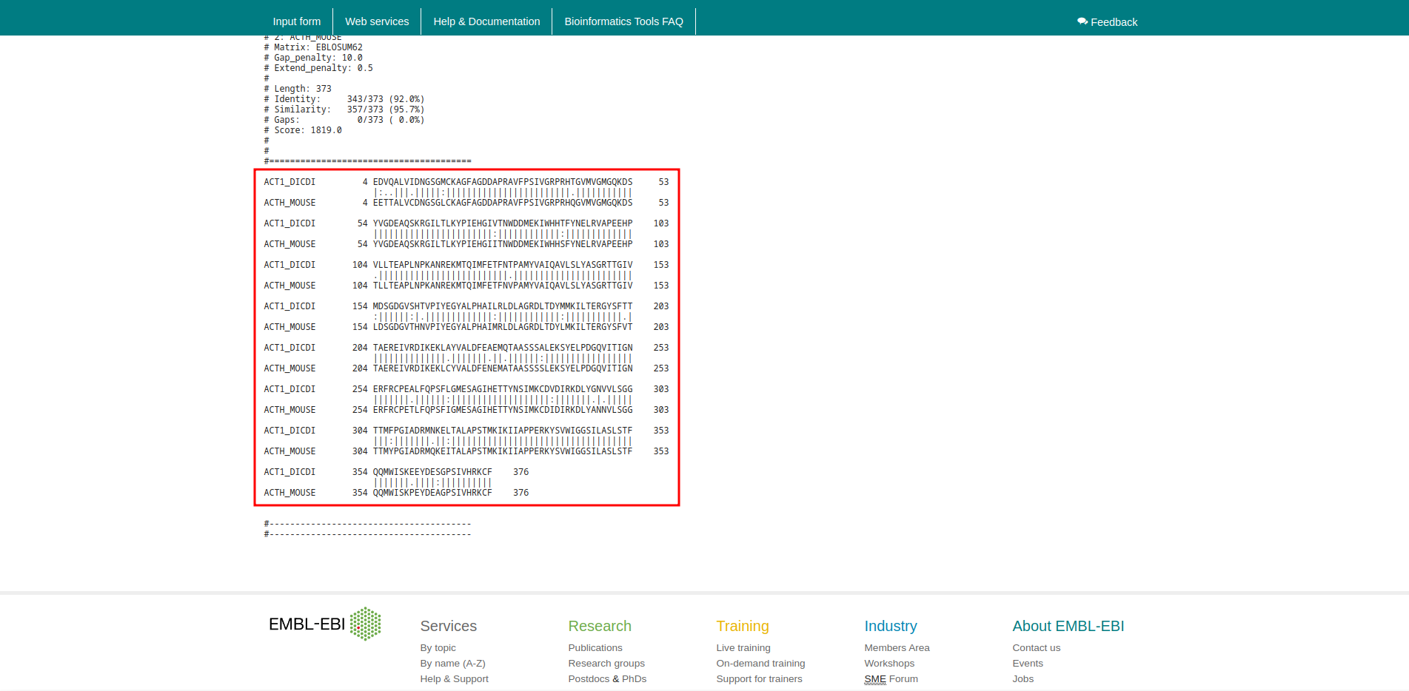**Fig5. Two Sequences Alignment for Actin**

**Results:**

In Smith-Water alignment algorithm for Actin sequences it showing score 1819. It has length 373, Identity 343/373 (92.0%), Similarity 357/373 (95.7%), Gaps 0/373. At matrix EBLOSUM62 with gap penalty10 and extend penalty 0.5.

**Conclusion:**

The alignment tab shows the alignment of the two sequences, with all the described parameters, used scoring matrices and Gap penalty scored values. The alignment tab has an option fo rhte user to download the entire alignemtn. The alignment between the two sequences is shown in Figure 4, the gaps are represented with ‘-’. If a match is there between the two nucleotide there is a symbol ‘|’ and the mismatch is represented with a dot ‘.’

**References:**

1. Xiong, J. (2006). Essential Bioinformatics (1st ed.). Cambridge University Press.
2. (n.d.). Retrieved from <https://www.uniprot.org/uniprot/P63268.fasta>
3. (n.d.). Retrieved from <https://www.uniprot.org/uniprot/P07830.fasta>
4. Dominguez, R., & Holmes, K. C. (2011). Actin structure and function. Retrieved from <https://www.ncbi.nlm.nih.gov/pmc/articles/PMC3130349/>
5. Embl-Ebi. (n.d.). Pairwise Sequence Alignment. Retrieved from <https://www.ebi.ac.uk/Tools/psa/>
6. Embl-Ebi. (n.d.). EMBOSS Needle. Retrieved from <https://www.ebi.ac.uk/Tools/psa/emboss_needle/>
7. Embl-Ebi. (n.d.). EMBOSS Stretcher. Retrieved from <https://www.ebi.ac.uk/Tools/services/web/toolresult.ebi?jobId=emboss_stretcher-I20211026-162235-0667-98345526-p1m>
8. Embl-Ebi. (n.d.). EMBOSS Stretcher. Retrieved from <https://www.ebi.ac.uk/Tools/services/web/toolresult.ebi?jobId=emboss_stretcher-I20211026-162235-0667-98345526-p1m>

**DATE: 7-11-21**

**WEBLEM 11**

**Introduction To Sequence Alignment**

**BLAST:**

A sequence similarity search often provides the first information about a new DNA or protein sequence. A search allows scientists to infer the function of a sequence from similar sequences. There are many ways of performing a sequence similarity search, but probably the most popular method is the “Basic Local Alignment Search Tool” (BLAST) (1, 2). BLAST uses heuristics to produce results quickly. It also calculates an “expect value” that estimates how many matches would have occurred at a given score by chance, which can aid a user in judging how much confidence to have in an alignment.

As the name implies, BLAST performs “local” alignments. Most proteins are modular in nature, with one or more functional domains occurring within a protein. The same domains may also occur in proteins from different species. The BLAST algorithm is tuned to find these domains or shorter stretches of sequence similarity. The local alignment approach also means that an mRNA can be aligned with a piece of genomic DNA, as is frequently required in genome assembly and analysis. If instead BLAST started out by attempting to align two sequences over their entire lengths (known as a global alignment), fewer similarities would be detected, especially with respect to domains and motifs.

1. BLASTN:

The BLASTN nucleotide-nucleotide search looks for more distant sequences.

1. BLASTP:

BLASTP performs protein-protein sequence comparison, and its algorithm is the basis of many other types of BLAST searches such a BLASTX and TBLASTN.

1. PHI-BLAST:

PHI-BLAST (Pattern-Hit Initiated BLAST) is a search program that combines matching of regular expressions with local alignments surrounding surrounding the match. The most important features of the program have been incorporated into the BLAST software framework partly for user convenience and partly so that PHI-BLAST may be combined seamlessly with PSI-Blast. Other features that do not fit into the BLAST framework will be released later as a separate and/or separate web page query option.

1. PSI-BLAST:

PSI-BLAST first performs a BLASTP search to collect information that it then uses to produce a Position-Specific-Scoring-Matrix (PSSM). A PSSM for a query of length N is an N x 20 matrix. Each of the N columns corresponds to a letter in the query, and each column contains 20 rows. Each row corresponds to a specific residue and describes the probability of related sequences having that residue at that position. PSI-BLAST can then search a database of protein sequences with this PSSM.

**FASTA:**

At EMBL-EBI, we make the world’s public biological data freely available to the scientific community via a range of services and tools, perform basic research and provide professional training in bioinformatics. We are part of the European Molecular Biology Laboratory (EMBL), an international, innovative and interdisciplinary research organization funded by over 20 member states, prospect and associate member states.

ASTA (pronounced FAST-AYE) is a suite of programs for searching nucleotide or protein databases with a query sequence. FASTA itself performs a local heuristic search of a protein or nucleotide database for a query of the same type. FASTX and FASTY translate a nucleotide query for searching a protein database. TFASTX and TFASTY translate a nucleotide database to be searched with a protein query. Optimal searches are available with the programs SSEARCH (local), GGSEARCH (global) and GLSEARCH (global query against local database).

1. FASTAp;

This tool provides sequence similarity searching against protein databases using the FASTA suite of programs. FASTA provides a heuristic search with a protein query. FASTX and FASTY translate a DNA query. Optimal searches are available with SSEARCH (local), GGSEARCH (global) and GLSEARCH (global query, local database).

1. FASTAn:

This tool provides sequence similarity searching against nucleotide databases using the FASTA suite of programs. FASTA provides a heuristic search with a nucleotide query. TFASTX and TFASTY translate the DNA database for searching with a protein query. Optimal searches are available with SSEARCH (local), GGSEARCH (global) and GLSEARCH (global query, local database).

**DATE: 7-11-21**

**WEBLEM 11/a**

**(URL:** [**https://blast.ncbi.nlm.nih.gov/Blast.cgi**](https://blast.ncbi.nlm.nih.gov/Blast.cgi)**)**

**Aim:**

To study the Query ‘Keratin’ in BLASTn.

**Introduction:**

As the name implies, BLAST performs “local” alignments. Most proteins are modular in nature, with one or more functional domains occurring within a protein. The same domains may also occur in proteins from different species. The BLAST algorithm is tuned to find these domains or shorter stretches of sequence similarity. The local alignment approach also means that an mRNA can be aligned with a piece of genomic DNA, as is frequently required in genome assembly and analysis. If instead BLAST started out by attempting to align two sequences over their entire lengths (known as a global alignment), fewer similarities would be detected, especially with respect to domains and motifs.

* The BLASTN nucleotide-nucleotide search looks for more distant sequences.

**Rhodopsin**, also called **visual purple**, pigment-containing sensory protein that converts light into an electrical signal. Rhodopsin is found in a wide range of organisms, from vertebrates to bacteria. In many seeing animals, including humans, it is required for vision in dim light and is located in the retina of the eye specifically, within the tightly packed disks that make up the outer segment of the retina’s photoreceptive rod cells, which are specially adapted for vision under low-light conditions.

Rhodopsin was discovered in 1876 by German physiologist Franz Christian Boll, who observed that the normally reddish purple frog retina turned pale in bright light. The fading of colour was later attributed to the destruction of rhodopsin, via a process known as bleaching. Bleaching and the subsequent regeneration of rhodopsin are major steps in the visual cycle—the series of biochemical reactions that is critical for vision in low light.

**Methodology:**

1. Open the homepage of blast.
2. After that click the Blastn.
3. Enter the sequence for keratin taken by Genebank.
4. Open the result page.
5. Interpret the result.

**Observation:**

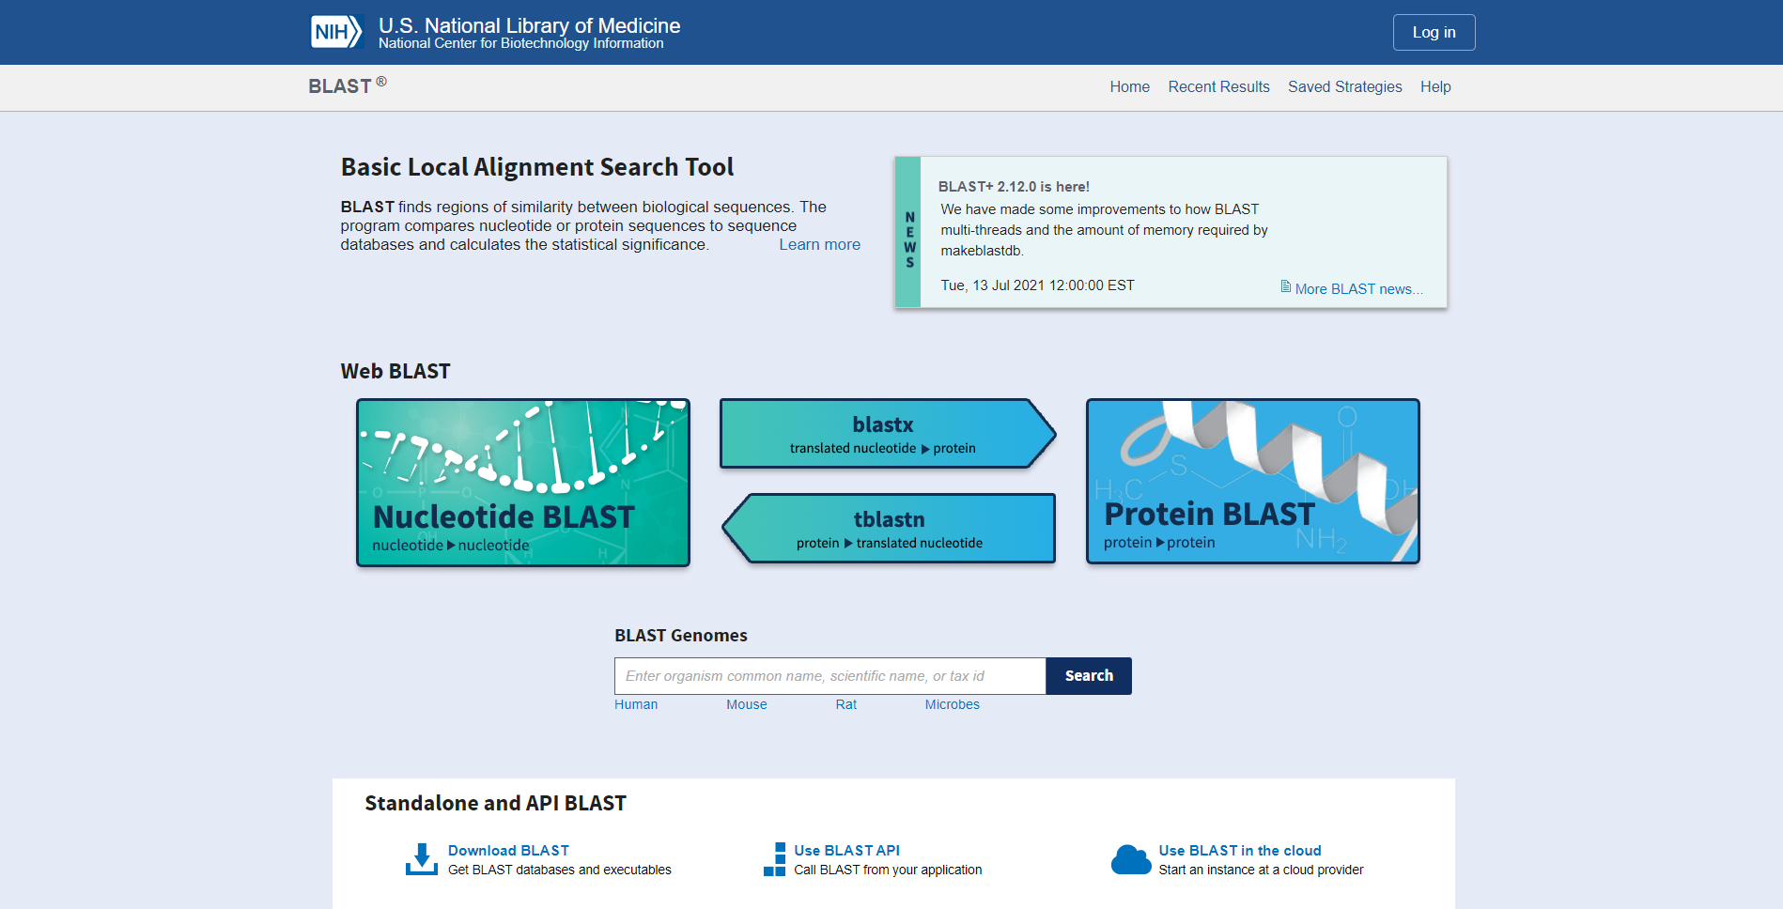**Fig1. Homepage of BLAST**

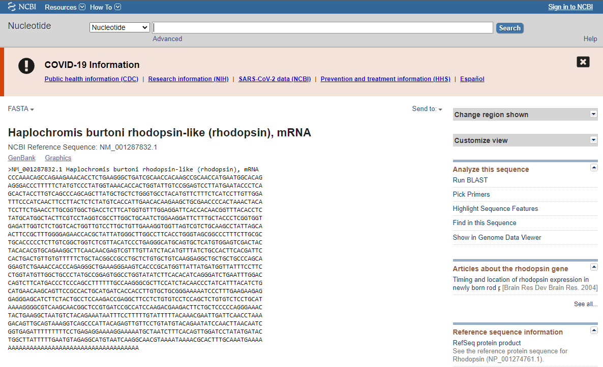**Fig2. Fasta sequence taken from genebank**

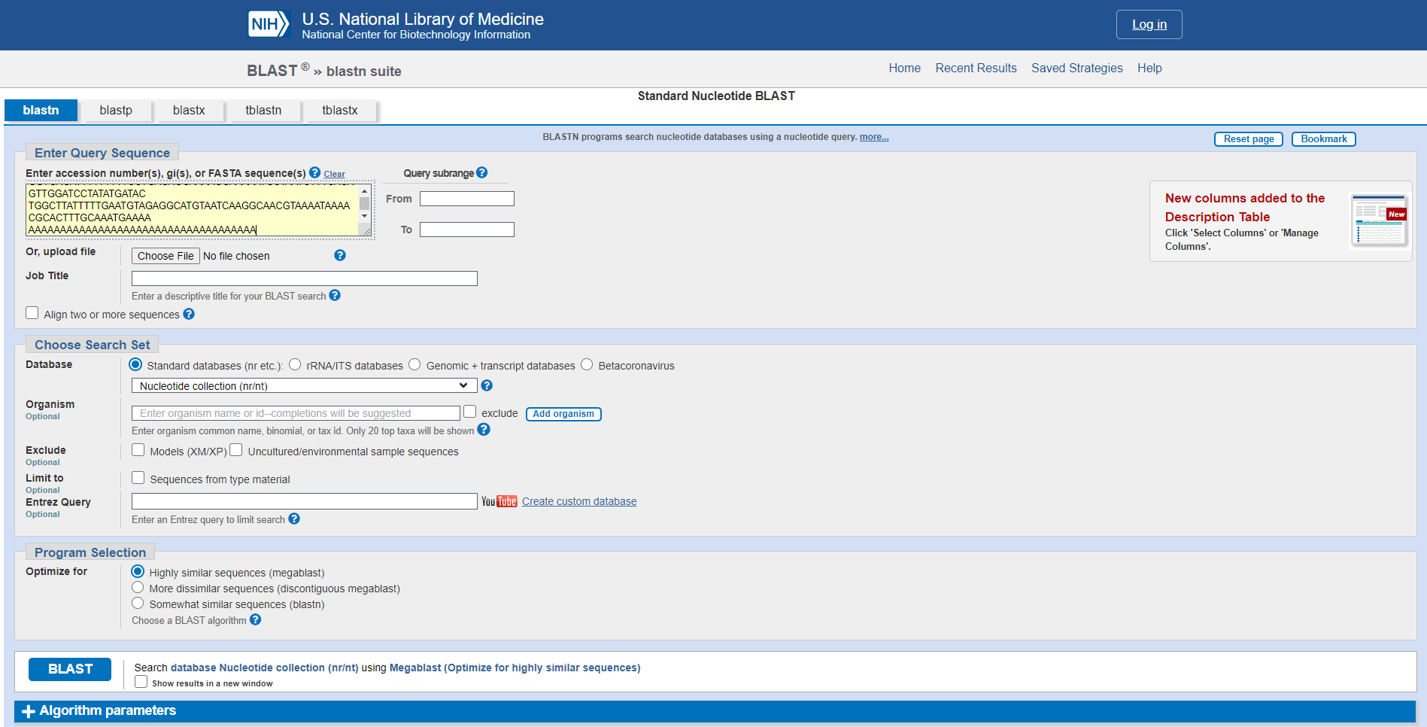**Fig3. Search bar for blastn with sequence.**

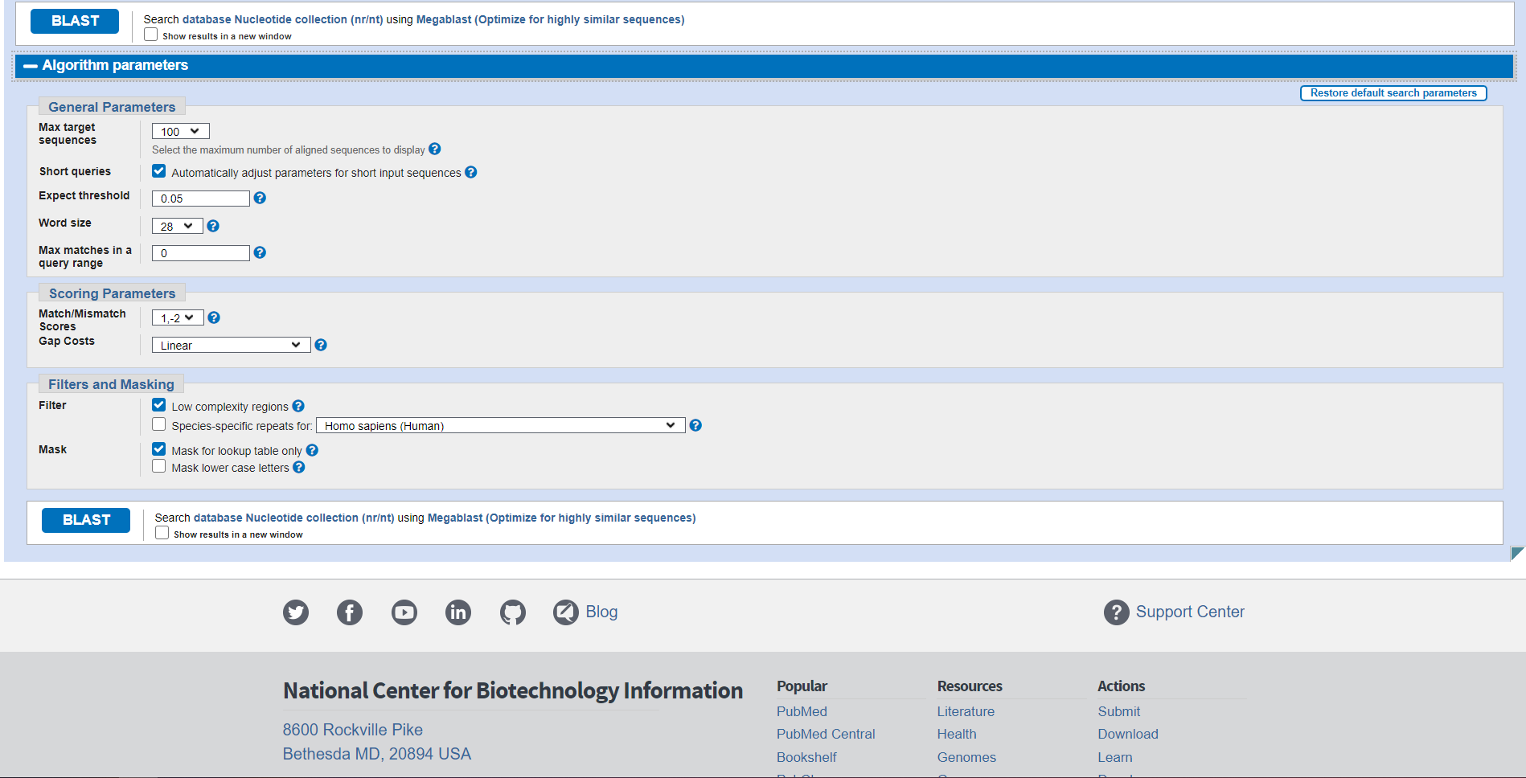**Fig4. Algorithm parameters in blastn**

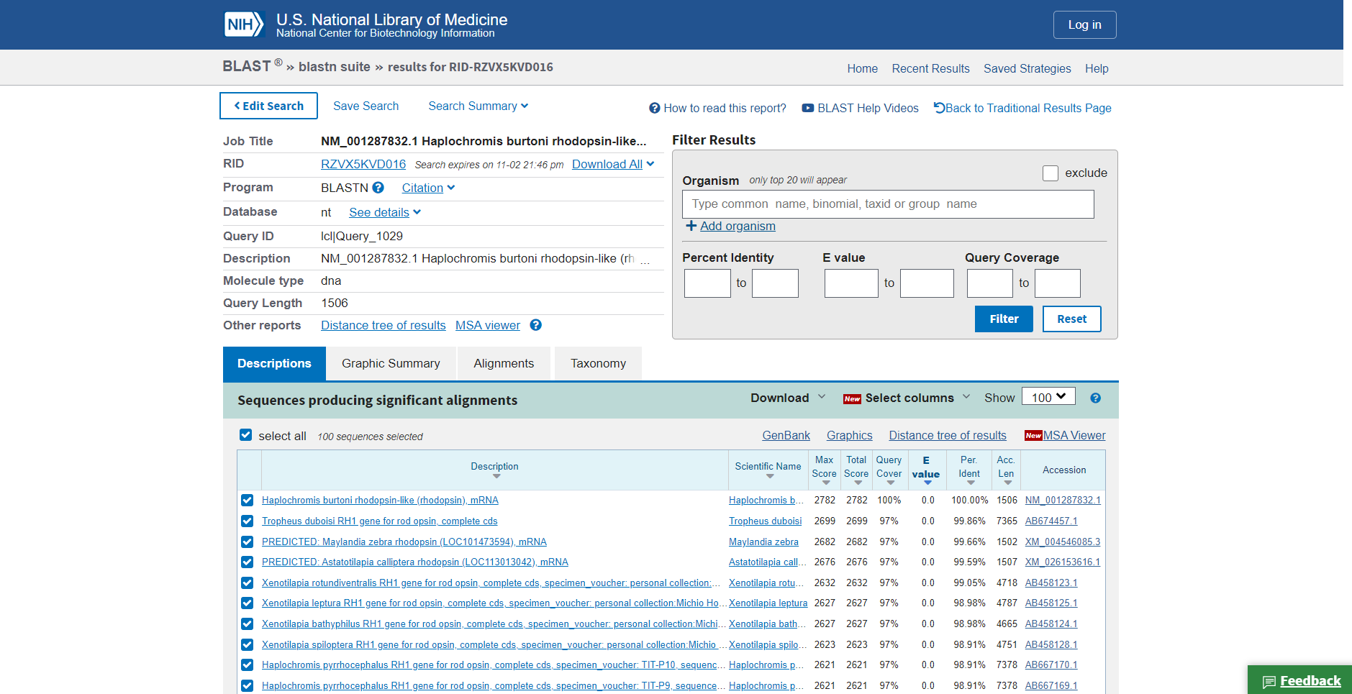**Fig5. Result page (header file) for Rhodopsin.**

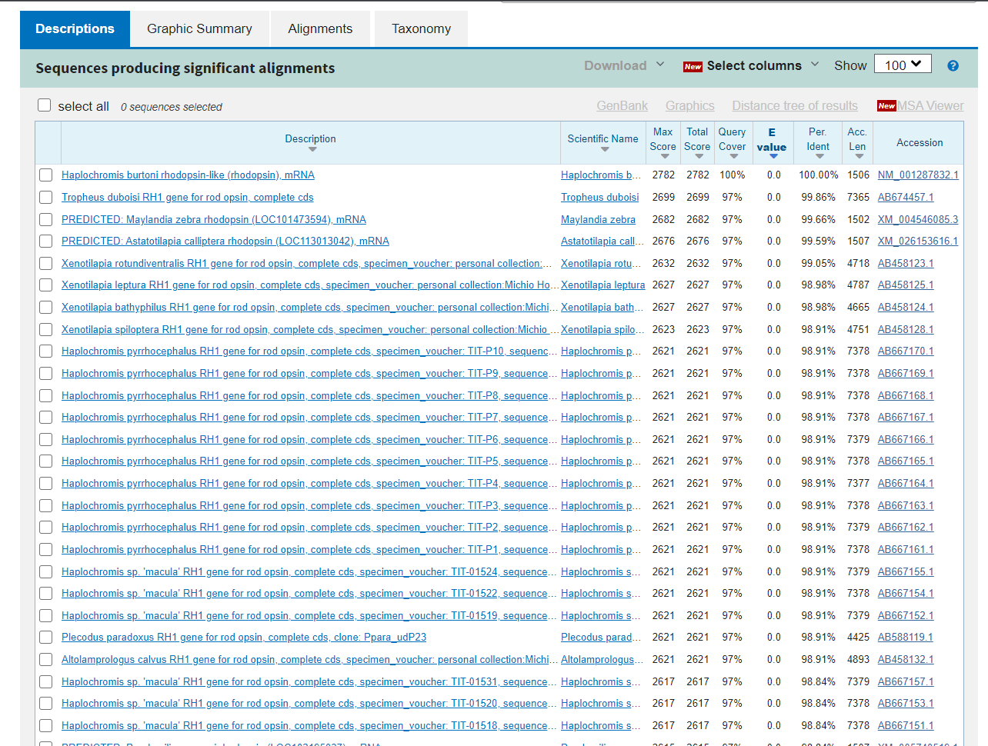**Fig6. Description for query Rhodopsin**

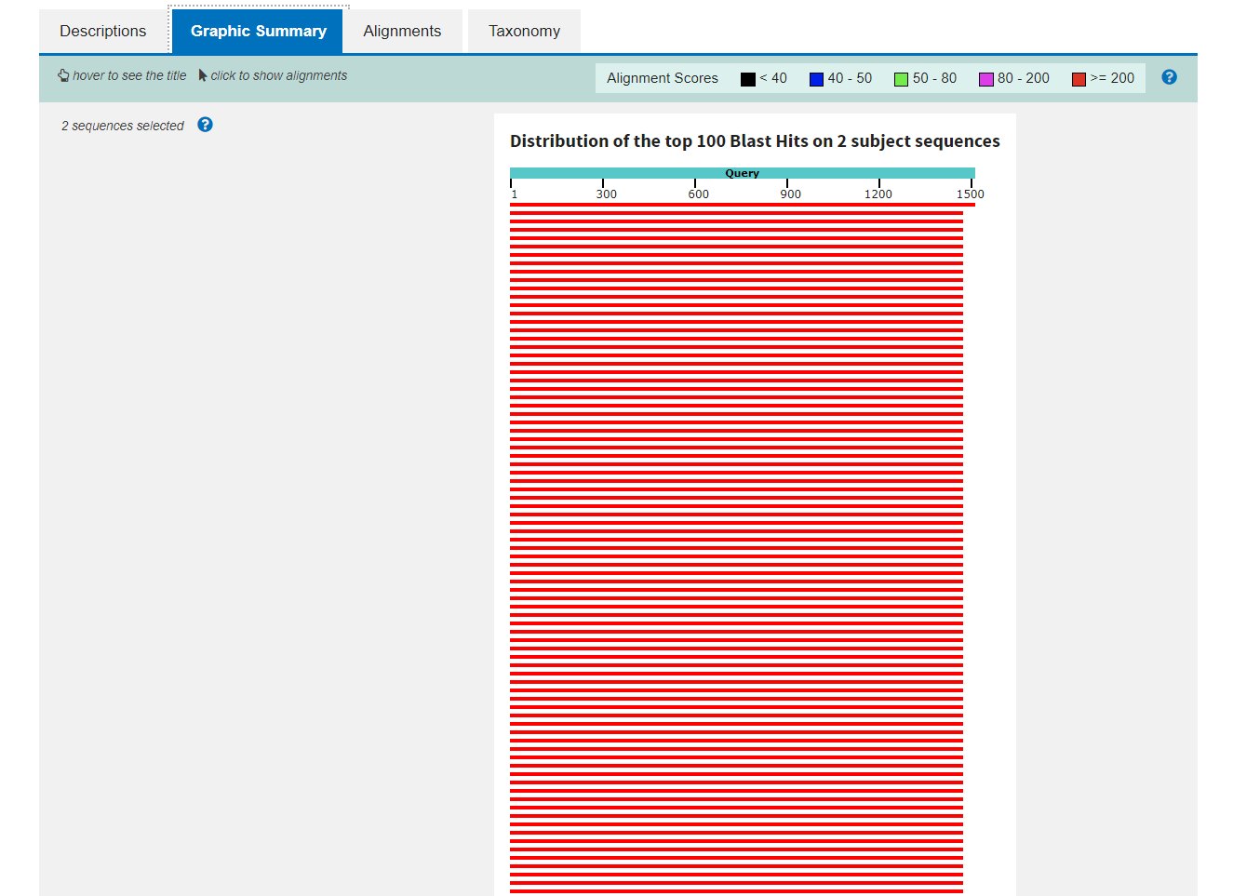**Fig7. Graphic Summary for query Rhodopsin**

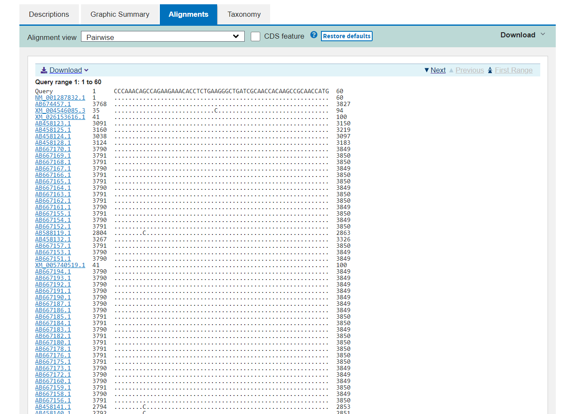**Fig8. Alignment for query Rhodopsin**

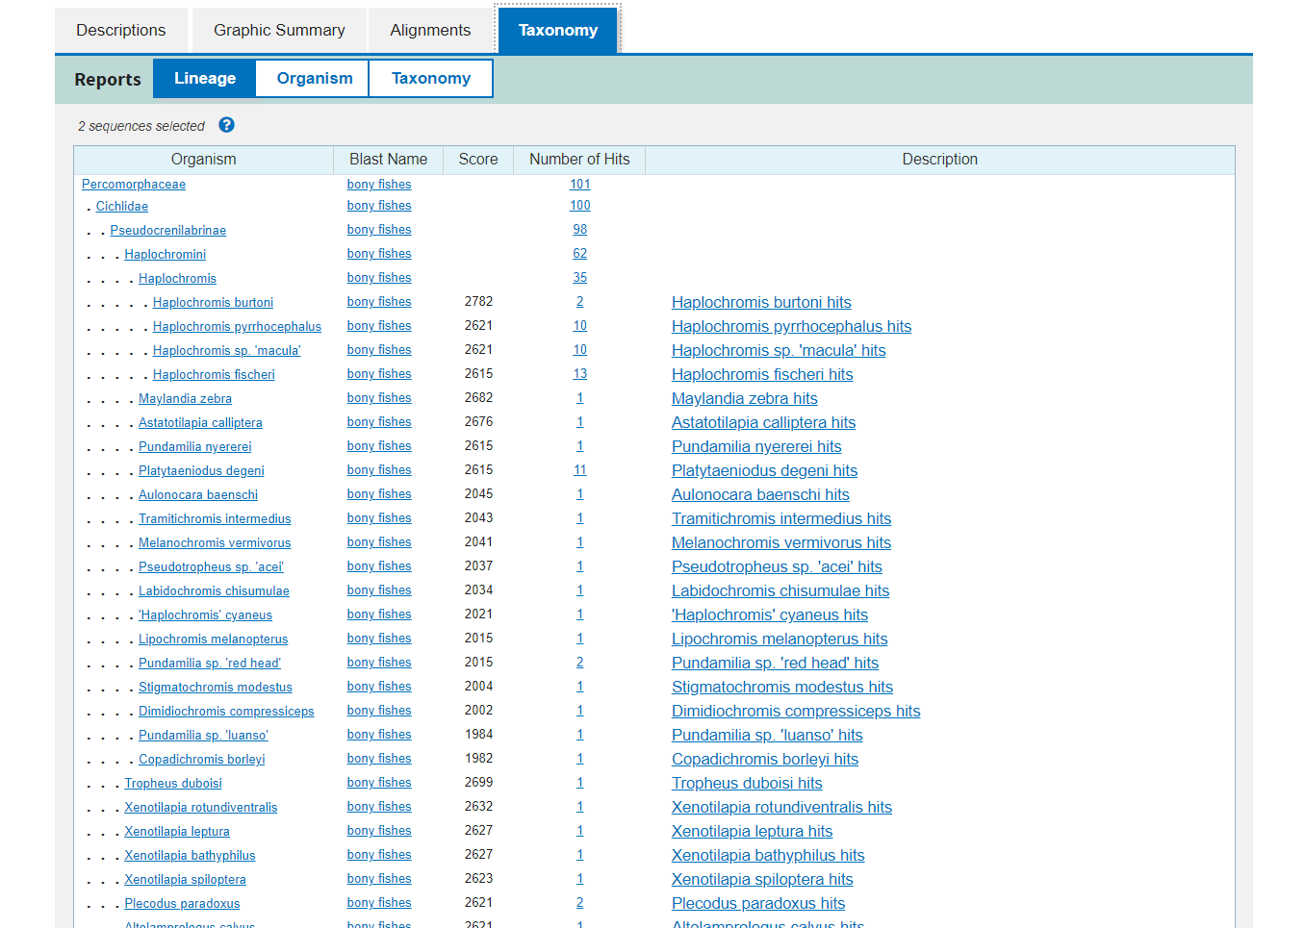**Fig9. Taxonomy for query Rhodopsin**

**Results:**

Here we have acquired info about the descriptions, Graphical summary, Alignment, and taxonomy related information on our query rhodopsin.

The results can be interpreted as:

Maximum score is the highest alignment score between the query sequence and the database segments.

Total score is the sum of the alignment scores of all sequences from the same db.

Percent Query coverage is the percent of the query length that is included in the aligned segments.

E-value is the measure of likeliness that sequence similarity is not random chance percent identity describes how similar the query is to the aligned sequences.

**Conclusion:**

BLASTN is a great tool to get the required information on a particular FASTA sequence in detail.

**References:**

1. BLAST: Basic Local Alignment Search Tool. (n.d.). Retrieved from https://blast.ncbi.nlm.nih.gov/Blast.cgi
2. BLAST: Basic Local Alignment Search Tool. (n.d.). Retrieved from <https://blast.ncbi.nlm.nih.gov/Blast.cgi#alnHdr_2>
3. Nucleotide BLAST: Search nucleotide databases using a nucleotide query. (n.d.). Retrieved from https://blast.ncbi.nlm.nih.gov/Blast.cgi?PROGRAM=blastn&PAGE_TYPE=BlastSearch&LINK_LOC=blasthome
4. Haplochromis burtoni rhodopsin-like (rhodopsin), mRNA - Nucleotide - NCBI. (n.d.). Retrieved from <https://www.ncbi.nlm.nih.gov/nuccore/NM_001287832.1?report=fasta>

**Date: 7-11-21**

**WEBLEM 11/b**

**(URL:** [**https://blast.ncbi.nlm.nih.gov/Blast.cgi**](https://blast.ncbi.nlm.nih.gov/Blast.cgi)**)**

**Aim:**

To study the Query ‘Rhodopsin’ in BLASTp

**Introduction:**

A sequences similarity search often provides the first information about a new DNA or protein sequence. A search allows scientists to infer the function of a sequence from similar sequence. There are many ways of performing a sequences similarity search, but probably the most popular method is the “Basic Local Alignment Search Tools” (BLAST). BLAST uses heuristics to produces result quickly. It also calculates an “expect value” that estimates how many matches would have occurred at a given score by chance, which can aid a user in judging how much confidence to have in an alignment.

* BLASTP performs protein-protein sequence comparison, and its algorithm is the basis of many other types of BLAST searches such as BLASTX and TBLASTN.

**Rhodopsin**, also called **visual purple**, pigment-containing sensory protein that converts light into an electrical signal. Rhodopsin is found in a wide range of organisms, from vertebrates to bacteria. In many seeing animals, including humans, it is required for vision in dim light and is located in the retina of the eye specifically, within the tightly packed disks that make up the outer segment of the retina’s photoreceptive rod cells, which are specially adapted for vision under low-light conditions.

Rhodopsin was discovered in 1876 by German physiologist Franz Christian Boll, who observed that the normally reddish purple frog retina turned pale in bright light. The fading of colour was later attributed to the destruction of rhodopsin, via a process known as bleaching. Bleaching and the subsequent regeneration of rhodopsin are major steps in the visual cycle—the series of biochemical reactions that is critical for vision in low light.

**Methodology:**

1. Open the homepage of blast.
2. After that click the Blastp.
3. Enter the sequence for rhodopsin taken from uniport
4. Open the result page.
5. Interpret the result.

**Observation:**

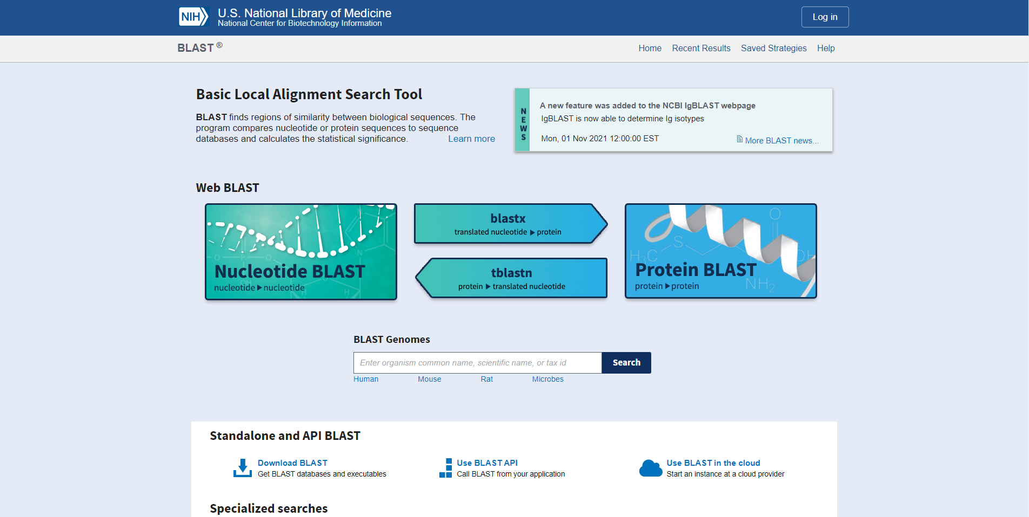**Fig1. Home page of BLAST**

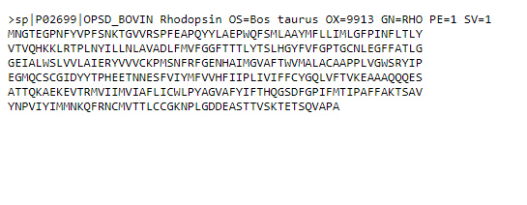**Fig2. Fasta Sequence for query rhodopsin taken from uniport**

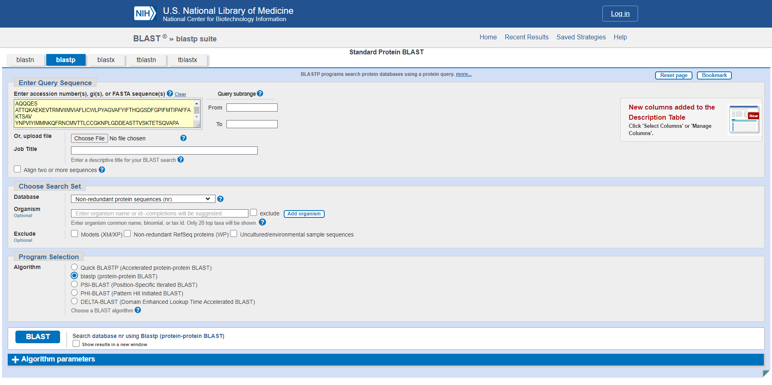**Fig3. Search page for blastp with sequence.**

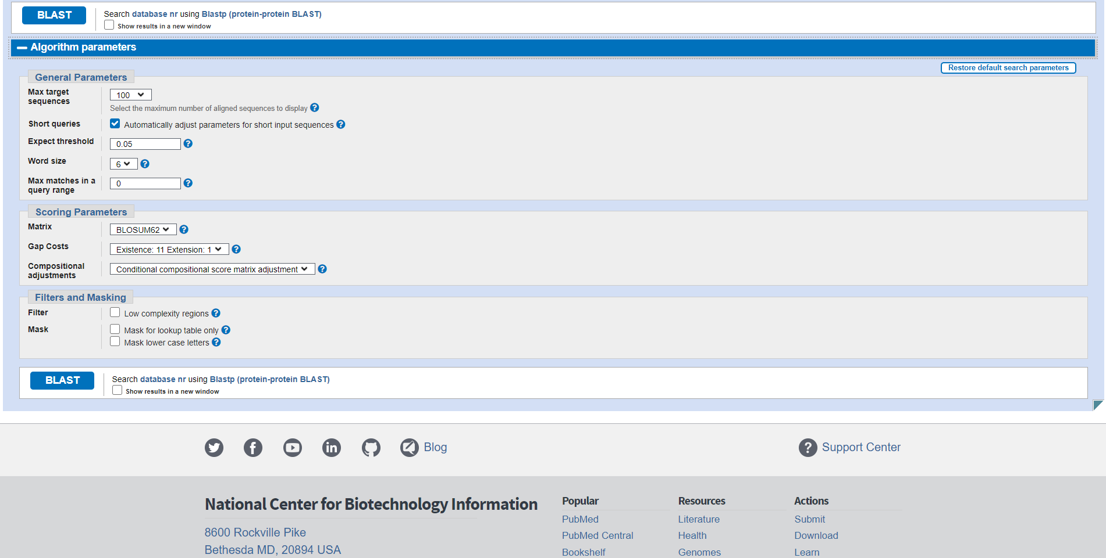**Fig4. Algorithm parameters in BLASTP**

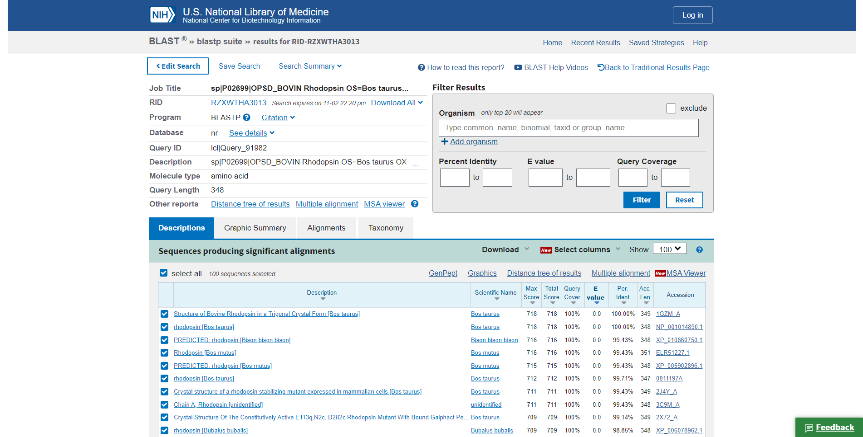**Fig5. Result page for rhodopsin**

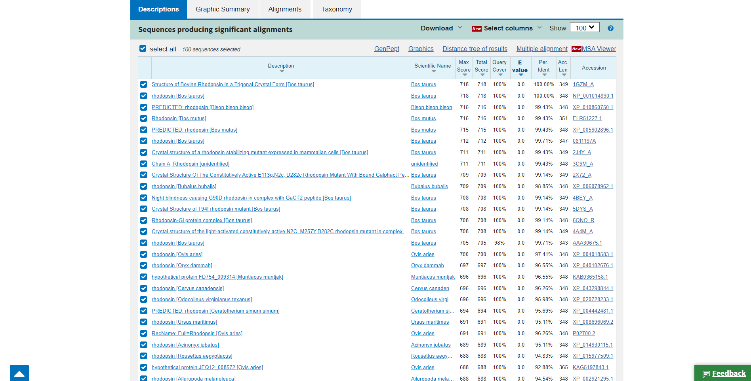**Fig6. Description for query Rhodopsin**

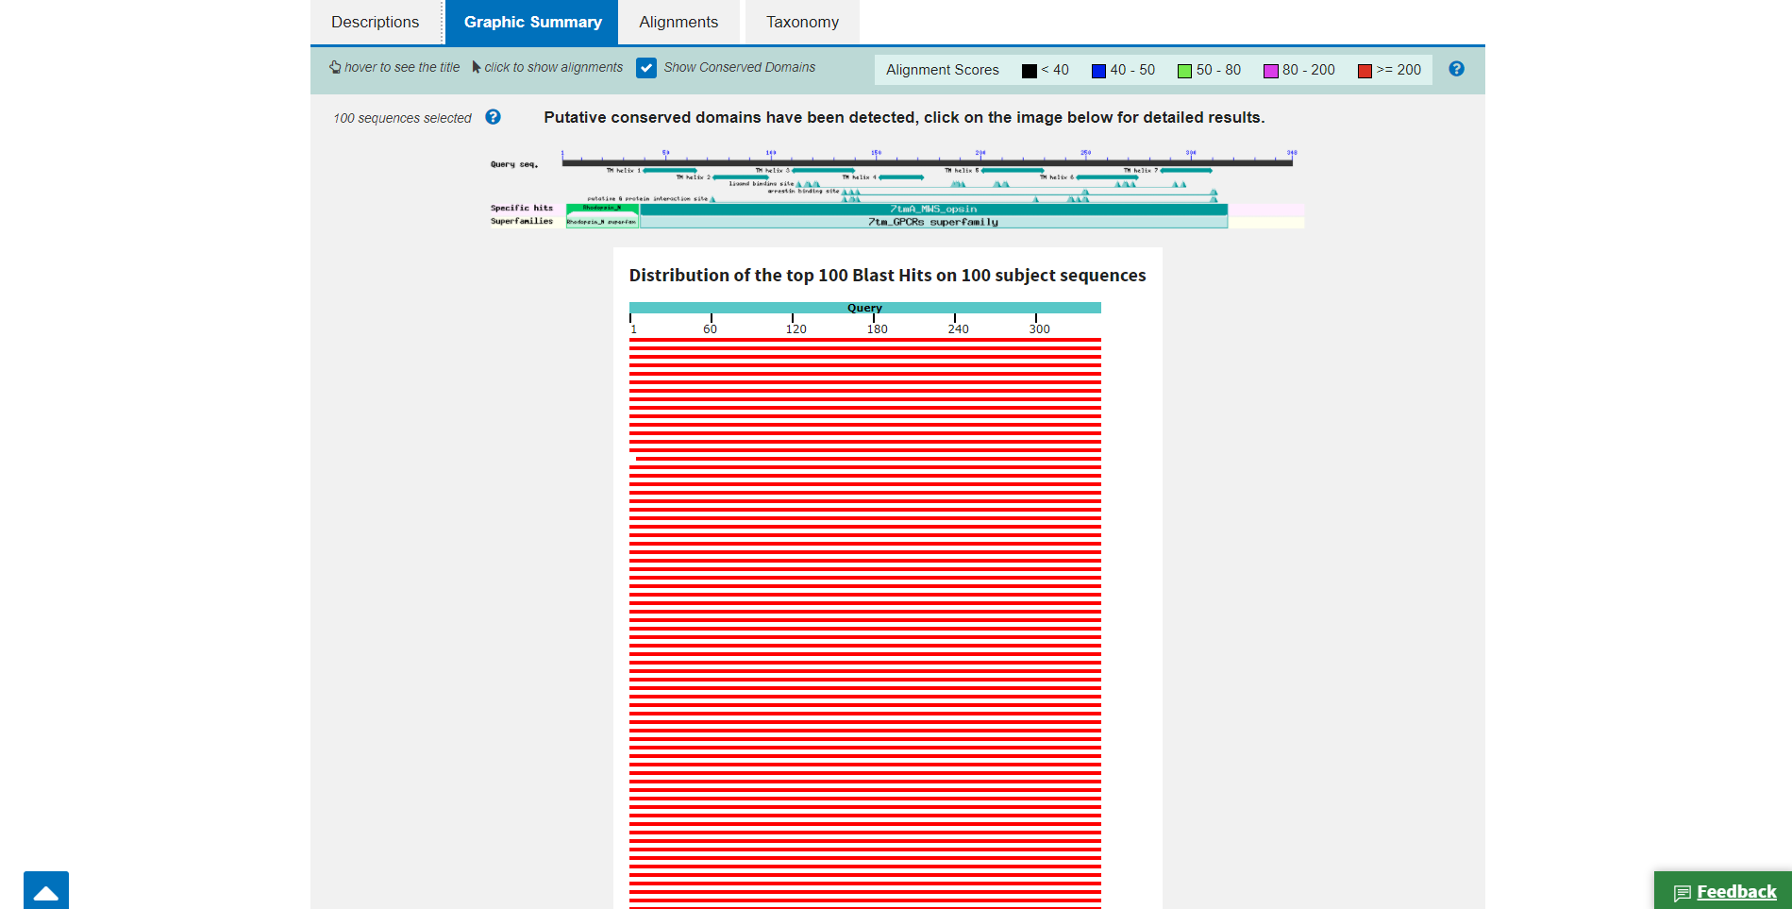**Fig7. Graphic Summary for query rhodopsin**

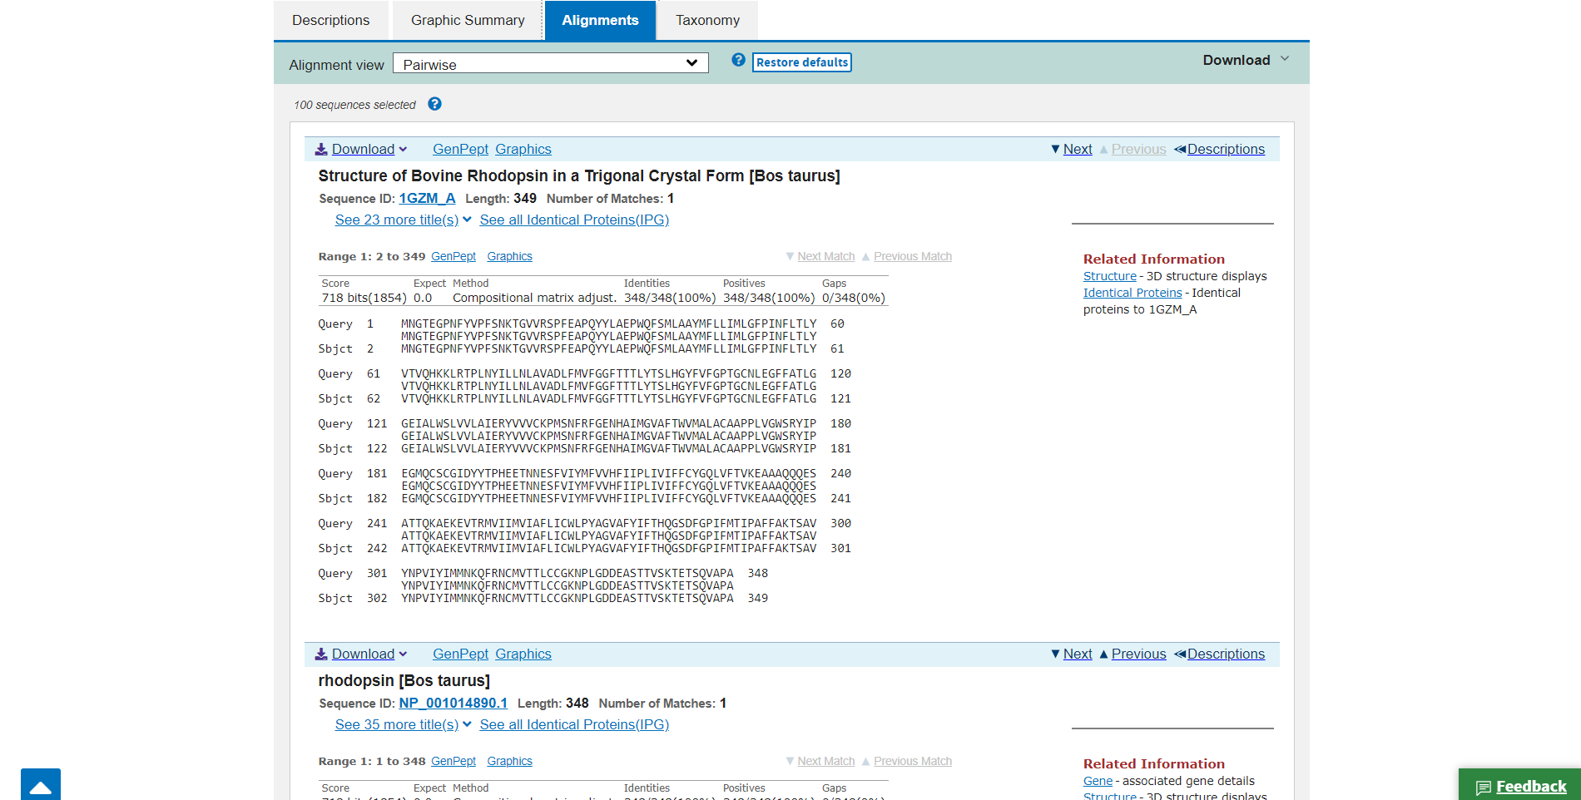**Fig8. Alignment for query rhodopsin**

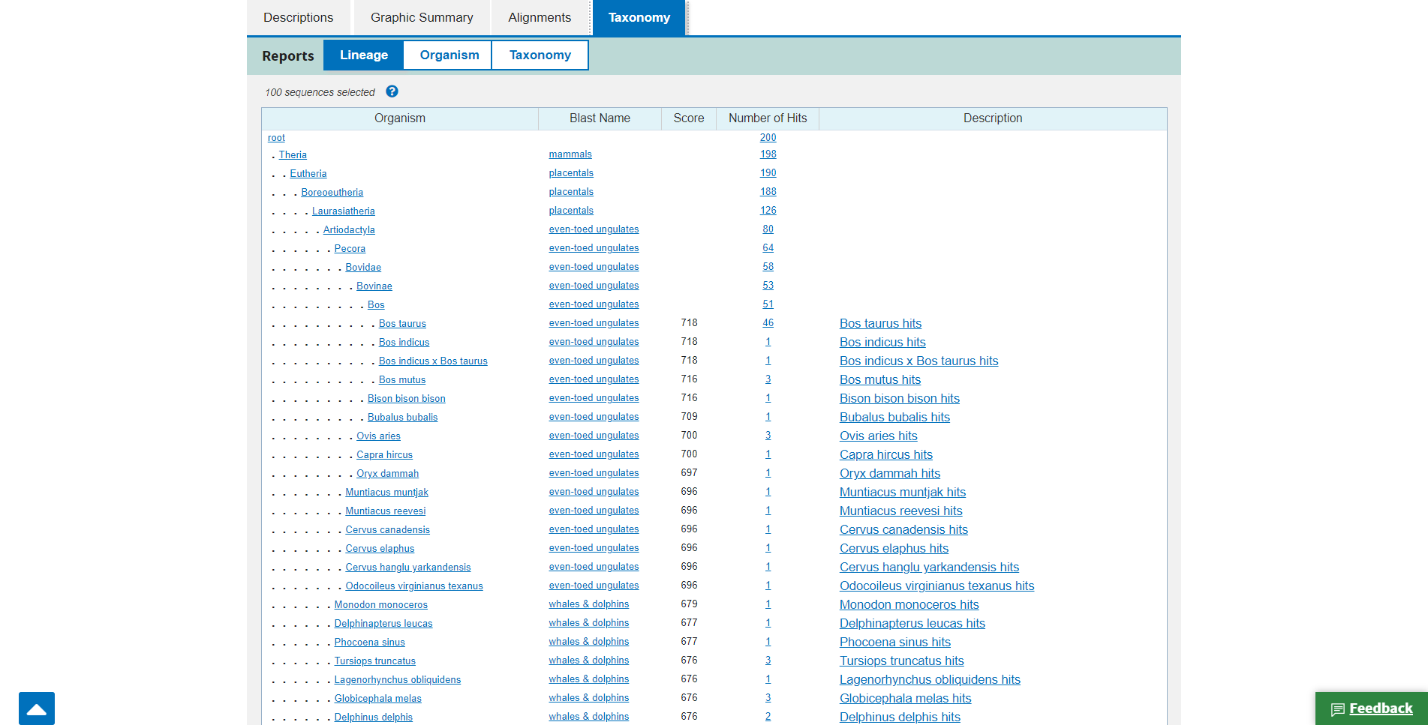**Fig9. Taxonomy for query rhodopsin**

**Results:**

Here we have acquired info about the descriptions, Graphical summary, Alignment, and taxonomy related information on our query rhodopsin.

The results can be interpreted as:

Maximum score is the highest alignment score between the query sequence and the database segments.

Total score is the sum of the alignment scores of all sequences from the same db.

Percent Query coverage is the percent of the query length that is included in the aligned segments.

E-value is the measure of likeliness that sequence similarity is not random chance percent identity describes how similar the query is to the aligned sequences.

**Conclusion:**

BLASTN is a great tool to get the required information on a particular FASTA sequence in detail.

**References:**

1. (n.d.). Retrieved from https://www.uniprot.org/uniprot/P02699.fasta
2. BLAST: Basic Local Alignment Search Tool. (n.d.). Retrieved from https://blast.ncbi.nlm.nih.gov/Blast.cgi
3. Protein BLAST: Search protein databases using a protein query. (n.d.). Retrieved from https://blast.ncbi.nlm.nih.gov/Blast.cgi?PROGRAM=blastp&PAGE_TYPE=BlastSearch&LINK_LOC=blasthome
4. Rhodopsin. (n.d.). Retrieved from <https://www.britannica.com/science/rhodopsin>

**DATE: 7-11-21**

**WEBLEM 11/c**

**(URL:** [**https://www.ebi.ac.uk/Tools/sss/fasta/**](https://www.ebi.ac.uk/Tools/sss/fasta/)**)**

**Aim:**

To study the Query ‘Rhodopsin’ in FASTAn

**Introduction:**

FASTA (pronounced FAST-AYE) is a suite of programs for searching nucleotide or protein databases with a query sequence. FASTA itself performs a local heuristic search of a protein or nucleotide database for a query of the same type. FASTX and FASTY translate a nucleotide query for searching a protein database. TFASTX and TFASTY translate a nucleotide database to be searched with a protein query. Optimal searches are available with the programs SSEARCH (local), GGSEARCH (global) and GLSEARCH (global query against local database).

FASTAn:

This tool provides sequence similarity searching against nucleotide databases using the FASTA suite of programs. FASTA provides a heuristic search with a nucleotide query. TFASTX and TFASTY translate the DNA database for searching with a protein query. Optimal searches are available with SSEARCH (local), GGSEARCH (global) and GLSEARCH (global query, local database).

**Rhodopsin**, also called **visual purple**, pigment-containing sensory protein that converts light into an electrical signal. Rhodopsin is found in a wide range of organisms, from vertebrates to bacteria. In many seeing animals, including humans, it is required for vision in dim light and is located in the retina of the eye specifically, within the tightly packed disks that make up the outer segment of the retina’s photoreceptive rod cells, which are specially adapted for vision under low-light conditions.

Rhodopsin was discovered in 1876 by German physiologist Franz Christian Boll, who observed that the normally reddish purple frog retina turned pale in bright light. The fading of colour was later attributed to the destruction of rhodopsin, via a process known as bleaching. Bleaching and the subsequent regeneration of rhodopsin are major steps in the visual cycle—the series of biochemical reactions that is critical for vision in low light.

**Methodology:**

1. Open the homepage of FASTA.
2. After that click the FASTAn hyperlink
3. Enter the sequence for keratin taken by Genebank.
4. Open the result page.
5. Interpret the results.

**Observation:**

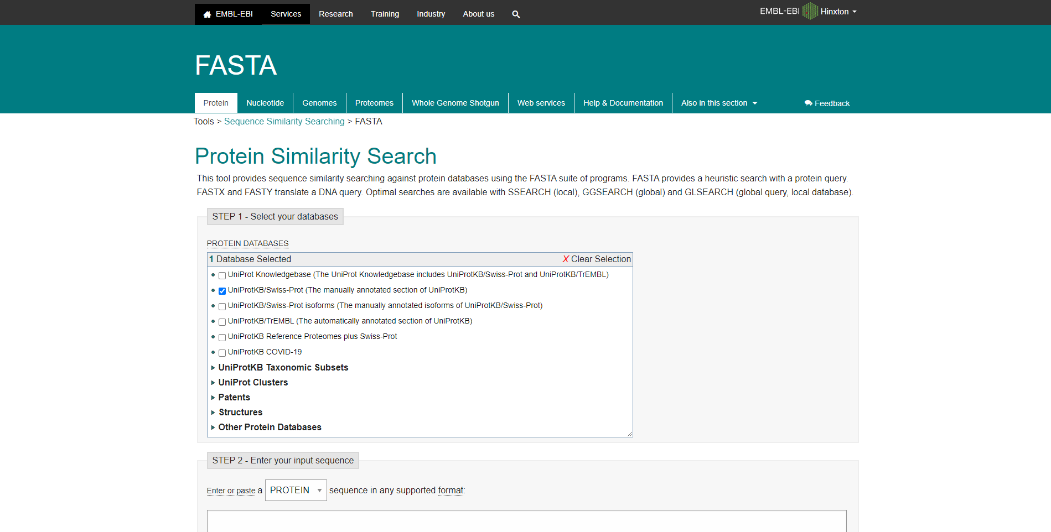**Fig1. Homepage of FASTAn.**

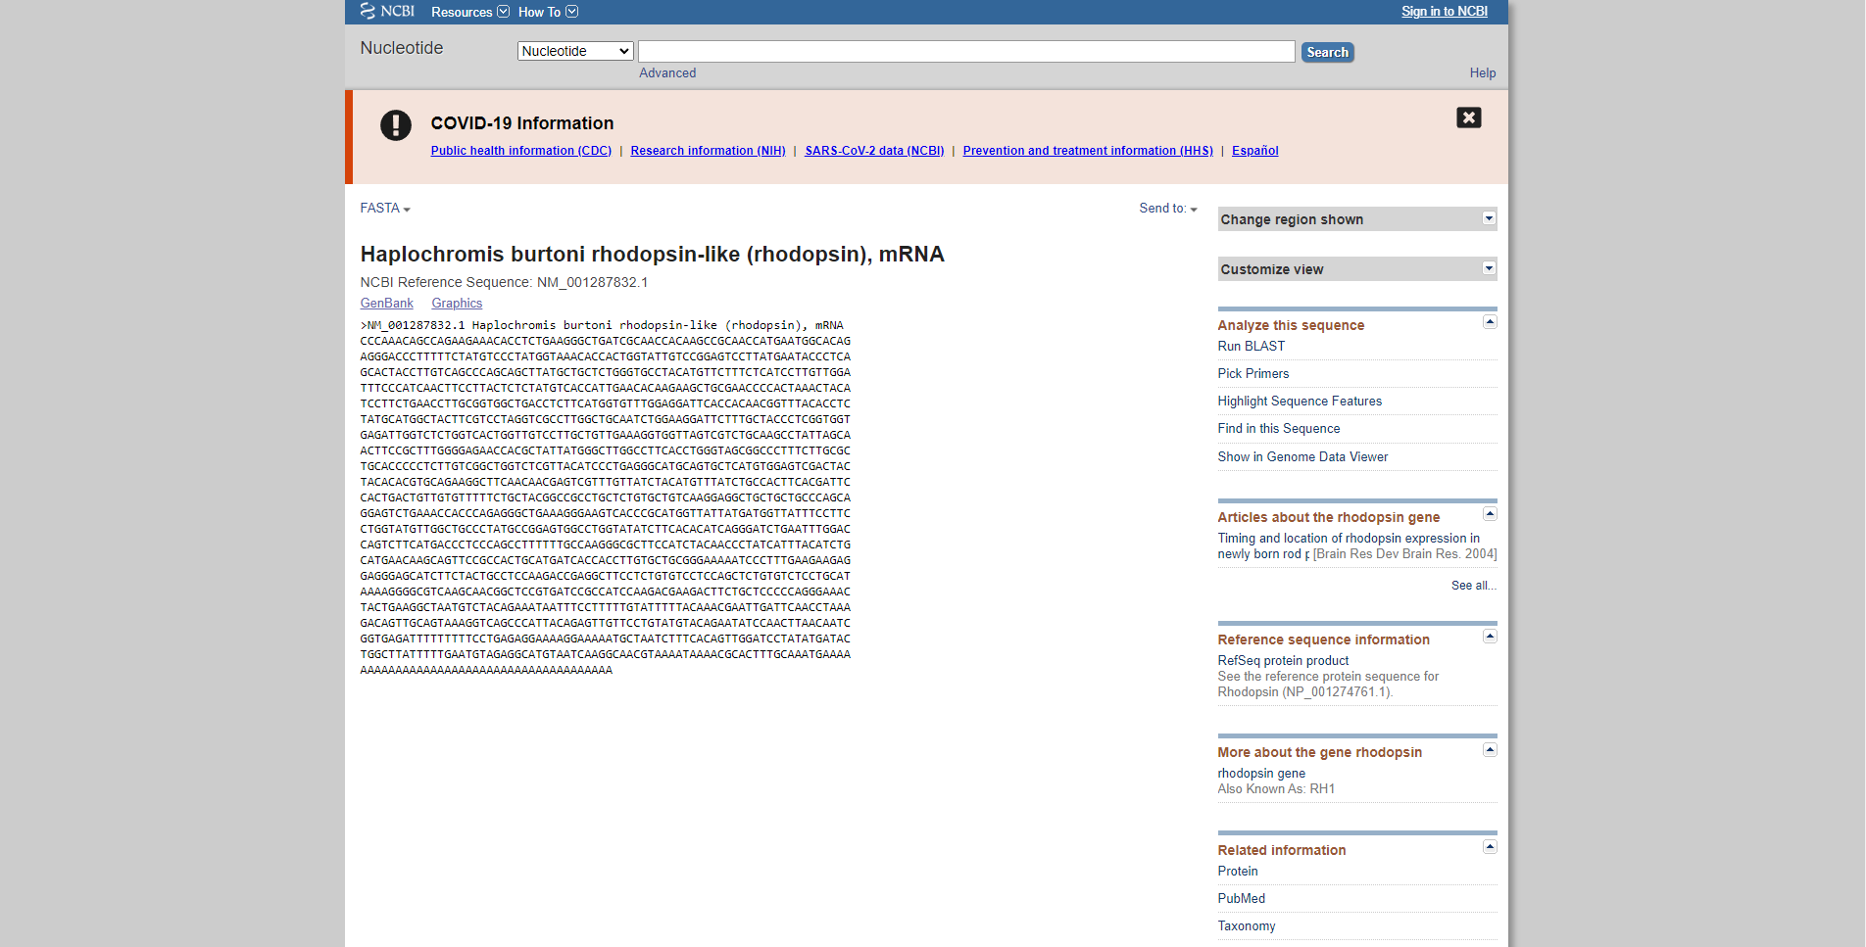**Fig2. Fasta sequence for my quesry rhodopsin on genbank**

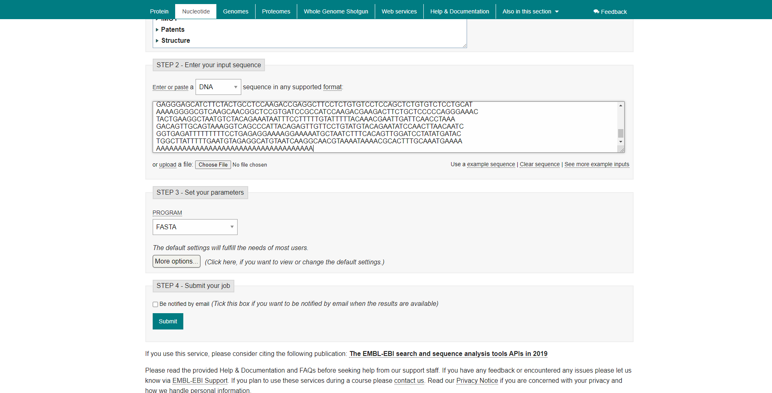**Fig3. Search bar of FASTAn with sequence.**

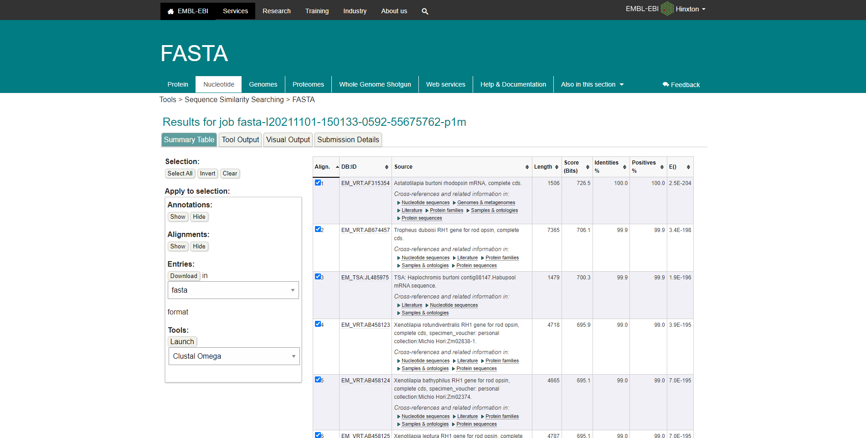**Fig4. Summary table for FASTAn with sequence**

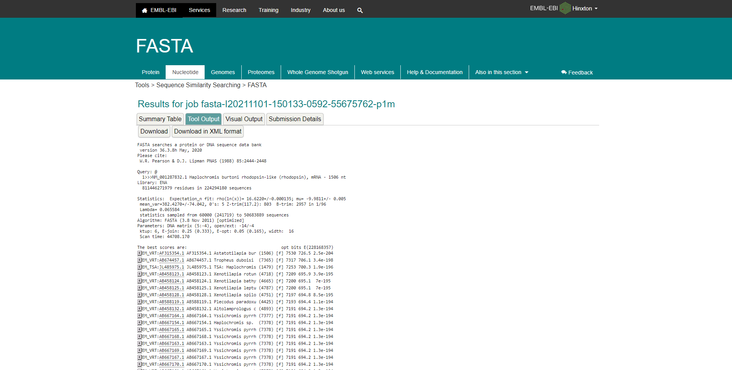**Fig5. Tool output for Rhodopsin in FASTAn**

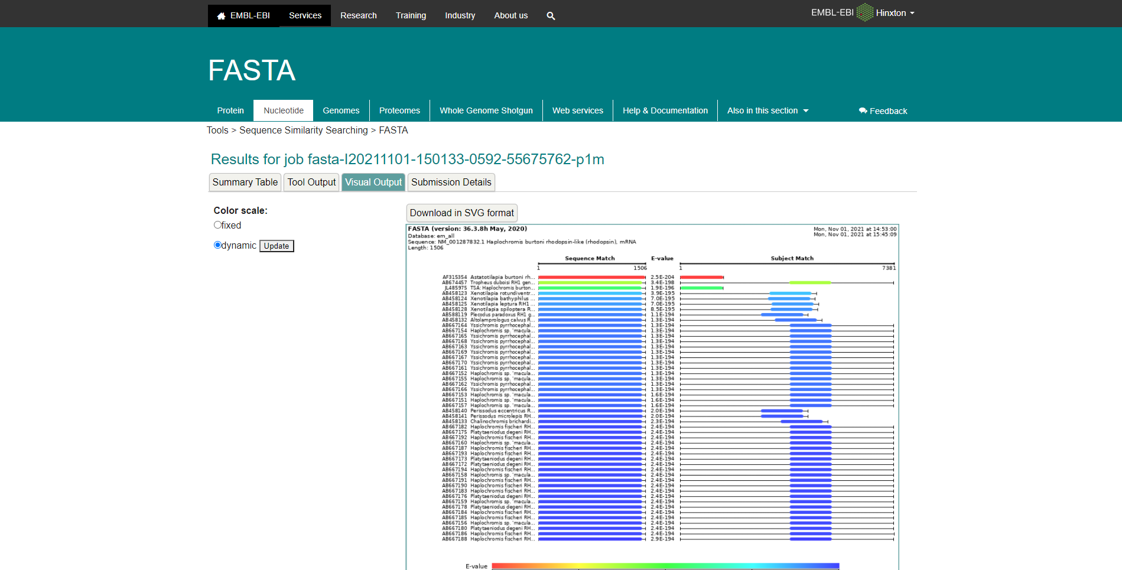**Fig6. Visual output for Rhodopsin in FASTAn**

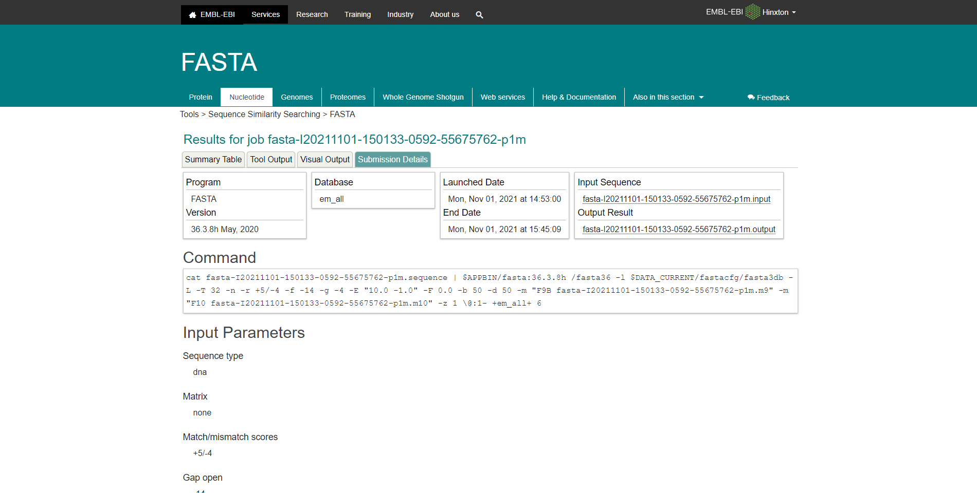**Fig7. Submission details for Rhodopsin in FASTAn**

**Results:**

FASTAp Result divided into 5 sections summary tables, Tool output, visual output, functional predictions, Submission details.

In summary tables it shows alignment of sequence that is length, score bits, identity percentage and positive percentage.

Tools output for keratin in FASTAp shows multiple outputs for results

In visual output the color scale can be changed between fixed and dynamic, showing E-Values

Functional Prediction’s color scale can also be switched between dynamic and fixed, showing E-Values

The submission details shows use the commands and input parameters that were used before we submitted the query for running.

**Conclusion:**

FASTA is another sequence alignment tool which is used to search similarities between sequences of DNA and proteins. The query sequence is broken down into sequence patterns or words known as k-tuples and the target sequences are searched for these k-tuples in order to find the similarities between the two.

**References:**

1. Rhodopsin. (n.d.). Retrieved from <https://www.britannica.com/science/rhodopsin>
2. (n.d.). Retrieved from <https://www.uniprot.org/uniprot/P02699.fasta>
3. Embl-Ebi. (n.d.). FASTA. Retrieved from <https://www.ebi.ac.uk/Tools/sss/fasta/>
4. Embl-Ebi. (n.d.). FASTA. Retrieved from <https://www.ebi.ac.uk/Tools/services/web/toolresult.ebi?jobId=fasta-I20211101-150915-0959-51807210-p2m>

**DATE: 7-11-21**

**WEBLEM 11/d**

**(URL:** [**https://www.ebi.ac.uk/Tools/sss/fasta/**](https://www.ebi.ac.uk/Tools/sss/fasta/)**)**

**Aim:**

To study the Query ‘Rhodopsin’ in FASTAp.

**Introduction:**

FASTA (pronounced FAST-AYE) is a suite of programs for searching nucleotide or protein databases with a query sequence. FASTA itself performs a local heuristic search of a protein or nucleotide database for a query of the same type. FASTX and FASTY translate a nucleotide query for searching a protein database. TFASTX and TFASTY translate a nucleotide database to be searched with a protein query. Optimal searches are available with the programs SSEARCH (local), GGSEARCH (global) and GLSEARCH (global query against local database).

FASTAp:

This tool provides sequence similarity searching against protein databases using the FASTA suite of programs. FASTA provides a heuristic search with a protein query. FASTX and FASTY translate a DNA query. Optimal searches are available with SSEARCH (local), GGSEARCH (global) and GLSEARCH (global query, local database).

**Rhodopsin**, also called **visual purple**, pigment-containing sensory protein that converts light into an electrical signal. Rhodopsin is found in a wide range of organisms, from vertebrates to bacteria. In many seeing animals, including humans, it is required for vision in dim light and is located in the retina of the eye specifically, within the tightly packed disks that make up the outer segment of the retina’s photoreceptive rod cells, which are specially adapted for vision under low-light conditions.

Rhodopsin was discovered in 1876 by German physiologist Franz Christian Boll, who observed that the normally reddish purple frog retina turned pale in bright light. The fading of colour was later attributed to the destruction of rhodopsin, via a process known as bleaching. Bleaching and the subsequent regeneration of rhodopsin are major steps in the visual cycle—the series of biochemical reactions that is critical for vision in low light.

**Methodology:**

1. Open the homepage of FASTA
2. Click on the FASTAp hyperlink
3. Enter the sequence for keratin taken by uniport
4. Open the result page.
5. Interpret the result.

**Observation:**

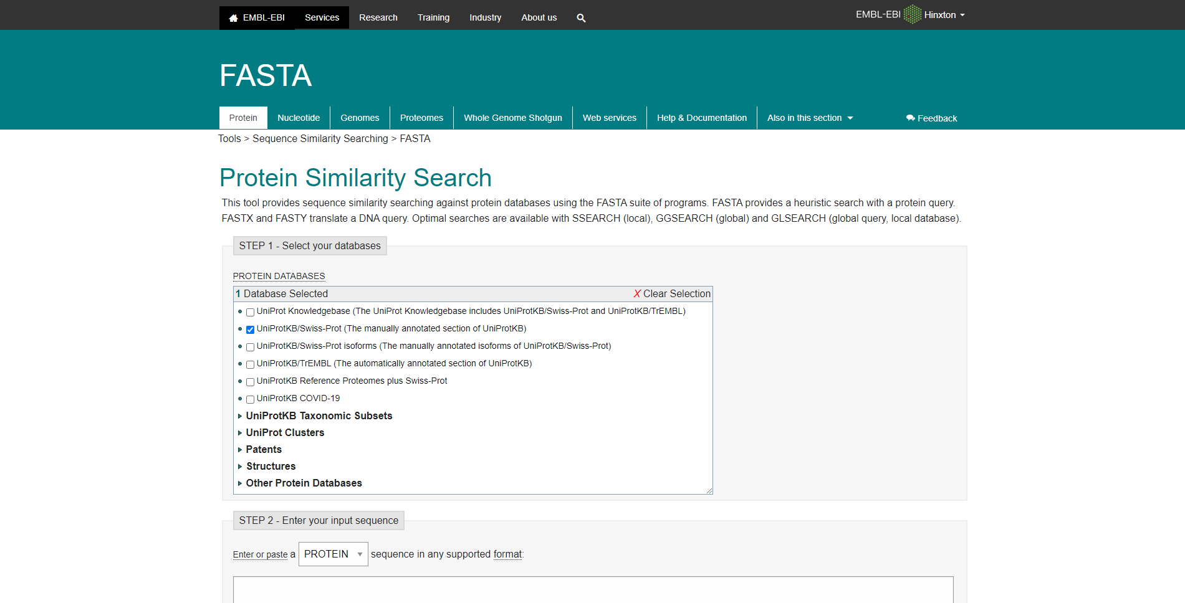**Fig1. Homepage of FASTAp**

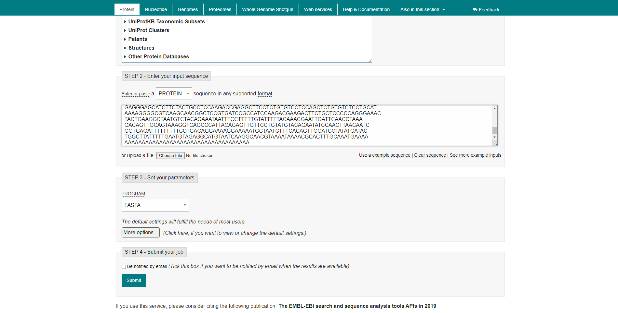**Fig2. Search bar for FASTAp with sequence for rhodopsin taken from uniprot**

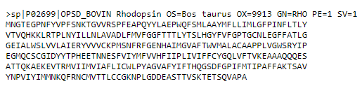**Fig3. Fasta sequence for my query Rhodopsin**

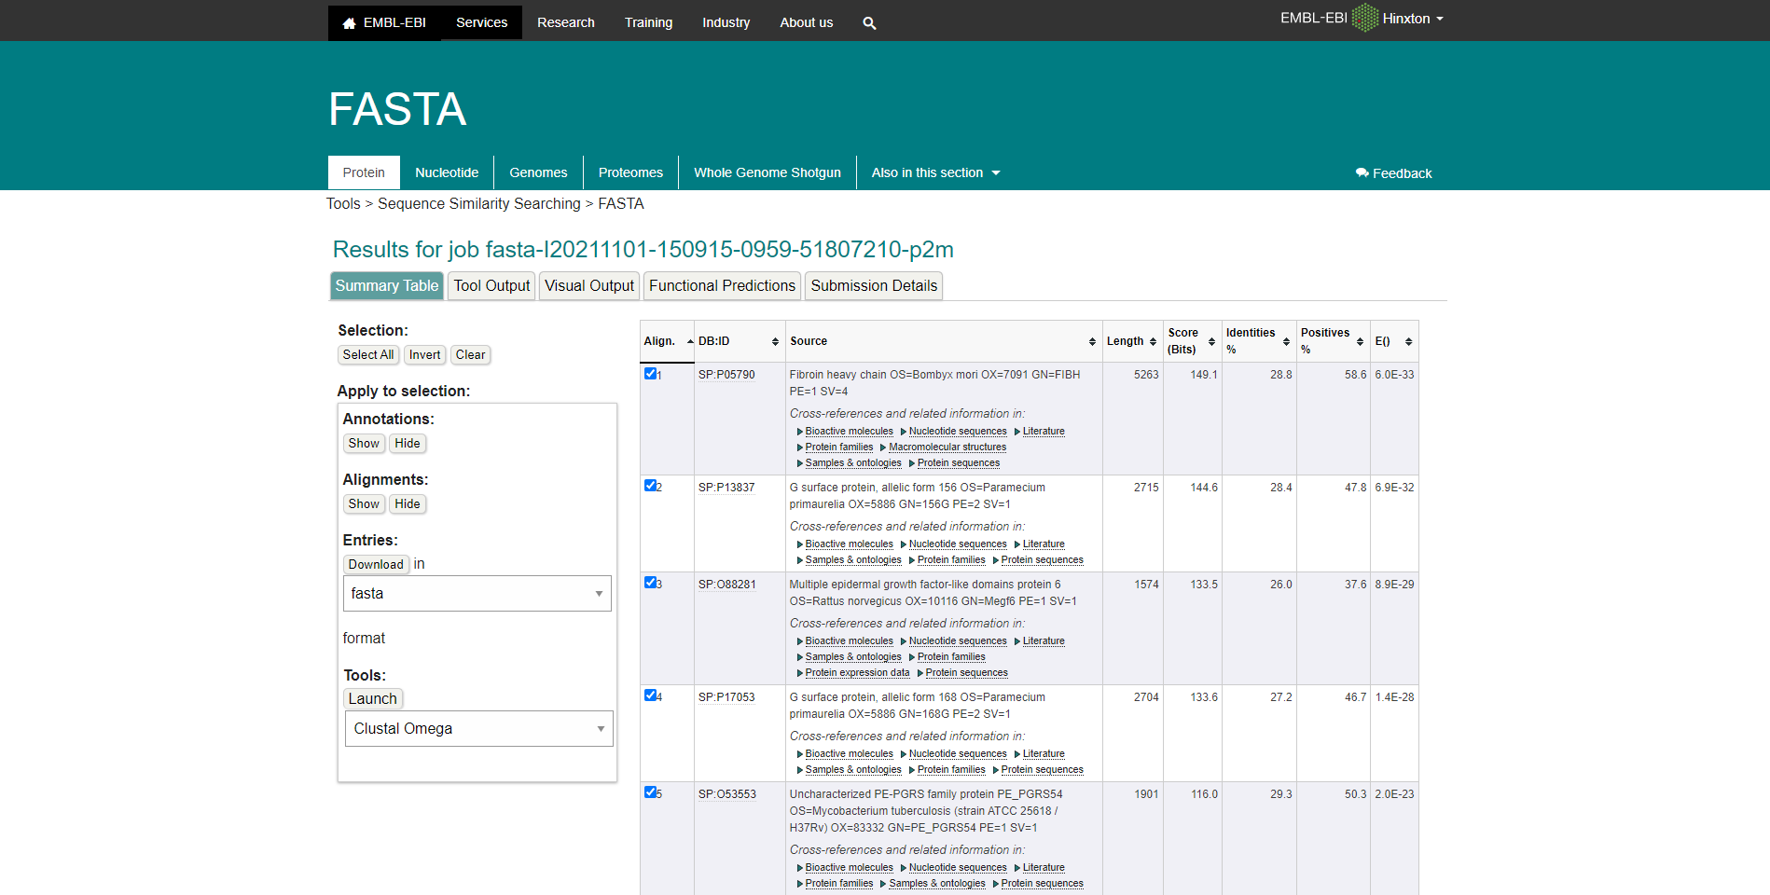**Fig4. Summary table for Rhodopsin in FASTAp**

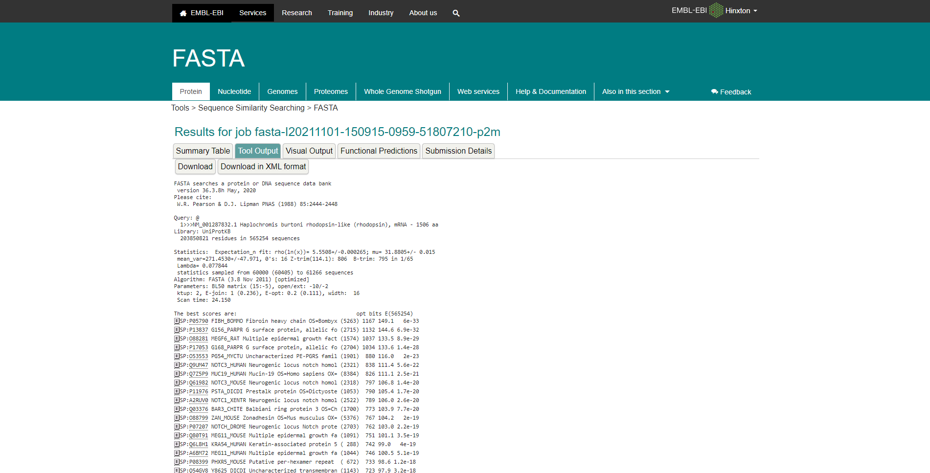**Fig5. Tool Output for Rhodopsin in FASTAp.**

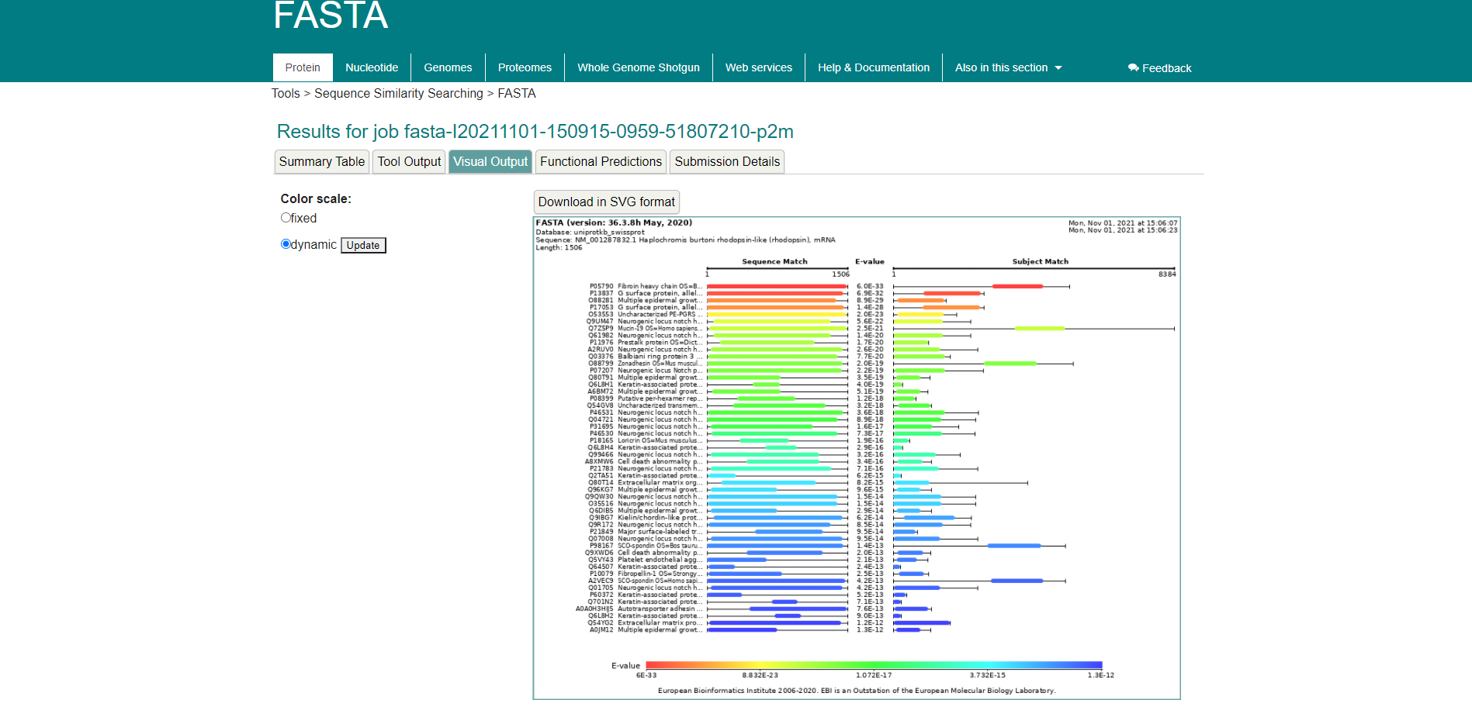**Fig6. Visual output for Rhodopsin in FASTAp**

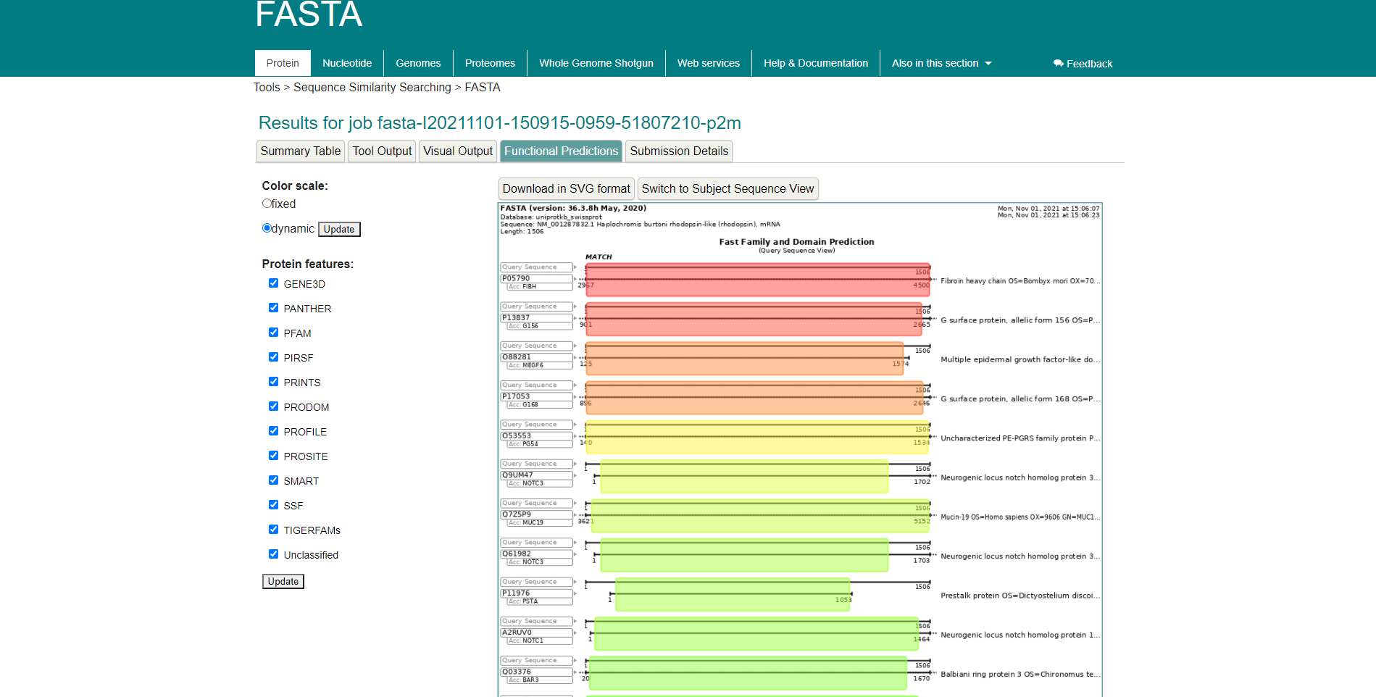**Fig7. Functional Predictions for Rhodopsin in FASTAp**

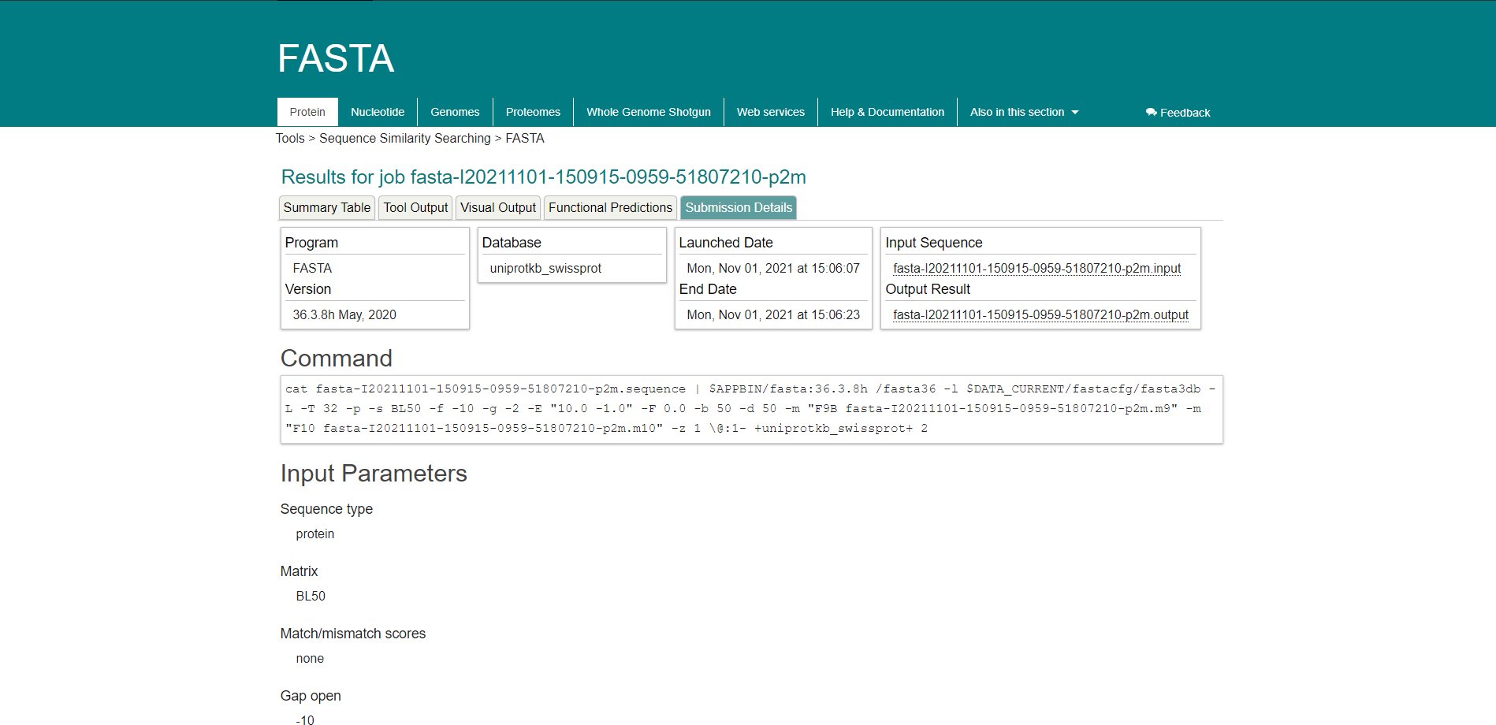**Fig8. Submission Details for Rhodopsin in FASTAp**

**Results:**

FASTAp Result divided into 5 sections summary tables, Tool output, visual output, functional predictions, Submission details.

In summary tables it shows alignment of sequence that is length, score bits, identity percentage and positive percentage.

Tools output for keratin in FASTAp shows multiple outputs for results

In visual output the color scale can be changed between fixed and dynamic, showing E-Values

Functional Prediction’s color scale can also be switched between dynamic and fixed, showing E-Values

The submission details shows use the commands and input parameters that were used before we submitted the query for running.

**Conclusion:**

FASTA is another sequence alignment tool which is used to search similarities between sequences of DNA and proteins. The query sequence is broken down into sequence patterns or words known as k-tuples and the target sequences are searched for these k-tuples in order to find the similarities between the two.

**References:**

1. Rhodopsin. (n.d.). Retrieved from <https://www.britannica.com/science/rhodopsin>
2. (n.d.). Retrieved from <https://www.uniprot.org/uniprot/P02699.fasta>
3. Embl-Ebi. (n.d.). FASTA. Retrieved from <https://www.ebi.ac.uk/Tools/sss/fasta/>
4. Embl-Ebi. (n.d.). FASTA. Retrieved from <https://www.ebi.ac.uk/Tools/services/web/toolresult.ebi?jobId=fasta-I20211101-150915-0959-51807210-p2m>

**DATE: 7-11-21**

**WEBLEM 11/e**

**(URL:** [**https://blast.ncbi.nlm.nih.gov/Blast.cgi**](https://blast.ncbi.nlm.nih.gov/Blast.cgi)**)**

**Aim:**

To study the Query ‘Rhodopsin’ in PHI BLAST

**Introduction:**

A sequence similarity search often provides the first information about a new DNA or protein sequence. A search allows scientists to infer the function of a sequence from similar sequences. There are many ways of performing a sequence similarity search, but probably the most popular method is the “Basic Local Alignment Search Tool” (BLAST) (1, 2). BLAST uses heuristics to produce results quickly. It also calculates an “expect value” that estimates how many matches would have occurred at a given score by chance, which can aid a user in judging how much confidence to have in an alignment.

PHI-BLAST (Pattern-Hit Initiated BLAST) is a search program that combines matching of regular expressions with local alignments surrounding the match. The most important features of the program have been incorporated into the BLAST software framework partly for user convenience and partly so that PHI-BLAST may be combined seamlessly with PSI-BLAST. Other features that do not fit into the BLAST framework will be released later as a separate program and/or separate Web page query options. One very restrictive way to identify protein motifs is by regular expressions that must contain each instance of the motif. The PROSITE database is a compilation of restricted regular expressions that describe protein motifs. Given a protein sequence S and a regular expression pattern P occurring in S, PHI-BLAST helps answer the question: What other protein sequences both contain an occurrence of P and are homologous to S in the vicinity of the pattern occurrences? PHI-BLAST may be preferable to just searching for pattern occurrences because it filters out those cases where the pattern occurrence is probably random and not indicative of homology. PHI-BLAST may be preferable to other flavors of BLAST because it is faster and because it allows the user to express a rigid pattern occurrence requirement.

**Rhodopsin**, also called **visual purple**, pigment-containing sensory protein that converts light into an electrical signal. Rhodopsin is found in a wide range of organisms, from vertebrates to bacteria. In many seeing animals, including humans, it is required for vision in dim light and is located in the retina of the eye specifically, within the tightly packed disks that make up the outer segment of the retina’s photoreceptive rod cells, which are specially adapted for vision under low-light conditions. Rhodopsin was discovered in 1876 by German physiologist Franz Christian Boll, who observed that the normally reddish purple frog retina turned pale in bright light. The fading of colour was later attributed to the destruction of rhodopsin, via a process known as bleaching. Bleaching and the subsequent regeneration of rhodopsin are major steps in the visual cycle—the series of biochemical reactions that is critical for vision in low light.

**Methodology:**

1. Open the homepage of blast.
2. After that click the BLASTp
3. Enter the sequence for rhodopsin taken by uniport.
4. Change the program selection Algorithm to PHI-BLAST
5. Enter the pattern taken by prosite
6. Open the result page
7. Interpret the result.

**Observation:**

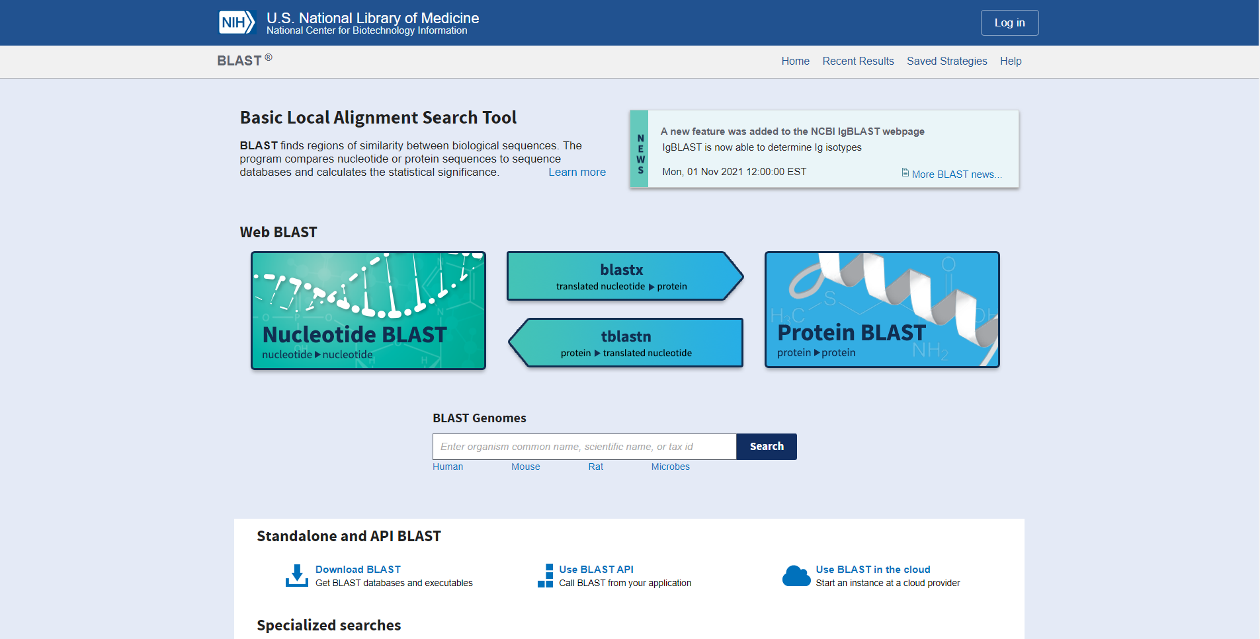**Fig1. Homepage of BLAST**

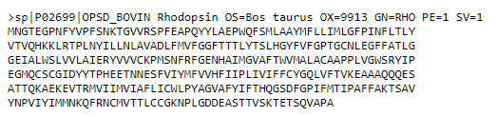**Fig2. FASTA sequences for query Rhodopsin**

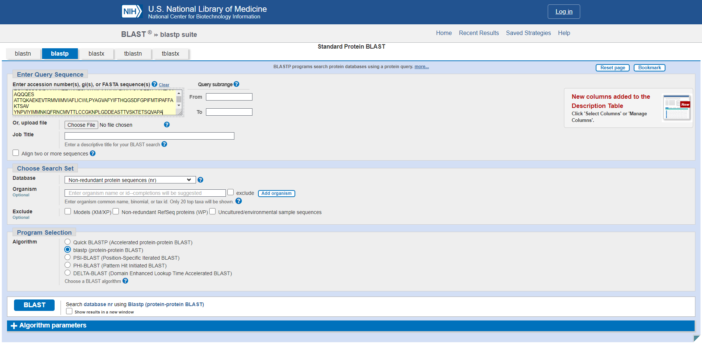**Fig3. Search bar for PHI blast with sequence pasted**

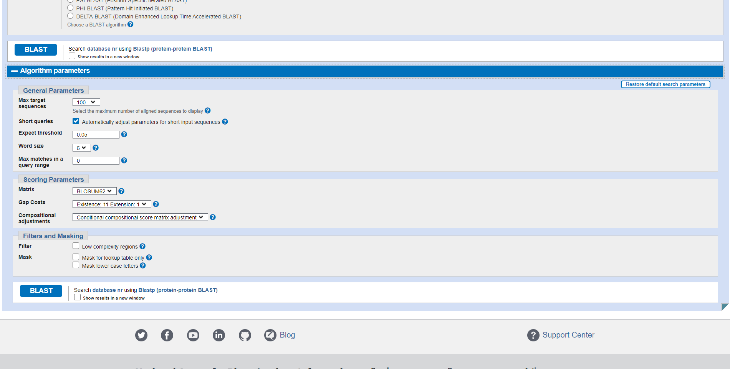**Fig4. Algorithm parameters for PHI blast for Rhodopsin**

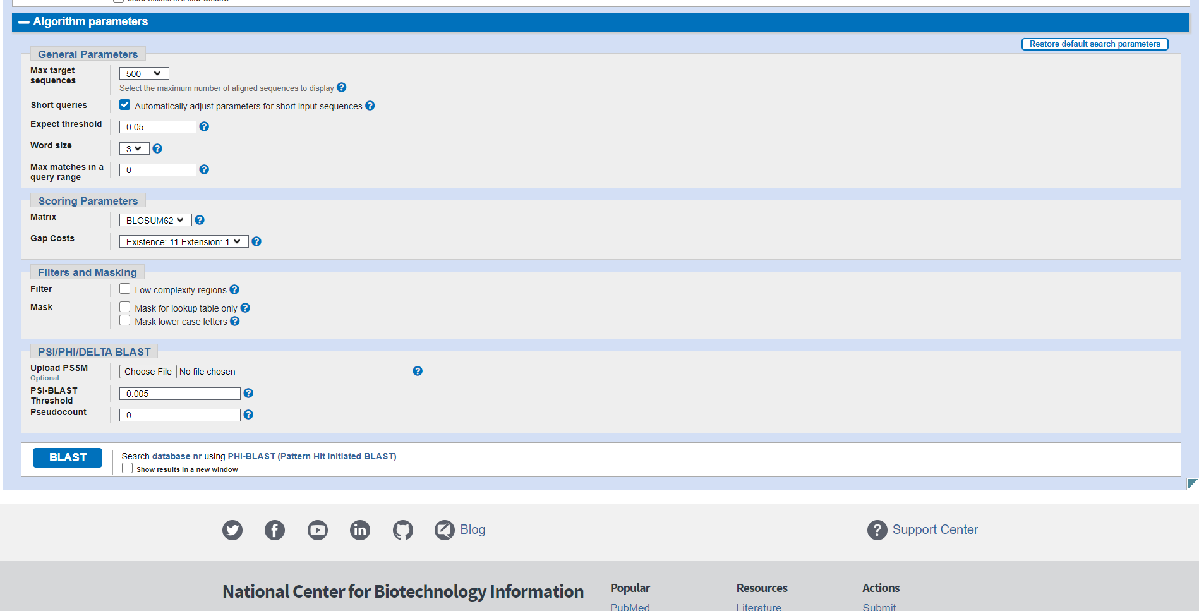**Fig5. PSI/PHI/DELTA parameters for Rhodopsin in BLAST**

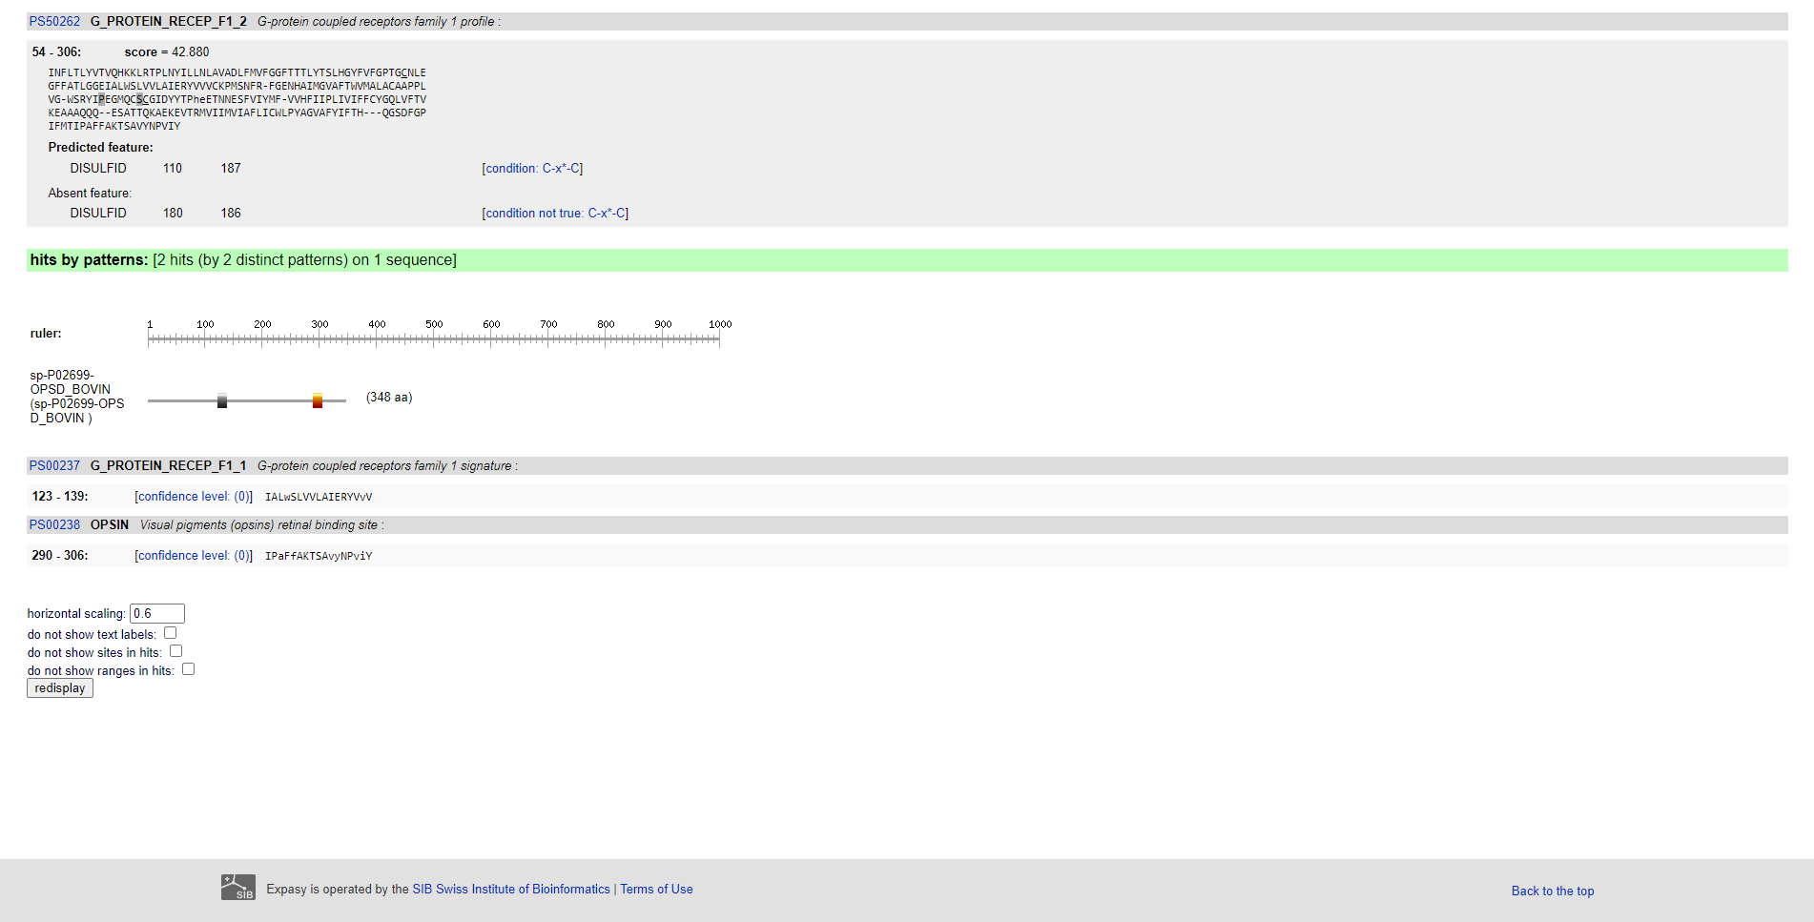**Fig6. Pattern for query in Rhodopsin in PROSITE**

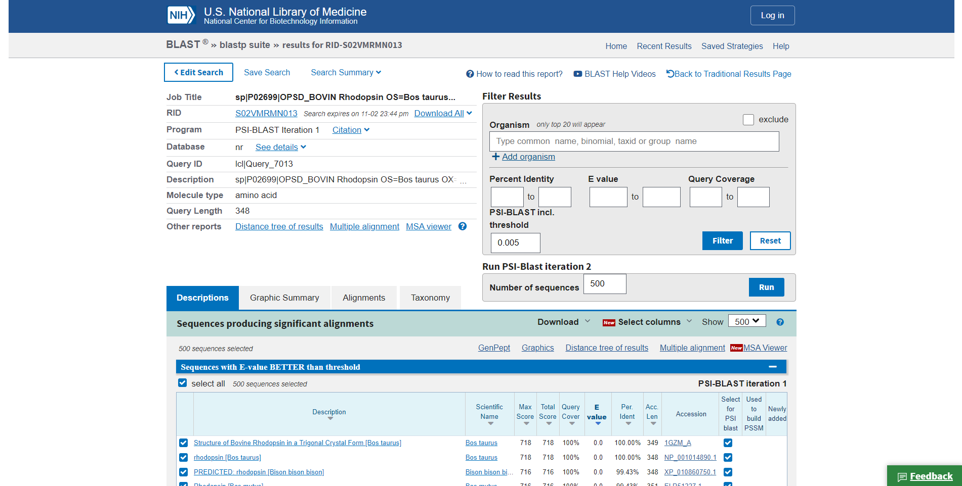**Fig7. Result page (header) for Rhodopsin**

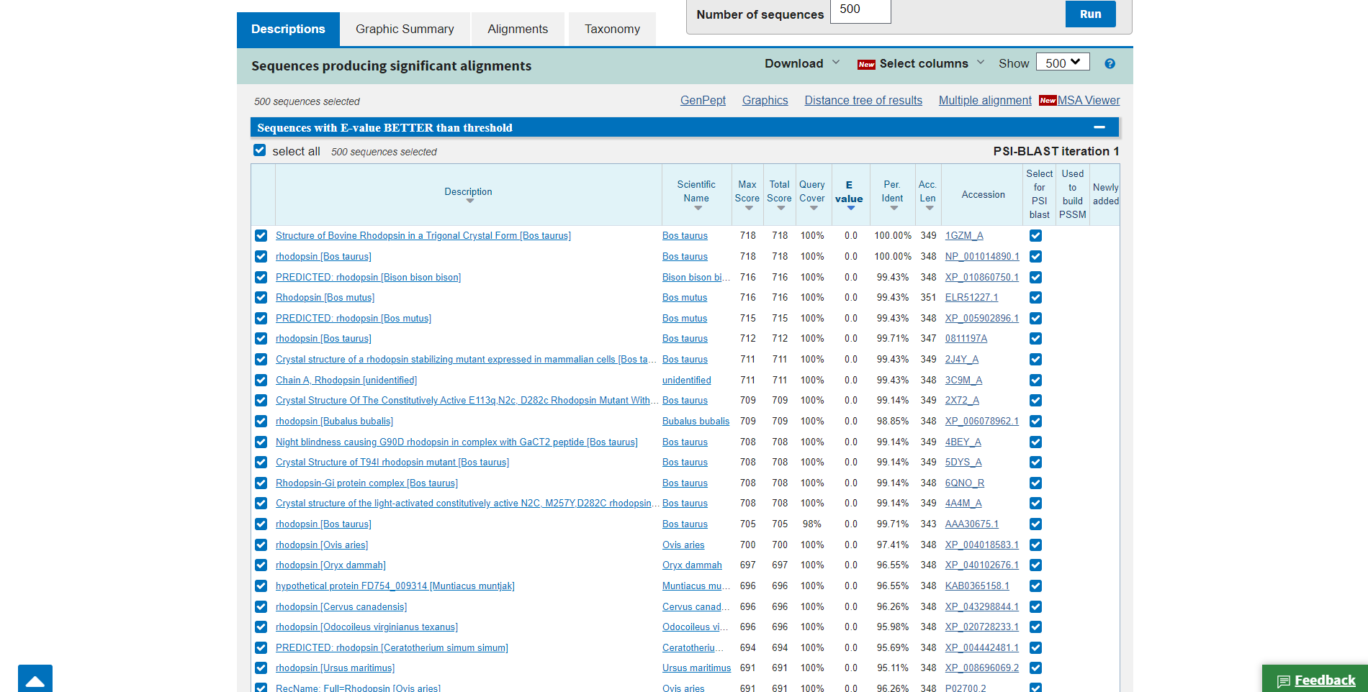**Fig8. Description for query Rhodopsin**

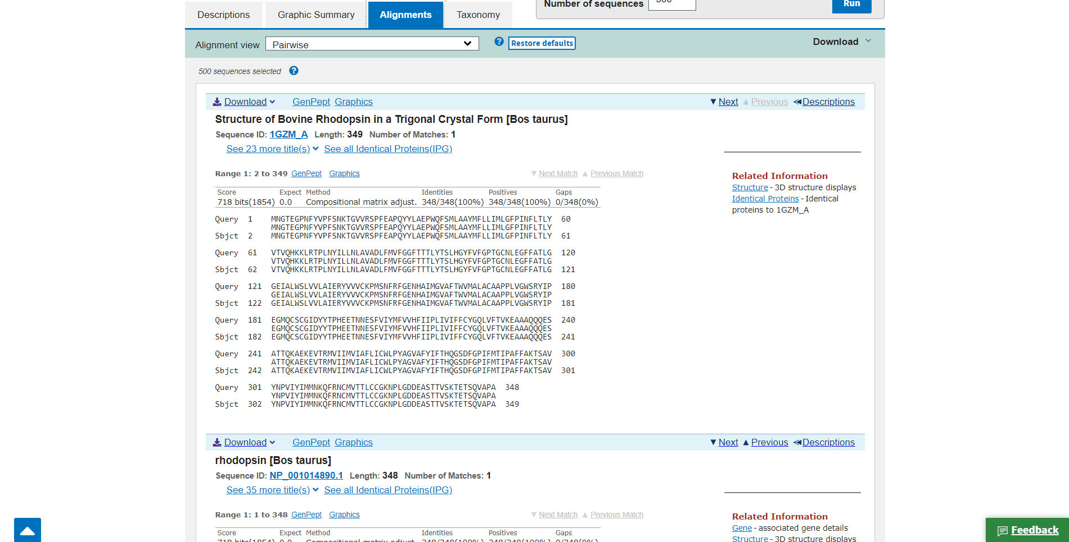**Fig9. Alignments view for query Rhodopsin**

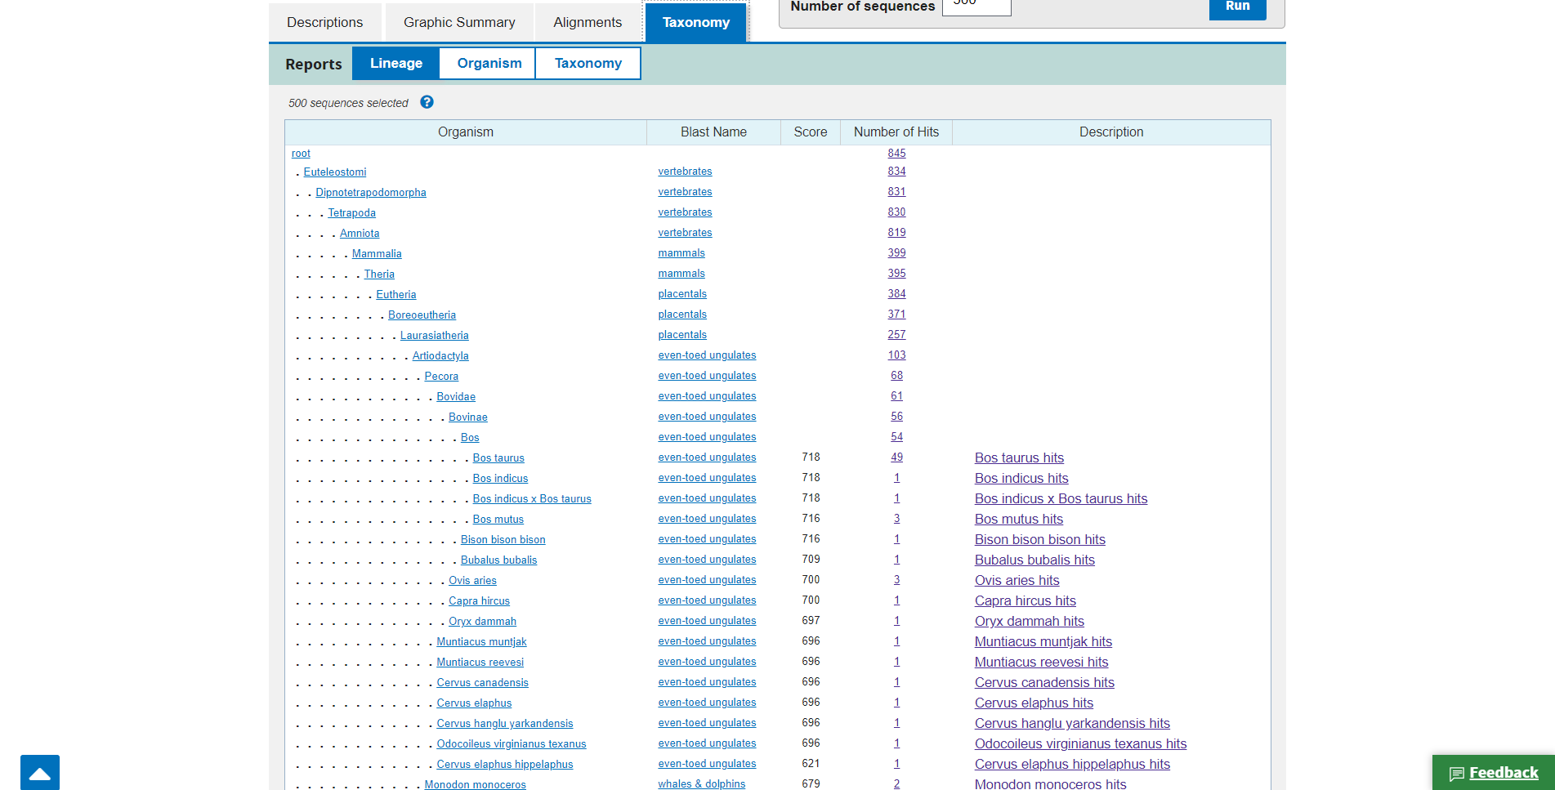**Fig10. Taxonomy for Query Rhodopsin**

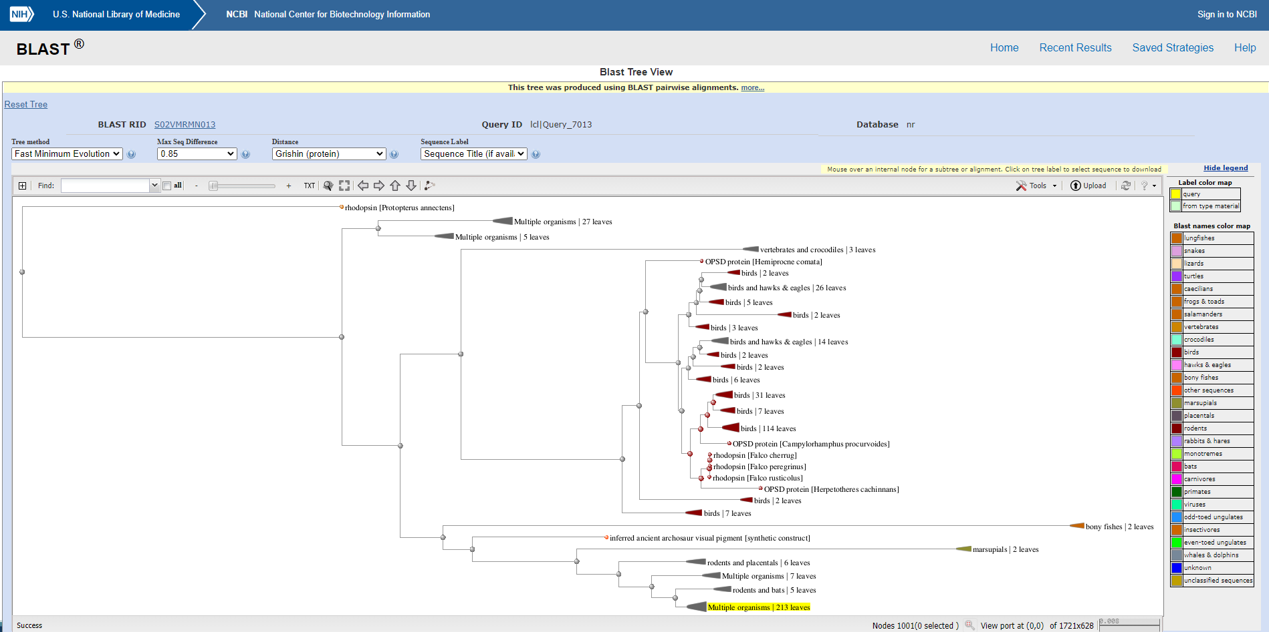**Fig11. Blast tree view for Rhodopsin**

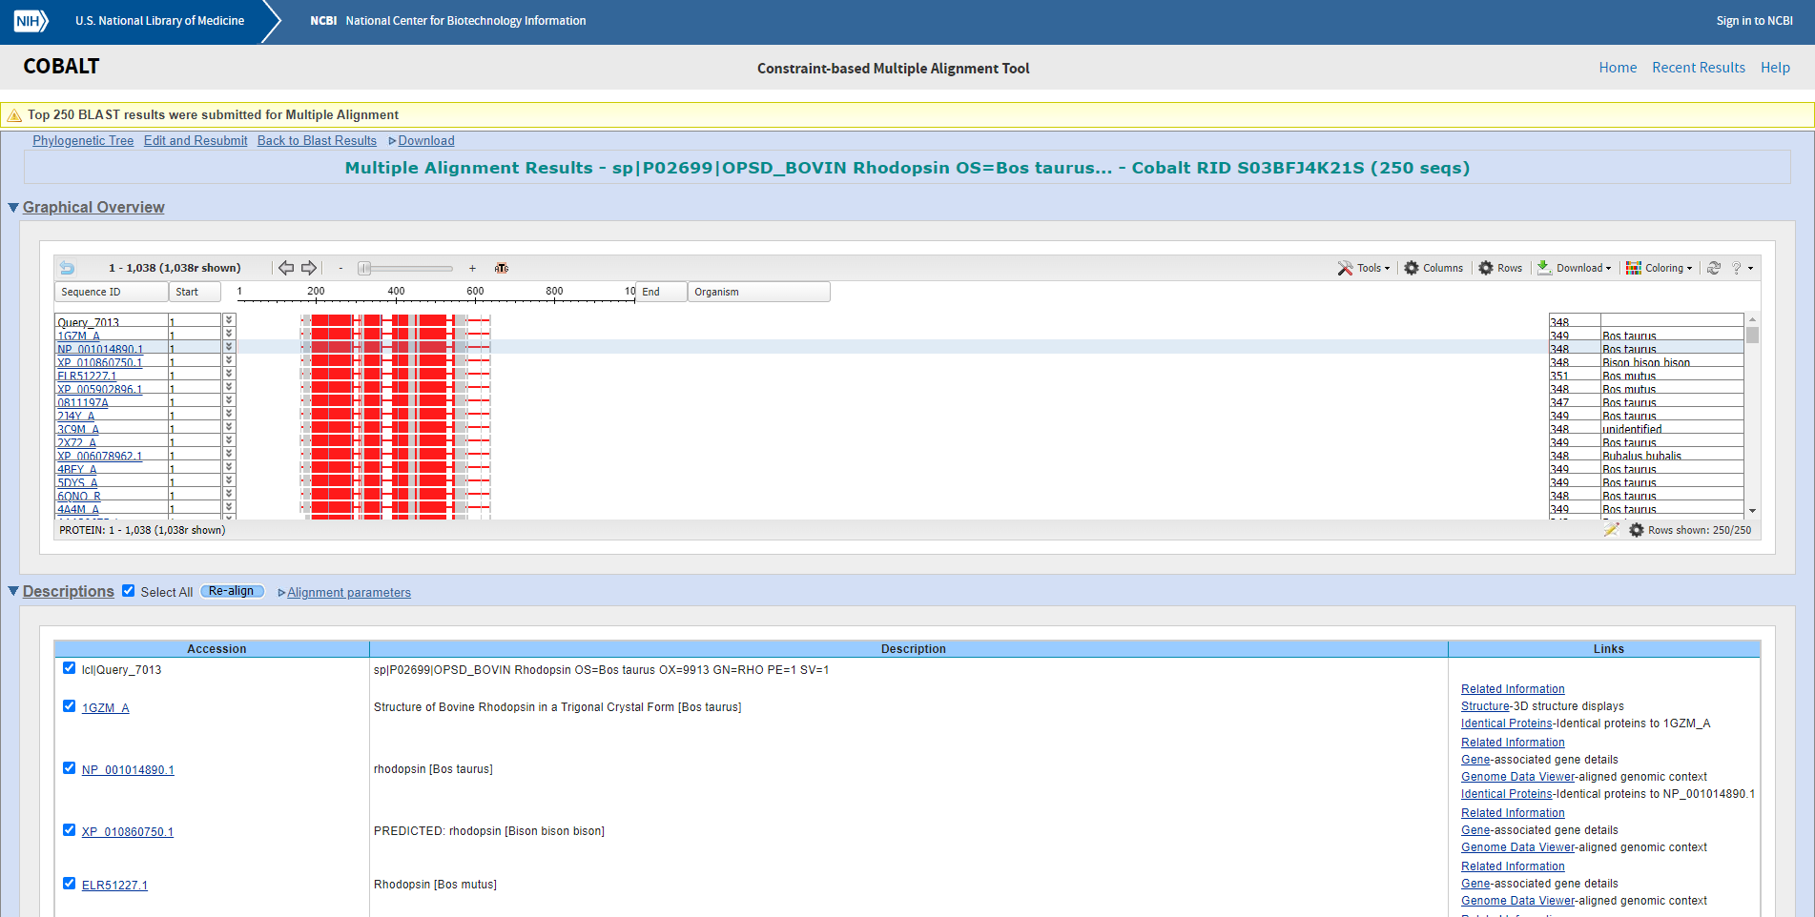**Fig12: Multiple alignment view via cobalt for rhodopsin**

**Results:**

In PHI-BLAST the result is divided into 4 parts. Description, Graphic summary alignment, taxonomy. We can also access other tools from within the result page like BLAST tree view and COBALT.

**Conclusion:**

PHI-BLAST (Pattern-Hit Initiated BLAST) is a search program that combines matching of regular expressions with local alignments surrounding the match. The most important features of the program have been incorporated into the BLAST software framework.

**References:**

1. (n.d.). Retrieved from <https://www.uniprot.org/uniprot/P02699.fasta>
2. Blast Tree View Widget. (n.d.). Retrieved from <https://blast.ncbi.nlm.nih.gov/blast/treeview/treeView.cgi?request=page&blastRID=S02VMRMN013&queryID=lcl|Query_7013&entrezLim=&ex=&exl=&exh=&ns=500>
3. COBALT:Multiple Alignment Tool. (n.d.). Retrieved from <https://www.st-va.ncbi.nlm.nih.gov/tools/cobalt/cobalt.cgi>
4. Expasy is operated by the SIB Swiss Institute of Bioinformatics | Terms of Use. (n.d.). PROSITE. Retrieved from <https://prosite.expasy.org/cgi-bin/prosite/ScanView.cgi?scanfile=97965544372.scan.gz>
5. Protein BLAST: Search protein databases using a protein query. (n.d.). Retrieved from <https://blast.ncbi.nlm.nih.gov/Blast.cgi?PROGRAM=blastp&PAGE_TYPE=BlastSearch&BLAST_SPEC=&LINK_LOC=blasttab&LAST_PAGE=blastn>
6. Rhodopsin. (n.d.). Retrieved from <https://www.britannica.com/science/rhodopsin>

**DATE: 7-11-21**

**WEBLEM 11/f**

**(URL:** [**https://blast.ncbi.nlm.nih.gov/Blast.cgi/**](https://blast.ncbi.nlm.nih.gov/Blast.cgi/)**)**

**Aim:**

To study the query Rhodopsin in PSI BLAST.

**Introduction:**

A sequence similarity search often provides the first information about a new DNA or protein sequence. A search allows scientists to infer the function of a sequence from similar sequences. There are many ways of performing a sequence similarity search, but probably the most popular method is the “Basic Local Alignment Search Tool” (BLAST) (1, 2). BLAST uses heuristics to produce results quickly. It also calculates an “expect value” that estimates how many matches would have occurred at a given score by chance, which can aid a user in judging how much confidence to have in an alignment. PSI-BLAST first performs a BLASTP search to collect information that it then uses to produce a Position-Specific-Scoring-Matrix (PSSM). A PSSM for a query of length N is an N x 20 matrix. Each of the N columns corresponds to a letter in the query, and each column contains 20 rows. Each row corresponds to a specific residue and describes the probability of related sequences having that residue at that position. PSI-BLAST can then search a database of protein sequences with this PSSM.

**Rhodopsin**, also called **visual purple**, pigment-containing sensory protein that converts light into an electrical signal. Rhodopsin is found in a wide range of organisms, from vertebrates to bacteria. In many seeing animals, including humans, it is required for vision in dim light and is located in the retina of the eye specifically, within the tightly packed disks that make up the outer segment of the retina’s photoreceptive rod cells, which are specially adapted for vision under low-light conditions. Rhodopsin was discovered in 1876 by German physiologist Franz Christian Boll, who observed that the normally reddish- purple frog retina turned pale in bright light. The fading of colour was later attributed to the destruction of rhodopsin, via a process known as bleaching. Bleaching and the subsequent regeneration of rhodopsin are major steps in the visual cycle—the series of biochemical reactions that is critical for vision in low light.

**Methodology:**

1. Open the homepage of BLAST.
2. After that click the BLASTp hyperlink
3. Enter the sequence for Rhodopsin taken from uniport
4. Change the program selection algorithm to PSI-BLAST
5. Change the PSI-BLAST threshold value (0.0001)
6. Open the result page.
7. Interpret the results.

**Observations:**

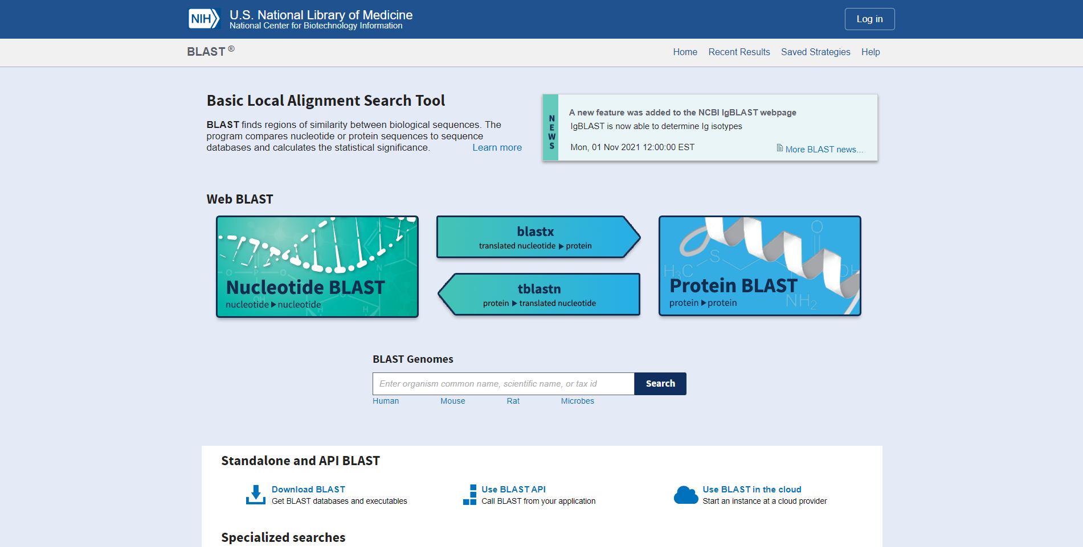**Fig1. Homepage of BLAST**

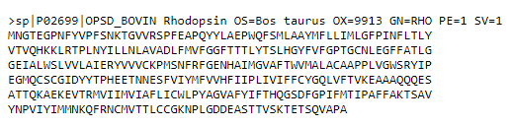**Fig2. FASTA sequence for Rhodopsin**

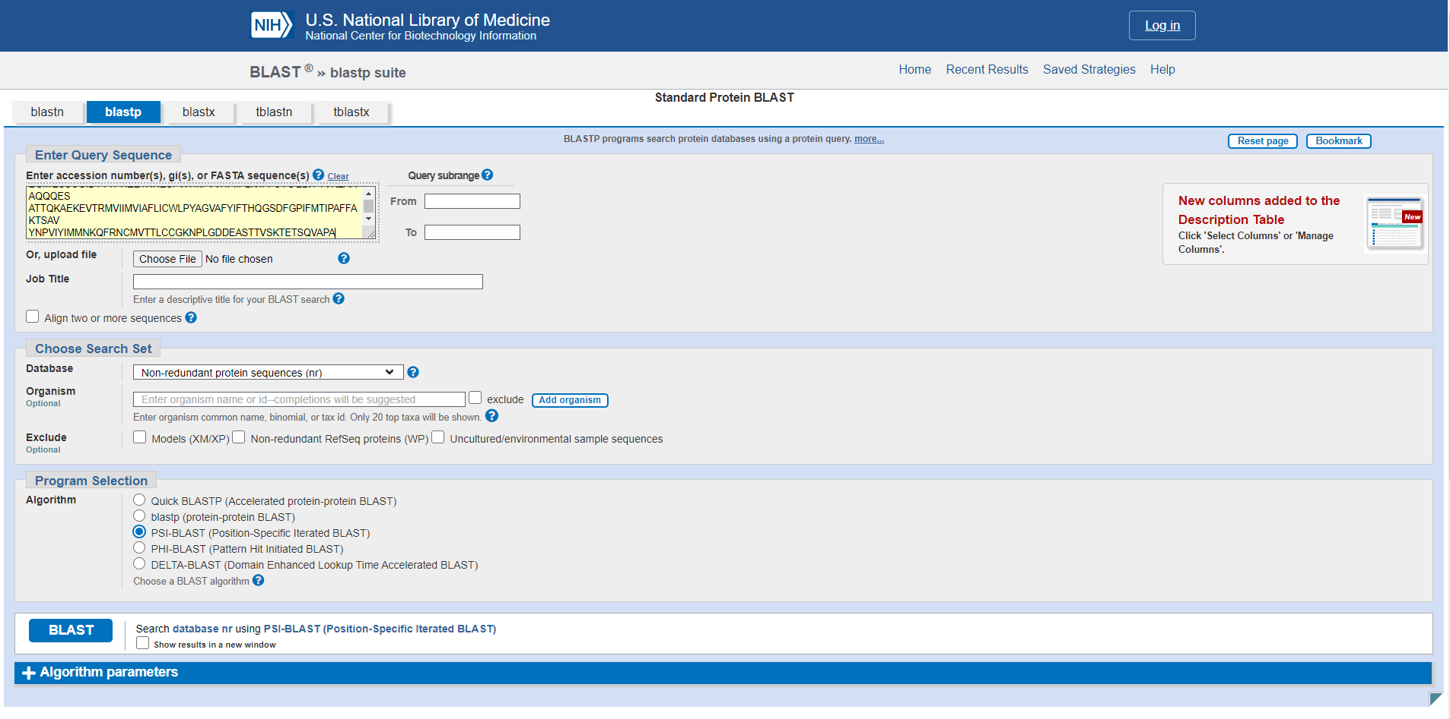**Fig3. Search bar for PSI blast with sequence for rhodopsin taken from uniport**

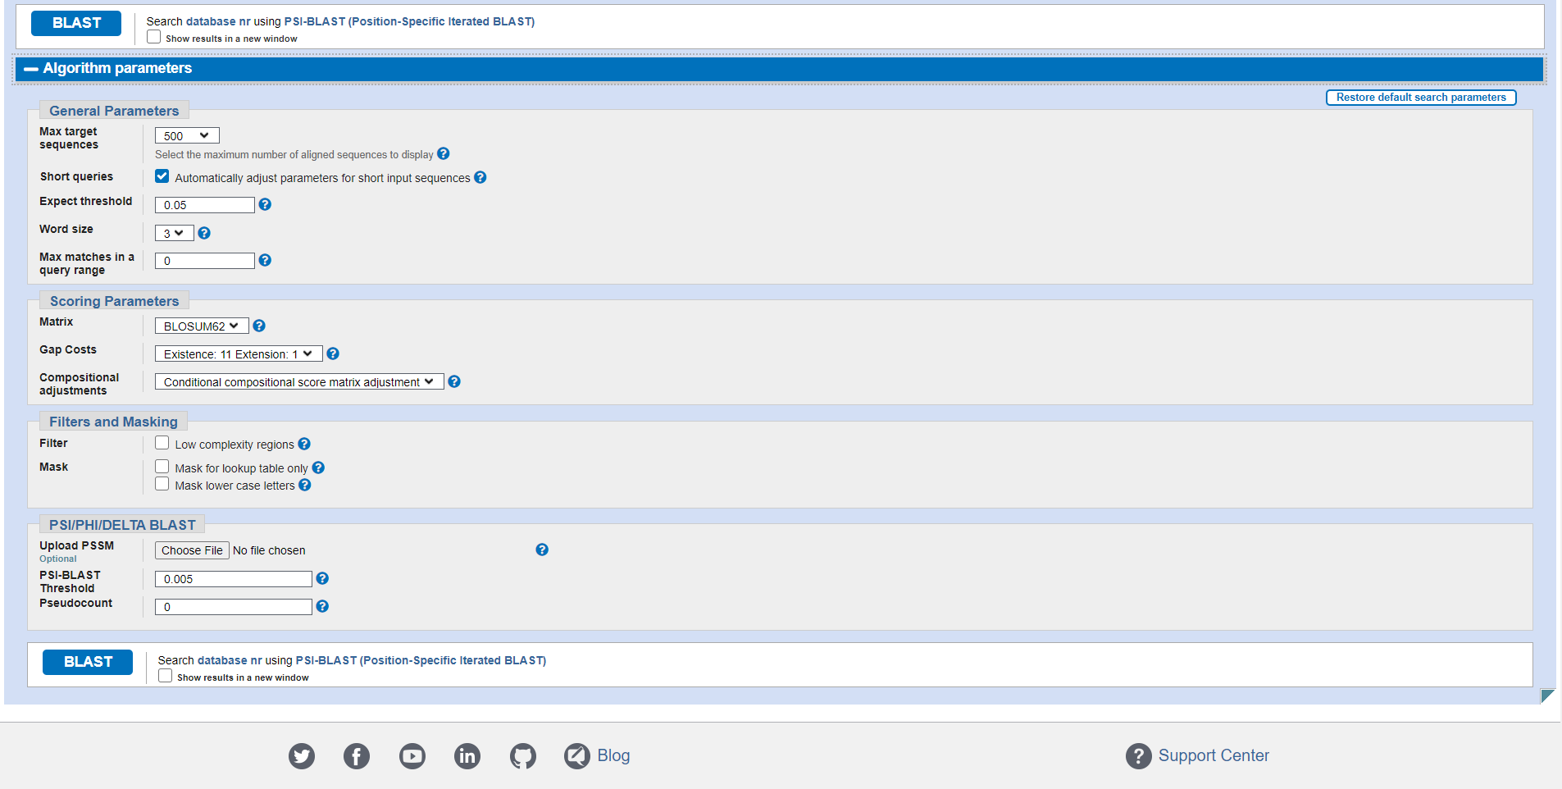**Fig4. Algorithm parameters (General, Scoring, Filters, Masking)**

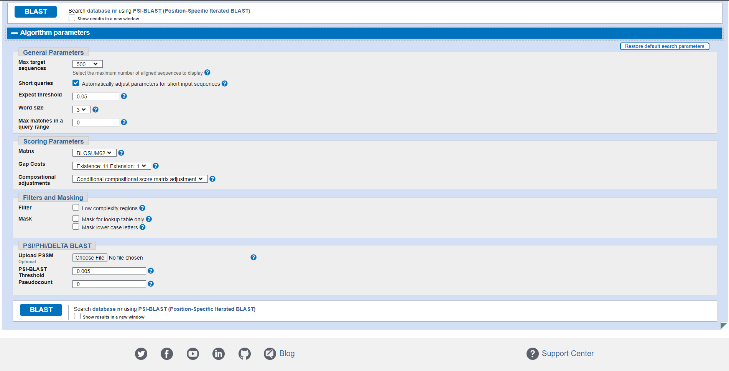**Fig5. Algorithm parameters for PSI/PHI/DELTA BLAST**

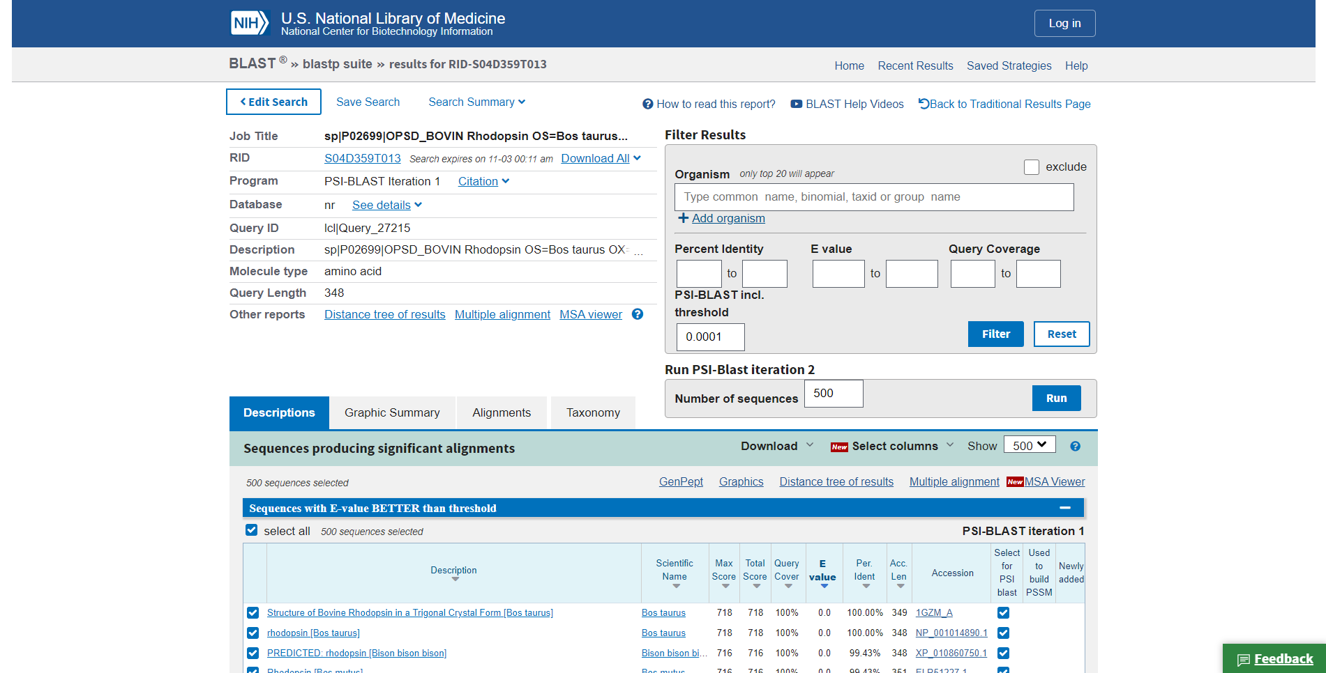**Fig6. Result page (header) for rhodopsin in PSI-BLAST**

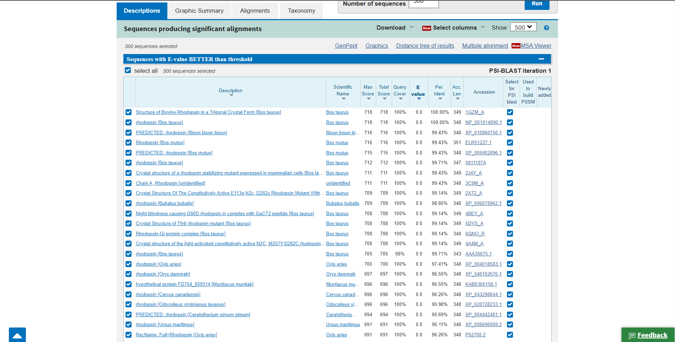**Fig7. Description for query Rhodopsin in PSI-BLAST**

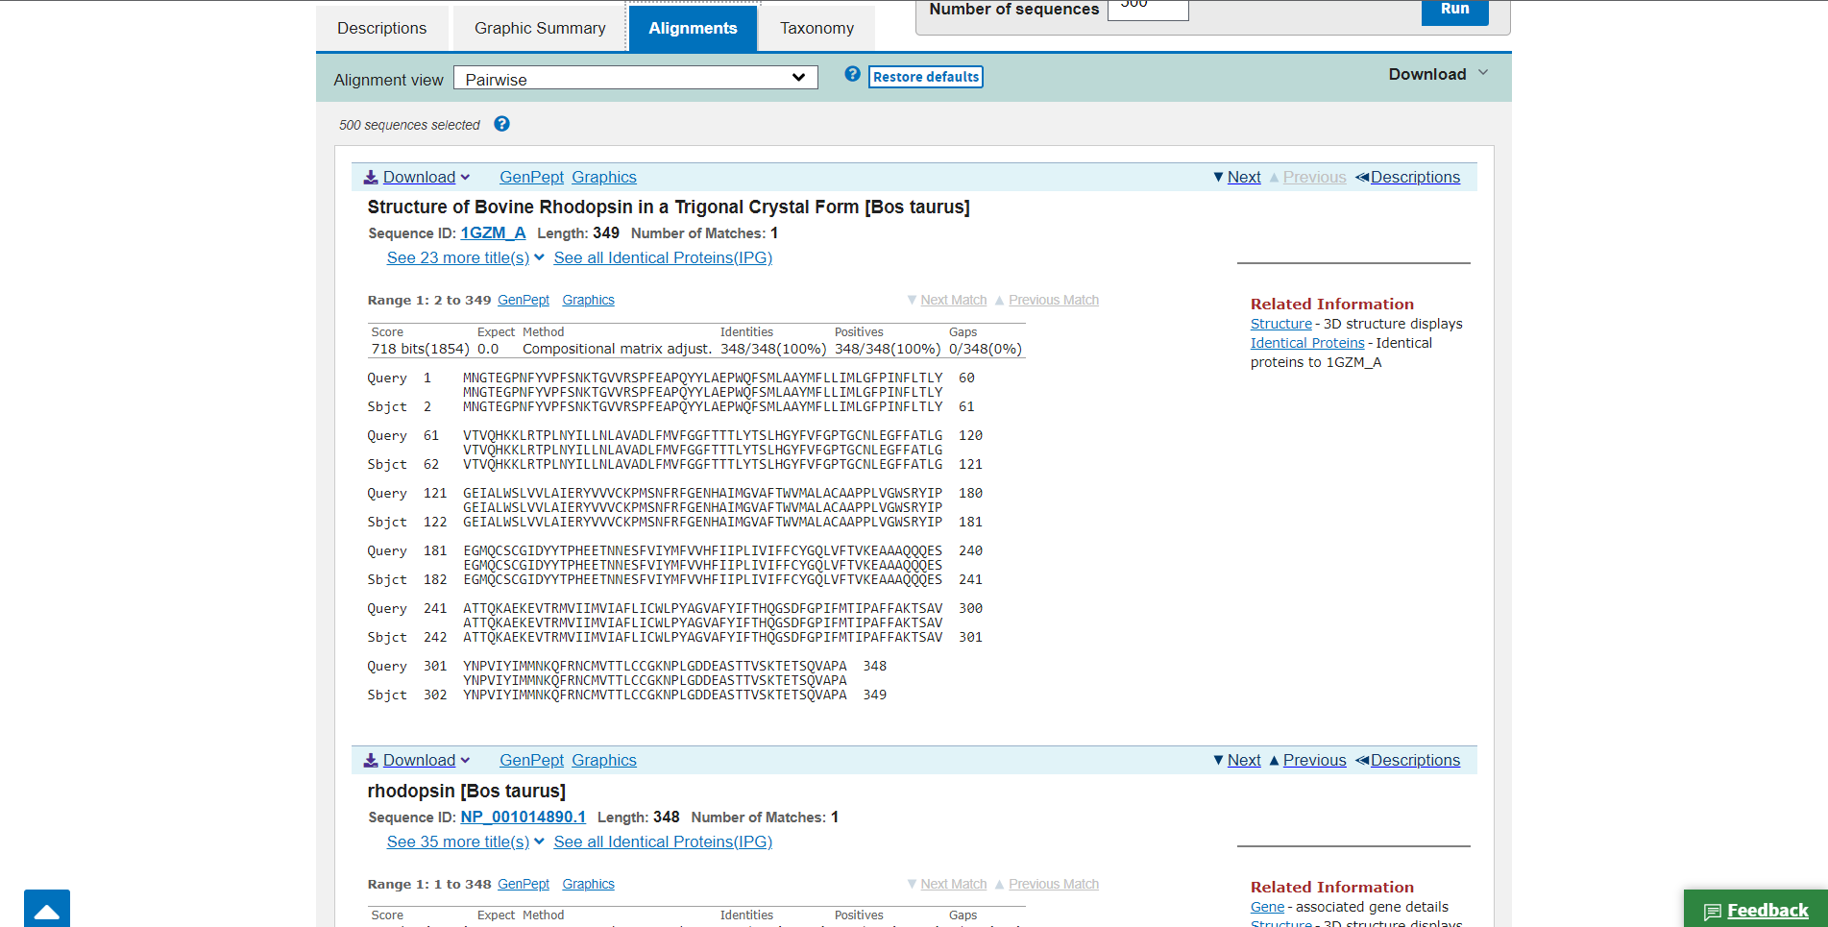**Fig8. Alignments for query Rhodopsin in PSI-BLAST**

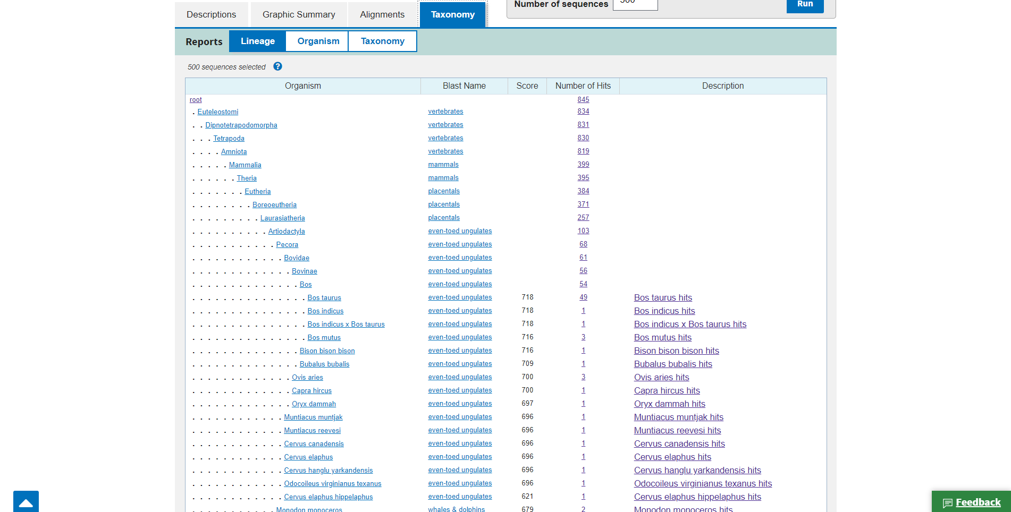**Fig9. Taxonomy for Rhodopsin in PSI-BLAST**

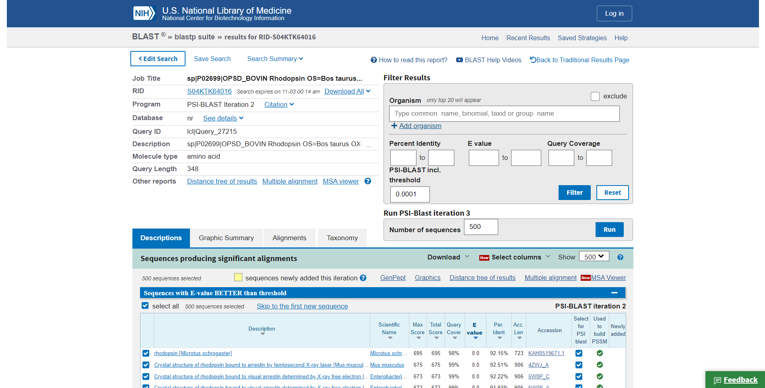**Fig10. Result page for Iteration 1**

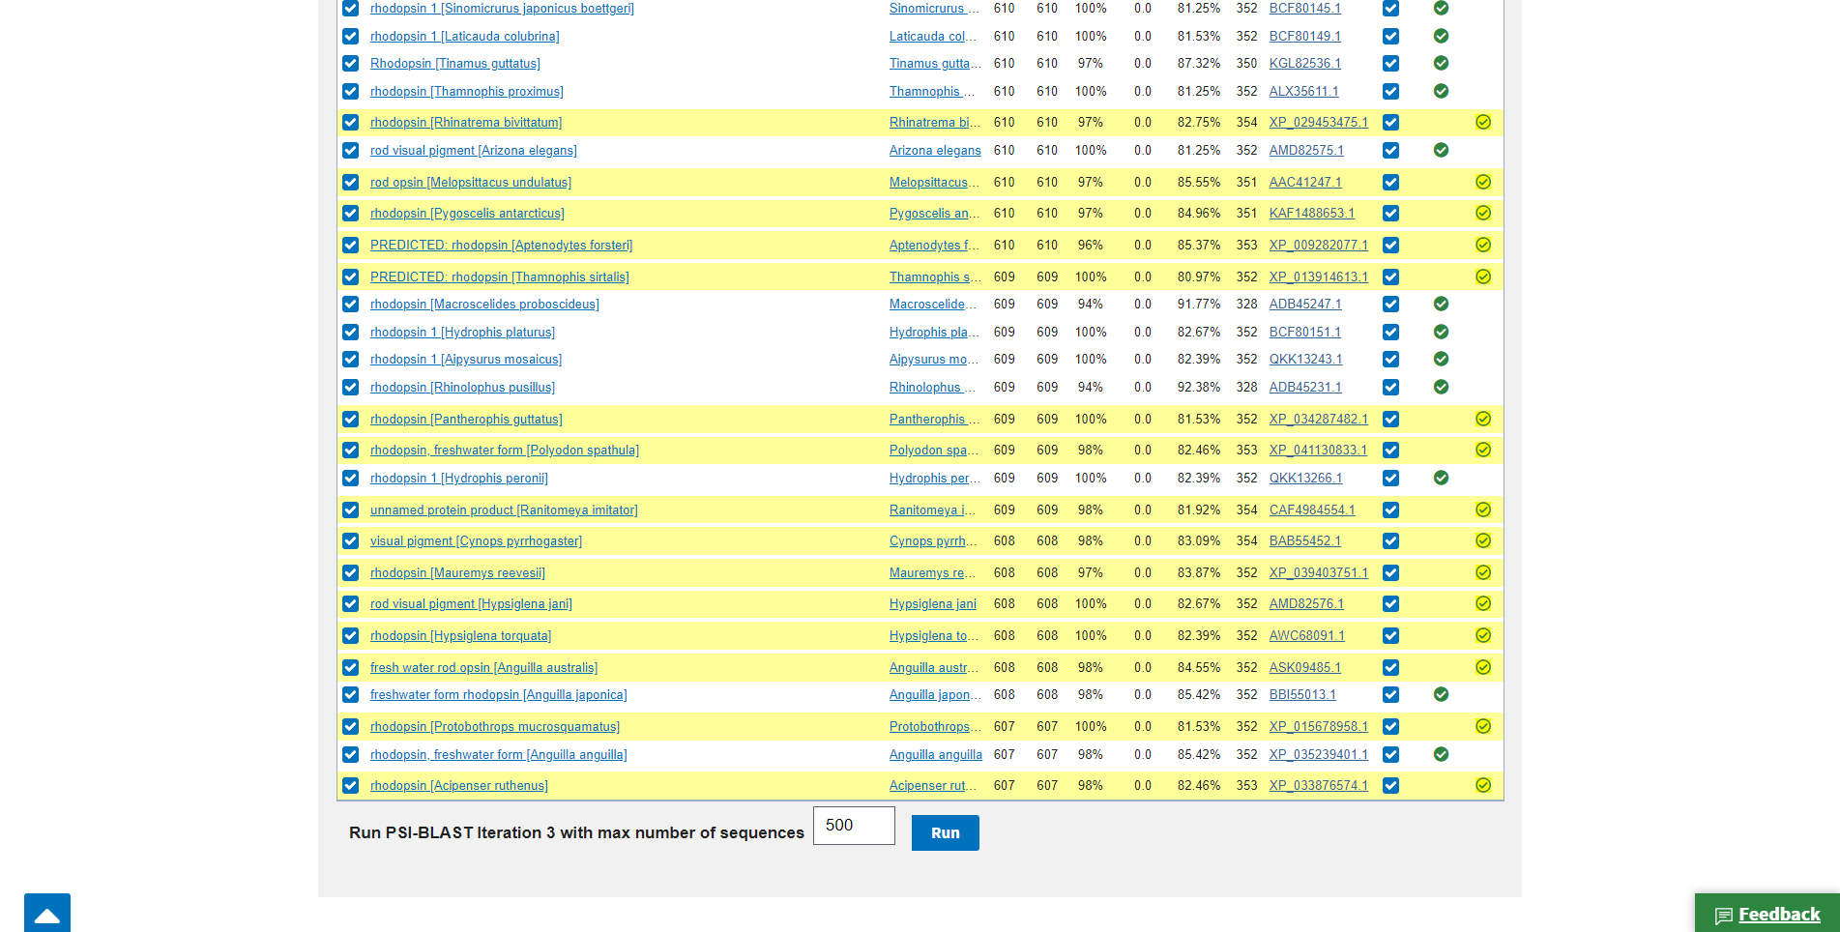**Fig11. Newly added sequences in iteration 1**

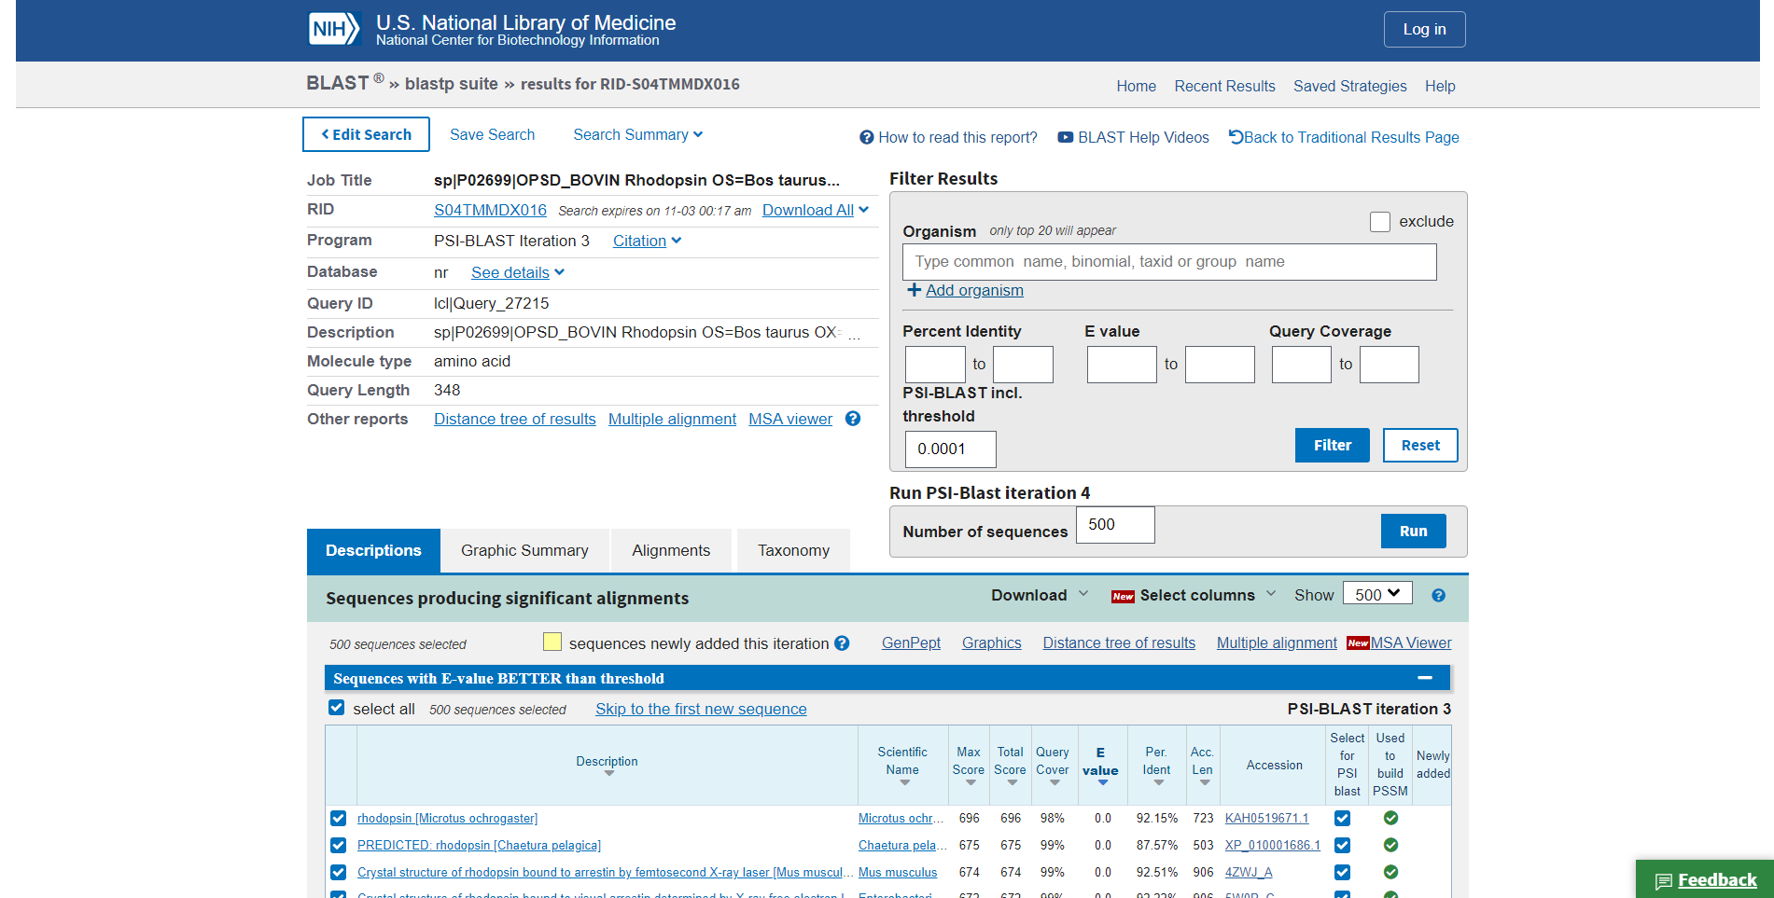**Fig12. Result page for Iteration 2**

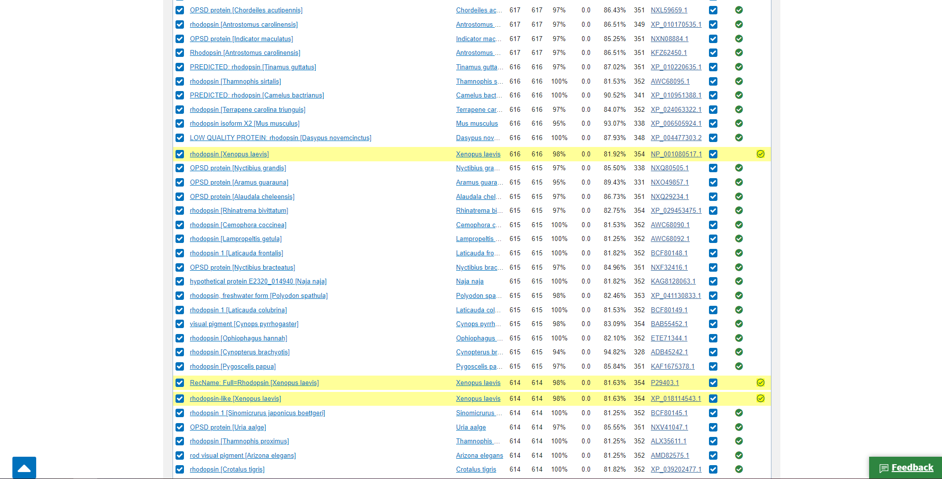**Fig13. Newly found sequences in Iteration 2**

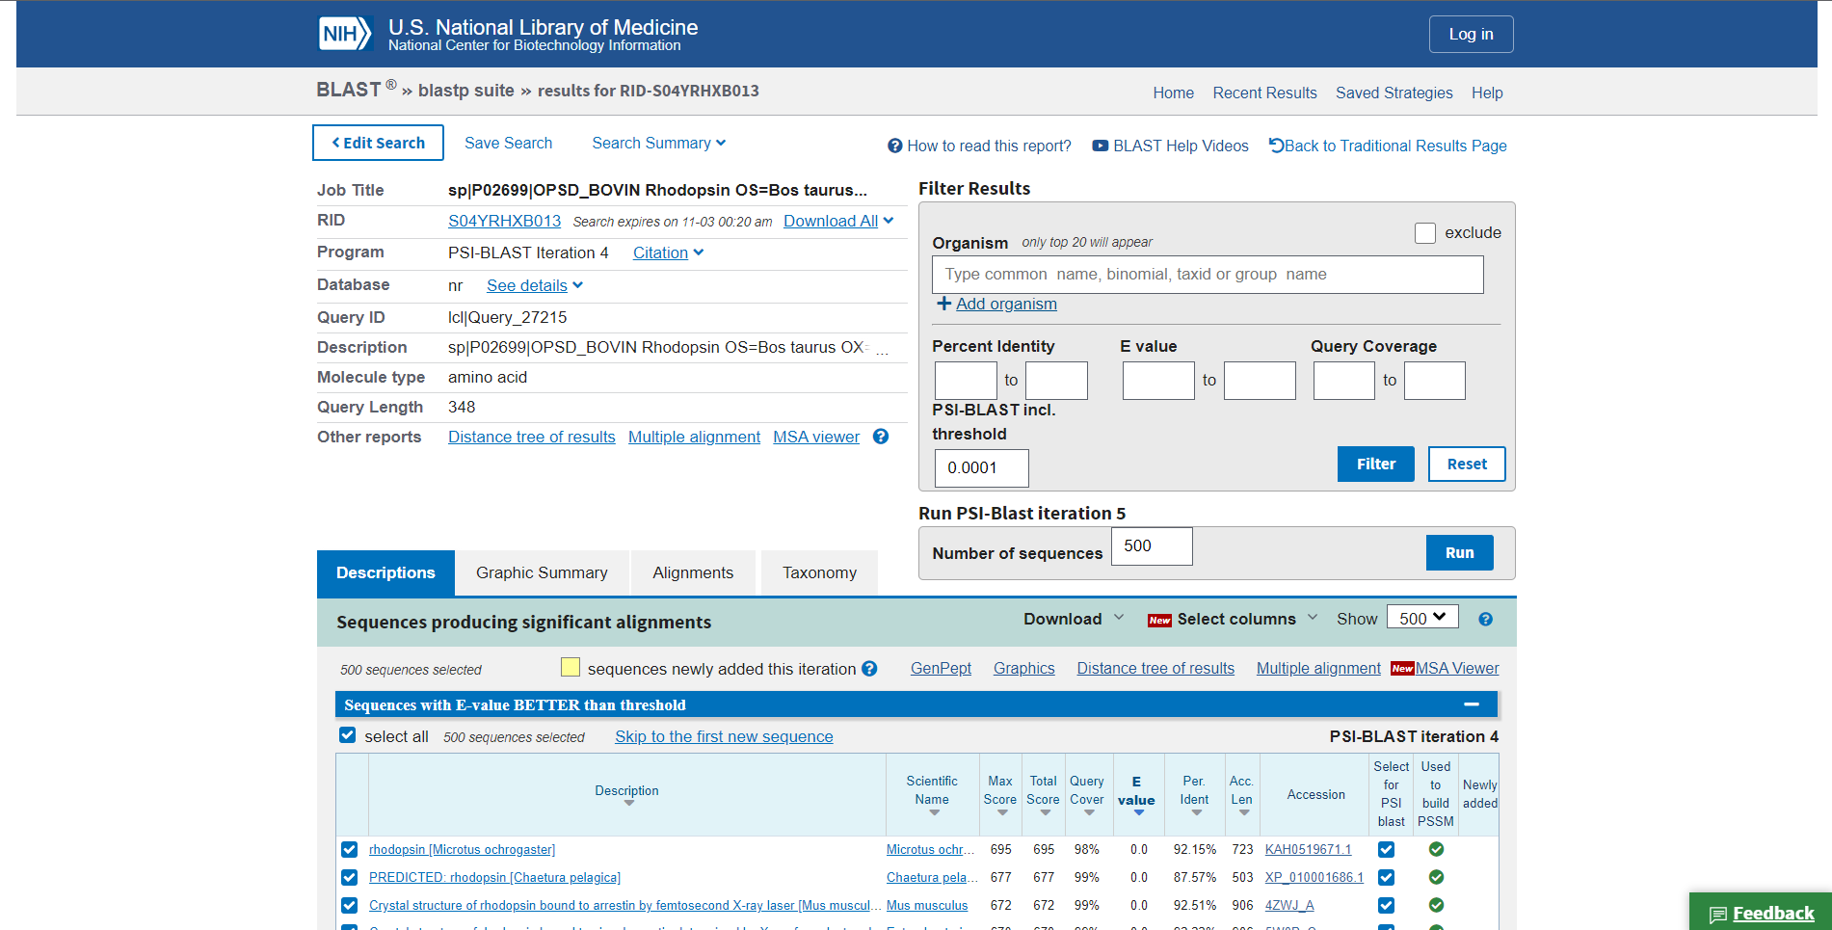**Fig14. Result page for Iteration 3**

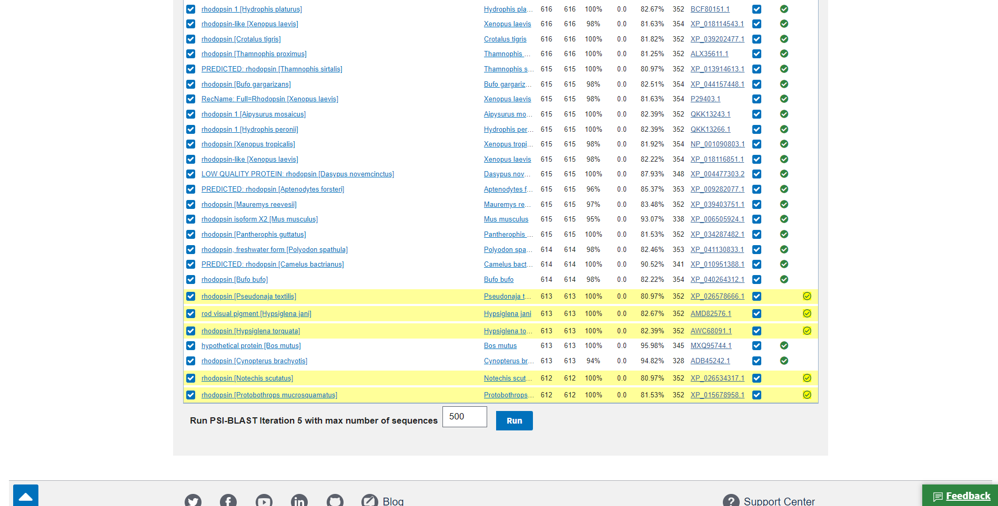**Fig15. Newly found sequences in Iteration 3**

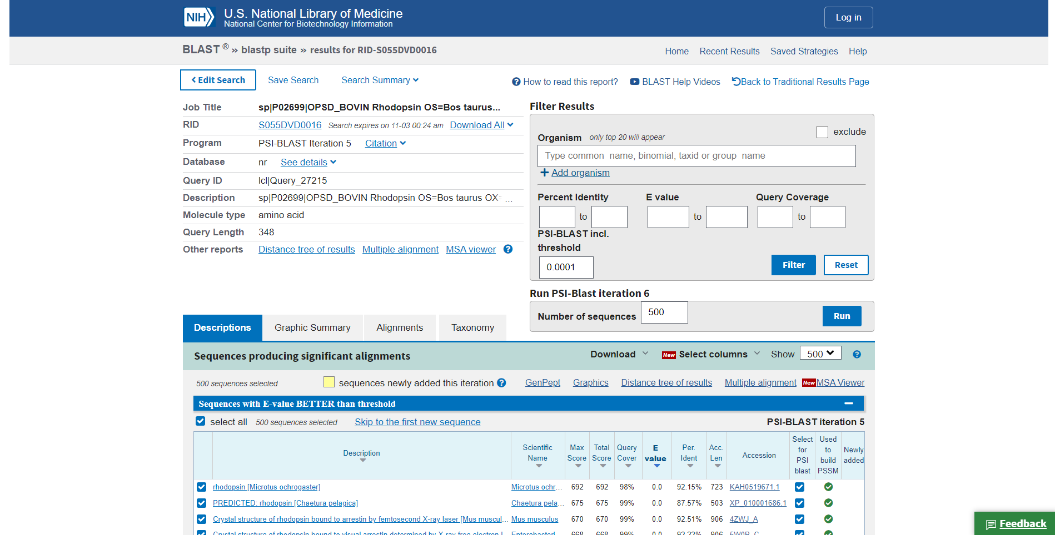**Fig16. Result page for iteration 4**

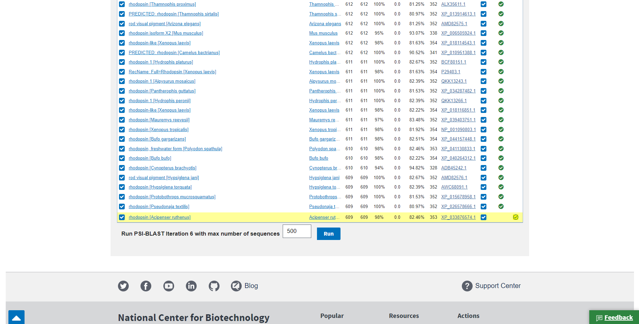**Fig17. Newly found sequences in Iteration 4**

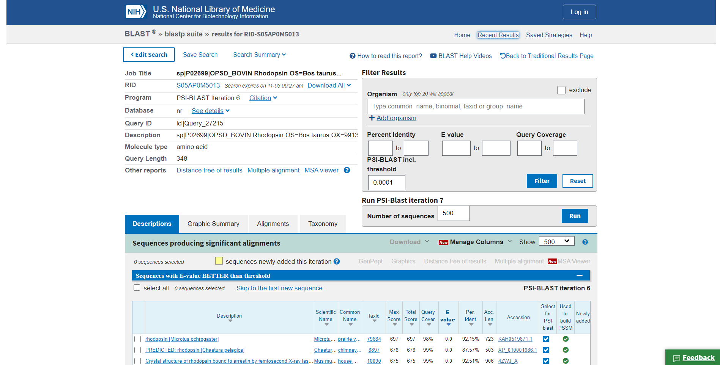**Fig18. Result page for Iteration 5**

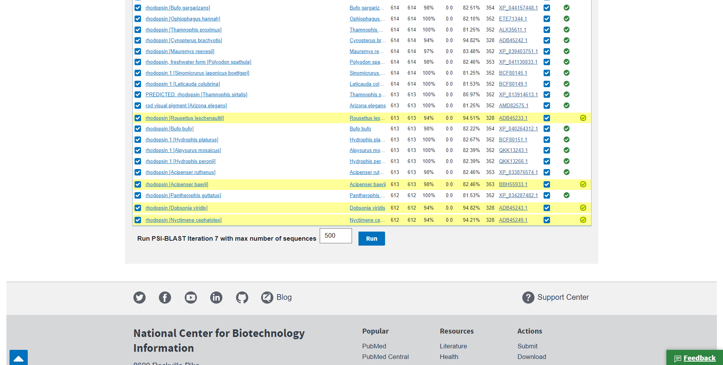**Fig19. Newly found sequences in iteration 5**

**Results:**

In PHI-BLAST the result is divided into 4 parts. Description, Graphic summary alignment, taxonomy. We can also iterate through multiple result pages where the database searches for more and more sequence alignments

**Conclusion:**

The PSI-blast is used to find distantly related proteins, what you need is the results in the final iteration. The PSI-blast runs in the following five steps: Repeat steps [3] and [4] iteratively, typically 5 times. At each new search, a new PSSM is used as the query. Hope my answer could help you to understand the use of PSI-blast.

**References:**

1. (n.d.). Retrieved from <https://www.uniprot.org/uniprot/P02699.fasta>
2. NCBI Blast:sp|P02699|OPSD_BOVIN Rhodopsin OS=Bos taurus... (n.d.). Retrieved from <https://blast.ncbi.nlm.nih.gov/Blast.cgi?CMD=Get&VIEW_RESULTS=FromRes&RID=S04D359T013&UNIQ_OBJ_NAME=A_SearchResults_1mhZtz_215p_diTIoYKm2MJ_GTXQl_fSITZ&QUERY_INDEX=0>
3. NCBI Blast:sp|P02699|OPSD_BOVIN Rhodopsin OS=Bos taurus... (n.d.). Retrieved from <https://blast.ncbi.nlm.nih.gov/Blast.cgi?CMD=Get&VIEW_RESULTS=FromRes&RID=S04KTK64016&UNIQ_OBJ_NAME=A_SearchResults_1mhZxS_8Gf_du382JTU5wJ_GTXQl_1aKLYe&QUERY_INDEX=0>
4. NCBI Blast:sp|P02699|OPSD_BOVIN Rhodopsin OS=Bos taurus... (n.d.). Retrieved from <https://blast.ncbi.nlm.nih.gov/Blast.cgi?CMD=Get&VIEW_RESULTS=FromRes&RID=S04TMMDX016&UNIQ_OBJ_NAME=A_SearchResults_1mha0S_2tWP_dgi0SViy52a_GTWlT_s8Vrj&QUERY_INDEX=0>
5. NCBI Blast:sp|P02699|OPSD_BOVIN Rhodopsin OS=Bos taurus... (n.d.). Retrieved from <https://blast.ncbi.nlm.nih.gov/Blast.cgi?CMD=Get&VIEW_RESULTS=FromRes&RID=S04YRHXB013&UNIQ_OBJ_NAME=A_SearchResults_1mha36_1HG1_dh5iZ3ya7Ag_GTW6B_1xr8fY&QUERY_INDEX=0>
6. NCBI Blast:sp|P02699|OPSD_BOVIN Rhodopsin OS=Bos taurus... (n.d.). Retrieved from <https://blast.ncbi.nlm.nih.gov/Blast.cgi?CMD=Get&VIEW_RESULTS=FromRes&RID=S055DVD0016&UNIQ_OBJ_NAME=A_SearchResults_1mha6X_2snk_dhWv52Lw3FN_GTWlT_TnXX2&QUERY_INDEX=0>
7. NCBI Blast:sp|P02699|OPSD_BOVIN Rhodopsin OS=Bos taurus... (n.d.). Retrieved from <https://blast.ncbi.nlm.nih.gov/Blast.cgi?CMD=Get&VIEW_RESULTS=FromRes&RID=S05AP0M5013&UNIQ_OBJ_NAME=A_SearchResults_1mha9H_12l1_dwXZcxLU55P_GTXQl_1s3jJ9&QUERY_INDEX=0>
8. Rhodopsin. (n.d.). Retrieved from <https://www.britannica.com/science/rhodopsin>

**DATE: 9-11-21**

**WEBLEM 12**

**Comparison between BLAST and FASTA**

|  |  |
| --- | --- |
| BLAST | FASTA |
| Basic local alignment search tool available in NCBI website that facilitates comparison of biological sequence similarities | A program available at European Bioinformatics Institute that provides facility to search similar sequences to one’s quert sequence. |
| Less sensitive as compared to FASTA | FASTA scans smaller window sizes. Thus, it gives more sensitive |
| BLAST uses a substitution matrix to find matching words. | FASTA identifies identical matching owords using the hashing procedure. |
| Uses local sequence alignment. | Uses local sequence alignment first, then extends to global alignment.. |
| BLAST sometimes gives best-scoring alignments from the same sequence. | FASTA returns only one final alignment |
| Better for similarity searching in closely related sequences. | Better for similarity searching in less similar sequences |
| Low-complexity masking in the BLAST procedure means that it may have higher specificity than FASTA because potential false positives are reduced | Less accurate as compared to BLAST |
| Faster than FASTA | Comparatively slow. |

**References:**

1. [**https://www.differencebetween.com/difference-between-blast-and-vs-fasta/**](https://www.differencebetween.com/difference-between-blast-and-vs-fasta/)
2. <https://pediaa.com/difference-between-blast-and-fasta/>

**DATE: 12-11-21**

**WEBLEM 13**

**Introduction to MSA**

Multiple sequence alignment, which is to align multiple related sequences to achieve optimal matching of the sequences. Related sequences are identified through the database similarity searching. As the process generates multiple matching sequence pairs, it is often necessary to convert the numerous pairwise alignments into a single alignment, which arranges sequences in such a way that evolutionarily equivalent positions across all sequences are matched.

It is theoretically possible to use dynamic programming to align any number of sequences as for pairwise alignment. However, the amount of computing time and memory it requires increases exponentially as the number of sequences increases. As a consequence, full dynamic programming cannot be applied for datasets of more than ten sequences. In practice, heuristic approaches are most often used.

There is a unique advantage of multiple sequence alignment because it reveals more biological information than many pairwise alignments can. For example, it allows the identification of conserved sequence patterns and motifs in the whole sequence family, which are not obvious to detect by comparing only two sequences. Many conserved and functionally critical amino acid residues can be identified in a protein multiple alignment. Multiple sequence alignment is also an essential prerequisite to carrying out phylogenetic analysis of sequence families and prediction of protein secondary and tertiary structures. Multiple sequence alignment also has applications in designing degenerate polymerase chain reaction (PCR) primers based on multiple related sequences.

**SCORING FUNCTION:**

Multiple sequence alignment is to arrange sequences in such a way that a maximum number of residues from each sequence are matched up according to a particular scoring function. The scoring function for multiple sequence alignment is based on the concept of sum of pairs (SP). As the name suggests, it is the sum of the scores of all possible pairs of sequences in a multiple alignment based on a particular scoring matrix. In calculating the SP scores, each column is scored by summing the scores for all possible pairwise matches, mismatches and gap costs. The score of the entire alignment is the sum of all of the column scores. The purpose of most multiple sequence alignment algorithms is to achieve maximum SP scores.

**Progressive Alignment Method:**

Progressive alignment depends on the stepwise assembly of multiple alignment and is heuristic in nature. It speeds up the alignment of multiple sequences through a multistep process. It first conducts pairwise alignments for each possible pair of sequences using the Needleman–Wunsch global alignment method and records these similarity scores from the pairwise comparisons. The scores can either be percent identity or similarity scores based on a particular substitution matrix. Both scores correlate with the evolutionary distances between sequences. The scores are then converted into evolutionary distances to generate a distance matrix for all the sequences involved. A simple phylogenetic analysis is then performed based on the distance matrix to group sequences based on pairwise distance scores. As a result, a phylogenetic tree is generated using the neighbor-joining method. The tree reflects evolutionary proximity among all the sequences.

In the next step, the next closest sequence based on the guide tree is aligned with the consensus sequence using dynamic programming. More distant sequences or sequence profiles are subsequently added one at a time in accordance with their relative positions on the guide tree. After realignment with a new sequence using dynamic programming, a new consensus is derived, which is then used for the next round of alignment. The process is repeated until all the sequences are aligned.

**Two of the popular progressive alignment methods used at present are:**

1. Clustal Omega
2. T-Coffee

**Clustal Omega:**

It is a new multiple sequence alignment program that uses seeded guide trees and HMM profile-profile techniques to generate alignments between three or more homologous nucleotide or amino acid sequences. This has been one of the most widely used procedures in bioinformatics for decades, as it is an essential prerequisite for most phylogenetic or comparative analyses of homologous genes or proteins.

One or two iterations are usually found to have a small beneficial effect on alignment quality. One of the most important features of this program is the flexibility of using substitution matrices. Clustal does not rely on a single substitution matrix. Instead, it applies different scoring matrices when aligning sequences, depending on degrees of similarity.

Another feature of Clustal is the use of adjustable gap penalties that allow more insertions and deletions in regions that are outside the conserved domains, but fewer in conserved regions. For example, a gap near a series of hydrophobic residues carries more penalties than the one next to a series of hydrophilic or glycine residues, which are common in loop regions. In addition, gaps that are too close to one another can be penalized more than gaps occurring in isolated loci.

The program also applies a weighting scheme to increase the reliability of aligning divergent sequences (sequences with less than 25% identity). This is done by down weighting redundant and closely related groups of sequences in the alignment by a certain factor. This scheme is useful in preventing similar sequences from dominating the alignment. The weight factor for each sequence is determined by its branch length on the guide tree. The branch lengths are normalized by how many times sequences share a basal branch from the root of the tree.

One feature of Clustal Omega that is especially useful is the ability to use an external HMM to help guide an alignment. This is referred to as External Profile Alignment (EPA) in this unit. It consists of taking each sequence to be aligned and aligning it against the HMM to help its alignment with other sequences in the dataset. It can be used with publicly available HMMs from PFAM, for example, or from an expert alignment that the user has built up. This procedure can also be used to iteratively generate an HMM from an output MSA and to input this to realign the input sequences.

**What do the consensus symbols mean in the alignment?**

A “-” character is used to pad sequences with gaps, which are necessary to align the sequences.

An * (asterisk) indicates positions which have a single, fully conserved residue.  
A : (colon) indicates conservation between groups of strongly similar properties as below - roughly equivalent to scoring > 0.5 in the Gonnet PAM 250 matrix.

A . (period) indicates conservation between groups of weakly similar properties as below - roughly equivalent to scoring =< 0.5 and > 0 in the Gonnet PAM 250 matrix.

What do the colours mean when I show them on protein alignments?

This protein-only option colours the residues according to their physicochemical properties:

|  |  |  |
| --- | --- | --- |
| Residue | Colour | Property |
| AVFPMILW | RED | Small (small+ hydrophobic (incl.aromatic -Y)) |
| DE | BLUE | Acidic |
| RK | MAGENTA | Basic - H |
| STYHCNGQ | GREEN | Hydroxyl + sulfhydryl + amine + G |
| Others | Grey | Unusual amino/imino acids etc |

**References:**

* Xiong, J. (2006). Multiple Sequence Alignment. *Essential Bioinformatics* (1st ed.). Cambridge University Press, 63-71.

1. Sievers, F., & Higgins, D. G. (2014). Clustal Omega. Current Protocols in Bioinformatics, 3.13.1–3.13.16. doi:10.1002/0471250953.bi0313s48
2. Help - Clustal Omega FAQ - Tools Help & Documentation - EMBL-EBI. (n.d.). EMBL-EBI. Retrieved October 30, 2021, from <https://www.ebi.ac.uk/seqdb/confluence/display/THD/Help+-+Clustal+Omega+FAQ>
3. Clustal Omega < Multiple Sequence Alignment < EMBL-EBI. (n.d.). EMBL-EBI. Retrieved October 30, 2021, from <https://www.ebi.ac.uk/Tools/msa/clustalo/>

**DATE: 10-11-21**

**WEBLEM 13/a**

**Clustal Omega**

**(URL:** <https://www.ebi.ac.uk/Tools/msa/clustalo/>**)**

**Aim:**

To study rhodopsin sequnces similarity using Clustal Omega

**Introduction:**

Clustal Omega is a new multiple sequence alignment program that uses seeded guide trees and HMM profile-profile techniques to generate alignments between three or more homologous nucleotide or amino acid sequences. This has been one of the most widely used procedures in bioinformatics for decades, as it is an essential prerequisite for most phylogenetic or comparative analyses of homologous genes or proteins. One or two iterations are usually found to have a small beneficial effect on alignment quality. One of the most important features of this program is the flexibility of using substitution matrices. Clustal does not rely on a single substitution matrix. Instead, it applies different scoring matrices when aligning sequences, depending on degrees of similarity.The choice of a matrix depends on the evolutionary distances measured from the guide tree. For example, for closely related sequences that are aligned in the initial steps, Clustal automatically uses the BLOSUM62 or PAM120 matrix. When more divergent sequences are aligned in later steps of the progressive alignment, the BLOSUM45 or PAM250 matrices may be used instead.

**Rhodopsin**, also called **visual purple**, pigment-containing sensory protein that converts light into an electrical signal. Rhodopsin is found in a wide range of organisms, from vertebrates to bacteria. In many seeing animals, including humans, it is required for vision in dim light and is located in the retina of the eye specifically, within the tightly packed disks that make up the outer segment of the retina’s photoreceptive rod cells, which are specially adapted for vision under low-light conditions.

Rhodopsin was discovered in 1876 by German physiologist Franz Christian Boll, who observed that the normally reddish purple frog retina turned pale in bright light. The fading of colour was later attributed to the destruction of rhodopsin, via a process known as bleaching. Bleaching and the subsequent regeneration of rhodopsin are major steps in the visual cycle—the series of biochemical reactions that is critical for vision in low light.

**Methodology:**

1. Open homepage for Clustal Omega (<https://www.ebi.ac.uk/Tools/msa/culstalo/>)
2. Select multiple sequences for query “Rhodopsin” from UniProt database and retrieve FASTA sequences for the same.
3. Ener FASTA sequences in Clustal Omega search page.
4. Submit query.
5. Observe and interpret the results.

**Observation:**

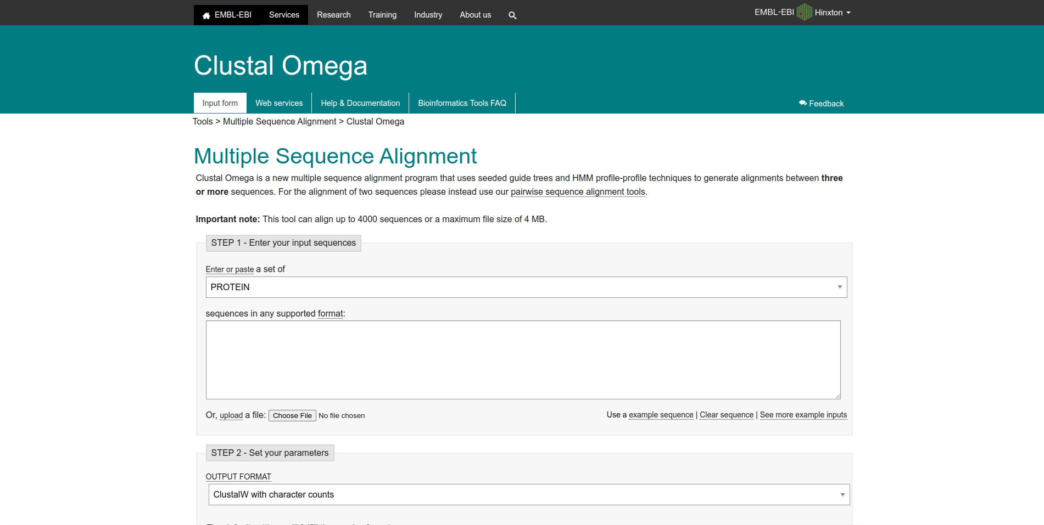**Fig1. Homepage of Clustal Omega**

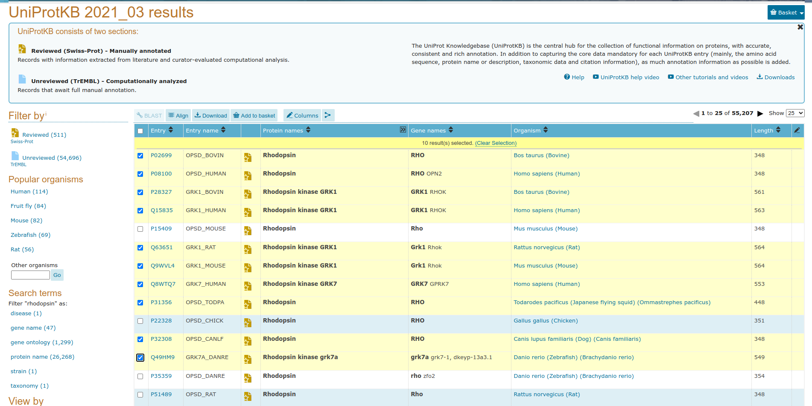**Fig2. Selected sequences for query “Rhodopsin” in UniProt database.**

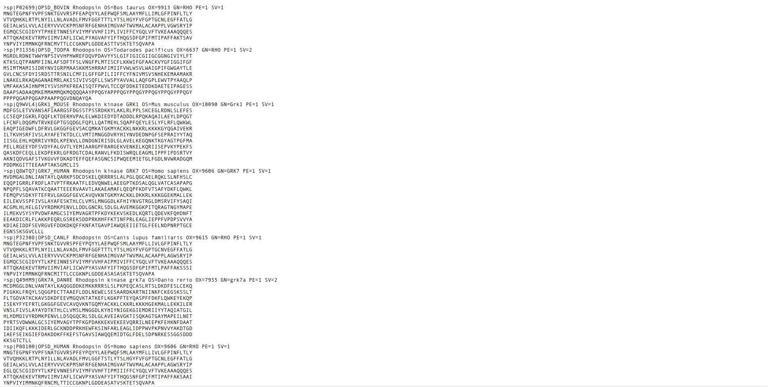**Fig3. FASTA sequences for the selected sequences for query Rhodopsin**

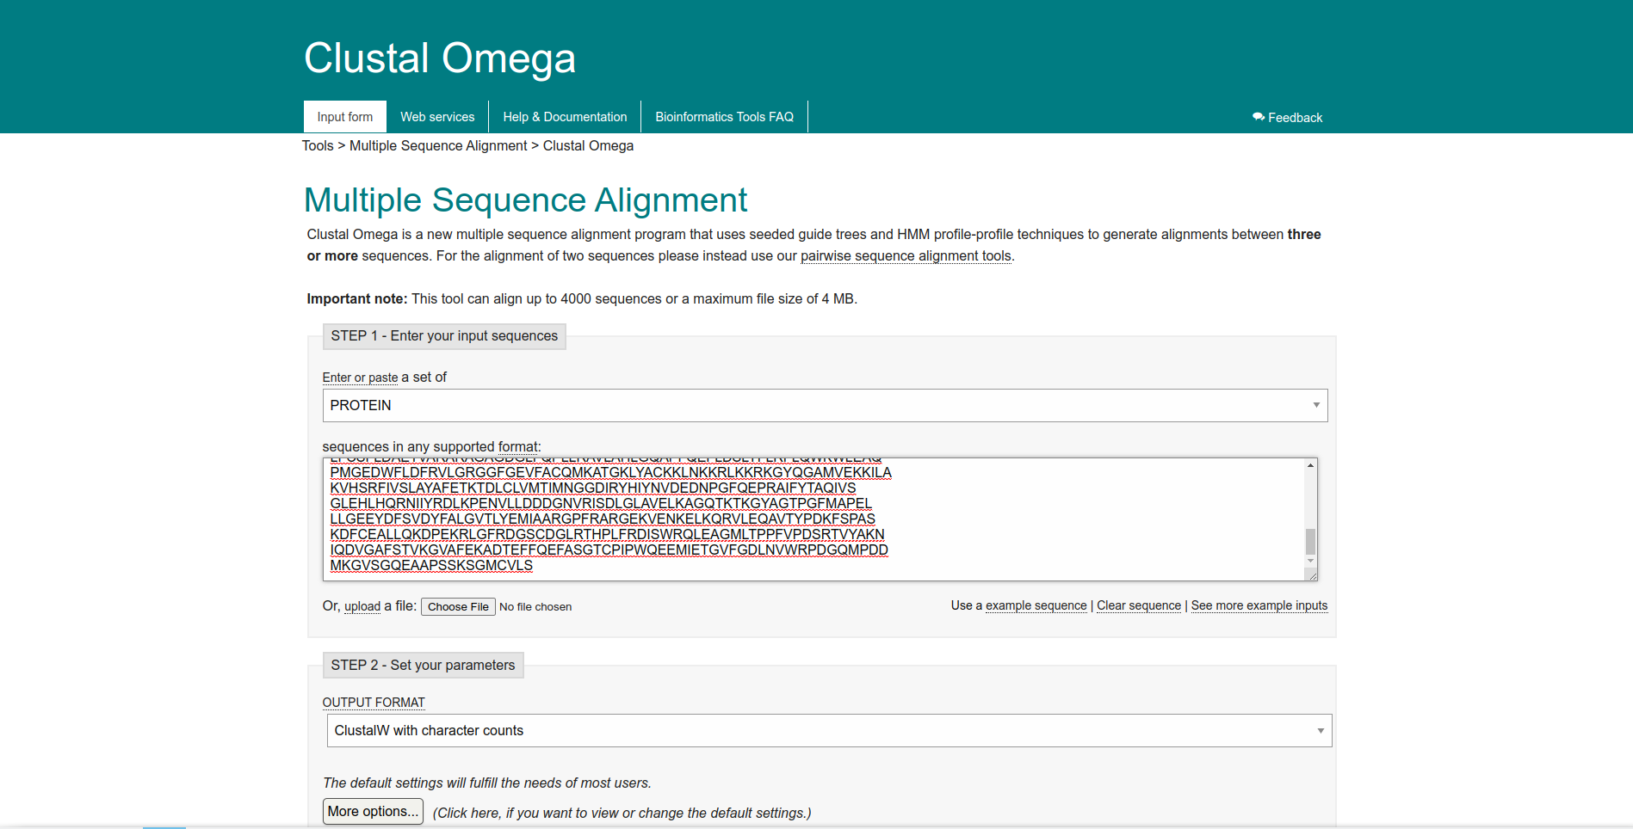**Fig4. Search page for query Rhodopsin in Clustal Omega**

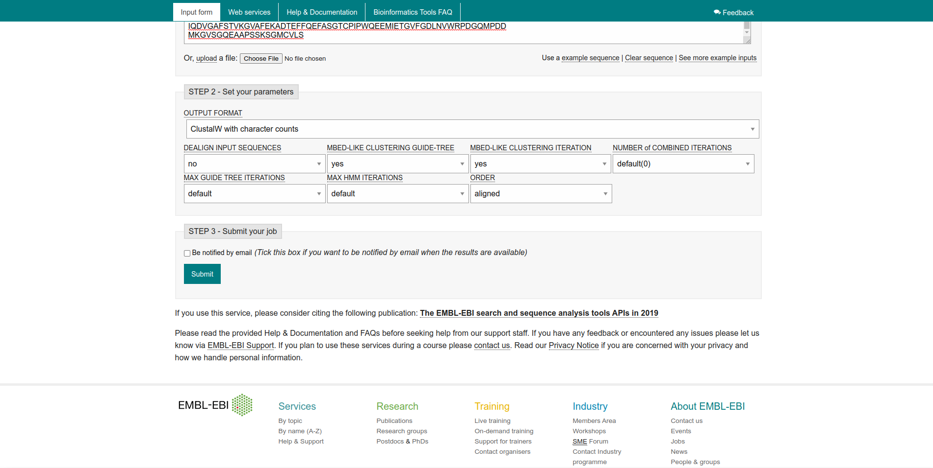**Fig5. Parameters used for query Rhodopsin**

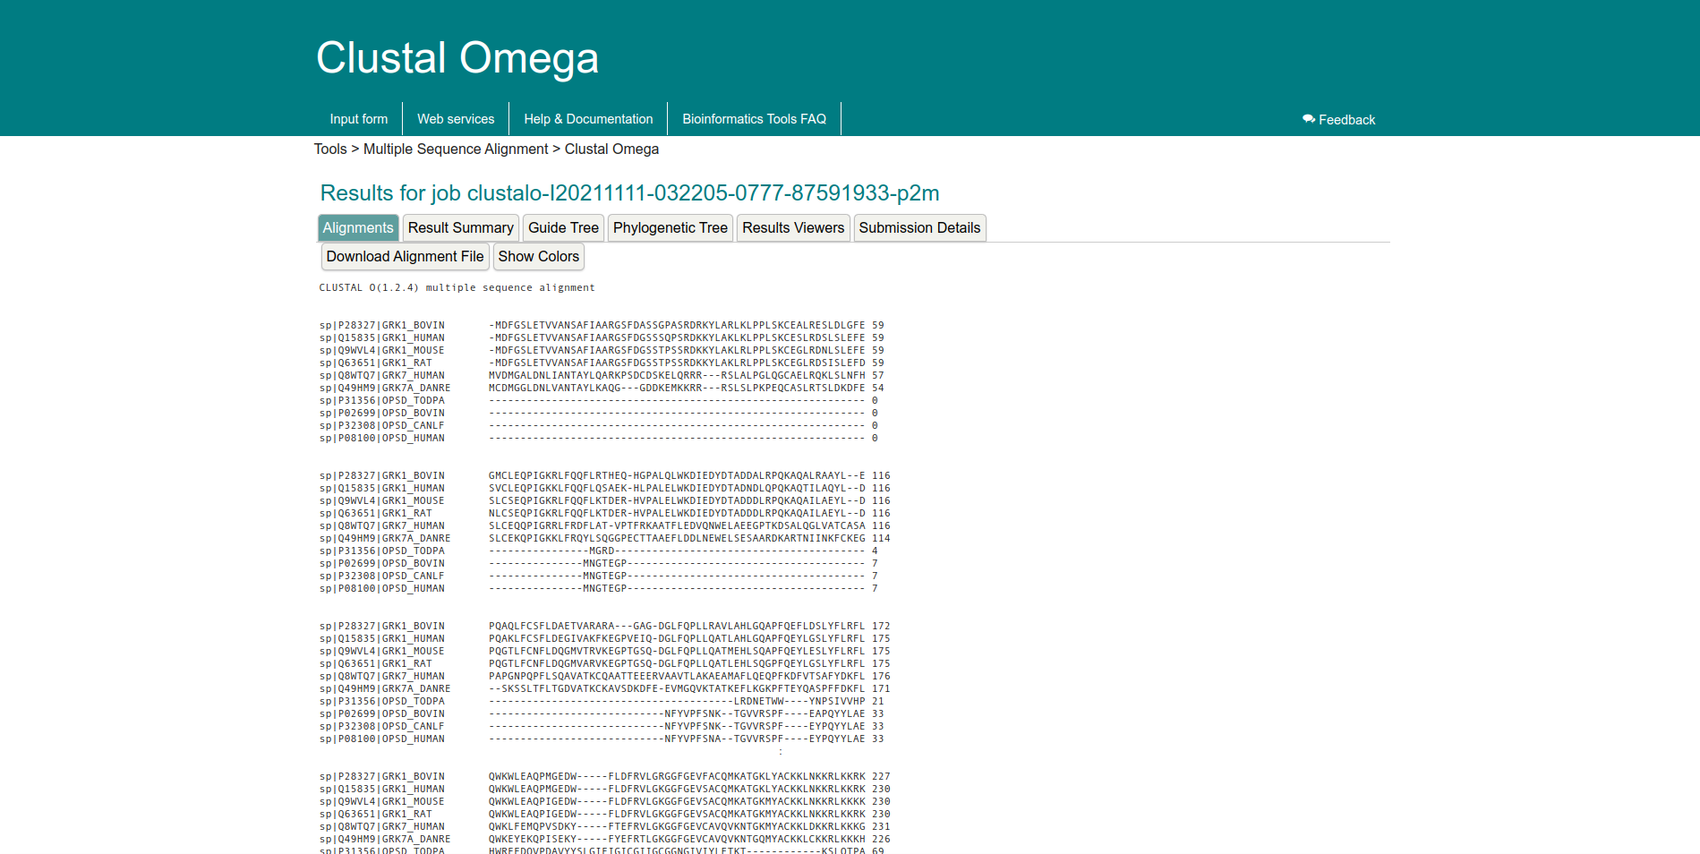**Fig6. Result page for query Rhodopsin showing alignments**

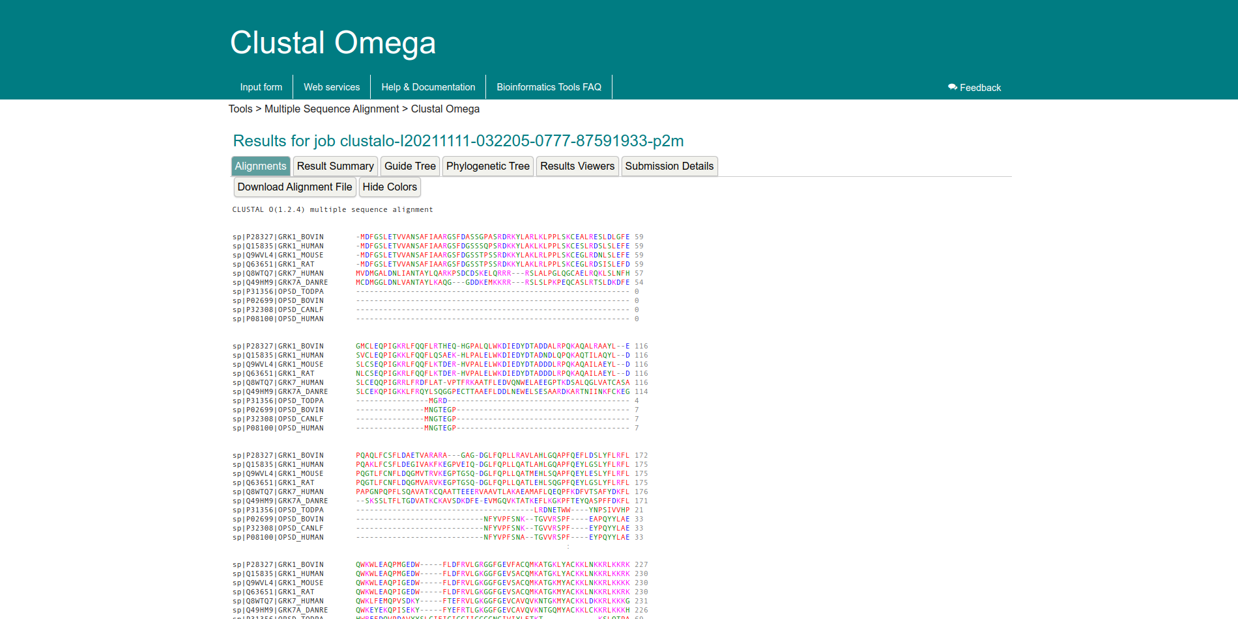**Fig7. Result page for query rhodopsin showing alignments with colors**

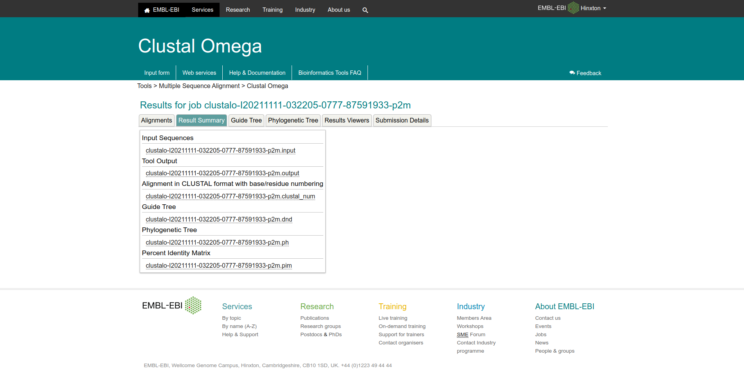**Fig8. Result page for query Rhodopsin showing result summary**

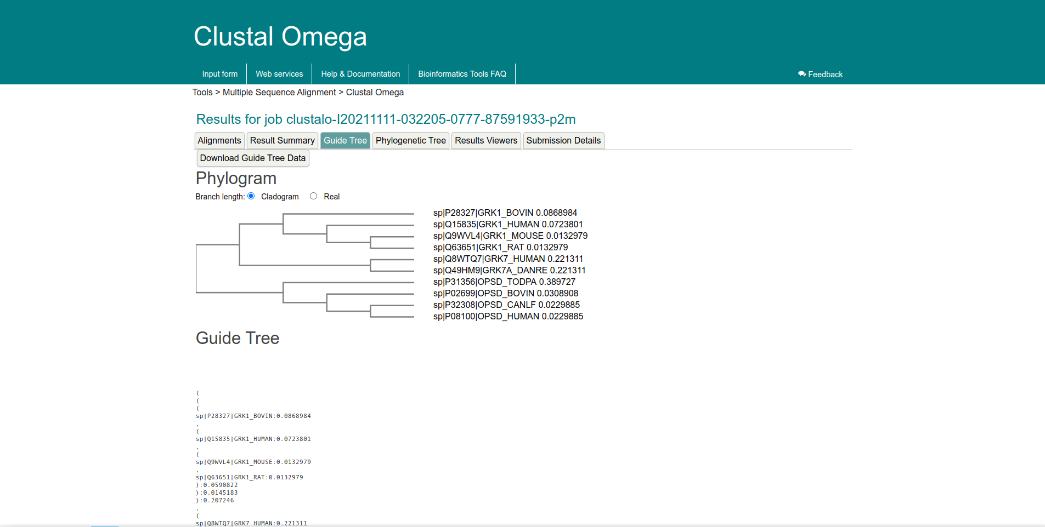**Fig9. Result page for query Rhodopsin showing Phylogram and guide tree information**

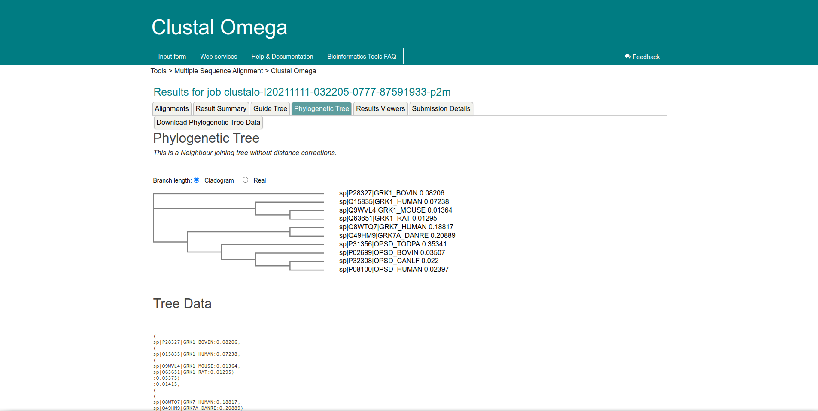**Fig10. Resukt page for query Rhodopsin showing Phylogenetic tree and tree data**

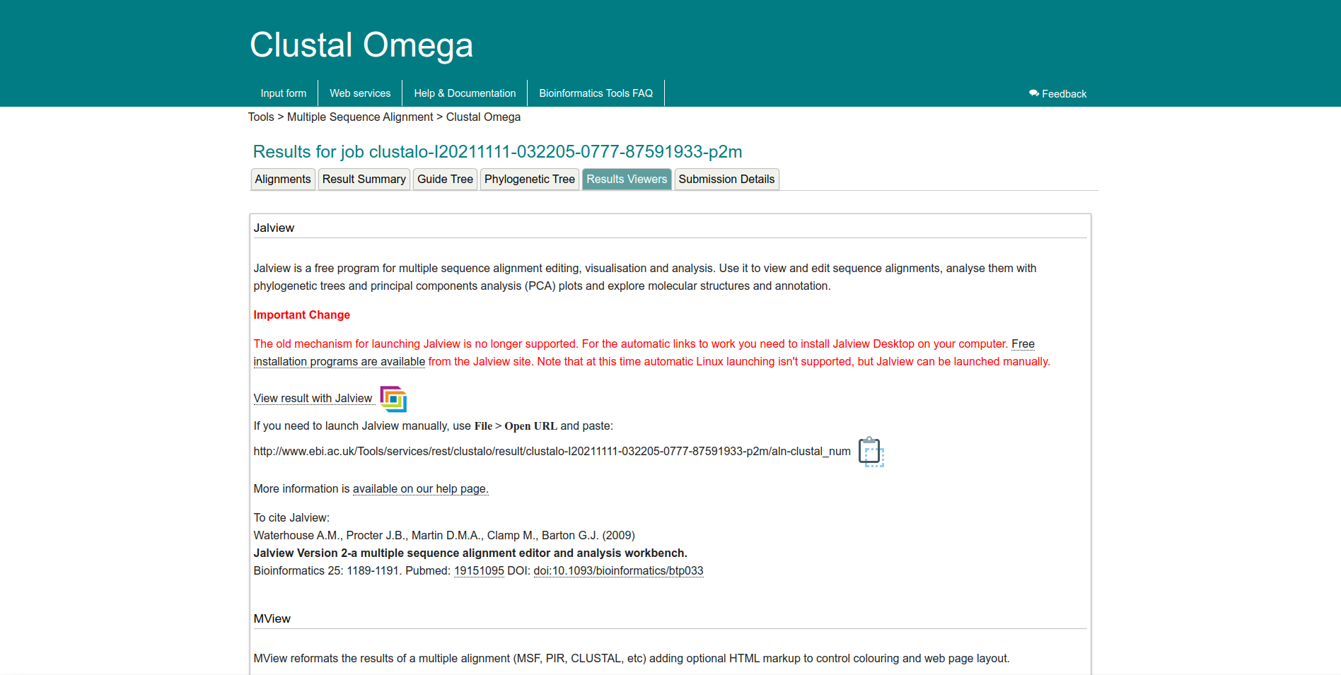**Fig11. Result page for query Rhodopsin showing result viewers section to open the results in external software**

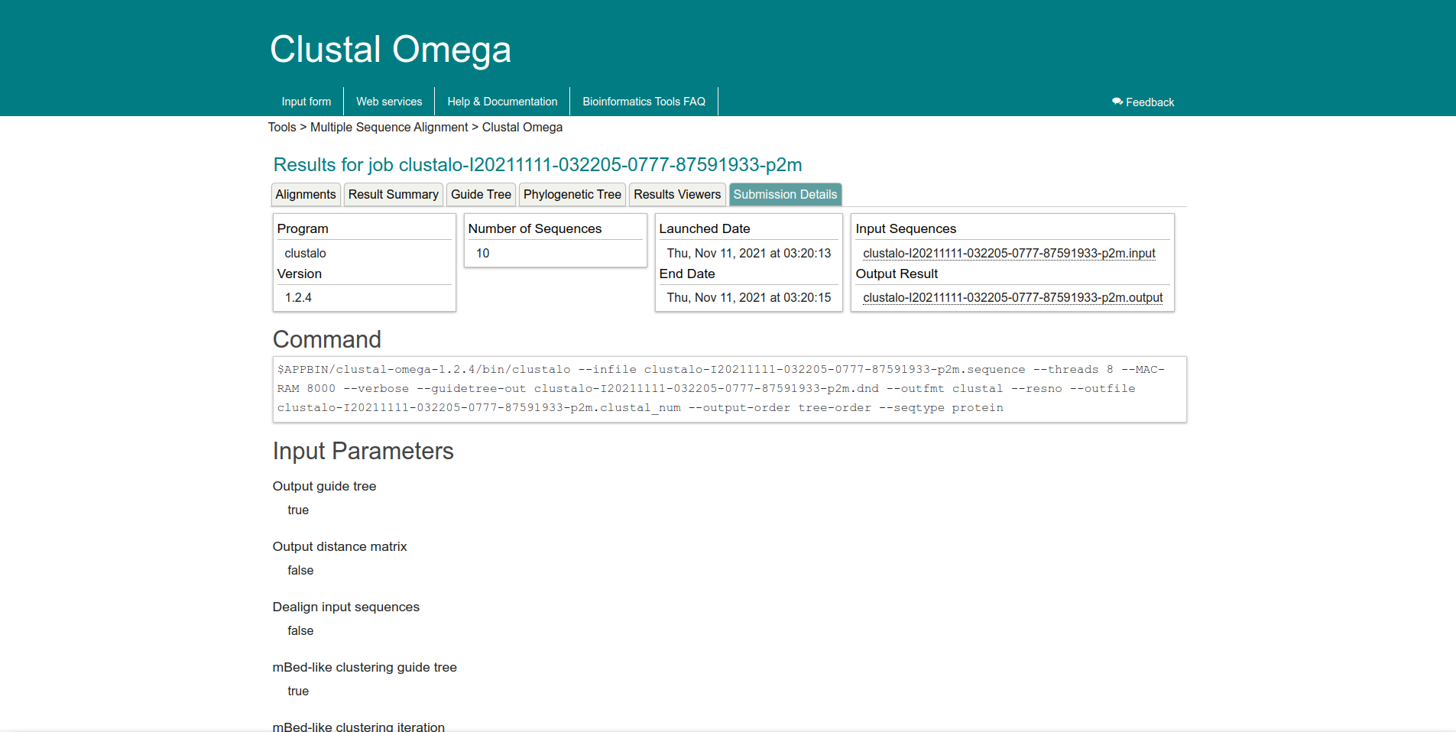**Fig12. Result page for query Rhodopsin showing submission details giving info about our search parameters**

**Result:**

Protein sequences for query “Rhodopsin” from various species was used to perform multiple sequence alignment and alignments, result summary, guide tree, phylogenetic tree, result viewers and submission details information was observed for the same.

**Conclusion:**

Clustal omega which is a heuristic algorithm working on progressive alignment method allows users to achieve quick multiple sequence alignment results. It is useful identification of conserved sequence patterns and motifs, conserved and functionally critical amino acid residues can be identified in a protein, phylogenetic analysis of sequence families and prediction of protein secondary and tertiary structures.

**References:**

1. Xiong, J. (2006). Multiple Sequence Alignment. *Essential Bioinformatics* (1st ed.). Cambridge University Press, 63-71.
2. Moman, R. N., & Varacallo, M. (2018). Physiology, Albumin. Nih.gov; StatPearls Publishing. Retrieved November 11th,, 2021, from <https://www.ncbi.nlm.nih.gov/books/NBK459198/>
3. (n.d.). Retrieved November 11th,, 2021, from https://www.uniprot.org/uniprot/?query=id:P02699 OR id:P08100 OR id:P28327 OR id:Q15835 OR id:Q63651 OR id:Q9WVL4 OR id:Q8WTQ7 OR id:P31356 OR id:P32308 OR id:Q49HM9&format=fasta&sort=score
4. (n.d.). Retrieved November 11th,, 2021, from <https://www.uniprot.org/uniprot/?query=Rhodopsin&sort=score>
5. (n.d.). Retreived November 11th,, 2021, from <https://www.ebi.ac.uk/Tools/services/web/toolresult.ebi?jobId=clustalo-I20211111-032205-0777-87591933-p2m&analysis=alignments>
6. Haplochromis burtoni rhodopsin-like (rhodopsin), mRNA - Nucleotide - NCBI. (n.d.). Retrieved from <https://www.ncbi.nlm.nih.gov/nuccore/NM_001287832.1?report=fasta>

**DATE: 10-11-21**

**WEBLEM 13/b**

**Tree view**

**Aim:**

To view query Rhodopsin phylogenetic tree data produced in Clustal Omega in tree view

**Introduction:**

TreeView provides a simple way to view the phylogenetic trees produced by a range of programs, such as PAUP* and PHYLIP, TREE-PUZZLE, and ClustalX. While some phylogenetic programs (such as the Macintosh version of PAUP*) have excellent tree-printing facilities, many programs do not have the ability to generate publication-quality trees. TreeView addresses this need. The program can read and write a range of tree file formats, display trees in a variety of styles, print trees, and save the tree as a graphic file.

**Rhodopsin**, also called **visual purple**, pigment-containing sensory protein that converts light into an electrical signal. Rhodopsin is found in a wide range of organisms, from vertebrates to bacteria. In many seeing animals, including humans, it is required for vision in dim light and is located in the retina of the eye specifically, within the tightly packed disks that make up the outer segment of the retina’s photoreceptive rod cells, which are specially adapted for vision under low-light conditions. Rhodopsin was discovered in 1876 by German physiologist Franz Christian Boll, who observed that the normally reddish purple frog retina turned pale in bright light. The fading of colour was later attributed to the destruction of rhodopsin, via a process known as bleaching. Bleaching and the subsequent regeneration of rhodopsin are major steps in the visual cycle—the series of biochemical reactions that is critical for vision in low light.

**Methodology:**

1. Retrieve phylogenetic tree data for query Rhodopsin from MSA performed on Vlustal Omega.
2. Save data on notepad with .php as file extension.
3. Open file in tree view and make required changes.

**Observation:**

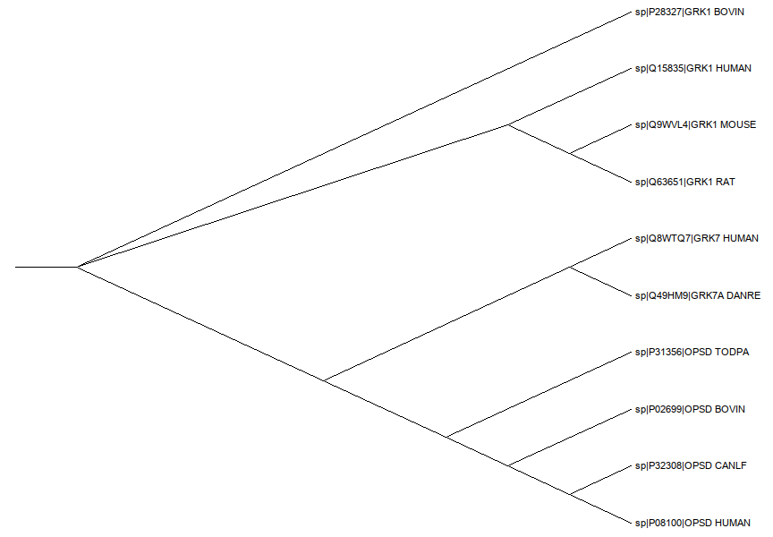**Fig1. Phylogenetic tree data for query Rhodopsin in tree view**

**Result:**

Phylogenetic tree data produced in Clustal Omega for query Rhodopsin was viewed on tree view

**Conclusion:**

Tree view provides users various display options, such as viewing internal node labels. Choosing the style in which the tree is drawn and desginating an outgroup. It also allows the user to define default display preferences.

**References:**

1. (n.d.). Retrieved on November 11, 2021, from <https://www.ebi.ac.uk/Tools/services/web/toolresult.ebi?jobId=clustalo-I20211111-032205-0777-87591933-p2m&analysis=phylotree>
2. Haplochromis burtoni rhodopsin-like (rhodopsin), mRNA - Nucleotide - NCBI. (n.d.). Retrieved from <https://www.ncbi.nlm.nih.gov/nuccore/NM_001287832.1?report=fasta>